
CA-2 REPORT
“Predicting Top-Selling Product Categories”
INT-315

NAME-SAURABH SONAL
REG. NO. -12223119
SUBJECT- CLUSTER COMPUTING

Contents
Abstract 3
Introduction 3
PySpark 4
Definition of PySpark 4
Key Characteristics of PySpark 4
Uses of PySpark 4
Justification for Using PySpark in This Project 4
Methodology 5
Data Collection and Description 5
Data Preprocessing 5
Feature Engineering 5
Model Selection: Random Forest Classifier 6
Evaluation Strategy 6
Models and Functions Used 6
SparkSession 6
DataFrame Operations 7
SQL Functions 7
Feature Transformation 7
Machine Learning Model 7
Evaluation Tool 7
Implementation 8
Results and Discussion 8
Conclusion 9
References 9
Appendix 9
Appendix A: Code 9
Appendix B: Visualization Output 12

Abstract
In the modern retail ecosystem, the exponential growth of transactional data has created a pressing need for scalable and intelligent data analytics solutions. This project presents a distributed machine learning approach to predict top-selling product categories using historical sales data processed through PySpark, the Python interface of Apache Spark. The system leverages Spark’s distributed computing framework to efficiently preprocess large datasets, perform feature engineering, and train a Random Forest classifier for predictive modeling. The model classifies product categories into high-performing and low-performing groups based on aggregated sales patterns. Experimental results demonstrate that the proposed approach can effectively capture temporal and categorical patterns in retail data, enabling accurate prediction of top-selling categories. The study highlights the importance of scalable machine learning pipelines in retail analytics and provides insights into key factors influencing product performance.

Introduction
The retail industry is increasingly driven by data, with organizations collecting massive volumes of transactional information from point-of-sale systems, online platforms, and customer interactions. Extracting meaningful insights from this data is critical for optimizing inventory management, improving customer satisfaction, and increasing profitability.
One of the most valuable insights for retailers is identifying which product categories are likely to achieve high sales in the future. Accurate prediction of top-selling categories allows businesses to:
- Optimize stock levels and reduce inventory costs
- Design targeted marketing campaigns
- Improve supply chain efficiency
- Enhance decision-making processes
However, traditional data processing systems are often inadequate for handling large-scale datasets due to limitations in scalability and performance. This is where Apache Spark and PySpark become highly relevant.
PySpark enables distributed data processing across clusters, allowing large datasets to be processed efficiently using parallel computation. Additionally, Spark’s MLlib provides a powerful suite of machine learning algorithms that can be applied directly to big data.
In this project, we utilize PySpark to build a scalable machine learning pipeline that predicts whether a product category will become a top-selling category based on historical sales data. The study integrates data preprocessing, feature engineering, and classification modelling into a unified workflow.

PySpark

Definition of PySpark
PySpark is the Python API for Apache Spark, an open-source distributed computing framework designed for processing large-scale data efficiently. It allows developers and data scientists to write Spark applications using Python, combining ease of use with high computational power.
Unlike traditional data processing systems that rely heavily on disk-based operations, Spark uses in-memory computation, significantly improving processing speed for iterative algorithms and machine learning tasks.

Key Characteristics of PySpark
- Distributed Computing: Data is processed across multiple nodes in a cluster
- Fault Tolerance: Automatic recovery from failures using lineage graphs
- Lazy Evaluation: Optimizes execution plans before running transformations
- Scalability: Can handle datasets ranging from gigabytes to petabytes
- Integration: Supports SQL, streaming, machine learning, and graph processing

Uses of PySpark
PySpark is widely used in various domains, including:
- Big Data Analytics: Processing large datasets for insights
- Machine Learning: Building scalable ML models using MLlib
- ETL Pipelines: Extracting, transforming, and loading data efficiently
- Real-Time Processing: Using Spark Streaming for live data analysis
- Data Engineering: Cleaning, transforming, and preparing datasets

Justification for Using PySpark in This Project
The dataset used in this project represents transactional sales data, which can grow significantly in size. PySpark is chosen because:
- It efficiently handles large datasets
- It supports distributed feature engineering
- It provides built-in machine learning algorithms
- It ensures scalability for future extensions

Methodology
The methodology adopted in this project follows a structured data science pipeline, consisting of data preprocessing, feature engineering, model training, and evaluation.

Data Collection and Description
The dataset includes the following attributes:
- Category: Product category
- Brand: Brand name
- Region: Geographic location
- Sales: Sales amount
- Date: Transaction date

Data Preprocessing
Data preprocessing is a crucial step to ensure data quality and consistency. The following operations were performed:
- Removal of missing or null values
- Conversion of date column into proper date format
- Extraction of temporal features such as month and year
These steps help in transforming raw data into a structured format suitable for analysis.

Feature Engineering
Feature engineering involves transforming raw data into meaningful features that improve model performance.
Key steps include:
- Aggregating sales data to compute monthly average sales
- Grouping data by category, brand, region, year, and month
- Creating a binary target variable (label) based on a threshold
A binary target variable was created to represent whether a product category is top-performing or not. Categories with average monthly sales greater than 300 were labelled as top-selling (1), while the remaining were labelled as non top-selling (0). During the initial stages of model development, average sales was included as one of the input features. However, this resulted in a data leakage problem, where the model indirectly learned the target variable, leading to unrealistically high accuracy. To resolve this issue, average sales was removed from the feature set. This ensured that the model learns meaningful relationships from independent variables such as category, region, and time, resulting in a more realistic and generalizable prediction model.

Model Selection: Random Forest Classifier
The Random Forest algorithm is an ensemble learning method that constructs multiple decision trees and combines their outputs to improve prediction accuracy.
Advantages:
- Handles high-dimensional data
- Reduces overfitting
- Captures non-linear relationships
- Provides feature importance

Evaluation Strategy
The model is evaluated using:
- Binary classification metrics
- Accuracy score
- Feature importance analysis
In order to classify product categories into top-selling and non top-selling groups, a threshold value of 300 was selected based on the distribution of average monthly sales. This value was chosen to ensure a more balanced dataset, as an imbalanced dataset can lead to biased model predictions. By adjusting the threshold, the number of high-selling and low-selling instances becomes more evenly distributed, which improves the learning capability of the model and leads to more reliable predictions.

Models and Functions Used
This project utilizes several PySpark components, each playing a critical role in the pipeline.

SparkSession
The SparkSession acts as the entry point for interacting with Spark.
SparkSession.builder.appName("SalesPrediction").getOrCreate()
It initializes the Spark application and allows DataFrame operations.

DataFrame Operations
Key operations include:
- read.csv() → Loads dataset into DataFrame
- dropna() → Removes missing values
- withColumn() → Adds or modifies columns
- groupBy() → Groups data
- agg() → Performs aggregation

SQL Functions
Used for data transformation:
- col() → Refers to columns
- to_date() → Converts string to date
- month(), year() → Extract temporal features
- avg() → Computes averages
- when() → Applies conditional logic

Feature Transformation
StringIndexer
Converts categorical variables into numerical indices required for machine learning models.
VectorAssembler
Combines multiple feature columns into a single feature vector.

Machine Learning Model
RandomForestClassifier
The model builds multiple decision trees and aggregates their predictions.

Evaluation Tool
BinaryClassificationEvaluator
Evaluates model performance using classification metrics.

Implementation
The implementation is carried out using PySpark in the following sequence:
- Initialize Spark session
- Load dataset into DataFrame
- Perform data cleaning and preprocessing
- Engineer features
- Encode categorical variables
- Assemble features into vectors
- Train Random Forest model
- Generate predictions
- Evaluate model performance
- Visualize results
This structured pipeline ensures scalability and modularity.
In addition to model training and evaluation, visualization techniques were incorporated to better understand the data and support the interpretation of results. Graphs such as category-wise performance, regional sales comparison, and monthly trends were generated to provide a clear representation of sales patterns and enhance the overall analysis.

Results and Discussion
The Random Forest model demonstrated effective performance in predicting top-selling product categories using historical retail data. After correcting the issue of data leakage and refining the feature set, the model achieved an accuracy of approximately 86%, which indicates a good balance between model complexity and generalization.
Initially, the model showed extremely high accuracy due to the inclusion of average sales as both a feature and a target variable. This created a direct dependency that allowed the model to make trivial predictions. After removing this feature, the accuracy decreased to a more realistic level, confirming that the model is now learning actual patterns rather than relying on direct correlations.
The results indicate that categorical variables such as product category, sub-category, and region play a significant role in determining sales performance. In addition, temporal features such as month and year help the model capture seasonal variations in demand. These features together allow the model to identify patterns in consumer behavior and product performance across different time periods and locations.
Furthermore, visualization techniques were used to support the findings. The monthly sales trend highlighted seasonal fluctuations in sales, while region-wise comparisons revealed differences in demand across geographical areas. Sub-category analysis helped identify the most profitable product segments, and segment-based visualization provided insights into customer distribution. These visual insights strengthen the interpretability of the model and provide meaningful business implications.

Conclusion
This project successfully demonstrates the application of PySpark for large-scale retail analytics. By leveraging distributed computing and machine learning, the system effectively predicts top-selling product categories.
The study confirms that scalable analytics frameworks like Spark are essential for modern data-driven decision-making.
Future work can focus on:
- Real-time prediction systems
- Advanced machine learning models
- Integration with business intelligence tools

References
- Apache Spark Official Documentation
- PySpark MLlib Guide
- Breiman, L. (2001). Random Forests
- Han, J., Kamber, M. – Data Mining Concepts and Techniques
- Géron, A. – Hands-On Machine Learning

Appendix

Appendix A: Code
The following section presents the implementation of the project using PySpark. It includes all major steps such as data loading, preprocessing, feature engineering, model training, and evaluation.

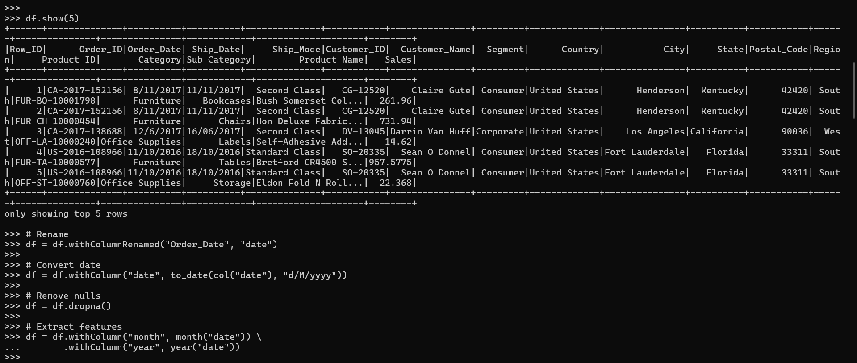
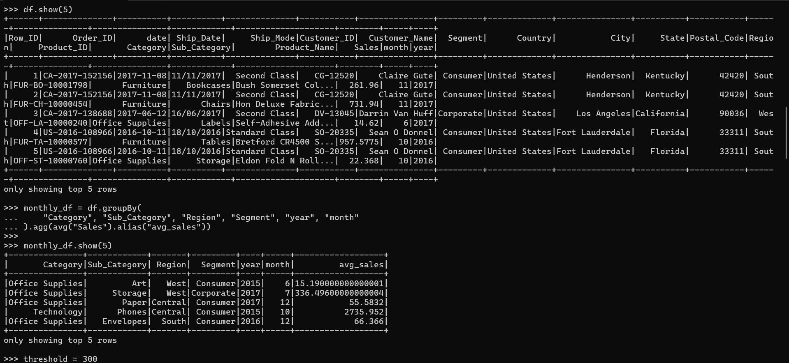
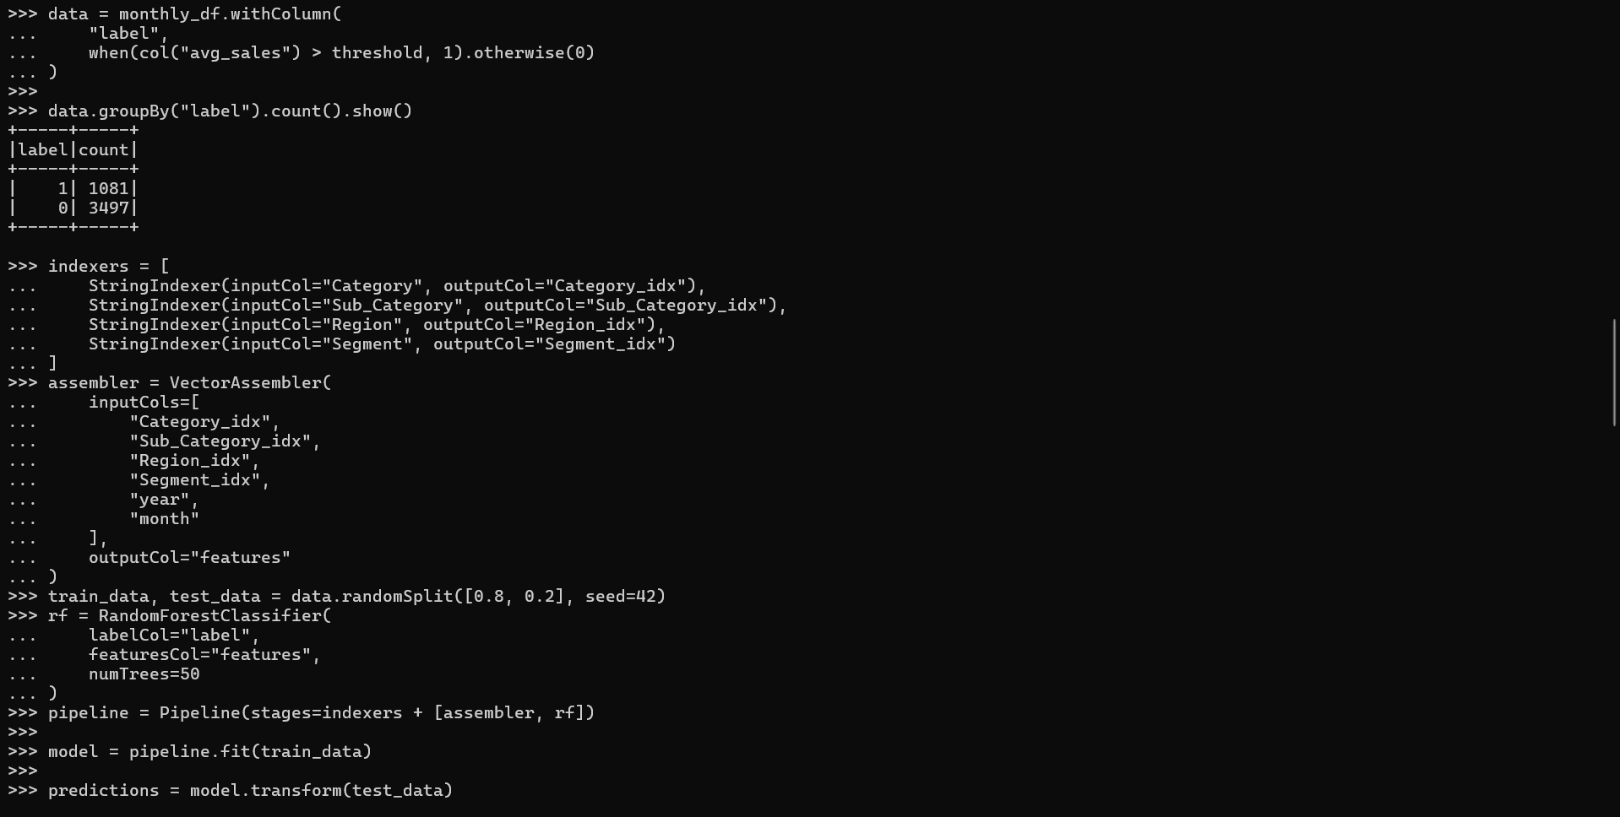
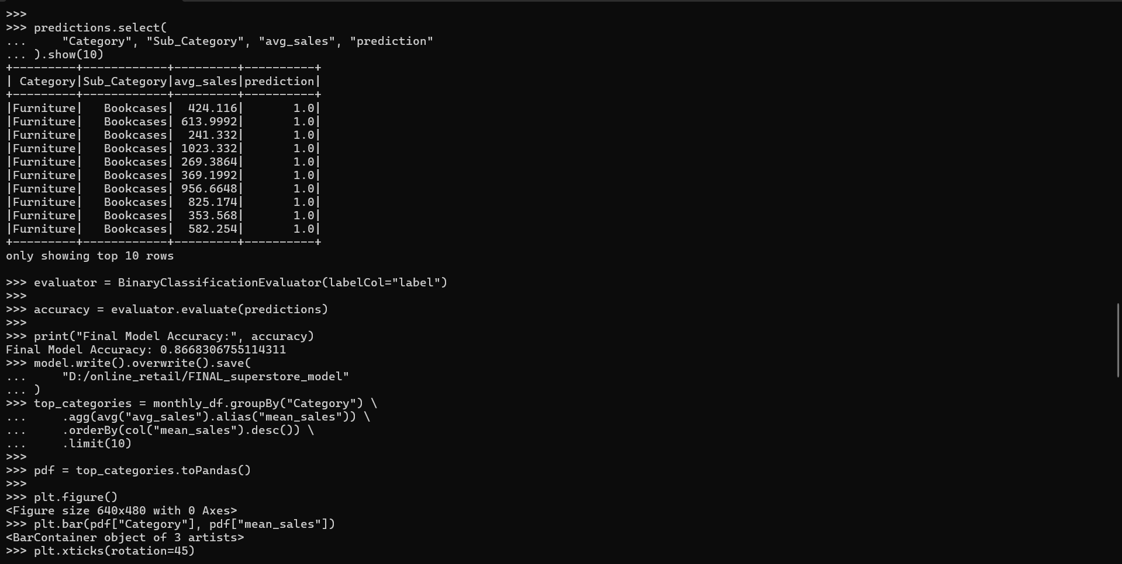
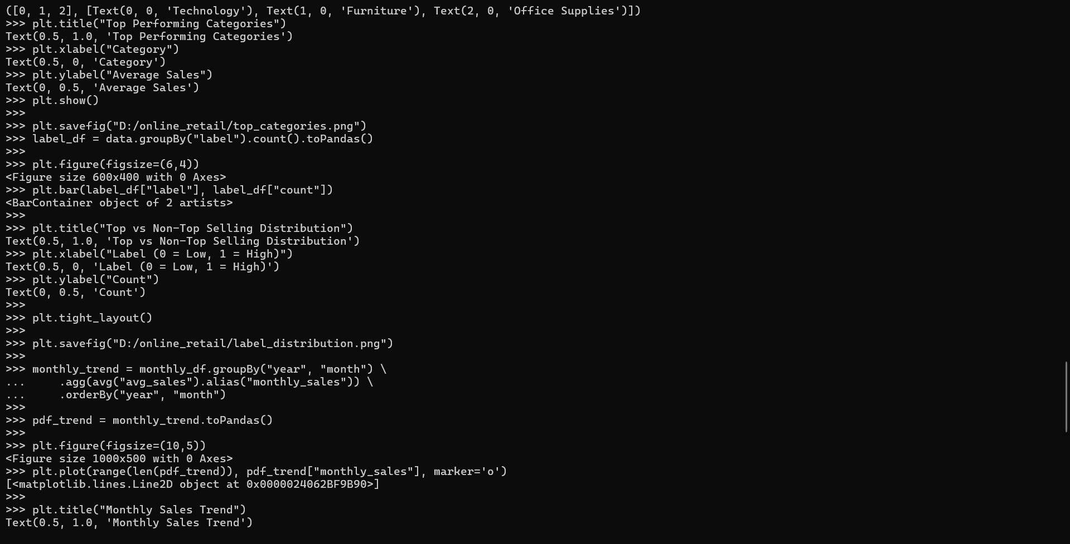
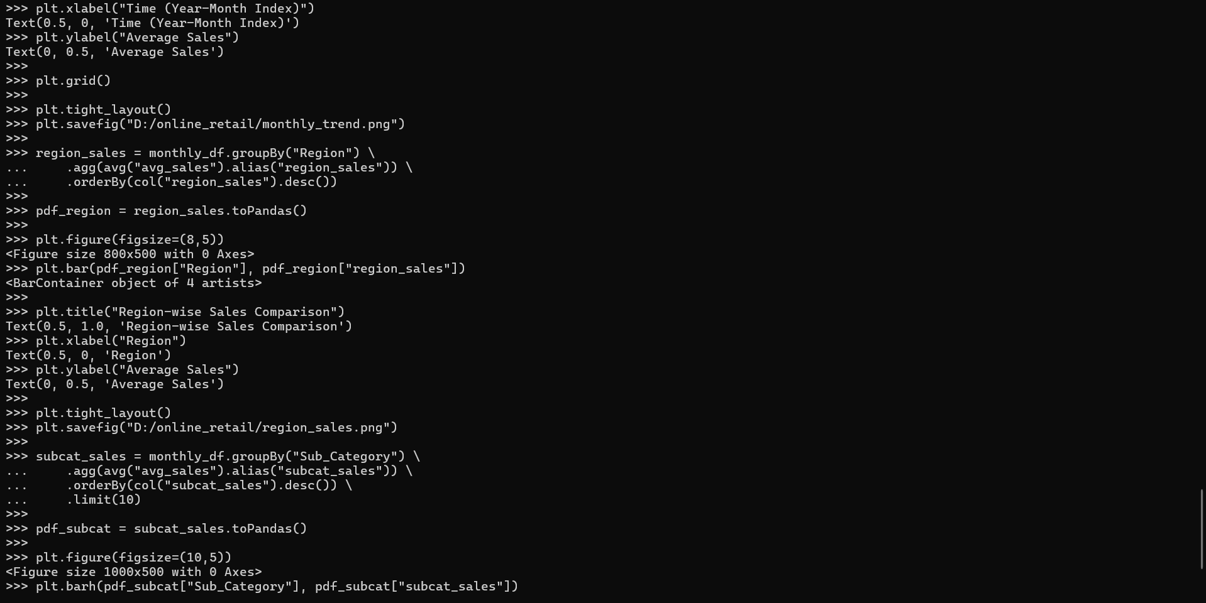
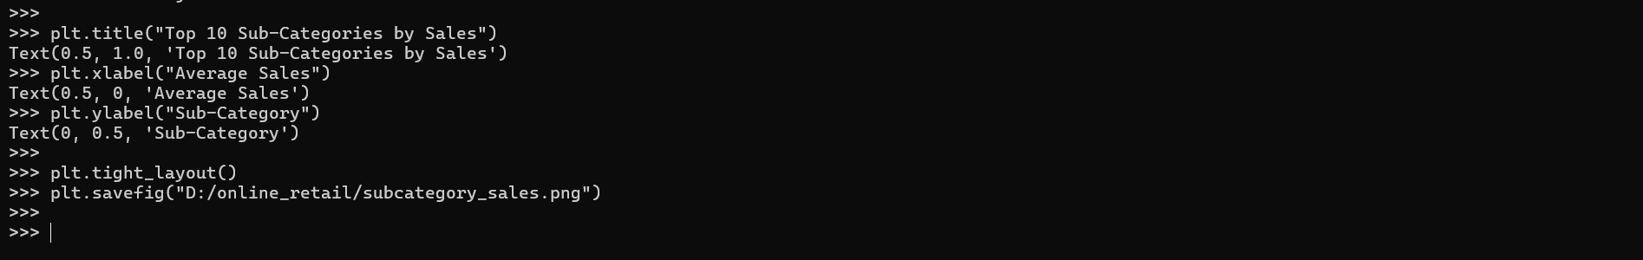

Appendix B: Visualization Output
This section includes the graphical outputs generated during the analysis. The visualizations illustrate important patterns such as top-performing categories, seasonal trends in sales, regional differences, and customer segment distribution. These graphs provide additional insights that complement the machine learning results and help in better understanding the dataset.
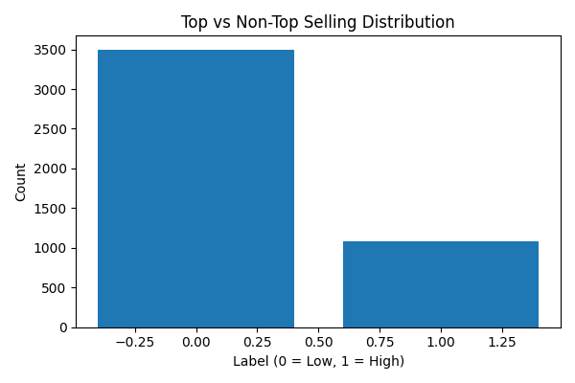
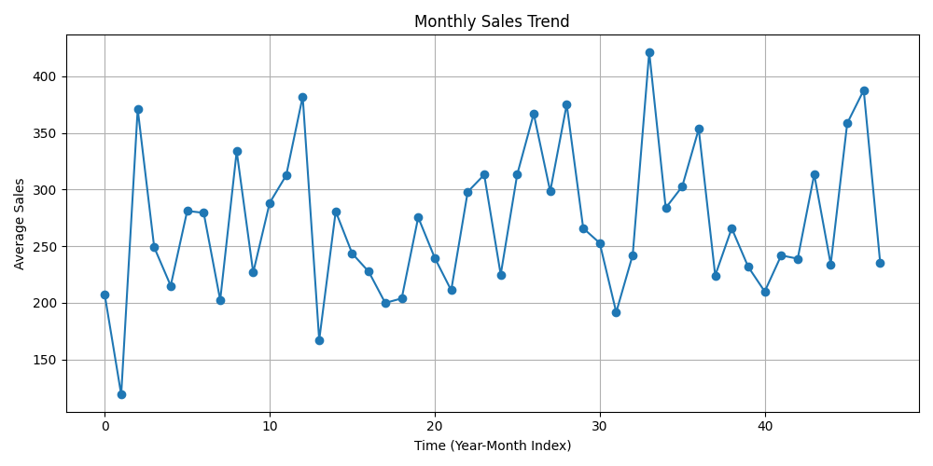
FIG.1

FIG.2
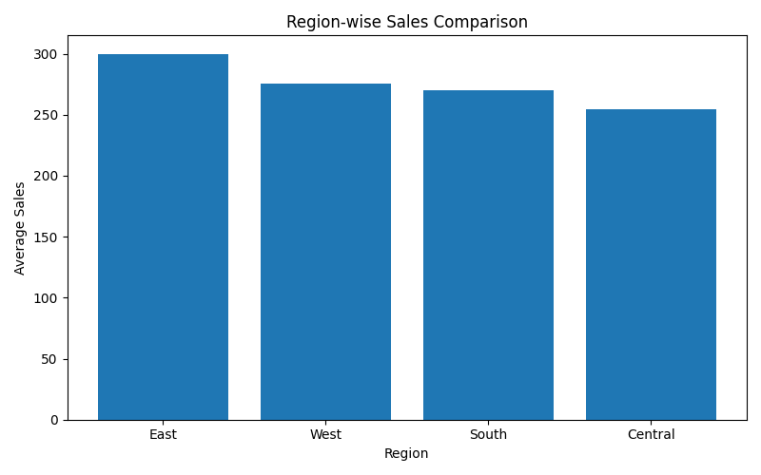
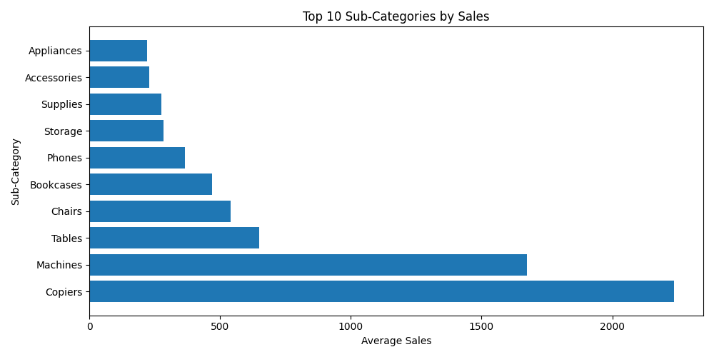
FIG.3

FIG.4
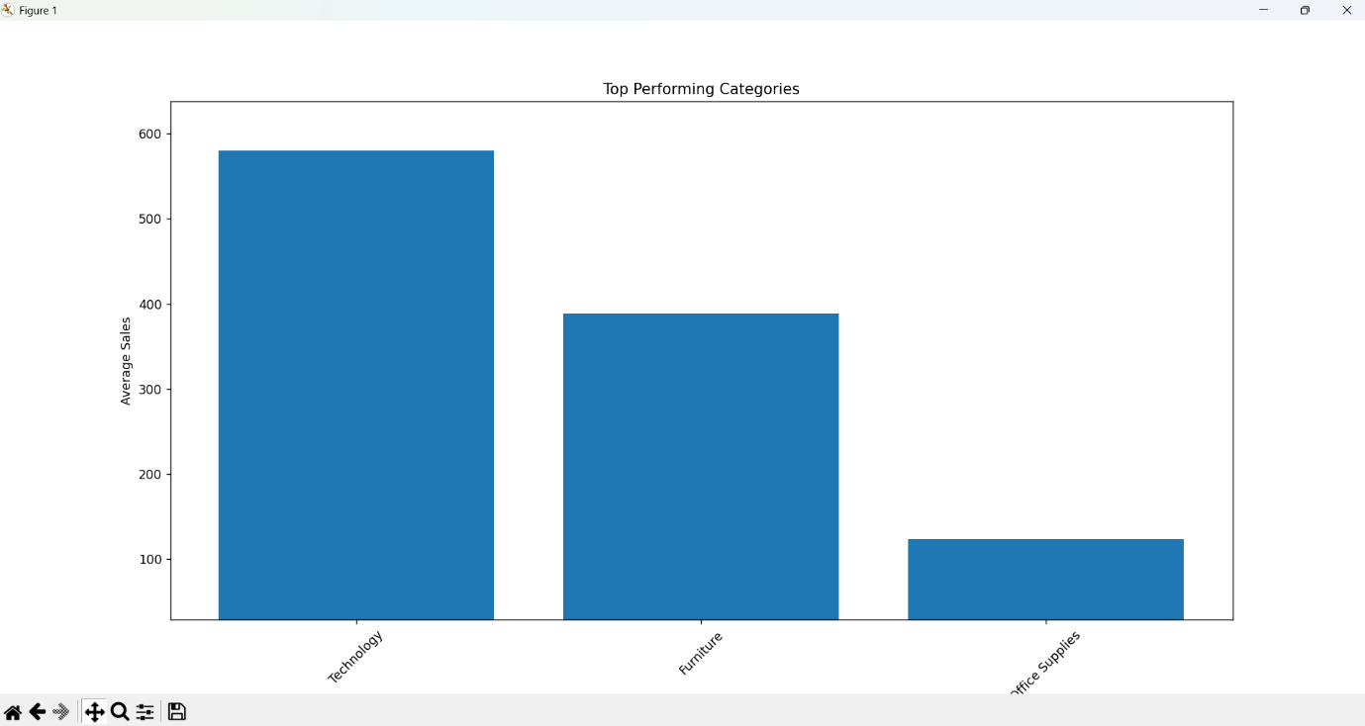
FIG.5

