* **Team**

1. Anirudh Tiwari
2. Daniel Milroy
3. Sneha Parmar
4. Saurabh Sood

* **Title:** NextBox
* **Project Summary:** NextBox is a cloud based application on the lines of Dropbox, which allows users to manage their files, and share it with others. The system allows the users to manipulate and share files and directories.
* **Project Requirements:**

1. User Requirements

|  |  |  |  |
| --- | --- | --- | --- |
| **ID** | **Actor** | **Requirement** | **Priority** |
| UR 01 | User | View home directory and navigate filesystem | Critical |
| UR 02 | User | Must be able to create account | Critical |
| UR 03 | User | Change directory structure (creating, deleting, moving, renaming directories) | Critical |
| UR 04 | User | Copy, paste, delete, rename files | Critical |
| UR 05 | User | Upload files | Critical |
| UR 06 | User | Download files | High |
| UR 07 | User | View and edit text file | High |
| UR 08 | User | View photos | High |
| UR 09 | User | Search for file or directory | Medium |
| UR 10 | User | View usage | High |
| UR 11 | User | Change plan | Medium |
| UR 12 | User | Share file with another user | Medium |
| UR 13 | User | View and pay bill | Medium |
| UR 14 | User | Add a credit card | Medium |
| UR 15 | Admin | Create users | High |
| UR 16 | Admin | Change the activation status | Critical |
| UR 17 | Admin | Modify Plan | Low |
| UR 18 | Admin | Create a plan (change per month rate and space) | Low |

1. Business Requirements

|  |  |  |  |
| --- | --- | --- | --- |
| **ID** | **Actor** | **Description** | **Priority** |
| BR1 | Billing System | Update bill monthly based on usage | Medium |
| BR2 | Billing System | Warn and do not allow the user in case they exceed the usage | Medium |

1. Non-Functional Requirements

|  |  |  |  |
| --- | --- | --- | --- |
| **ID** | **Actor** | **Description** | **Priority** |
| NFR1 | System | Prohibit escalation of privilege | Critical |
| NFR2 | System | Support at least 100 user accounts | Medium |
| NFR3 | System | Support at least 4 concurrect directory listings/FS tree walks | High |
| NFR4 | System | Run on HTTPS | Nice to Have |

* **Use Cases**

1. Use Case Document

|  |  |  |  |
| --- | --- | --- | --- |
| **Use Case ID** | **Actor** | **Description** | **Responsible** |
| UC 01 | User | Create an account | Anirudh |
| UC 02 | User | Add credit card | Anirudh |
| UC 03 | User | Rename file | Anirudh |
| UC 04 | User | Delete file | Anirudh |
| UC 05 | User | Copy file | Anirudh |
| UC 06 | User | Paste file | Anirudh |
| UC 07 | User | Create directory | Dan |
| UC 08 | User | Delete directory | Dan |
| UC 09 | User | Move directory | Dan |
| UC 10 | User | Rename directory | Dan |
| UC 11 | User | Upload file | Saurabh |
| UC 12 | User | Download files | Sneha |
| UC 13 | User | View text file | Sneha |
| UC 14 | User | View photo | Dan |
| UC 15 | User | Search for file or directory | Sneha |
| UC 16 | User | See account usage | Sneha |
| UC 17 | User | Change plan | Dan |
| UC 18 | User | Share file | Saurabh |
| UC 19 | User | Check bill | Saurabh |
| UC 20 | Admin | Create user | Dan |
| UC 21 | Admin | Change activation status | Sneha |
| UC 22 | Admin | Create plan | Saurabh |
| UC 23 | Admin | Modify plan | Saurabh |
| UC 24 | User | Edit text file | Sneha |

1. Use Case Diagram
2. Admin Use Case Diagram:

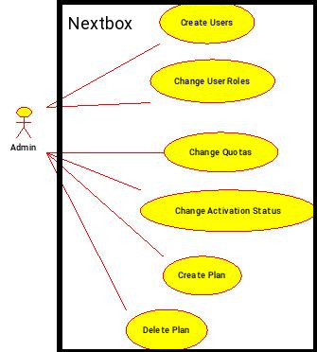

1. User Use Case Diagram

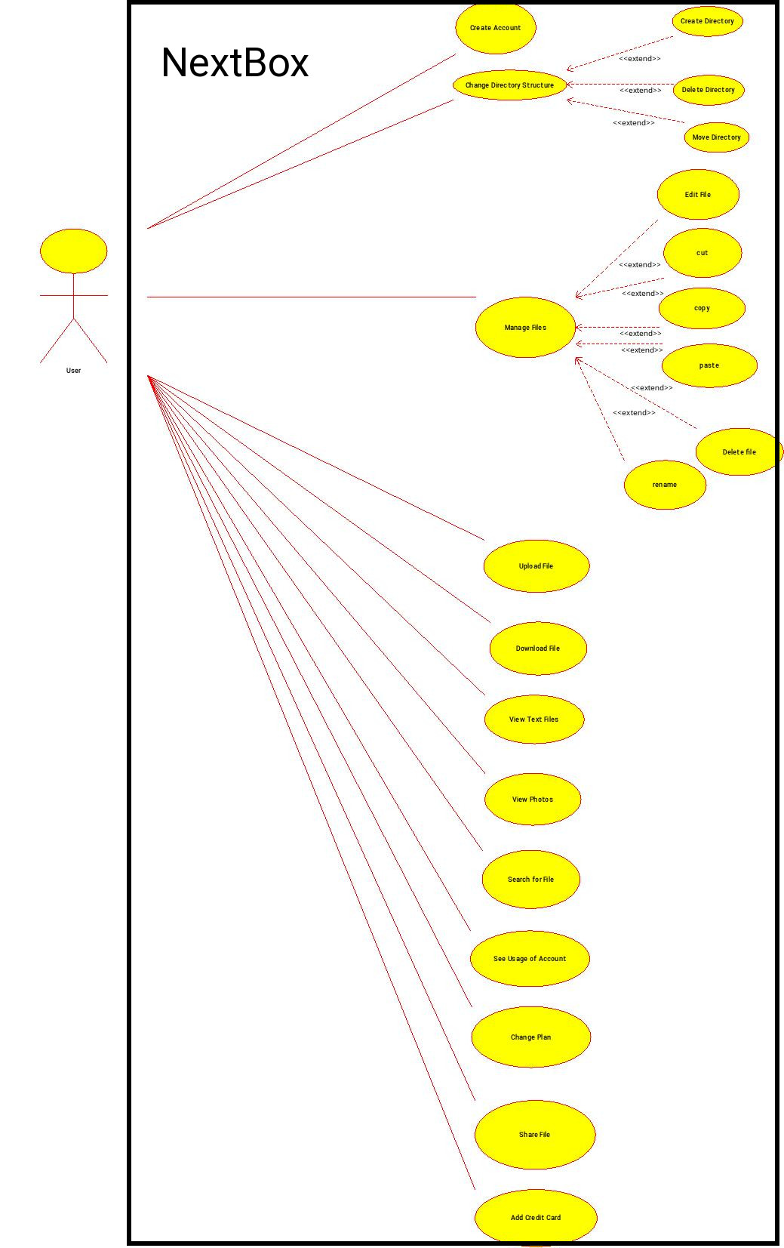

* **UI Mockup**

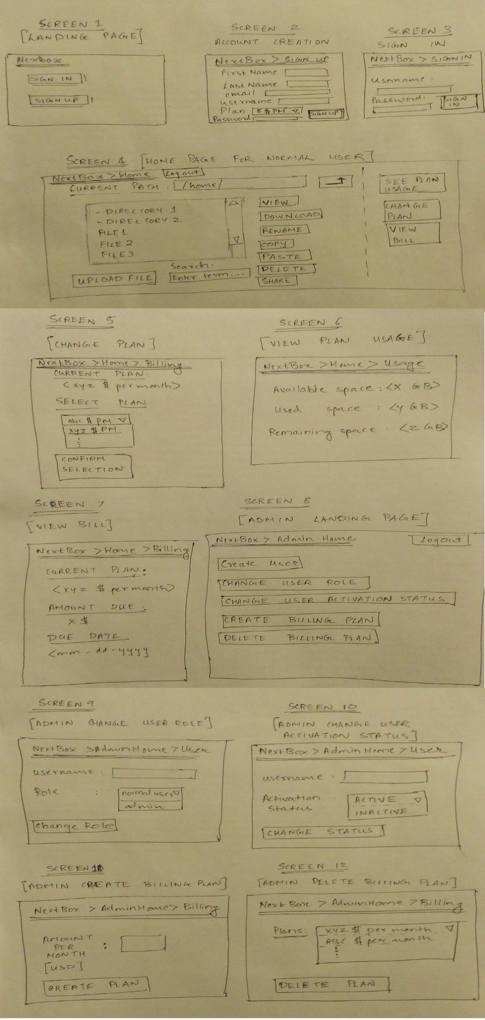

* **Data Storage**

Database to be used: MySQL

Data to be stored in it:

1. User tables (having user account information necessary for login, file mapping paths, payment details)
2. Billing information for users
3. List of available plans

* **Class Diagram**

