* **Name:** ANIRUDH TIWARI
* **Project:** NextBox
* **Requirements:**My User Requirements:

UR 02 : (User) Must be able to create an account.

UR 04 : (User) Must be able to Copy, Delete, Rename, Paste Files  
UR 14 : (User) Must be able to add a credit card.

* **Use Case Documents -**

**Use Case 01:** Create an account

|  |  |
| --- | --- |
| **Use Case ID:** | UC 01 |
| **Use Case Name:** | Create an Account |
| **Description:** | User can create an account in the application with a unique username. |

|  |  |
| --- | --- |
| **Actors:** | User |
| **Pre-conditions:** | User is on the signup page of the application with option to fill the required information. |
| **Post-conditions:** | User after creating an account should land on the welcome screen as a logged in user or land on the sign-up page in case of incorrect information. |
| **Frequency of Use:** | Once (User can sign up only once with a unique username) |
| **Flow of Events:** | |  |  |  | | --- | --- | --- | |  | **Actor Action** | **System Response** | | **1.** | Enter User credentials |  | | **2.** | Choose Plan |  | | **3.** | Enter username |  | | **4.** | Enter password |  | | **5.** | Submit Details | Store details and Check for unique username and create an account with the entered credentials. | |
| **Variations:** |  |
| **Exceptions:** | User Action 5. If username is not unique error message is displayed and the user is prompted to enter username again. |
| **Developer Notes:** |  |
|  |  |

**Use Case 02: Add Credit Card**

|  |  |
| --- | --- |
| **Use Case ID:** | UC 02 |
| **Use Case Name:** | Add Credit Card |
| **Description:** | User can edit credit card details. |

|  |  |
| --- | --- |
| **Actors:** | Actor |
| **Pre-conditions:** | User has already opted for Sign-up and has chosen a paid plan. |
| **Post-conditions:** | User after creating an account should land on the welcome screen as a logged in user. |
| **Frequency of Use:** | Once (User can sign up only once with a unique username) |
| **Flow of Events:** | |  |  |  | | --- | --- | --- | |  | **Actor Action** | **System Response** | | **1.** | Successfully created an account. | If free plan display welcome message. | | **2.** | Enter Card Details |  | | **3.** | Submit Card details | Stores the card details and display Welcome Screen. | |
| **Variations:** |  |
| **Exceptions:** | User Action 1. If not a free plan, prompt user to enter card details. |
| **Developer Notes:** |  |

**Use Case 03:** Rename File

|  |  |
| --- | --- |
| **Use Case ID:** | UC 03 |
| **Use Case Name:** | Rename File |
| **Description:** | User should be able to rename a file. |

|  |  |
| --- | --- |
| **Actors:** | Actor |
| **Pre-conditions:** | User is already logged in and is on the home directory. |
| **Post-conditions:** | User should be able to see the rename file. |
| **Frequency of Use:** | About once in 15 Days. |
| **Flow of Events:** | |  |  |  | | --- | --- | --- | |  | **Actor Action** | **System Response** | | **1.** | Select file to rename. |  | | **2.** | Click rename. |  | | **3.** | Enter the new name. |  | | **4.** | Submit | Display the fine with new name. | |
| **Variations:** |  |
| **Exceptions:** |  |
| **Developer Notes:** |  |

**Use Case 04:** Delete File

|  |  |
| --- | --- |
| **Use Case ID:** | UC 04 |
| **Use Case Name:** | Delete File |
| **Description:** | User should be able to delete a file. |

|  |  |
| --- | --- |
| **Actors:** | Actor |
| **Pre-conditions:** | User is already logged in and is on the home directory. |
| **Post-conditions:** | User should be able to see the directory without the file deleted. |
| **Frequency of Use:** | Once in 15 Days. |
| **Flow of Events:** | |  |  |  | | --- | --- | --- | |  | **Actor Action** | **System Response** | | **1.** | Select file to delete. |  | | **2.** | Click delete. |  | | **3.** | Submit | Delete the file and display the directory. | |
| **Variations:** |  |
| **Exceptions:** |  |
| **Developer Notes:** |  |

**Use Case 05:** Copy File

|  |  |
| --- | --- |
| **Use Case ID:** | UC 05 |
| **Use Case Name:** | Copy File |
| **Description:** | User should be able to copy a file onto the clipboard. |

|  |  |
| --- | --- |
| **Actors:** | Actor |
| **Pre-conditions:** | User is already logged in and is on the home directory at the source. |
| **Post-conditions:** | Clipboard should have the path to the file. |
| **Frequency of Use:** | Once in 3 Days. |
| **Flow of Events:** | |  |  |  | | --- | --- | --- | |  | **Actor Action** | **System Response** | | **1.** | Select file to copy. |  | | **2.** | Click copy. |  | | **3.** | Submit | Copy the file onto the clipboard. | |
| **Variations:** |  |
| **Exceptions:** |  |
| **Developer Notes:** |  |

**Use Case 06:** Paste File

|  |  |
| --- | --- |
| **Use Case ID:** | UC 06 |
| **Use Case Name:** | Paste File |
| **Description:** | User should be able to paste a file at the destination. |

|  |  |
| --- | --- |
| **Actors:** | Actor |
| **Pre-conditions:** | User is already logged in and is on the home directory. |
| **Post-conditions:** | User should be able to paste the file and view on the destination. |
| **Frequency of Use:** | Once in 3 Days. |
| **Flow of Events:** | |  |  |  | | --- | --- | --- | |  | **Actor Action** | **System Response** | | **1.** | Select destination. |  | | **2.** | Click Paste. |  | | **3.** | Submit | Paste the file from clipboard to destination. | |
| **Variations:** |  |
| **Exceptions:** |  |
| **Developer Notes:** |  |

* **Activity Diagrams**

Activity Diagram 1

* 1. **Requirement ID**: UR 02 and UR 14
  2. **Use Case ID:** 
     1. UC 01- Create an Account  
        Description: The User should be able to create an account in NextBox.
     2. UC 02- Add credit card

Description: The user should be able to add credit card details on choosing a paid plan.

* 1. **Implementor:** ANIRUDH TIWARI

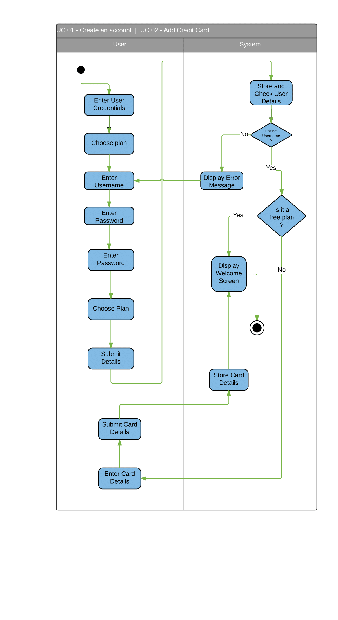

Activity Diagram 2

1. **Requirement ID**: UR 04
2. **Use Case ID:**

UC 03: Rename File  
Description: The User should be able to Rename a file in his home directory.

1. **Implementor:** ANIRUDH TIWARI

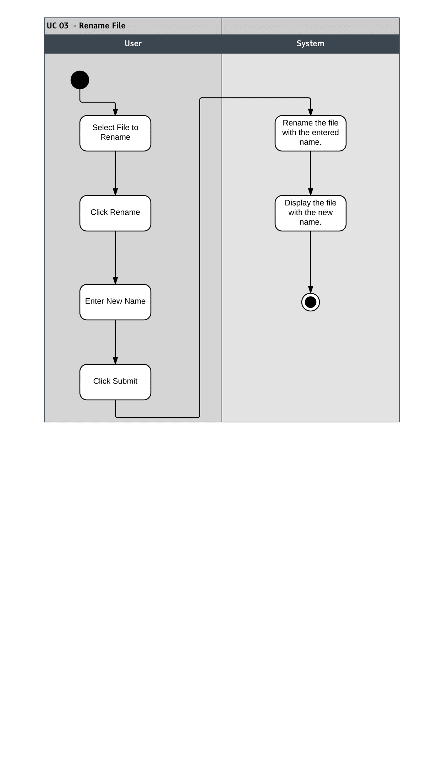

Activity Diagram 3

1. **Requirement ID**: UR 04
2. **Use Case ID:**

UC 04: Delete File  
Description: The User should be able to Delete a file from his home directory.

1. **Implementor:** ANIRUDH TIWARI

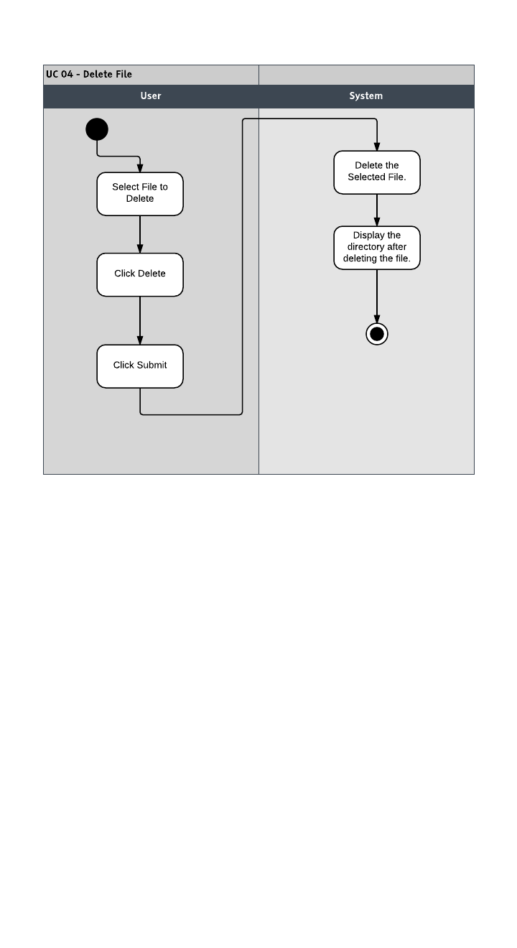

Activity Diagram 4

1. **Requirement ID**: UR04
2. **Use Case ID:**

UC 05: Copy File

Description: The User should be able to Copy a file from his home directory (On the Clipboard).

1. **Implementor:** ANIRUDH TIWARI

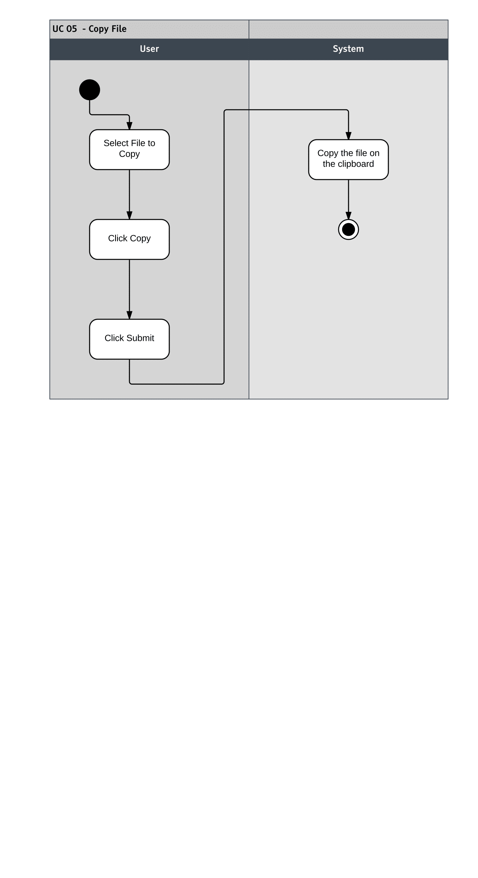

Activity Diagram 5

1. **Requirement ID**: UR 04
2. **Use Case ID:**

UC 05: Paste File

Description: The User should be able to Paste a file from the clipboard on to a destination in his home directory.

1. **Implementor:** ANIRUDH TIWARI

