Name: Saurabh Sood

Project: Nextbox

Use Case Documents

Use Case ID: | UC 18
Use Case Name: | Share File
Description: | A user should be able to share a file to another user on the platform.

Actors: | User
Pre-conditions: | - User has created a user account  - User is logged in  - The other user has a user on the platform.
Post-conditions: | Other user should be able to access the shared file
Frequency of Use:
Flow of Events:
   | Actor Action | System Response
  1  2  3 | User clicks on “Select File”, and select the file they want to share.  Enter the email address of the person they want to share the file with  Click Share File | The system makes a copy of the file for the other user
Variations:
Exceptions:
Developer Notes:

Use Case ID: | UC 11
Use Case Name: | Upload File
Description: | A user should be able to upload their files from their local filesystem to the web server.

Actors: | User
Pre-conditions: | - User has created a user account  - User is logged in
Post-conditions: | User should be able see the uploaded file
Frequency of Use:
Flow of Events:
   | Actor Action | System Response
  1.  2.  3. | User clicks “Select File” button  User selects file  User clicks “Upload File” | System uploads the file to the server
Variations:
Exceptions: | If there is not enough space to accommodate the file, an error message is shown
Developer Notes:

Use Case ID: | UC 19
Use Case Name: | Check Bill
Description: | A user should be able to see their monthly bill

Actors: | User
Pre-conditions: | - User has created a user account  - User is logged in
Post-conditions: | The system should show a Dollar value for the monthly bill
Frequency of Use:
Flow of Events:
   | Actor Action | System Response
  1. | User clicks “Check Bill” button | System shows a web page with the current monthly bill, along with the monthly rate.
Variations:
Exceptions:
Developer Notes:

Use Case ID: | UC22
Use Case Name: | Create Plan
Description: | An admin should be able to create a new plan for users to select

Actors: | Admin
Pre-conditions: | - Admin is logged in
Post-conditions: | A user should be able to apply the new plan for the current month
Frequency of Use:
Flow of Events:
   | Actor Action | System Response
  1.  2.  3. | Admin clicks ‘Add Plan’ button  Admin enters the monthly rate, and the space  Click ‘Add’ | 1. System responds with a web page which has fields to enter the monthly dollar rate, and space in GB  System adds plan to the database
Variations:
Exceptions:
Developer Notes:

Use Case ID: | UC23
Use Case Name: | Modify Plan
Description: | An admin should be able to modify the rate of an existing plan

Actors: | Admin
Pre-conditions: | - Admin is logged in
Post-conditions: | The bill for the users plan should reflect the new rate
Frequency of Use:
Flow of Events:
   | Actor Action | System Response
  1.  2.  3. | User selects a plan, and clicks ‘Modify Plan’ button  Admin enters a new monthly rate  Admin clicks on ‘Modify’ button | 1. System responds with a web page which has fields to enter the monthly dollar rate, and shows the space usage in a non editable field.  System adds the plan to the database
Variations:
Exceptions:
Developer Notes:

Activity Diagrams

Requirement#: UR 13
Use Case#: UC 19 – Check Bill
A user should be able to see their monthly bill
Implementor: Saurabh Sood

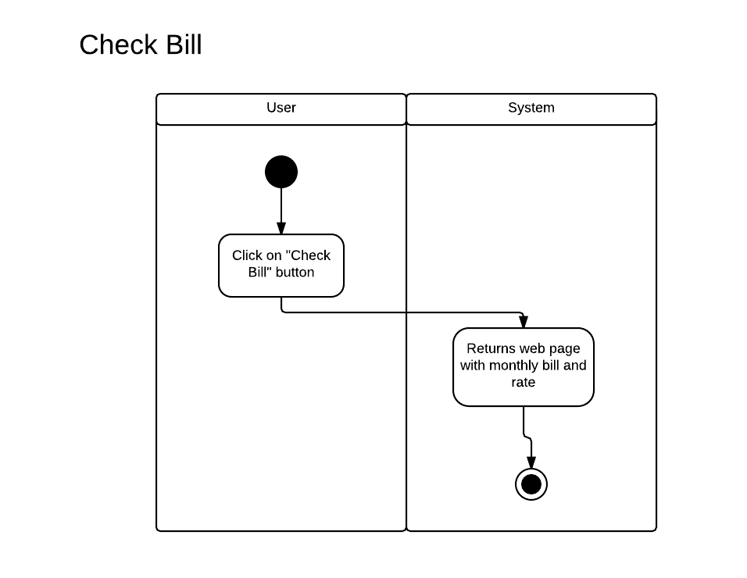
Requirement#: UR18
Use Case#: UC 22 – Create Plan
An admin should be able to create a new plan for users to select
Implementor: Saurabh Sood

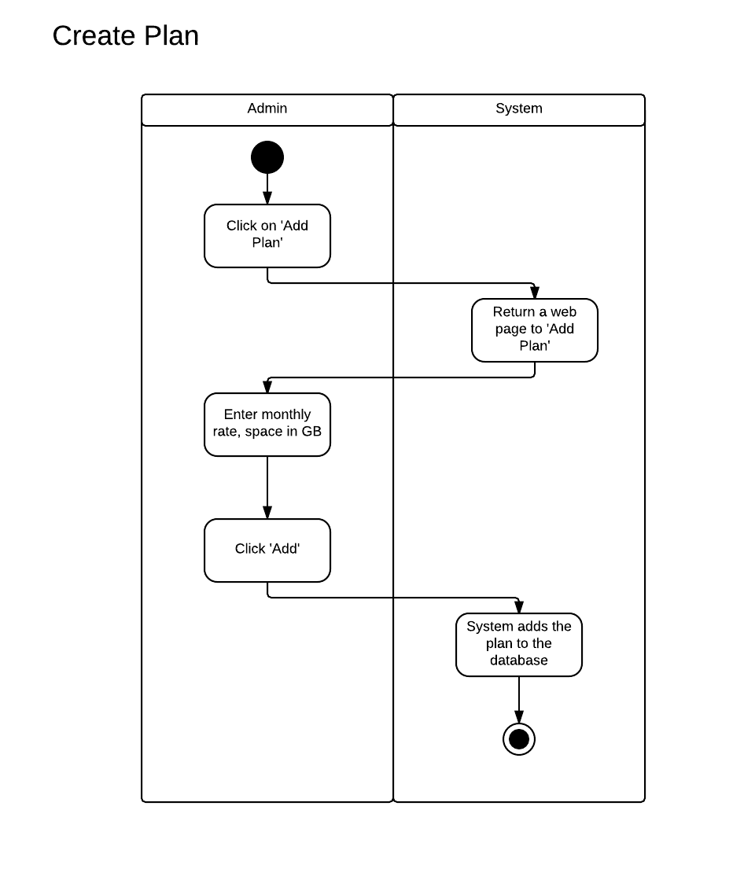
Requirement#: UR 17
Use Case#: UC 23 – Modify Plan
An admin should be able to modify the rate of an existing plan
Implementor: Saurabh Sood

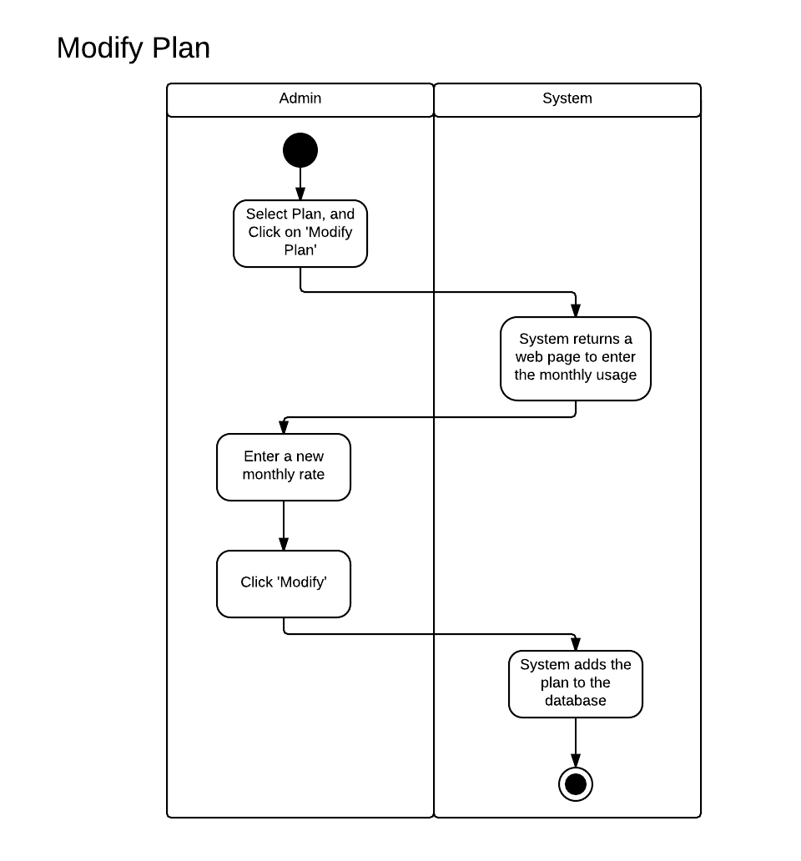

Requirement#: UR 12
Use Case#: UC 18 – Share File
An admin should be able to share a file to another user on the platform
Implementor: Saurabh Sood

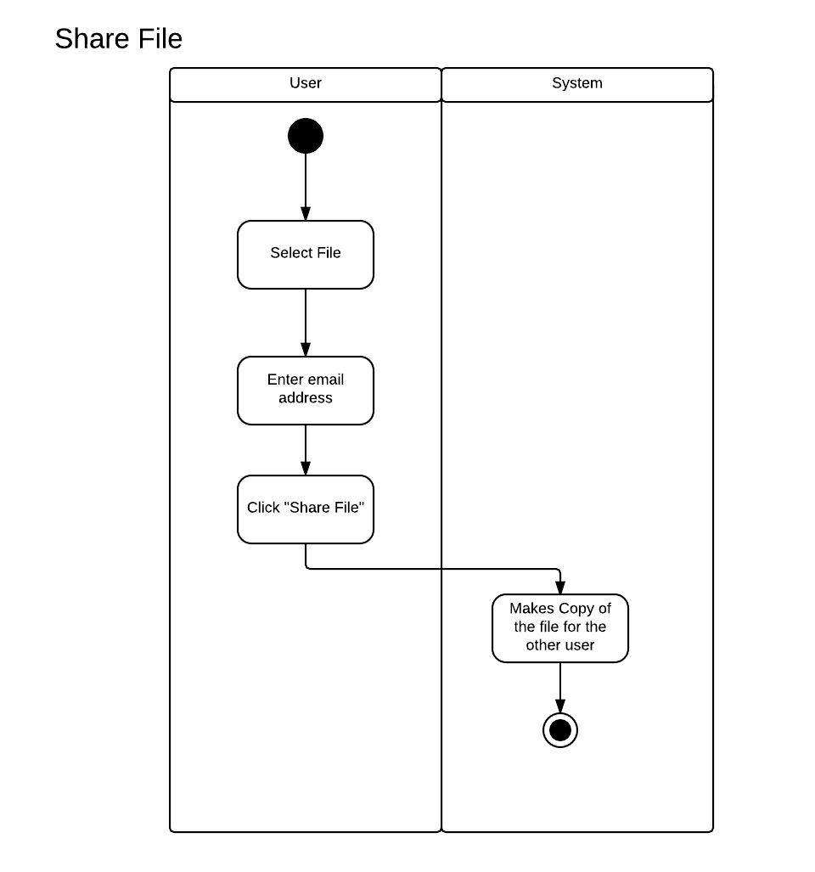

Requirement#: UR 05
Use Case #: UC 11 – Upload File
A user should be able to upload their files form their local filesystem to the web server
Implementor: Saurabh Sood

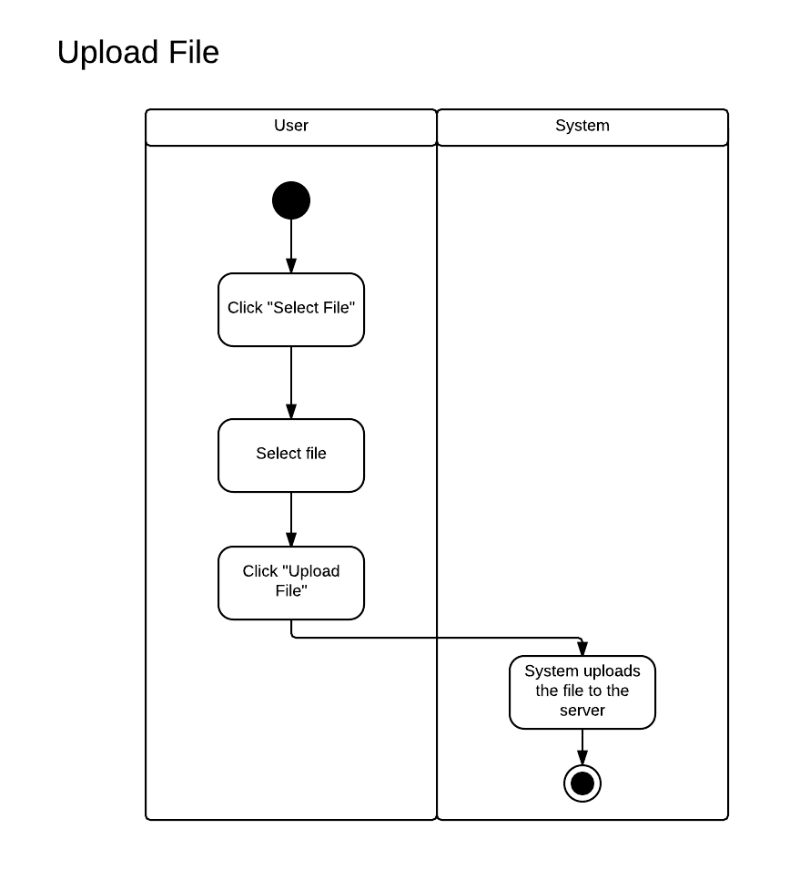
Sequence Diagrams

Requirement#: UR 13
Use Case#: UC 19 – Check Bill
A user should be able to see their monthly bill
Implementor: Saurabh Sood

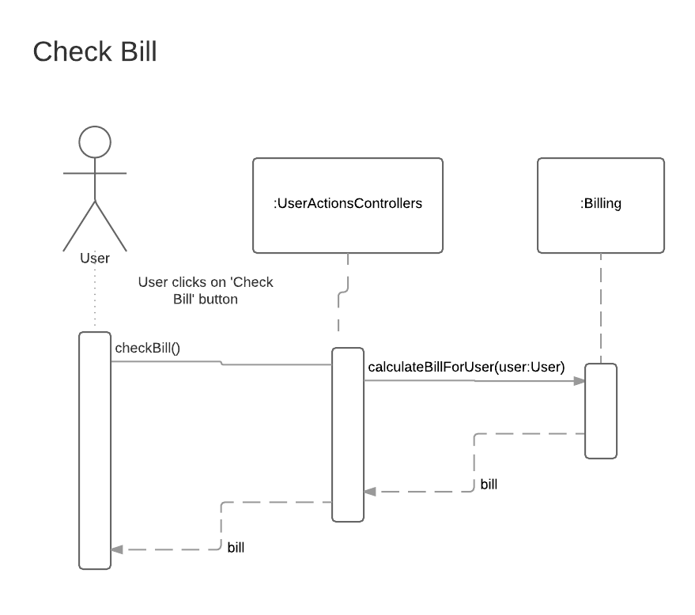
Requirement#: UR 18
Use Case#: UC 22 – Create Plan
An admin should be able to create a new plan for users to select
Implementor: Saurabh Sood

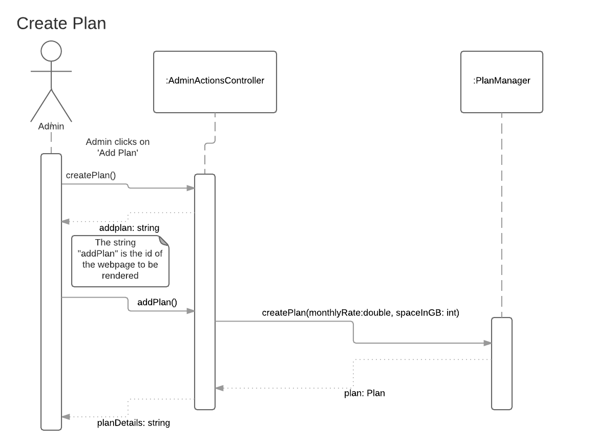
Requirement#: UR 17
Use Case#: UC 23 – Modify Plan
An admin should be able to modify the rate of an existing plan
Implementor: Saurabh Sood
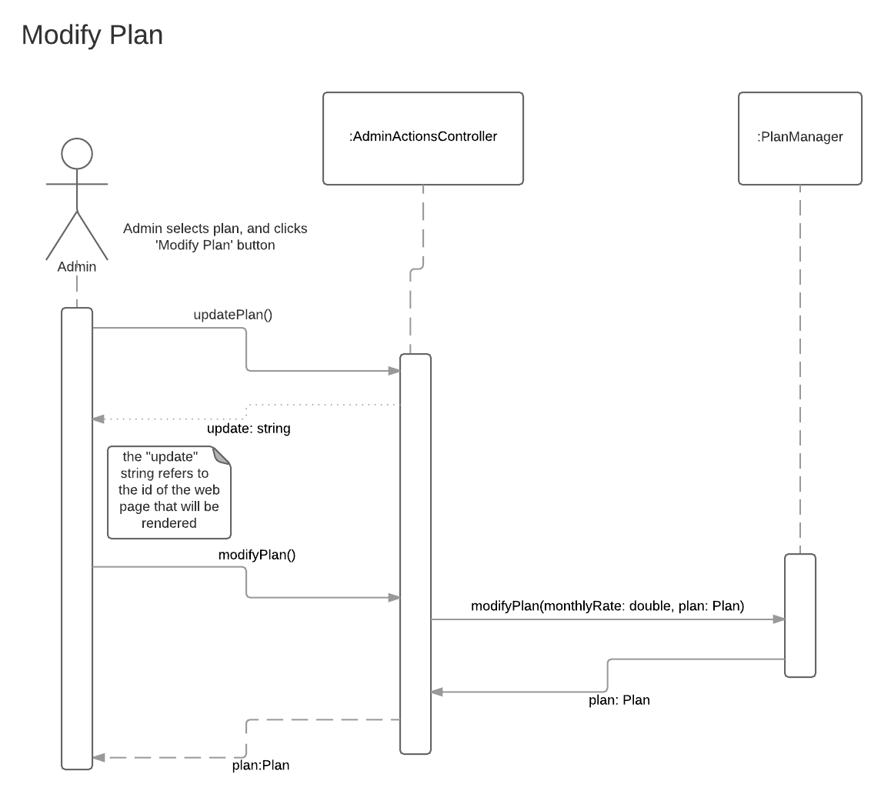

Requirement#: UR 12
Use Case#: UC 18 – Share File
An admin should be able to share a file to another user on the platform
Implementor: Saurabh Sood
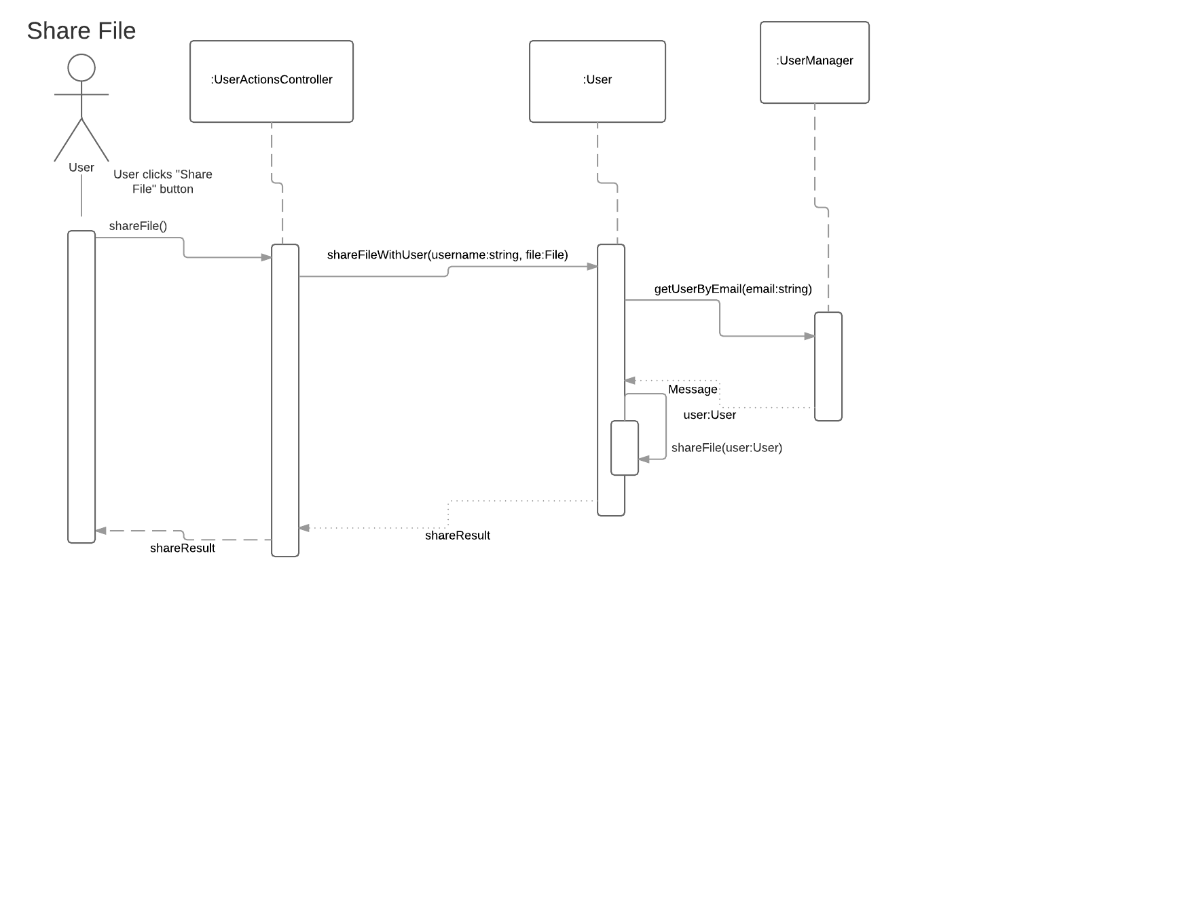
Requirement#: UR 05
Use Case#: UC 11 – Upload File
A user should be able to upload their files form their local filesystem to the web server
Implementor: Saurabh Sood
