NAME: SAURABH KUMAR KASHINWAR

ROLL NO:2200290120153

TOPIC NAME: TO-DO LIST

HTML CODE:

<!DOCTYPE html>

<html lang="en">

<head>

   <meta charset="UTF-8">

   <meta http-equiv="X-UA-Compatible" content="IE=edge">

   <meta name="viewport" content="width=device-width, initial-scale=1.0">

   <link rel="stylesheet" href="styles.css">

   <link rel="preconnect" href="https://fonts.googleapis.com">

   <link rel="preconnect" href="https://fonts.gstatic.com" crossorigin>

   <link href="https://fonts.googleapis.com/css2?family=Caveat&display=swap" rel="stylesheet">

   <link href=link rel="preconnect" href="https://fonts.googleapis.com">

   <link rel="preconnect" href="https://fonts.gstatic.com" crossorigin>

   <link href="https://fonts.googleapis.com/css2?family=Quicksand:wght@400;600&display=swap" rel="stylesheet">

   <title>TO-DO List</title>

</head>

<body>

    <div>

        <h1><nobr>Create your own To-Do List!</nobr></h1>

            <div class="user-input">

                <label for="task">Enter Task :</label>

                <input type="text" id="task" placeholder="Let's add something worth doing!">

                <button  id="addtask">Add to List</button>

                <button  id="clear" onclick="clearStorage()">Clear List</button>

            </div>

            <div>

                <span class="display">

                    <h2>Your Items:</h2>

                    <span class="progress">

                        <p>Completed: <span id="completed-count">0</span> || Pending: <span id="pending-count">0</span></p>

                        <!-- <p>Pending: <span id="pending-count">0</span></p> -->

                    </span>

                </span>

                <section class="table">

                    <table>

                        <thead>

                            <tr>

                                <th scope="c">Serial No.</th>

                                <th scope="c">Task</th>

                                <th scope="c">Actions</th>

                            </tr>

                        </thead>

                        <tbody id="tablebody">

                            <tr>

                                <th scope="r">1</th>

                                <td>Post this on LinkedIn!</td>

                                <td class="tbtns"><button>Done</button>

                                <button>Delete</button></td>

                            </tr>

                        </tbody>

                    </table>

                </section class="table">

            </div>

            <script src="javascript.js"></script>

</body>

</html>

CSS CODE:

/\* ------------------------Global Styles------------------------ \*/

\* {

    margin: 0;

    padding: 0;

    box-sizing: border-box;

}

body {

    display: flex;

    align-items: center;

    justify-content: center;

    background-color: rgb(183, 121, 172);

    line-height: 1.5rem;

    font-family: 'Quicksand',sans-serif;

}

/\* ------------------------Input & Display------------------------ \*/

body>div{

    min-width: 65%;

    padding: 0 5%;

}

h1{

    text-align: center;

    margin-top: 15%;

    margin-bottom: 12%;

    font-family: 'Caveat', sans-serif;

    font-size: 3.5rem;

    color: rgb(114, 61, 106);

}

.user-input{

    font-weight: bold;

    display: flex;

    justify-content: space-around;

    margin-bottom: 5%;

    text-align: center;

}

label{

    font-size: 1.5rem;

    padding: 1%;

    color: rgb(114, 61, 106);

}

#task{

    width: 50%;

    margin-left: 0;

    padding: 1%;

    border-radius: 20px;

    height: 43px;

    font-size: 0.9rem;

    background-color: #ffffff88;

    border: none;

}

button{

    padding: 1%;

    border-radius: 25px;

    border: transparent double rgb(114, 61, 106);

    height: 43px;

    font-size: 0.9rem;

    box-shadow: 0 0.2rem 0.4rem rgba(0, 0, 0, 0.304) ;

    color: rgb(255, 208, 243);

    background-color: rgb(114, 61, 106);

    font-weight: bold;

}

button:active{

    font-size: 1.01rem;

}

button:nth-child(odd):hover{

    border: transparent double rgb(87, 114, 61);

    color: rgb(227, 255, 208);

    background-color: rgb(85, 114, 61);

}

button:nth-child(even):hover{

    border: transparent double rgb(114, 61, 61);

    color: rgb(255, 208, 208);

    background-color: rgb(123, 38, 38);

}

.display{

    display: flex;

    justify-content: space-between;

    padding: 2.7%;

    font-size: large;

    background-color: rgb(144, 86, 135);

    border-radius: 0.8rem;

    box-shadow: 0 0.4rem 0.8rem rgba(0, 0, 0, 0.304) ;

    margin-bottom: 1%;

    color: rgb(255, 208, 243);

    font-weight: bolder;

}

.progress{

    text-align: right;

}

#completed-count{

    color: rgb(171, 233, 95);

}

#pending-count{

    color: rgb(255, 161, 161);

}

/\* ------------------------Table------------------------ \*/

table{

    border-collapse: collapse;

    padding: 1%;

    width: 100%;

    font-weight: bold;

    font-size: 1.1rem;

}

.table{

    margin-top: 0.5%;

    background-color: #ffffff45;

    border-radius: 0.8rem;

    box-shadow: 0 0.4rem 0.8rem rgba(0, 0, 0, 0.304) ;

    color: rgb(114, 61, 106);

}

thead{

    background-color: #ffffff45;

}

th{

    font-weight: bold;

}

th, td{

    text-align: center;

    padding: 10px;

}

tr:nth-child(even) {

    background-color: #ffffff45;

}

.tbtns{

    display: flex;

    justify-content: space-evenly;

}

.tbtns button{

    height: 43px;

    padding: 2%;

    width: 70px;

}

JAVASCRIPT CODE:

function getAndUpdate(){

    t = document.getElementById('task').value;

    if (localStorage.getItem('stringitems')==null){

        itemsarray = [];

        itemsarray.push([t]);

        localStorage.setItem('stringitems', JSON.stringify(itemsarray))

    }

    else{

        stritemsarray = localStorage.getItem('stringitems')

        itemsarray = JSON.parse(stritemsarray);

        itemsarray.push([t]);

        localStorage.setItem('stringitems', JSON.stringify(itemsarray))

        }

        update()

        pendingtasks++;

        updatetaskcount();

}

const tasks = document.getElementById("tablebody");

const completedcount = document.getElementById("completed-count");

const pendingcount = document.getElementById("pending-count");

let completedtasks = 0;

let pendingtasks = 0;

function updatetaskcount(){

    completedcount.textContent = completedtasks;

    pendingcount.textContent = pendingtasks;

}

function update(){

    if (localStorage.getItem('stringitems')==null){

        itemsarray = [];

        localStorage.setItem('stringitems', JSON.stringify(itemsarray))

    }

    else{

                    stritemsarray = localStorage.getItem('stringitems')

                    itemsarray = JSON.parse(stritemsarray);

    }

    // Populate the table

    let tablebody = document.getElementById("tablebody");

    let str = "";

    itemsarray.forEach((element, index) => {

        str += `

        <tr>

        <th scope="r">${index + 1}</th>

        <td>${element[0]}</td>

        <td class="tbtns"><button onclick="donetask(${index})">Done</button><button onclick="deletetask(${index})">Delete</button></td>

        </tr>`;

    });

    tablebody.innerHTML = str;

    document.getElementById("task").value = "";

}

addtask = document.getElementById("addtask");

addtask.addEventListener("click", getAndUpdate);

update();

function donetask(taskindex){

    // console.log("Delete", itemIndex);

    stritemsarray = localStorage.getItem('stringitems')

    itemsarray = JSON.parse(stritemsarray);

    // Delete itemIndex element from the array

    itemsarray.splice(taskindex, 1);

    localStorage.setItem('stringitems', JSON.stringify(itemsarray));

    update();

    completedtasks++;

    pendingtasks--;

    updatetaskcount();

}

function deletetask(taskindex){

    // console.log("Delete", itemIndex);

    stritemsarray = localStorage.getItem('stringitems')

    itemsarray = JSON.parse(stritemsarray);

    // Delete itemIndex element from the array

    itemsarray.splice(taskindex, 1);

    localStorage.setItem('stringitems', JSON.stringify(itemsarray));

    update();

    pendingtasks--;

    updatetaskcount();

}

function clearStorage(){

    if (confirm("Do you areally want to clear?"))

    {

    localStorage.clear();

    update()

    }

    document.getElementById("task").value = "";

    completedtasks = 0;

    pendingtasks = 0;

    updatetaskcount();

}

OUTPUT OF THE CODE:

HOMEPAGE OF PROJECT:

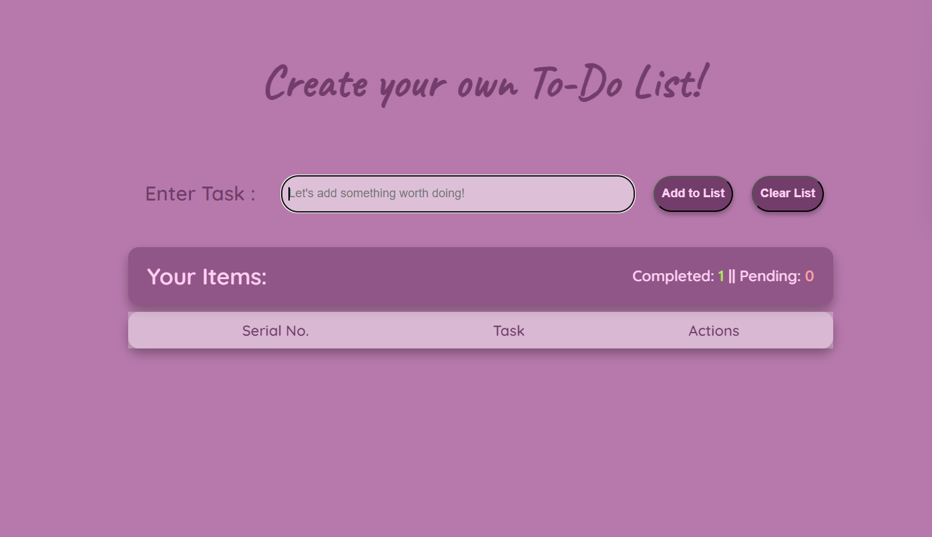

TASK IS ADDED TO THE LIST:

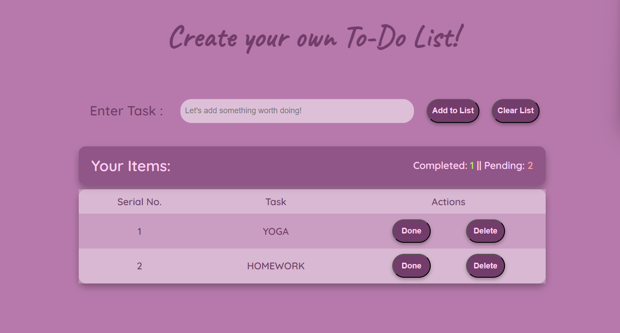

WHEN TASK IS COMPLETED:

