BITS WILP M.Tech AIML
Machine Learning Assignment 2

Student Name: Saurabh Tayal
BITS ID: 2026AJ05009

QSAR Biodegradation Classifier

- GitHub repository link
Repository: https://github.com/saurabhtayal/ml-assignment-2-qsar-biodegradation
- Live Streamlit app link
Application: https://ml-assignment-2-qsar-biodegradation-onsuyyappeeggmgshgvpift.streamlit.app/
- BITS Virtual Lab execution screenshot
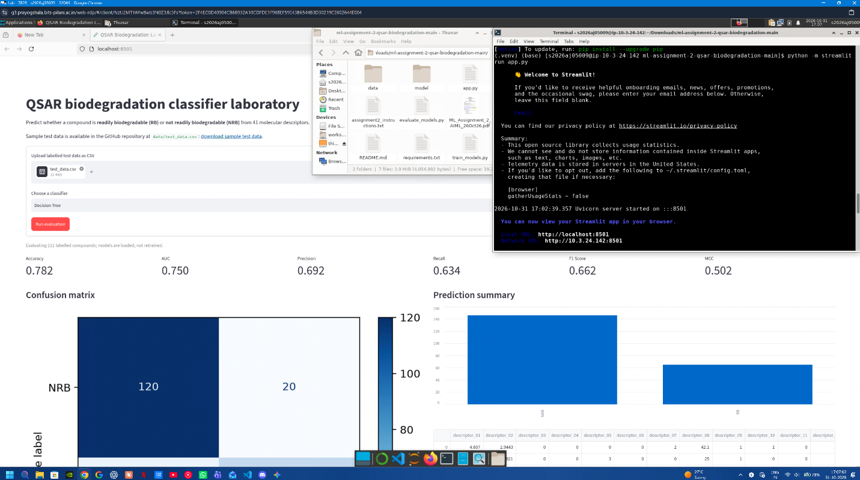

- GitHub README content

Problem statement:

Given molecular descriptors for an organic compound, predict whether it is readily biodegradable (RB) or not readily biodegradable (NRB). The application accepts a labelled CSV test set, loads one of the pre-trained models, and reports its performance without retraining on uploaded data.

Dataset description:

This project uses the QSAR biodegradation dataset from the UCI Machine Learning Repository.
- 1,055 compounds and 41 numerical molecular-descriptor features.
- Binary target: RB (readily biodegradable) and NRB (not readily biodegradable).
- The supplied data is stored as data/qsar_biodegradation.csv.
- An 80/20 stratified holdout split uses random_state=2026. The labelled holdout used for the results is data/test_data.csv.

The descriptor names are neutral (descriptor_01 through descriptor_41) because the original UCI file provides descriptor values without a header row. The original source remains the authoritative definition of each descriptor.

GitHub repository link:
Repository: https://github.com/saurabhtayal/ml-assignment-2-qsar-biodegradation

Live Streamlit application:
Application: https://ml-assignment-2-qsar-biodegradation-onsuyyappeeggmgshgvpift.streamlit.app/

Models used and evaluation:

All models were trained on the same training partition and evaluated on the same untouched 211-row test partition. Standard scaling is included in the Logistic Regression, KNN, and SVM pipelines. The Decision Tree and Gaussian Naive Bayes models use the original numerical values

ML Model Name | Accuracy | AUC | Precision | Recall | F1 | MCC
Logistic Regression | 0.8673 | 0.8925 | 0.8308 | 0.7606 | 0.7941 | 0.6980
Decision Tree | 0.7820 | 0.7501 | 0.6923 | 0.6338 | 0.6618 | 0.5025
KNN | 0.8152 | 0.8570 | 0.7162 | 0.7465 | 0.7310 | 0.5906
Naive Bayes | 0.6919 | 0.8335 | 0.5242 | 0.9155 | 0.6667 | 0.4742
Support Vector Machine | 0.8578 | 0.8913 | 0.8361 | 0.7183 | 0.7727 | 0.6742

Observations:

ML Model Name | Observation about model performance
Logistic Regression | Best overall accuracy, AUC, F1, and MCC. Scaling helps it combine the many correlated descriptors into a stable linear boundary.
Decision Tree | Lowest AUC among the tree-based and distance-based alternatives; its single, bounded-depth tree cannot represent all descriptor interactions as effectively.
KNN | Balanced performance, but weaker than the linear and kernel models. Distance-based decisions are sensitive to the high-dimensional descriptor space even after scaling.
Naive Bayes | Highest recall, so it identifies most RB compounds, but its low precision and accuracy indicate many false positives. The conditional-independence assumption is restrictive for molecular descriptors.
Support Vector Machine | Very strong AUC and precision, close to Logistic Regression. Its slightly lower recall leads to a marginally lower F1 and accuracy on this split.
Overall winner | Logistic Regression, because it leads to the principal aggregate measures while remaining interpretable and efficient. SVM is a close second.

