**International Conference**

**on**

**Sustainable Supply Chain Management**

**under India's G20 Presidency**

**(SSCM-G20)**

**November 4-5, 2023**

[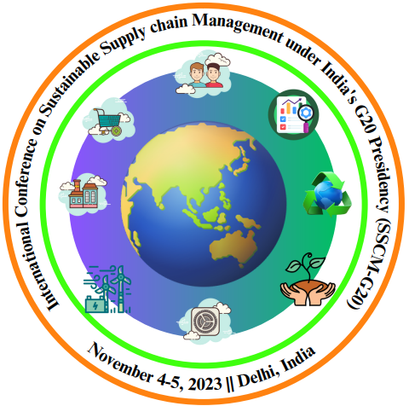](https://aiap.in/sscmg20/)

**Organized by**

**Department of Operational Research, University of Delhi**

**&**

**Association of Inventory Academicians and Practitioners**

[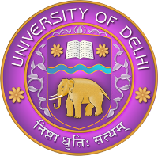](https://www.du.ac.in/)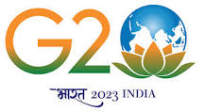[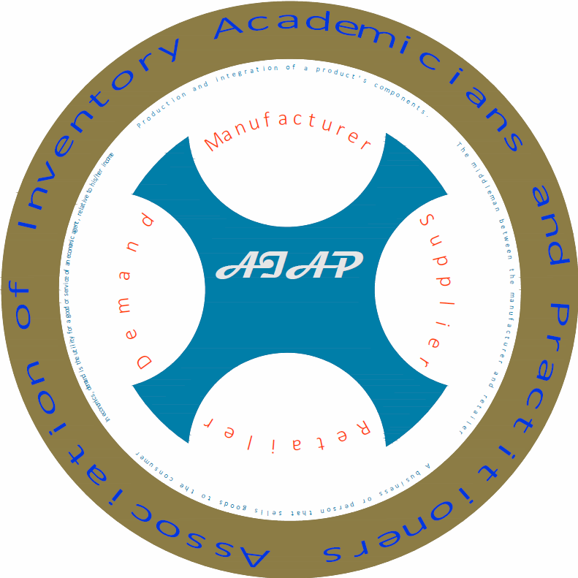](https://aiap.in/)

**OVERVIEW**

**Association of Inventory Academicians and Practitioners (AIAP)** in association with **Department of Operational Research, University of Delhi,** is delighted to announce its **International Conference on Sustainable Supply Chain Management under India's G20 Presidency (SSCM-G20)** to be held during **November 4-5, 2023**, at **University of Delhi, Delhi, India**. The conference's objective is to emphasize the role of Operational Research for the G20 key goals on sustainable supply chain development: to apply mathematical and analytical techniques to optimize and enhance supply chain operations to combat climate change. SSCM-G20 aims to foster global collaboration and innovative solutions in creating resilient and environmentally responsible supply chains under India's G20 agenda. The conference intends to bring together industry experts, academicians, professionals, and scientists to discuss and address challenges concerning responsible sourcing, green logistics, circular economy practices, and social inclusivity in supply chains which are the key objectives of G20. Participants will have the chance to delve into discussions and keynote sessions that offer insights into nurturing a sustainable environment to enhance supply chain operations.

**Theme of the Conference:**

SSCM-G20 2023 encourages topics related to the following aspects:

Sustainable Development Goals

Supply Chain Management

Industry 4.0

Block Chain Technology

Inventory and Production Management

Circular Economy

Supply Chain Analytics

and related sub themes*

**Important Deadlines:**

|  |  |
| --- | --- |
| **Last date of abstract Submission** | October 27, 2023 |

**Registration Details:**

|  |  |  |
| --- | --- | --- |
| **Category** | **Local Delegates (₹)** | **Foreign Delegates ($)** |
| **Corporate Delegates** | 7000 | 350 |
| **Academicians** | 4000 | 250 |
| **Research Scholar** | 2000 | 80 |

***Note: AIAP life member’s discount: ₹ 250***

\***The link for registration:** [**https://forms.gle/YejgMLfunHPmxmX49**](https://forms.gle/YejgMLfunHPmxmX49)

*We are now processing the special issue of the International Journal of System Assurance Engineering and Management (IJSAEM) for the conference. So right now, we can't promise you for the publication in IJSAEM, but whenever we have a special issue, we have to follow the procedure of the journal.*

<https://aiap.in/sscmg20>

[sscmg20@gmail.com](mailto:sscmg20@gmail.com)

+91-9599408424, 8448912054, 9891919399

**Venue: Conference Centre**

**University of Delhi**

**Delhi -110 007**

**Advisory Committee**

* **Abhijit Majumdar,** IIT, Delhi, India
* **Adrijit Goswami,** IIT, Kharagpur, India
* **Amit Kumar Bardhan**, FMS, Delhi University, Delhi, India
* **Anand Chandra**, Aryatech Platforms Private Limited, India, India
* **Asoke Kumar Bhunia**, University of Burdwan, West Bengal, India
* **Bhavin J. Shah,** IIM, Indore, India
* **Bibhas Chandra Giri**, Jadavpur University, Kolkata, India
* **Bimal Kumar Mishra**, Vinoba Bhave University, Hazaribag, India
* **Biswajit Sarkar**, Yonsei University, Seoul, South Korea
* **Christoph H. Glock**, Technische Universitat Darmstadt, Germany
* **Gopalan Srinivasan**, University of New Brunswick, Canada
* **Hui Ming Wee**, Chung Yuan Christian University, Taiwan
* **I. V. Murlikrishna**, Jawaharlal Nehru Tech University, Hyderabad, India
* **Ioannis Konstantaras,** University of Macedonia, Macedonia, Greece
* **Kannan Govindan,** University of Southern, Denmark, Denmark
* **Konstantina Skouri**, University of Ioannina, Ioannina, Greece
* **Leopoldo Eduardo Cárdenas-Barrón,** Monterrey, Mexico
* **Madjid Tavana,** La Salle University, USA
* **Manoj K. Tiwari**, Director, IIM, Mumbai, India
* **Mark Goh**, National University of Singapore, Singapore
* **Muthu Mathirajan,** Indian Institute of Science, Bangalore, India
* **Nita H. Shah,** Gujarat University, Ahmedabad, India
* **P. K. Kapur**, Amity University, Noida, India
* **Pankaj Dutta,** IIT, Bombay, Mumbai, India
* **Preeti Wanti Srivastava**, University of Delhi, Delhi, India
* **R. Uthayakumar,** The Gandhigram Rural Institute, Tamil Nadu, India
* **Sachin Kumar Mangla,** O P Jindal Global University, Sonipat, India
* **Samarjit Kar**, NIT, Durgapur, India
* **Sanjeev G. Deshmukh,** IIT Delhi, India
* **Sarada P. Sarmah,** IIT, Kharagpur, India
* **Shib Shankar Sana**, KBBN College, Behala, Kolkata, India
* **Shiv Raj Singh,** CCS University, Meerut, India
* **Snigdha Banerjee,** Devi Ahilya University, Indore, India
* **Suraj Surendra Rane,** Goa College of Engineering, Goa, India
* **V. S. S. Yadavalli,** University of Pretoria, Pretoria, South Africa
* **Vijay Varshney,** Head of Technology: MESA, Smollan, India
* **Vivek Khandelwal**, India's Top 35 Mentors Niti Aayog, India
* **Vivek Saraswat**, Louis Dreyfus Company, India

**General Chair**

**Chandra K. Jaggi**, University of Delhi, Delhi, India.

**Conference Chair**

**K. K. Aggarwal**, University of Delhi, Delhi, India.

**Organizing Committee Chair(s)**

**Preeti Wanti Srivastava,** University of Delhi, Delhi, India

**Anu Gupta Agarwal,** University of Delhi, Delhi, India

**Program Committee Chair(s)**

**Prakash C. Jha**, University of Delhi, Delhi, India

**Technical Committee Chair(s)**

**Ompal Singh,** University of Delhi, Delhi, India

**Mukesh Kumar Mehlawat,** University of Delhi, Delhi, India

**Conference Secretary**

**Satish K. Goel,** University of Delhi, Delhi, India

**Keynote Speakers**

* **Christoph H. Glock**, Technische Universität Darmstadt, Germany
* **Manoj K. Tiwari**, Director, IIM, Mumbai, India
* **Sanjeev G. Deshmukh,** IIT, Delhi, India

**Prominent Speakers**

* **Abhijit Majumdar,** IIT, Delhi, India
* **Adrijit Goswami,** IIT, Kharagpur, India
* **Asoke Kumar Bhunia**, University of Burdwan, West Bengal, India
* **Bhavin J. Shah,** IIM, Indore, India
* **Bibhas Chandra Giri,** Jadavpur University, Kolkata, India
* **Bimal Kumar Mishra**, Vinoba Bhave University, Hazaribag, India
* **Biswajit Sarkar**, Yonsei University, Seoul, South Korea
* **Hui Ming Wee,** Chung Yuan Christian University, Taiwan
* **Mark Goh**, National University of Singapore, Singapore
* **Nita H. Shah,** Gujarat University, Ahmedabad, India
* **Pankaj Dutta,** IIT, Bombay, Mumbai, India
* **Sachin Kumar Mangla,** O P Jindal Global University, Sonipat, India
* **Samarjit Kar,** NIT, Durgapur, India
* **Shib Shankar Sana,** KBBN College, Behala, Kolkata, India
* **Shiv Raj Singh,** CCS University, Meerut, India
* **Shweta Nanda**,Amity University, Noida, India
* **Suraj Surendra Rane**, Goa College of Engineering, Goa, India

**Industry Speakers**

* **Anand Chandra,** Aryatech Platforms Private Limited, India
* **Vijay Varshney**, Head of Technology: MESA, Smollan, India
* **Vivek Khandelwal,** India's Top 35 Mentors NITI Aayog, India
* **Vivek Saraswat,** Louis Dreyfus Company, India

[https://aiap.in/sscmg2](https://aiap.in/sscmg20)0

sscmg20@gmail.com

+91-9599408424, 8448912054, 9891919399

SSCM-G20, with an objective to bring together academicians, industry professional and practitioners to interact and exchange ideas on the recent developments in the area of Inventory Control, Green Supply Chain Management and Block Chain management Circular Economy. The conference would be a platform to cherish interact, alliance and joint effort among the conference participants to advance the theory and practice as well as to identify major trends and applications in these interdisciplinary areas.

**Venue: Conference Centre**

**University of Delhi**

**Delhi -110 007**