

WEBSITE DESIGN & DEVELOPMENT SPECIFICATION
From Assam to Your Cup
Developer handoff • Desktop + mobile • Ecommerce • Authenticity • Motion
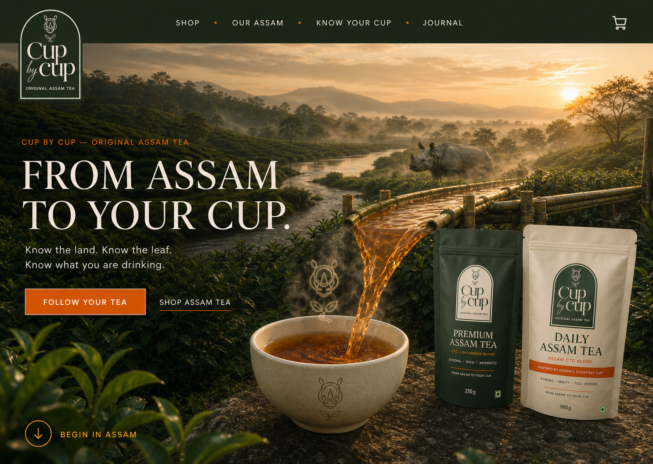
CUP BY CUP • ORIGINAL ASSAM TEA • FROM ASSAM TO YOUR CUP
Version 1.0 | Developer briefing document | 28 August 2026

1. Purpose and document control
This document is the implementation protocol for the Cup by Cup website.
Developer instruction
Treat this document and the seven supplied visual boards as the product brief. The boards define visual intent; this specification defines behaviour, data, integrations and acceptance. Where an image contains placeholder text or sample data, this written specification takes priority.

Item | Requirement
Project | Cup by Cup ecommerce and tea-authenticity website
Brand lockup | Cup by Cup • Original Assam Tea
Master promise | From Assam to Your Cup
Primary audience | Indian tea buyers seeking strong, fresh and traceable Assam tea
Platforms | Responsive desktop, tablet and mobile web
Commerce | Product catalogue, cart, checkout, Indian payments and shipping
Trust feature | Know Your Cup: QR/manual pack-code verification and Digital Cup Passport
Visual source | Seven Figma-style concept boards supplied with this document
Status | Build brief; platform/vendor decisions marked TBD require approval before implementation

This specification is deliberately platform-neutral. The developer must recommend the most suitable architecture, explain trade-offs and obtain written approval before choosing a stack or paid service.

Contents
- Sections 1–2: Purpose, brand strategy and non-negotiables
- Sections 3–4: Goals, audiences, sitemap and navigation
- Sections 5–6: Homepage, products and commerce
- Sections 7–8: Know Your Cup and animation protocol
- Sections 9–10: Responsive UX, accessibility, architecture and integrations
- Sections 11–12: Content, CMS, SEO, analytics, privacy and security
- Sections 13–14: Performance, QA, deliverables and phases
- Sections 15–17: Acceptance criteria, developer checklist and wireflow diagrams

2. Brand strategy and non-negotiables
The website must make the brand promise unmistakable within the opening screen.

2.1 Brand hierarchy
Level | Exact wording | Role
Master brand | Cup by Cup | The name customers remember and buy.
Descriptor | Original Assam Tea | Defines the product category and place of origin.
Master promise | From Assam to Your Cup | The primary website hook and journey.
Supporting message | Know the land. Know the leaf. Know what you are drinking. | Explains transparency and education.
Trust platform | Know Your Cup | Pack verification and traceability experience.
Proof principle | Proof Over Promises | Claims must be supported by real product or system data.

2.2 Mandatory visual elements
- A dignified, realistic Indian one-horned rhinoceros. It represents Assam and authenticity and must visually echo the logo without becoming a mascot.
- Real Assam tea gardens with atmospheric depth, tea rows and natural light.
- Tea itself: leaves, dry tea, amber liquor, brewing and pouring.
- A Brahmaputra-inspired river or flowing line connecting Assam to the final cup.
- A refined bamboo or woven-bamboo visual/craft element used as framing or structure. It must not make the site look like a rustic restaurant or bamboo-products store.
- The exact Cup by Cup logo and exact Premium/Daily package artwork.
- The journey must resolve in a recognisable Indian cup and real Indian tea-drinking moments.

2.3 Visual character
- Premium, cinematic, rooted, honest and modern.
- Forest green, mist cream, Assam orange, Muga gold, amber tea and restrained bamboo beige.
- Large editorial serif headlines paired with a clean, highly readable UI sans-serif.
- Cultural details are selective. Do not create a tourism collage or cover every surface with gamcha/jaapi patterns.
- Products must remain visible and accurate; art direction must strengthen packaging rather than compete with it.

2.4 Prohibited interpretations
- No spices, herbs, masala, coffee or unrelated ingredients/products.
- No cartoon rhino, fantasy Assam, neon portal, excessive CGI or impossible fluid effects.
- No unverified “freshest”, “best”, “purest” or origin claims.
- No fake batch numbers, packed dates, estates or verification records on the live website.
- No generic ecommerce template with the Assam artwork added as decoration.

3. Goals, audiences and success measures
The product must sell tea while building confidence in what the customer is drinking.

3.1 Business goals
- Build a distinctive direct-to-consumer Assam tea brand.
- Convert visitors into buyers of Premium Assam Tea, Daily Assam Tea or the Assam Pair.
- Make the “From Assam to Your Cup” promise memorable and ownable.
- Increase trust through transparent product information and pack verification.
- Support repeat purchase through the Digital Cup Passport and Buy Again actions.
- Collect consented email/marketing leads without interrupting the shopping journey.

3.2 Primary audiences
Audience | Need | Required response
Everyday kadak-tea buyer | Strength, value and milk compatibility | Lead with Daily Assam Tea and a simple profile guide.
Premium tea explorer | Richer aroma and a more layered cup | Explain the CTC + Orthodox blend without jargon.
Trust-conscious shopper | Freshness, authenticity and source confidence | Show pack verification, batch/packed-on data when available and the Cup Passport.
Mobile-first Indian buyer | Fast checkout and easy payments | Prioritise mobile speed, UPI and clear shipping information.
Existing customer with a pack | Verify the pack or buy again | Provide immediate Scan/Enter Code access without requiring login.

3.3 Initial success measures
- Product-view to Add-to-Cart conversion.
- Checkout completion and payment success rate.
- Know Your Cup scan/code completion and successful verification rate.
- Repeat purchase and Buy Again conversion from the Cup Passport.
- Mobile Core Web Vitals and checkout abandonment.
- Email signup conversion and organic search growth for Assam-tea topics.

4. Sitemap and navigation
Navigation must serve shoppers, brand explorers and existing customers with a pack.

4.1 Primary navigation
Navigation item | Destination / behaviour
Shop | Shop landing with Premium, Daily and Assam Pair.
Our Assam | Land, people, leaf, craft and brand story.
Know Your Cup | Scan pack, enter code and view verification guidance.
Journal | Tea education, brewing and brand stories.
Cart | Persistent cart icon with item count.
Mobile menu | Same hierarchy; Shop and Know Your Cup remain visually prominent.

4.2 Required pages and routes
- Home
- Shop / collection
- Premium Assam Tea product page
- Daily Assam Tea product page
- Assam Pair bundle page or bundle section
- Cart
- Checkout: shipping, payment, review and confirmation
- Our Assam / brand story
- Know Your Cup gateway
- QR scanner and manual code verification states
- Digital Cup Passport
- Brewing guide
- Journal index and article template
- FAQ
- Contact and customer support
- Order tracking
- Shipping and returns, privacy policy, terms, refund/cancellation policy and any required legal pages.

5. Homepage experience
The homepage is the brand story, product discovery path and trust gateway in one continuous scroll.
Order | Section | Purpose and required content
1 | Hero — From Assam to Your Cup | Exact brand lockup; rhino, tea garden, river-to-amber pour, cup, both packs; Follow Your Tea and Shop Assam Tea CTAs.
2 | Born in Assam | Show the real place and explain that the land gives the leaf its character.
3 | Follow the Leaf | Plucked → Made → Tasted; documentary hands; bamboo framing.
4 | People Behind Your Cup | Respectful worker/craft imagery and concise proof-led copy.
5 | Signature Journey | Assam → Leaf → Pack → Pour → Cup; end on “Assam has reached your cup.”
6 | Indian Cups | From one land to millions of Indian cups: breakfast, office, quiet morning and guests.
7 | Choose Your Cup | Premium vs Daily with exact packs, prices and tasting/profile guidance.
8 | Proof Over Promises | Freshness/packed-on, batch, pack verification, tea profile and Cup Passport.
9 | Know Your Cup | Scan pack or enter code manually; verified rhino-leaf seal.
10 | Brewing | Measure, Brew, Pour with clear quantities sourced from approved product guidance.
11 | Why Cup by Cup | Brand purpose and exact master promise.
12 | Assam Pair | Both products, approved bundle price and Shop the Pair CTA.
13 | FAQ / signup / footer | Support, email capture and full navigation/legal links.

Homepage rule
The promise “From Assam to Your Cup” must remain dominant. Assam scenery is not decoration: each scene must advance the journey, explain the tea or provide proof.

6. Product and commerce experience
The site launches with two teas and one curated pair—no spices or unrelated catalogue items.

6.1 Product source of truth
Field | Premium Assam Tea | Daily Assam Tea
Blend | CTC + Orthodox | Assam CTC
Profile | Strong • Rich • Aromatic | Strong • Malty • Full-bodied
Pack size | 250 g | 500 g
Selling price | ₹199 | ₹299
MRP | ₹229 | ₹329
Primary role | Richer, more layered cup | Everyday kadak cup

Current Assam Pair concept price: ₹449. The business must reconfirm bundle price, tax treatment and offer duration before production launch.

6.2 Product page requirements
- Exact pouch imagery with zoom/gallery and package-back image.
- Product name, blend, pack size, price, MRP, discount if applicable and tax/shipping treatment.
- Taste profile in plain language; strength/liquor guide labelled as a guide unless supported by tested scoring.
- Quantity selector, Add to Cart, Buy Now if approved and mobile sticky purchase control.
- Delivery PIN-code serviceability check and estimated dispatch/delivery wording from the shipping integration.
- Brewing guidance, storage guidance, FAQs and link to Know Your Cup.
- Structured product data for search engines.
- Related recommendation limited to the other tea or Assam Pair.

6.3 Cart and checkout
- Cart must support quantity changes, removal, subtotal, discounts, shipping and tax display.
- Free-shipping threshold is ₹499. Show progress and an unlocked state; confirm whether this applies to prepaid orders only before development.
- Guest checkout is mandatory. Account creation must not block purchase.
- Shipping fields: full name, phone, email, address lines, landmark optional, city, state, PIN and Home/Work.
- Payment options required: UPI, debit/credit card, net banking and Cash on Delivery, subject to the approved payment provider.
- Never store raw card details. Payment processing must be delegated to the approved PCI-compliant provider.
- Order review must show items, address, delivery method, payment method and total before Place Order.
- Confirmation must provide order reference, tracking status and support access.

6.4 Shipping and post-purchase
- Integrate with the approved shipping aggregator/courier or provide an admin fulfilment workflow.
- PIN-code serviceability and delivery estimates must come from a controlled rule or shipping API.
- Support shipment creation, label/AWB generation, tracking updates and customer notification.
- Define failed-delivery, return-to-origin, cancellation, refund and damaged-pack workflows.
- Developer must document webhook retries and the source of truth for payment/order/shipping status.

7. Know Your Cup authenticity system
This is a core product feature—not a marketing-only QR page.

7.1 Customer flow
- Open Know Your Cup from the website or scan the QR on the package.
- Choose camera scanning or manual pack-code entry.
- Validate code format on the device, then send it securely to the verification service.
- Show a neutral “Tracing your tea” state while checking.
- Return one of three results: Genuine, Not Recognised or Already Checked / Needs Attention.
- For a genuine pack, offer the Digital Cup Passport and Buy Again action.
- For an exception, allow retry, rescan and Contact Support without exposing internal security logic.

7.2 Verification statuses
Status | Customer message | Required action
Verified | Your pack is genuine. | Open Cup Passport; optionally record consented verification event.
Not recognised | We could not verify this code. | Retry, rescan or contact support.
Already checked | This code has been checked before. | Show neutral last-check information if policy permits; inspect pack/contact support.
Service unavailable | Verification is temporarily unavailable. | Do not label the pack fake; allow retry later.

7.3 Minimum backend requirements
- Unique, non-sequential or otherwise non-guessable pack codes generated or imported before packing.
- A secure verification endpoint with rate limits, abuse monitoring and generic error responses.
- Code record fields sufficient for status, product, blend, pack size, batch, packed-on date and region, with optional fields enabled only when real data exists.
- Administrative import/export or API for codes and batch metadata, with validation and audit log.
- QR destination must work on normal mobile cameras and allow manual entry if permissions fail.
- Rules for first check, repeat check, invalid code, deactivated batch and service failure.
- No personally identifiable information stored against a verification unless the customer explicitly consents.

7.4 Digital Cup Passport
- Show only data returned by the real system. Never substitute design-board placeholders.
- Required display: verification status, product, blend and pack size.
- Conditional display: packed-on date, batch and specific origin detail only if operationally supplied.
- Educational sections: Garden, Making, Packing, Tea Profile, Brew Guide and Your Cup.
- Include Buy This Tea Again and support/report-an-issue actions.

8. Animation and motion protocol
Motion must explain the journey and remain fast, accessible and optional.
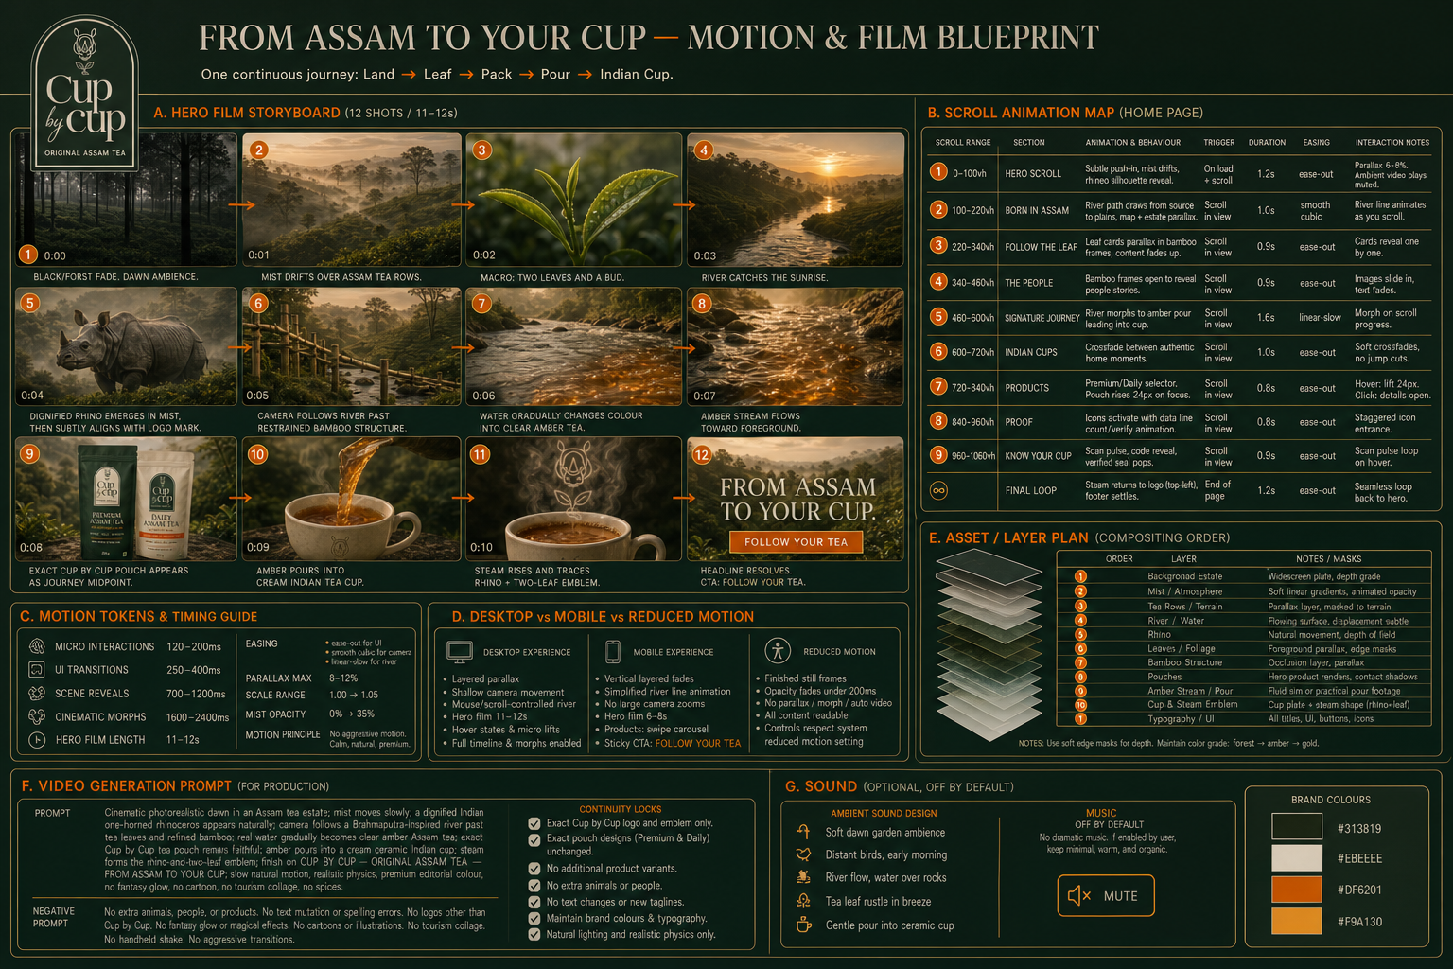
The separate file “07-animation-production-prompt.md” contains the full 12-shot prompt, continuity locks, negative prompt, scroll map, layers and sound direction.

8.1 Motion hierarchy
- Hero film: 11–12 seconds desktop; 6–8 seconds mobile; plays once, muted.
- Micro-interactions: 120–200 ms.
- Buttons and UI transitions: 250–400 ms.
- Scene reveals: 700–1200 ms.
- River-to-amber morph: 1600–2400 ms.
- Parallax limited to 8–12%; scale limited to 1.00–1.05.
- Reduced-motion mode uses completed still frames and opacity changes under 200 ms.

8.2 Implementation principles
- Do not make essential content dependent on video playback or scroll animation.
- Use responsive still-image fallbacks and poster frames before loading heavy media.
- Do not scroll-jack, trap the page, autoplay sound or loop attention-grabbing movement.
- Pause off-screen animation and avoid unnecessary CPU/GPU work on mobile.
- Exact logo and pouch artwork must not be regenerated or mutated inside production animation.
- Use layered assets so the developer can control mist, river, rhino, pack, pour, cup and typography independently.

9. Responsive, accessibility and usability
Mobile is a primary product surface, not a reduced desktop version.

9.1 Required breakpoints for design QA
Viewport | QA use
360 px | Small Android mobile
390–430 px | Primary mobile design range
768 px | Tablet portrait
1024 px | Tablet landscape / small laptop
1440 px | Primary desktop design
1920 px | Large desktop; content must not stretch excessively

9.2 Accessibility requirements
- Target WCAG 2.2 AA.
- Full keyboard navigation with visible focus states and logical focus order.
- Minimum 44 × 44 CSS-pixel touch targets for primary mobile controls.
- Sufficient colour contrast; do not place small text directly on busy photography.
- Semantic headings, landmarks, labels, errors and status announcements.
- Alternative text for meaningful imagery; decorative elements hidden from assistive technology.
- Camera permission denial must provide manual pack-code entry.
- Reduced-motion support and video pause/mute controls.
- Checkout and verification errors must identify the problem and recovery action.

10. Technical architecture and integrations
The developer must propose the stack and document why it meets these requirements.

10.1 Architecture expectations
- Responsive frontend with reusable components and a maintainable design-token system.
- Commerce backend supporting catalogue, inventory, pricing, coupons, orders, taxes, refunds and fulfilment.
- CMS for homepage content, stories, FAQs, brewing guide, journal and policy pages.
- Secure Know Your Cup verification service and administrator workflow.
- Separate staging and production environments with controlled deployment.
- Version control, documented setup, environment variables and backup/recovery procedure.

10.2 Required integrations
Capability | Requirement | Selection status
Payments | UPI, cards, net banking, COD; webhook-based status handling; refunds. | TBD — developer to recommend
Shipping | PIN serviceability, rates, AWB/labels, tracking and fulfilment updates. | TBD — developer to recommend
Email/SMS/WhatsApp | Transactional order and tracking messages; marketing only with consent. | TBD
Analytics | Consent-aware ecommerce funnel and Know Your Cup events. | TBD
Customer support | Contact form and order/verification issue context. | TBD
Tax/invoicing | Indian invoice/GST treatment per business and accountant instructions. | Business confirmation required

10.3 Environments and deployment
- Development, staging and production must use separate credentials and data.
- No production payment or pack-code secrets in the frontend or repository.
- Automated or documented deployment with rollback capability.
- Production domain, DNS, SSL/TLS and email authentication configured before launch.
- Daily backups for operational data, with a tested restore process and documented retention.

11. Content, CMS and data ownership
Cup by Cup must be able to update normal business content without developer intervention.

11.1 CMS-editable content
- Homepage headlines, supporting copy, CTAs and section visibility.
- Product descriptions, images, prices, MRP, stock and bundle offer.
- Brewing and storage guidance.
- FAQs, journal articles, Our Assam content and policy pages.
- Shipping threshold and promotional messages, subject to safe validation.
- Support/contact details and newsletter content.

11.2 Controlled system data
- Pack codes, batch records, packed-on data and verification status must use controlled imports or APIs, not normal rich-text CMS fields.
- Payment, order, refund and shipment status must come from their source systems.
- Every administrative change to verification data should be attributable and auditable.
- All code, accounts, domains, analytics properties, gateway accounts and production data must be owned by Cup by Cup or transferred at handover.

12. SEO, analytics, privacy and security
Search and measurement must be useful without compromising customer trust.

12.1 SEO
- Unique titles, meta descriptions, canonical URLs and social preview metadata.
- Product, Organisation, Breadcrumb and Article structured data where valid.
- Clean crawlable HTML; important content must not exist only inside animation or canvas.
- XML sitemap, robots configuration, redirect plan and 404 page.
- Optimised image formats, descriptive filenames and alt text.
- Journal structure for Assam tea, CTC/Orthodox education, brewing and authenticity topics.

12.2 Analytics events
- view_item, select_item, add_to_cart, begin_checkout, add_shipping_info, add_payment_info and purchase.
- know_your_cup_opened, scan_started, manual_code_started, verification_success, verification_attention, passport_opened and buy_again_clicked.
- CTA and scroll-depth measurement for the From Assam to Your Cup journey.
- No raw pack codes, payment data or unnecessary personal data in analytics payloads.

12.3 Security and privacy
- TLS everywhere, secure cookies, CSRF protection where applicable, output encoding and input validation.
- Rate limiting and abuse protection on verification, login/admin and contact endpoints.
- Least-privilege access, multi-factor authentication for administrative services and logged changes.
- Secrets stored outside the codebase; dependency and vulnerability update process documented.
- Privacy notice and consent controls appropriate to analytics and marketing integrations.
- Retention and deletion rules for customer, order, support and verification data.

13. Performance and quality assurance
The luxurious experience must remain fast on real Indian mobile networks.

13.1 Performance targets
- Target LCP ≤ 2.5 seconds, INP < 200 ms and CLS < 0.1 at the 75th percentile where practical.
- Use responsive images, modern formats, lazy loading below the fold and explicit dimensions.
- Load a lightweight hero poster immediately; defer high-resolution video until appropriate.
- Keep third-party scripts minimal and document their performance/privacy cost.
- Use caching and CDN delivery for static media.

13.2 Required testing
- Responsive visual QA at every listed viewport.
- Latest two major versions of Chrome, Safari, Edge and Firefox; current Android Chrome and iOS Safari.
- Keyboard, screen-reader smoke testing, colour contrast and reduced motion.
- Payment success/failure/cancel, COD, webhook retry and refund cases.
- Shipping serviceable/unserviceable PIN, tracking and return states.
- Verification valid, invalid, repeated, permission denied, offline, timeout and service-unavailable states.
- Inventory, discount, free-shipping threshold and price consistency.
- SEO metadata, structured data, sitemap, analytics events, cookie/consent and form spam protection.

14. Developer deliverables and project phases
Completion requires a working, documented and transferable product—not only frontend screens.

14.1 Required deliverables
- Responsive production website matching the approved visual boards and this specification.
- Reusable component library and design-token implementation.
- Commerce catalogue, cart, checkout, payment and shipping integration.
- Know Your Cup frontend, backend/API and administration process.
- CMS configuration and editor training.
- Animation assets and implementation with mobile/reduced-motion fallbacks.
- Staging and production deployment, domain/SSL configuration and monitoring.
- Source code, repository access, build/deploy instructions and environment-variable inventory.
- Test report, accessibility/performance report and known-issues list.
- Handover session and agreed post-launch support/warranty period.

14.2 Recommended phases
- Discovery and architecture: confirm platform, integrations, data model, code-generation process and content ownership.
- Design translation: convert static boards into responsive components, interaction states and final production assets.
- Foundation build: CMS, products, navigation, shared components and environments.
- Commerce build: cart, checkout, payments, shipping and order communications.
- Know Your Cup build: code database/import, verification API, states, passport and support workflow.
- Motion and content integration: hero film, scroll animations, fallbacks, copy and imagery.
- QA and UAT: functional, payment, shipping, verification, responsive, accessibility, performance and security testing.
- Launch and handover: production deployment, monitoring, training, documentation and support.

15. Acceptance criteria
The following conditions define whether the website is ready for launch.
Area | Launch acceptance condition
Brand | Cup by Cup, Original Assam Tea and From Assam to Your Cup are presented exactly and consistently.
Visual story | Rhino, tea garden, tea, river/flow, bamboo detail, packaging and Indian cup are integrated into one understandable journey.
Responsive | No clipping, overlap, broken navigation or unusable controls at required viewports.
Products | Names, blends, profiles, weights, prices and package artwork match the approved source.
Commerce | Cart, shipping, payment, order confirmation and tracking pass approved test cases.
Free shipping | ₹499 threshold behaves exactly as the final business rule specifies.
Verification | Valid, invalid, repeated and unavailable states work securely; manual entry works without camera access.
Proof | Live pages do not contain fabricated batch, packed-on, estate or freshness data.
Accessibility | Keyboard, focus, labels, contrast, alt text, reduced motion and error recovery meet the agreed standard.
Performance | Production pages meet agreed mobile performance targets or documented approved exceptions.
SEO/analytics | Metadata, structured data, sitemap and agreed events are validated.
Ownership | Cup by Cup controls the domain, accounts, data, repository, credentials and deploy process.
Handover | Documentation, training, backups, monitoring and support terms are complete.

16. Open decisions and developer response checklist
The developer should answer these items in the proposal before work begins.

16.1 Business decisions to confirm
- Final ecommerce platform and CMS.
- Payment gateway and Cash-on-Delivery rules.
- Shipping partner, service areas, dispatch SLA and final free-shipping rule.
- GST/tax and invoice requirements.
- Final Assam Pair price and promotion duration.
- Final tested strength/kadakness and brewing guidance.
- Source and workflow for packed-on, batch and origin information.
- Pack-code generation, printing, import and repeated-check policy.
- Customer account requirement, loyalty/rewards and subscription scope, if any.
- Email, SMS/WhatsApp, customer support and analytics providers.

16.2 Required developer response
- Proposed architecture and rationale.
- Detailed scope mapped to this specification, with inclusions and exclusions.
- Timeline by phase and named dependencies from Cup by Cup.
- Fixed and recurring costs, including third-party licences and transaction fees.
- Animation production approach and performance plan.
- Know Your Cup security/data design and administration workflow.
- QA plan, browser/device coverage and launch criteria.
- Ownership, source-code handover, documentation and post-launch support.
- List of assumptions, risks and decisions required before development.
Handoff package
Send this DOCX together with the seven PNG boards and “07-animation-production-prompt.md”. The developer should quote and plan against the complete package, not against screenshots alone.

Prepared for | Cup by Cup
Developer / agency | ____________________________
Specification approved by | ____________________________
Date | ____________________________

17. Wireflow and system connection diagrams
These diagrams define how pages, customer decisions, responsive screens and external systems connect. They supplement the visual boards and written requirements; they do not replace detailed API documentation.

17.1 Complete website wireflow
All customer-facing routes and the two critical loops: purchase and pack verification.
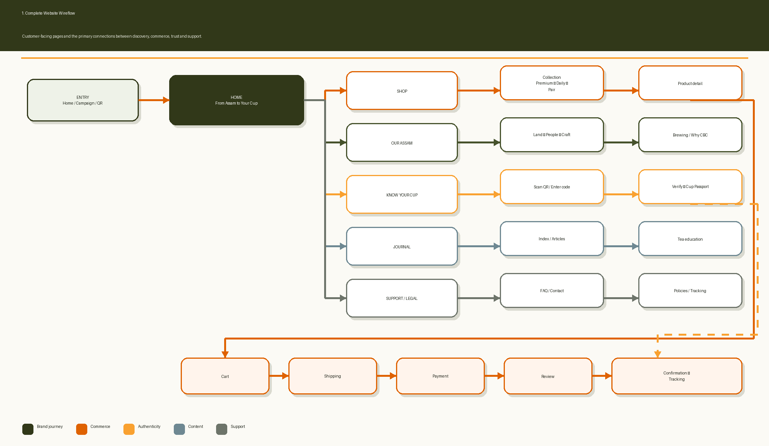
Figure 17.1 — All customer-facing routes and the two critical loops: purchase and pack verification.

17.2 Ecommerce service connection
Status ownership and webhooks across frontend, commerce, payment, shipping, messaging and operations.
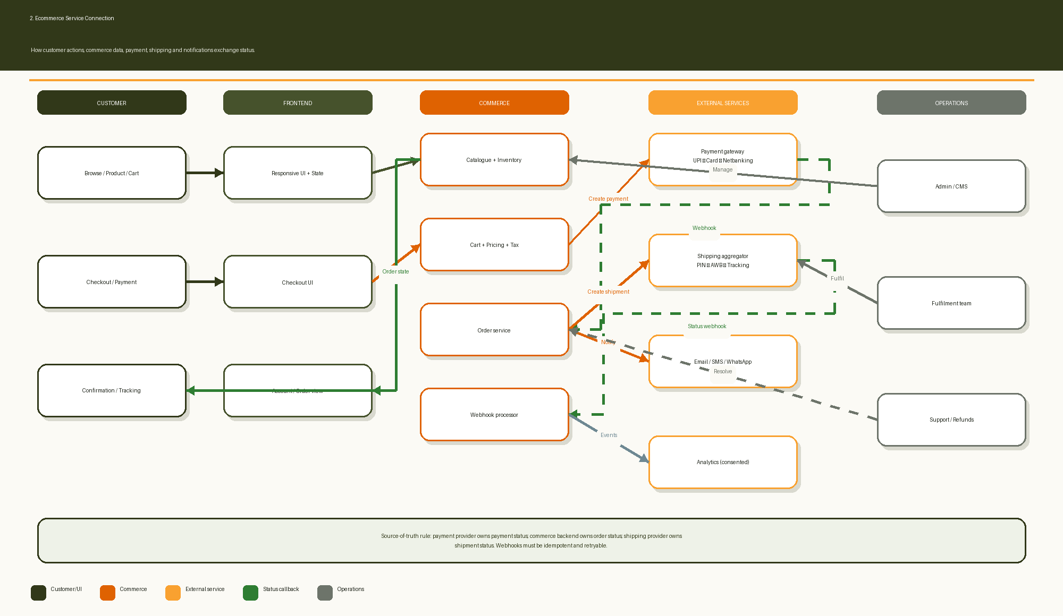
Figure 17.2 — Status ownership and webhooks across frontend, commerce, payment, shipping, messaging and operations.

17.3 Know Your Cup backend wireflow
Validation, verification decisions, Cup Passport data, administration and audit.
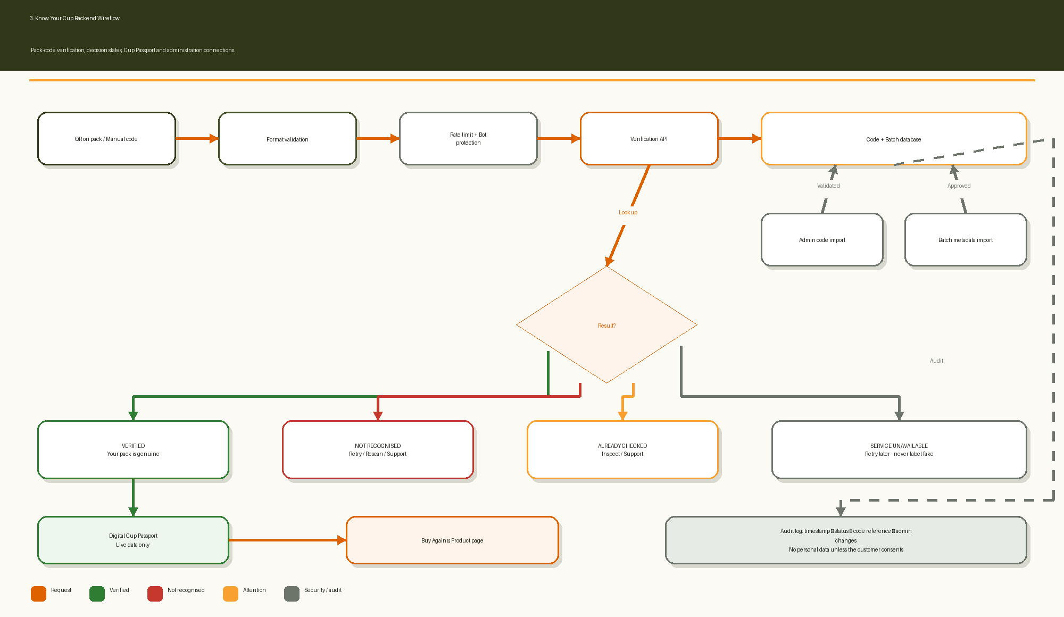
Figure 17.3 — Validation, verification decisions, Cup Passport data, administration and audit.

17.4 Desktop-to-mobile relationship
How the same content and actions adapt without disappearing on smaller screens.
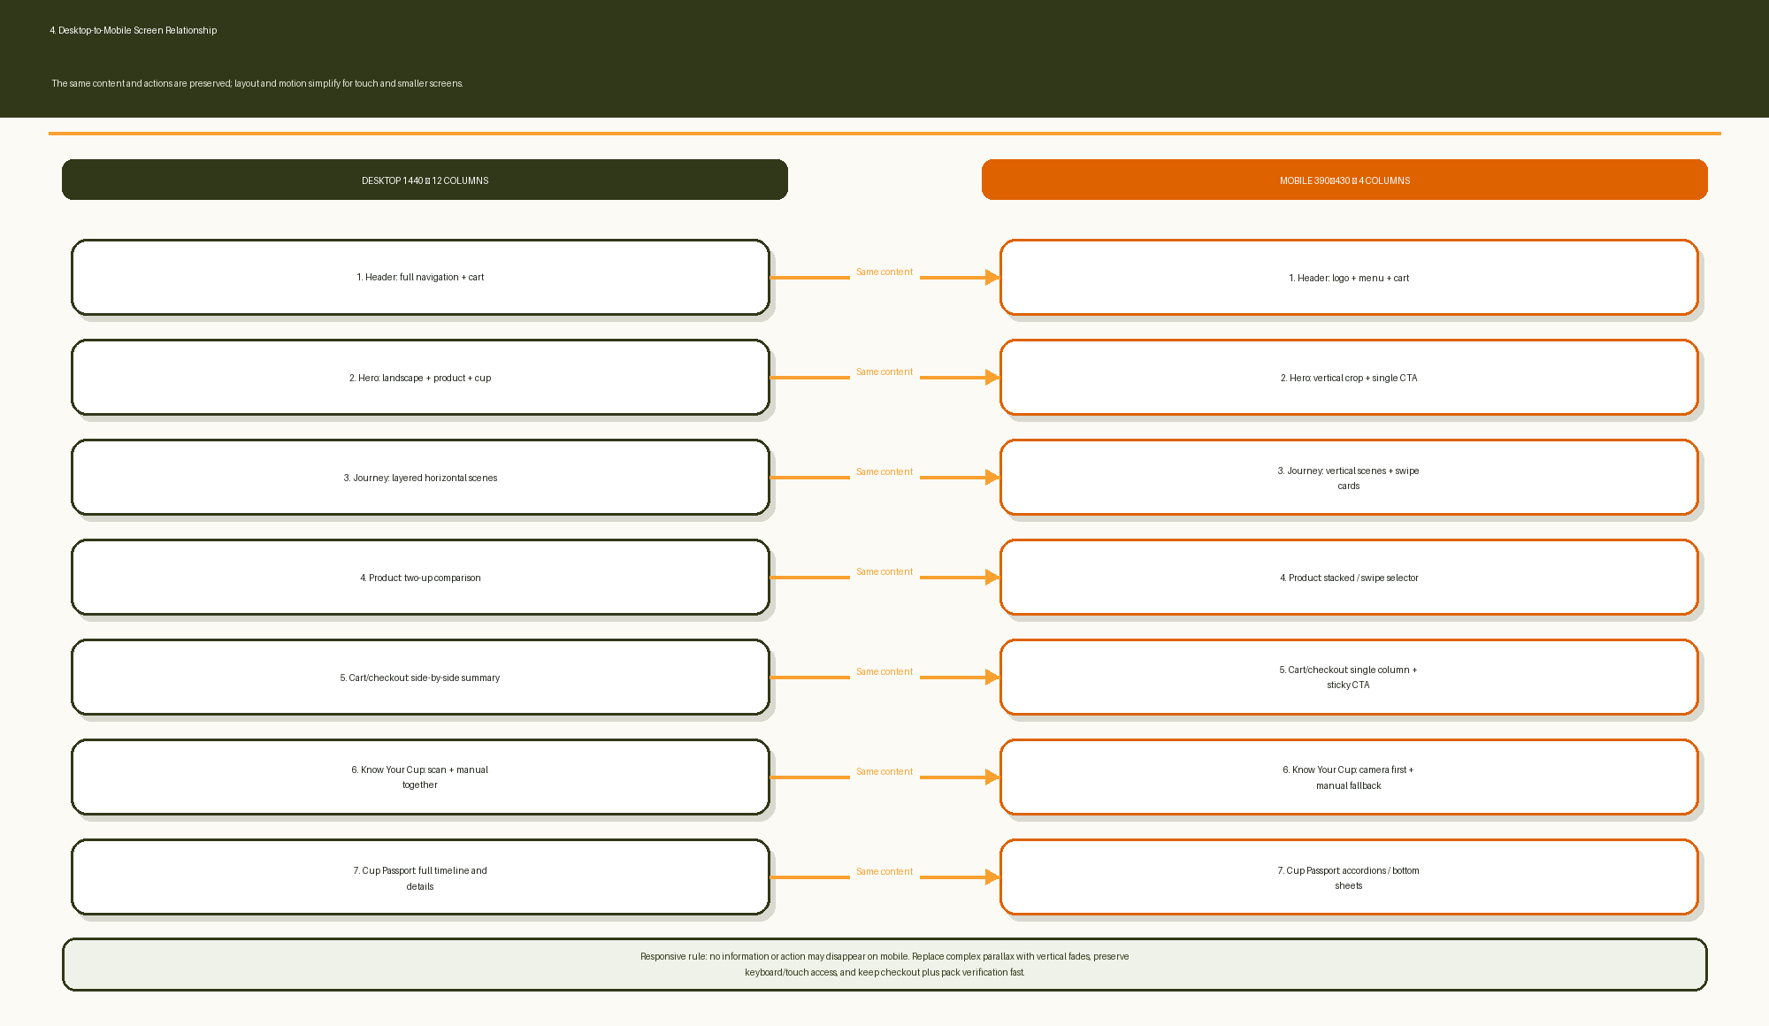
Figure 17.4 — How the same content and actions adapt without disappearing on smaller screens.

17.5 Full system and integration map
The system context and ownership boundaries the developer must preserve.
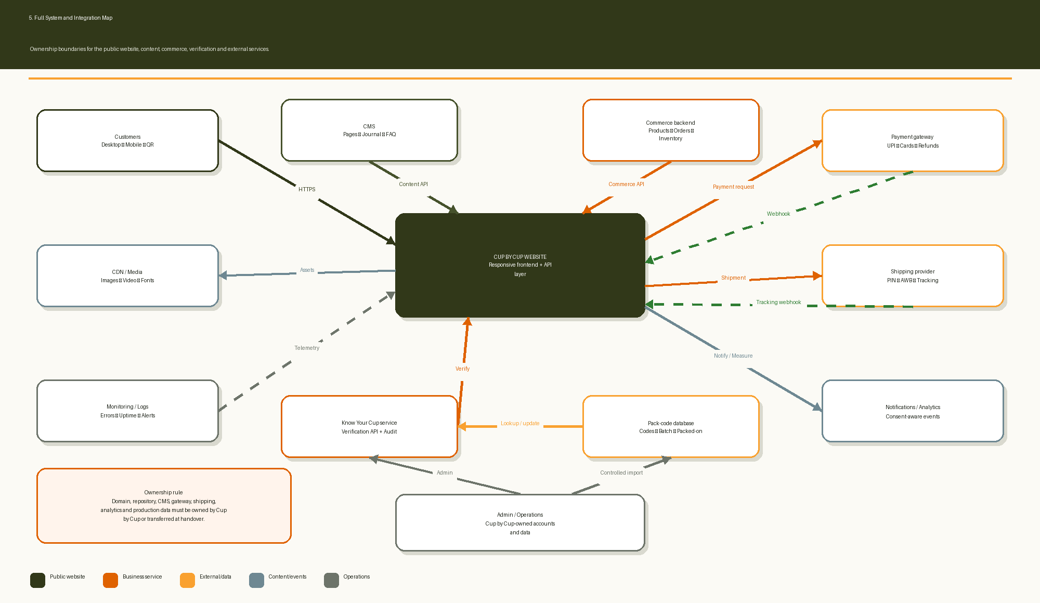
Figure 17.5 — The system context and ownership boundaries the developer must preserve.

