**NAME:- SAURABH YADAV**

**ASDM ASSIGNMENT NO.1:-**

**Q.1:- Discuss the prototyping model. What is the**

**Effect of designing a prototype on the overall**

**Cost of the project?**

**ANS:-** Prototyping is defined as the process of developing a working replication of a product or system that has to be engineered. It offers a small scale facsimile of the end product and is used for obtaining customer feedback.

The Prototyping Model is one of the most popularly used Software Development Life Cycle Models (SDLC models). This model is used when the customers do not know the exact project requirements beforehand. In this model, a prototype of the end product is first developed, tested and refined as per customer feedback repeatedly till a final acceptable prototype is achieved which forms the basis for developing the final product.

There are four types of models available:   
  **A) Rapid Throwaway Prototyping –**   
This technique offers a useful method of exploring ideas and getting customer feedback for each of them.

**B) Evolutionary Prototyping –**   
In this method, the prototype developed initially is incrementally refined on the basis of customer feedback till it finally gets accepted.

**C) Incremental Prototyping –** In this type of incremental Prototyping, the final expected product is broken into different small pieces of prototypes and being developed individually.

**D) Extreme Prototyping –**This method is mainly used for web development.

**Prototype on cost of project:-**

Prototyping may have some initial costs of developing, but it reduces the overall budget by helping your product to be free of the errors or glitches that could have occurred if the idea was made from scratch without any prior user testing. Furthermore, prototyping also helps to understand the intrinsic flaws, shortcomings and drawbacks that can be improved during the product development process. If the prototyping process is ignored completely, it might result in the restructuring and redesigning of the entire product after spending all your resources on its development. So, the effect of designing a prototype on the overall cost of a software project is to actually reduce the additional costs of restructuring and reframing it after its full-fledged development- which might cost a fortune.

**Q.2:- Compare iterative enhancement model and evolutionary process model ?**

**ANS:-**

Iterative Enhancement Model: This model has the similar phases as the waterfall model, but with fewer restrictions. In general the phases occur in the same order as in the waterfall model but these may be conducted in several cycles. A utilizable product is released at the end of the each cycle with each release providing additional functionality.

Evolutionary Development Model: Evolutionary development model bear a resemblance to iterative enhancement model. The similar phases as defined for the waterfall model occur here in a cyclical fashion. This model is different from iterative enhancement model in the sense that this doesn't require a useable product at the end of each cycle. In evolutionary development requirements are implemented by category rather than by priority.

**Q.3:- As we move outward along with process flow**

**Path of the spiral model , what can we say about**

**Software that is being developed or maintained.**

**ANS:-**

As work moves outward on the spiral the product moves toward a more complete state and the level of abstraction at which work is performed is reduced (implementation specific work accelerates as we move further from the origin).

**Q.4:- Explain the Scrum Agile methodology.**

**ANS:-**

* Agile and scrum are two similar project management systems with a few key differences.
* Agile is more flexible and promotes leadership teams, while scrum is more rigid and promotes cross-functional teams.
* Agile lets teams develop projects in small increments called “sprints” and allows for more effective collaborations among teams working on complex projects.

Agile scrum methodology is the combination of the agile philosophy and the scrum framework. Agile means “incremental, allowing teams to develop projects in small increments. Scrum is one of the many types of agile methodology, known for breaking projects down into sizable chunks called “sprints.” Agile scrum methodology is good for businesses that need to finish specific projects quickly.

Agile scrum methodology is a [project management system](https://www.businessnewsdaily.com/9977-best-online-project-management-software.html) that relies on incremental development. Each iteration consists of two- to four-week sprints, where the goal of each sprint is to build the most important features first and come out with a potentially deliverable product. More features are built into the product in subsequent sprints and are adjusted based on stakeholder and customer feedback between sprints.

Whereas other project management methods emphasize building an entire product in one operation from start to finish, agile scrum methodology focuses on delivering several iterations of a product to provide stakeholders with the highest business value in the least amount of time.

Agile scrum methodology has several benefits. First, it encourages products to be built faster, since each [set of goals](https://www.businessnewsdaily.com/11225-set-achievable-business-goals.html) must be completed within each sprint’s time frame. It also requires frequent planning and goal setting, which helps the scrum team focus on the current sprint’s objectives and increase productivity.

benefits of agile scrum methodology:-

These are some of the collective benefits of agile scrum methodology:

* [Flexibility and adaptability](https://www.businessnewsdaily.com/5696-pivot-business-strategy-shift.html)
* Creativity and innovation
* Lower costs
* Quality improvement
* Organizational synergy
* Employee satisfaction
* Customer satisfaction

**Q.5:- Explain the utility of Kanban CFD reports?**

## ANS:- (CFD) Cumulative Flow Diagram:-

A Cumulative Flow Diagram is a graphical representation of work as it flows through your Kanban system. It is a time-based plot, with the time interval in the x-axis and the number of cards in the y-axis. The graph is divided into different colored bands, with the bands representing a state or column in your Kanban board.

## CFD to Improve Team Performance

The cumulative flow diagram provides insights that may not be apparent with just basing progress on a Kanban board. As the CFD chart includes historical data, it shows trends and patterns that depict the performance of the team through a given period. With a single view, one can be able to spot if a bottleneck is becoming a recurring problem within a process state. If there are deviations to what should be the trajectory or form of the chart, the team can apply corrective action immediately.

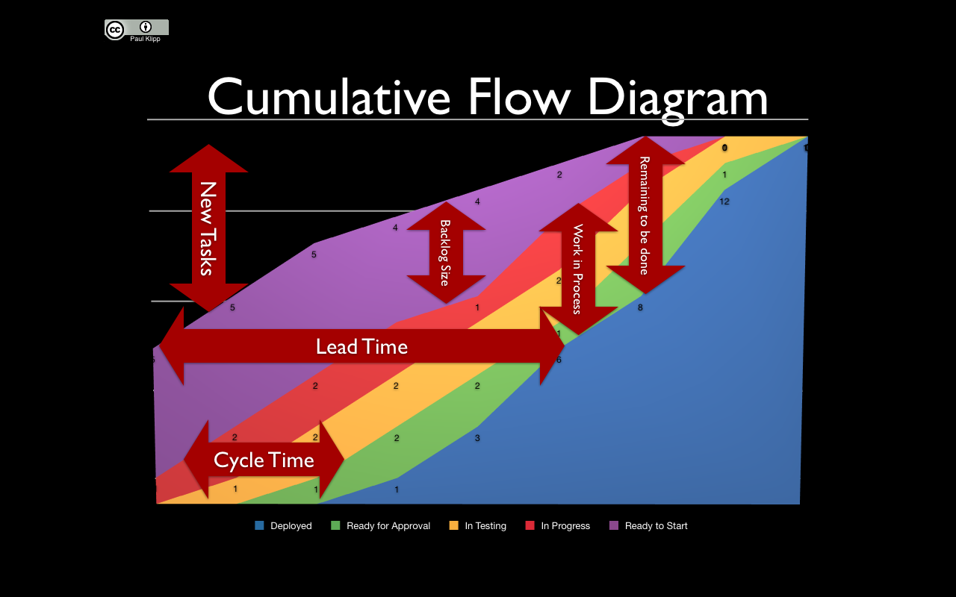

[This Photo](http://pm.stackexchange.com/questions/622/useful-charts-for-a-kanban-system) by Unknown Author is licensed under [CC BY-SA](https://creativecommons.org/licenses/by-sa/3.0/)