SECTZG629T: Dissertation (For SE)

Self-Service Segmentation model generator for E-Commerce sites

(MID-semester Report)

By

Sankar Ganeshan Gopalakrishnan
(BITS ID: 2010HZ78527/ Associate ID: 130545)

Dissertation work carried out at
Cognizant Technology Solutions

Dissertation Submitted in partial fulfillment of the requirement of
M.S in Software Engineering

Under the Supervision of
Veerabathiran Balasubramaniam
Director – Projects
Cognizant Technology Solutions, Chennai


BIRLA INSTITUTE OF TECHNOLOGY AND SCIENCE
PILANI, RAJASTHAN-333031

September 2014

BIRLA INSTITUE OF TECHNOLOGY AND SCIENCE, PILANI

CERTIFICATE

This is to certify that the Dissertation entitled “Self-Service Segmentation model generator for E-Commerce sites” submitted by Sankar Ganeshan Gopalakrishnan, BITS ID-No. 2010HZ78527 for the partial fulfillment of the requirements of M.S. Software engineering degree of BITS, embodies the work done by him under my supervision.

Veerabathiran Balasubramaniam

Signature of the Guide / Account Manager

Name : Veerabathiran Balasubramaniam
Designation : Director – Projects
Cognizant Technology Solutions
Location : Seattle, USA
Date : 02nd September 2014

ABSTRACT

Dissertation Title : Self-service Segmentation model generator for E-commerce sites

Name of Supervisor/Guide : Veerabathiran Balasubramaniam
Name of the Student : Sankar Ganeshan Gopalakrishnan
BITS ID. No. : 2010HZ78527
Semester : I Semester 2014-2015
Course Code : SECTZG629T (DS)

The objective of the dissertation is to provide a tool which would provide the framework for generating various segmentation models based on different operational and behavioral metrics and to validate the model with historical data. The tool will present different options for the analyst to choose and will guide the analyst to come up with a segmentation model even if the analyst has least idea about what he/she wants to generate. The various operational metrics for the users/customers are user/customer’s revenue, number of purchases, Overall Feedback – positive, negative or neutral, Shipping rating, Number of disputes etc., and the various behavioral metrics are page view count, count of Items viewed on the site, count of purchase intentions showed like add to cart, wish list. Tool will also present the options to customize user geography for which the analyst wants the segmentation to happen.

Currently there is *no* segmentation tool available in the market is sophisticated to handle such large volumes of data & integrate different datasets like clickstream, page view data, bids, buys, sells, listings, customer demographics, and scores. Since I have closely worked with the client for close to four years at onsite, I have a better understanding of their customers, business, business needs, data and data sources. Using my hard earned knowledge & with the help of right technology, I am sure I will be able to provide a product which integrates all the above data sets to server the purpose.

One more reason why large market places are hesitant to use the 3rd party tools is that they don’t want to share the proprietary data which could be used to identify their customer’s. This question of sharing the Private data will be void by the client’s business relationship with cognizant.

Sankar Ganeshan Gopalakrishnan Veerabathiran Balasubramaniam

Signature of Supervisor

Date: 02nd September 2014
Name of Supervisor:
Veerabathiran Balasubramaniam

Designation: Director– Projects

Cognizant Technology Solutions

Location:Seattle, United States of America

Signature of Student

Date: 02nd September 2014
Name: SankarGaneshan Gopalakrishnan

Designation: Manager - Projects

Cognizant Technology Solutions

Location: Seattle, United States of America

Acknowledgement

I take this opportunity to express my gratitude to my project guide Veerabathiran Balasubramaniam (Associate Director - Projects, Cognizant Technology Solutions) for providing his insight, guidance & advice whenever & wherever I needed. His sound understanding of the IT business, project manager needs, clear communication and guidance has helped me shape the direction of this dissertation project work.

Proposed Activities

Stage | Purpose | Activities | Status | Deliverable
Stage 1 | Define Scope of Dissertation  Define Requirements | Defining business problem statement and the proposed solution framework | 100% | Preliminary Report
Stage 1 | Define Scope of Dissertation  Define Requirements | Defining functional and non-functional requirements | 100% | Preliminary Report
Stage 2 | Refining the requirements  Proposed  Solution  Detailed design for the proposed Solution | Coming up with use case scenarios for the business problem | 100% | Mid Review report
Stage 2 |  | - High level design  - Technical Requirements | 100% | Mid Review report
Stage 2 |  | - Overall architecture  - Backend Data flow and data model  - Front end screen flow | 100% | Mid Review report
Stage 3 | Development QA and Implementation | - Coding & Unit testing  - Backend scripts for data load  - Frontend forms design  - VB scripting for the forms  - System testing and User acceptance testing  - Deployment of cod | 20% | Final review Report

Table of Contents

1. Objective 7
2. Scope 7
Software Requirement Specification 8
2.1 Functional Requirements 8
2.1.1 Use case scenarios 8
2.1.1.1 Creating a Buyer ABCDE segmentation model with trailing 7 days GMB metrics & static thresholds for US region 8
2.1.1.2 Creating a Seller “Large Merchants→Merchants→Entrepreneur →Regulars → Occasional” segmentation model with trailing 7 days GMV metrics & dynamic thresholds for UK region 8
2.1.1.3 Creating a Customer based customized segmentation model with trailing 30 days page views metric & static thresholds for DE region 9
2.2 Non Functional Requirements (NFR) 10
Solution for the business problem: 10
2.3 Proposed Solution 10
2.4 Technical Requirements 10
2.4.1 Software Requirements for End Users 10
2.4.2 Software Used in Development 10
2.5 Solution Architecture 11
2.5.1 Data sources 11
2.5.2 Segmentation platform 12
Detailed Design (Low Level) 13
2.6 Front end screen flow Diagram 13
2.7 Backend data model tables 14
3. Coding & Unit Testing 16
3.1 Coding Strategy 16
3.2 Best Practices 16
3.3 Coding Convention 17
3.4 Construction 17
3.5 Code Review 17
3.6 Unit Testing 17
4. QA 17
4.1 QA Strategy 17
4.1.1 QA Scope 17
4.2 Functional QA 17
4.3 QA Assessment 17
5. Application Screenshots 17
6. Future Extensibility 20
6.1 Scope for Future Extension 20
6.2 Guidelines 20
References 22

Objective

The basic objective of this tool is to help the analysts to generate various customer or user segmentation models and *not* just ad-hoc segmentations based on the given metric in quick time and to validate the models beforehand instead of implementing the models in the real world & gauging their value later. Generally the segmentation model will be derived by the analysts manually after multiple iterations of research by writing codes to extract the data from the Data Warehouse tables. Multiple manual iterations extends the lead time & in almost all the cases the model will be redefined after a period of time based on the ROI value which involves additional effort & cost.

The tool will present different options to choose and will guide the analyst to come up with a segmentation model even if the analyst has least idea about what he/she wants to generate. The various operational metrics for the users/customers are user/customer’s revenue, number of purchases, Overall Feedback – positive, negative or neutral, Shipping rating, Number of disputes etc., and the various behavioral metrics are page view count, count of Items viewed on the site, count of purchase intentions showed like add to cart, wish list. Tool will also present the options to customize user geography for which the analyst wants the segmentation to happen.

Scope

The Scope of my dissertation is to provide a self-service segmentation application which would provide the framework for generating various segmentation models based on different operational and behavioral metrics. The model could be derived based on a given combination of inputs. The inputs are not only the metrics but time interval for the metrics aggregation (either trailing 30 days or trailing 7 days), Region (or countries), role of the user (buyer, seller or customer group – group of user accounts created by the same individual) and type of thresholds (static or dynamic). Analyst can select from a given set of segmentation models or define their custom models with user defined thresholds. Generated SQL for the given inputs could be exported and also the segmentation models could be exported out of the tool.

Out of Scope:

- Scheduling the generated segmentation model SQLs to run at definite time intervals to refresh the segment data.

- Sharing customizable data model if this application needs to be implemented in a new client environment

Software Requirement Specification

Functional Requirements
Various combinations of the functional requirements are covered in the below three use case scenarios -

Use case scenarios

Creating a Buyer ABCDE segmentation model with trailing 7 days GMB metrics & static thresholds for US region

- User accesses the SSS model generator front end to create a new segment through the user interface.
- The user names the segment ‘US buyer static segmentation model’
- The user selects the segmentation level as ‘Buyer’ and the time period as ‘Trailing 7 days’
- The user selects ‘US’ as the region of segmentation
- Metrics for segmentation is selected as “GMB” i.e., gross merchandise bought
- User selects the threshold as “static” and the model as “ABCDE model”
- User enters the static threshold values – minimum and maximum values for GMB
- SSS model generator creates the segment definition and enters one or more rows as needed into the Segment table.
- SSS model generator accesses buyer metrics table to filter out all US region buyers and aggregate the GMB for last 7 days.
- SSS model generator applies the static thresholds and creates the segmented user list.
- Records for the given static thresholds are entered into the Segment threshold table.
- SSS model generator returns the SQL generated and the sample buyers with their segmentation to the user of their newly defined segment.
- User can choose to export the complete set of segmented users from Segment users table or the generated SQL to provide it to the developers to schedule it to run on specified time intervals (happens outside SSS model generator flow)

Creating a Seller “Large Merchants→Merchants→Entrepreneur →Regulars → Occasional” segmentation model with trailing 7 days GMV metrics & dynamic thresholds for UK region

- User accesses the SSS model generator front end to create a new segment through the user interface.
- The user names the segment ‘UK seller dynamic segmentation “Large Merchants→Merchants→Entrepreneur →Regulars → Occasional” model.
- The user selects the segmentation level as ‘Seller’ and the time period as ‘Trailing 7 days’
- The user selects ‘US’ as the region of segmentation
- Metrics for segmentation is selected as ‘GMV” i.e., gross merchandise sold volume
- User selects the threshold as “dynamic” and the model as “Large Merchants→Merchants →Entrepreneur →Regulars → Occasional”
- User enters the dynamic percentages for the dynamic threshold– Segment Large merchants: top 1%, Segment; Segment Merchants: next 4 %; Segment Entrepreneur: next 15%; Segment Regulars: next 30%; Segment occasional: last 50%.
- SSS model generator creates the segment definition and enters one or more rows as needed into the Segment table.
- SSS model generator accesses Seller metrics table to filter out all UK region sellers and aggregates the GMV for last 7 days.
- SSS model generator applies the dynamic thresholds and creates the segmented user list.
- Records for the given static thresholds are entered into the Segment threshold table.
- SSS model generator returns the SQL generated and the sample buyers with their segmentation to the user of their newly defined segment.
- User can choose to export the complete set of segmented user or the generated SQL to provide it to the developers to schedule it to run on specified time intervals (happens outside SSS model generator flow)

Creating a Customer based customized segmentation model with trailing 30 days page views metric & static thresholds for DE region

- User accesses the SSS model generator front end to create a new segment through the user interface.
- The user names the segment ‘DE customer based customized segmentation “Top viewer→Medium viewer→Low viewer” model’.
- The user selects the segmentation level as ‘Customer’ and the time period as ‘Trailing 30 days’
- The user selects ‘DE’ as the region of segmentation
- Metrics for segmentation is selected as ‘Page views count’.
- User selects the threshold as “static” and the model as customized model.
- The application prompted for the segment name and user provides 3 segments - Top viewer, Medium viewer and Low viewer.
- User enters the static thresholds for the three segments.
- SSS model generator creates the segment definition and enters one or more rows as needed into the Segment table.
- SSS model generator accesses Buyer metrics table to filter out all DE region buyers and aggregates the page view count for last 30 days.
- Customer to user link table will be accessed to get the customer ids for the buyers & the metrics are aggregated at customer level.
- SSS model generator applies the static thresholds and creates the segmented user list.
- Records for the given static thresholds are entered into the Segment threshold table.
- SSS model generator returns the SQL generated and the sample buyers with their segmentation to the user of their newly defined segment.
- User can choose to export the complete set of segmented user or the generated SQL to provide it to the developers to schedule it to run on specified time intervals (happens outside SSS model generator flow)

Non Functional Requirements (NFR)
- The user should be able to export the dynamically generated SQL and the complete list of sellers into a data file.
- User should be able to save and retrieve the defined segmentation models.
- User could delete any saved segmentation model.

Solution for the business problem:

Proposed Solution
The framework will be present different options for the analyst to choose and will guide the analyst to come up with a segmentation model even if the analyst has least idea about what he/she wants to generate. The various operational metrics for the users/customers are user/customer’s revenue, number of purchases, Overall Feedback – positive, negative or neutral, Shipping rating, Number of disputes etc., and the various behavioral metrics are page view count, count of Items viewed on the site, count of purchase intentions showed like add to cart, wish list. Tool will also present the options to customize user geography for which the analyst wants the segmentation to happen.

- Analyst uses the tool to play around on different metrics to come up with the model
- Tool generates the codes for the model based on the inputs from the analyst.
- Development team uses the tool generated codes to implement into production environment
- Business team could use the validated model data to take proper customer retention & reward programs.

In future, this tool can be scaled to provide a common data model which could be customized for different client’s business metrics and business needs & a well-established reporting structure as the front end application.

Technical Requirements

Software Requirements for End Users
Operating System: Windows

Software Used in Development
Programming language used: BTEQ, Core Java
Server/Client side programming: JSP, HTML5, Javascript
Tools used: Eclipse
Database: Teradata, ODBC connection

Solution Architecture

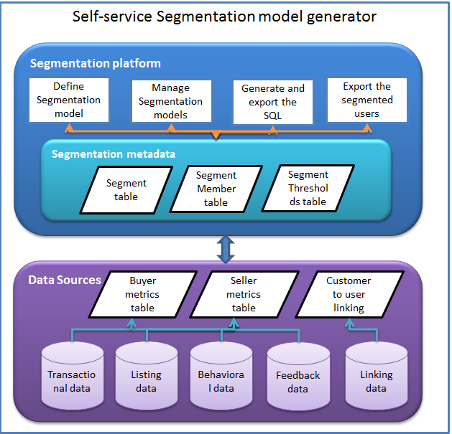

Data sources
Data sources for this tool comprises of various data warehouse tables like transactional data, listing data, Behavioral data, user feedback data and customer to user linking data. Daily, the user’s metrics will be aggregated and stored in the ‘user metrics’ table. For a given user and given date, there would be a record in this table with all the metrics combined. The customer to user linking from linking data is stored in a separate table. Customer is the household entity. One customer can have multiple user accounts. If the segmentation is at the customer level (a household account), then the metrics at user level have to be aggregated at customer level using the customer to user mapping table.

Segmentation platform
Segmentation platform is the frontend application that will be used to define the segmentation models by the analysts using the even driven approach of guiding the analyst with different options for the segmentation. Segmentation metadata will store the segment information, segmented member information and segmentation thresholds entered by the analyst. SQLs for the segmentation models could be generated and exported using this application.

Detailed Design (Low Level)

Front end screen flow Diagram
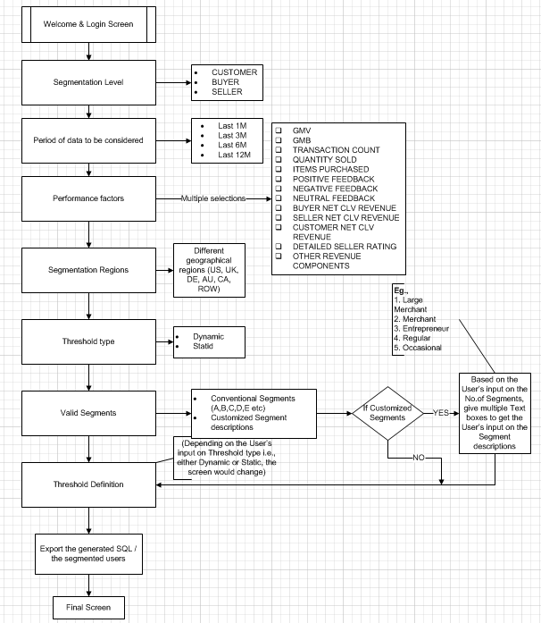

Backend data model tables

Buyer metrics table | SSS_BUYER_MTRC_SUM
Column description | Column name | Data type
Calculation date | CAL_DT | DATE
Buyer ID | BUYER_ID | DECIMAL(18,0)
Buyer country ID | CNTRY_ID | SMALLINT
Buyer Gross merchandise bought | BUYER_GMB_AMT | DECIMAL(18,2)
Buyer revenue | BUYER_RVNU_AMT | DECIMAL(18,2)
Total purchases | TOT_PRCHS_COUNT | DECIMAL(18,0)
Total positive feedback as buyer | BUYER_POS_FDBK_COUNT | DECIMAL(18,0)
Total neutral feedback as buyer | BUYER_NEUT_FDBK_COUNT | DECIMAL(18,0)
Total negative feedback as buyer | BUYER_NEG_FDBK_COUNT | DECIMAL(18,0)
Total page views | TOT_PAGE_VIEWS_COUNT | DECIMAL(18,0)
Total View item count | TOT_VI_COUNT | DECIMAL(18,0)
Total BID count | TOT_BID_COUNT | DECIMAL(18,0)
Total BIN count | TOT_BIN_COUNT | DECIMAL(18,0)
Total Watch count | TOT_WATCH_COUNT | DECIMAL(18,0)
Total Offer count | TOT_OFFER_COUNT | DECIMAL(18,0)
Total Ask Seller questions count | TOT_ASQ_COUNT | DECIMAL(18,0)
Seller metrics table | SSS_SELLER_MTRC_SUM
Column description | Column name | Data type
Calculation date | CAL_DT | DATE
Seller ID | SELLER_ID | DECIMAL(18,0)
Seller Country ID | CNTRY_ID | SMALLINT
Seller Gross merchandise sold volume | SELLER_GMB_AMT | DECIMAL(18,2)
Seller revenue | SELLER_RVNU_AMT | DECIMAL(18,2)
Total quantities sold | TOT_QTY_SOLD_COUNT | DECIMAL(18,0)
Total transactions | TOT_TRANS_COUNT | DECIMAL(18,0)
Total positive feedback as Seller | SELLER_POS_FDBK_COUNT | DECIMAL(18,0)
Total neutral feedback as Seller | SELLER_NEUT_FDBK_COUNT | DECIMAL(18,0)
Total negative feedback as Seller | SELLER_NEG_FDBK_COUNT | DECIMAL(18,0)
Detailed seller rating 1 (Shipping time) | SELLER_SHPNG_TIME_RTNG | BYTEINT
Detailed seller rating 2 (Shipping cost) | SELLER_SHPNG_COST_RTNG | BYTEINT
Detailed seller rating 3 (Item as described) | SELLER_ITEM_AS_DESC_RTNG | BYTEINT
Detailed seller rating 4 (Seller interaction) | SELLER_INTERACT_RATNG | BYTEINT
Total active listing count | TOT_ACTV_LSTG_COUNT | DECIMAL(18,0)
Customer to User linking table | SSS_CUST_USER_LINK_TABLE
Column description | Column name | Data type
Customer ID | CUSTOMER_ID | DECIMAL(18,0)
User ID | USER_ID | DECIMAL(18,0)

Segment table | SSS_SGMNTN_DTL_FACT
Column description | Column name | Data type
Segment ID | SGMNTNN_ID | DECIMAL(18,0)
Create Date | SGMNTNN_CRE_DATE | DATE
Update Date | SGMNTN_UPD_DATE | DATE
Segment Creator Name | SGMNTN_CRE_USER | VARCHAR(30)
Segment level ID | SGMNTN_LVL_ID | BYTEINT
Segment Period | SGMNTN_TIME_PERIOD | VARCHAR(20)
Segment Metrics | SGMNTN_MTRCS | VARCHAR(500)
Segment Region | SGMNTN_RGN_ID | SMALLINT
Threshold type | SGMNTN_THRSHLD_TYPE | BYTEINT
Segment Code | SGMNTN_SQL | VARCHAR(5000)
Segment member table | SSS_SGMNTN_MEMBER_DIM
Column description | Column name | Data type
Segment ID | SGMNTN_ID | DECIMAL(18,0)
Segment level | SGMNTN_LVL | CHAR(1)
Member ID | MEMBER_ID | DECIMAL(18,0)
Segment Member Begin date | SGMNTN_MEMBER_BEG_DT | DATE
Segment Member End date | SGMNTN_MEMBER_END_DT | DATE
Segment threshold values table | SSA_THRSLD_VALUE_FACT
Column description | Column name | Data type
Segment ID | SGMNTN_ID | DECIMAL(18,0)
Segment Name | SGMNTN_NAME | VARCHAR(30)
Threshold Metric name | THRSHLD_MTRC_NAME | VARCHAR(50)
Threshold Operator | THRSHLD_OPERATOR | VARCHAR(20)
Minimum Threshold value | MIN_THRSHLD_VALUE | DECIMAL(18,2)
Maximum threshold value | MAX_THRSLD_VALUE | DECIMAL(18,2)
Segment level lookup table | SSS_SGMNTN_LVL_DIM
Column description | Column name | Data type
Segment level ID | SGMNTN_LVL_ID | BYTEINT
Segment level Description | SGMNTN_LVL_DESC | VARCHAR(15)
Segment Region lookup table | SSS_SGMNTN_RGN_DIM
Column description | Column name | Data type
Segment region | SGMNTN_RGN_ID | SMALLINT
Segment region description | SGMNTN_RGN_DESC | VARCHAR(30)
Segment Region country lookup table | SSS_SGMNTN_RGN_CNTRY_LKP
Column description | Column name | Data type
Segment region | SGMNTN_RGN_ID | SMALLINT
country ID | CNTRY_ID | SMALLINT
country name | CNTRY_NAME | VARCHAR(30)
Segment threshold type lookup table | SSS_SGMNTN_THRSHLD_TYPE_DIM
Column description | Column name | Data type
Segment threshold type | SGMNT_THRSHLD_TYPE | BYTEINT
Segment threshold type description | SGMNT_THRSHLD_TYPE_DESC | VARCHAR(30)

Coding & Unit Testing

Coding Strategy

Best Practices
The concept of reusability and scalability are taken care in the codes.

Coding Convention

Construction

Code Review
Manual code review will be done.

Unit Testing
Manual unit testing will be done.

QA

QA Strategy

QA Scope

Functional QA

QA Assessment

Application Screenshots

Below are the mock screenshots for the front end application.

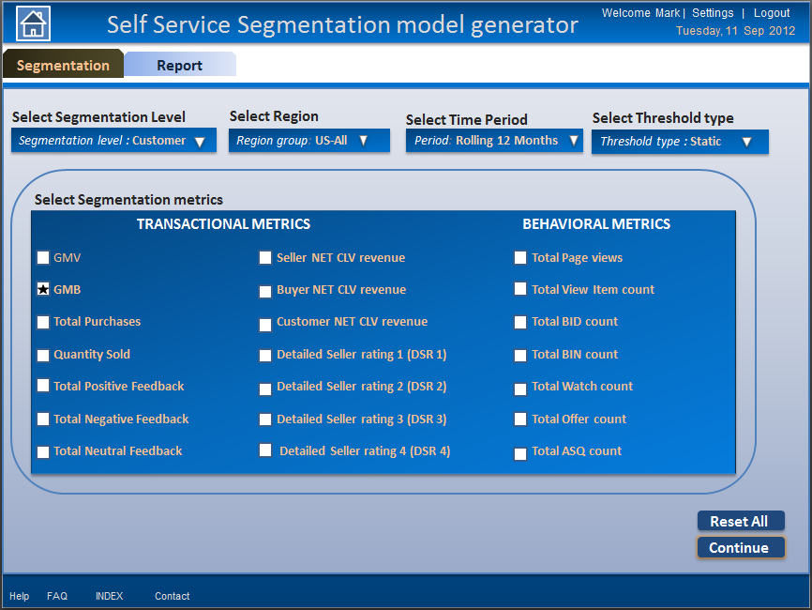

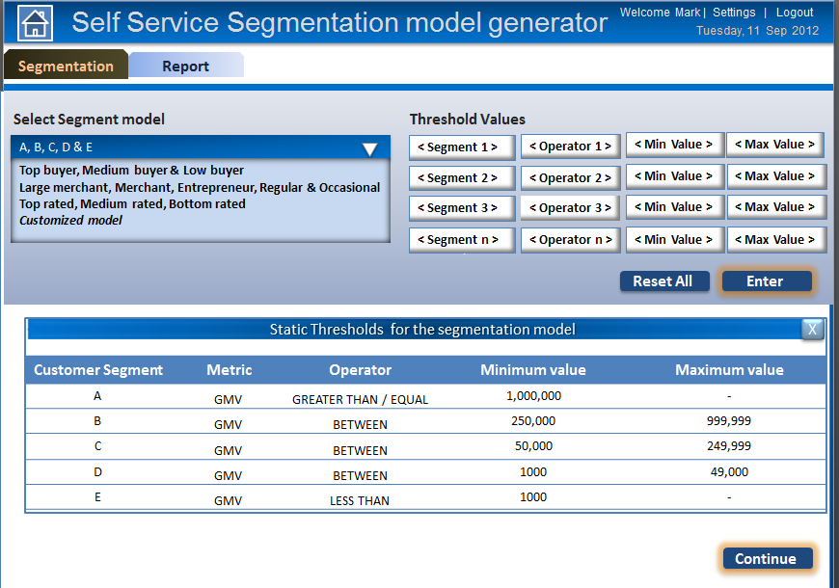

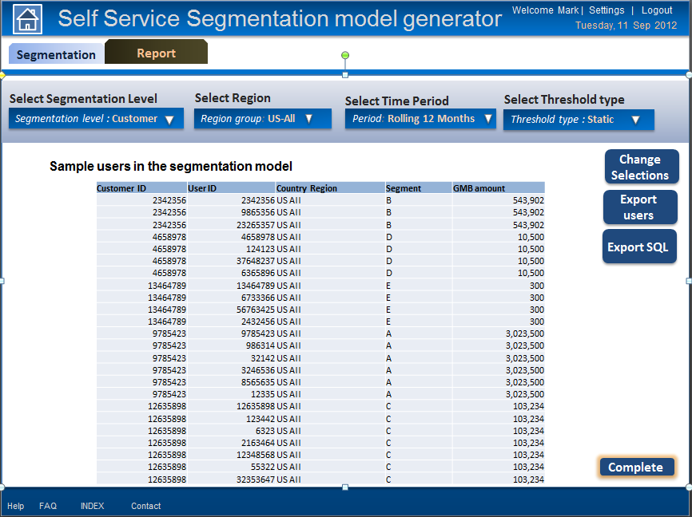

Future Extensibility

Scope for Future Extension
As an enhancement, the generated segmentation model SQLs could be scheduled to run at definite time intervals to refresh the segment data.

Also, if this application needs to be implemented in a new client environment, a customizable data model could be made and shared with the new client.

Instead of using ODBC connection to access the Teradata data sources, the data could also be shared as data files to the database (like Oracle) on top of which the application works.

Extensive polished reporting platform could be developed using ASP.NET.

Guidelines
The following are tips and guidelines for Teradata ETL developers

As a Teradata ETL developer,

Remember it’s very important to specify a column or list of columns as PI with high cardinality (number of unique values) as this helps the data to get distributed evenly across the system. If the selected PI does not have high number of unique values - the data will be saved on 1 or few AMPS causing high skew and could consume a lot of system resources (and time). This can further cause issues to your downstream process / query (if any).

Spend some time picking the PI before creating any table in your code. If you are not sure then you can add all the columns to the PI list. This way you will be helping yourself and other users.

Also note that if you do not specify a PI the first column is selected as PI and that might not be the ideal choice.

You may use below query to check the data distribution before selecting the PI.

SELECT HASHAMP(HASHBUCKET(HASHROW(Col1,Col2 etc.))) AS WhichAMP,COUNT(*) AMPRowCount FROM <Table_name>

Avoid the following whenever possible:
- use of CASE statement in the WHERE clause of your query
WHERE (CASE WHEN CMC_USR.USER_SMPL_ID = 2 THEN cyc.CNTRL_SRC_TRKING_CODE
ELSE cyc.SRC_TRKING_CODE END)=CMC_USR.SRC_TRKING_CODE
- use of TRIM statement on JOIN columns
trim(onetime.file_name) = trim(ticket.scriptname)

Ensure the following whenever possible:
- Proper stats are collected especially when using tables in SCRATCH areas

- If defining SET table, remember SET tables are very CPU intensive because for every row being inserted, the optimizer has to compare that row to every other row (every column in every other row) already in the table. Thus it becomes an O! (Order of Magnitude Factorial). If you have 100 rows, just inserting 1 row causes the optimizer to look at all 100 rows in the table before allowing the insert.

Because poorly performing queries have a significant impact on the system, please take into account the following points.
- If you plan to run the query often, please make the modifications before the next run. Even if you do not plan to run the query again, note that the same problem can appear in similar queries.
- Consider running the query on Wildcat as this system currently has available capacity (as a general rule, you should always run on Wildcat whenever possible).
- If possible, schedule/execute the query over the weekend or after 6 pm. Especially if it’s a repetitive process and has to be run on Caracal.

References

