SECTZG629T: Dissertation (For SE)

KNOWLEDGE MANAGEMENt REPOSITORY SYSTEM

(MID-semester Report)

By

Saurabh Bhatia
(BITS ID: 2014HT78092/ Associate ID: 461037)

Dissertation work carried out at
Cognizant Technology Solutions

Dissertation Submitted in partial fulfillment of the requirement of
M.S in Software Engineering

Under the Supervision of
Krishna Mohan Bathula
Senior-Manager
Cognizant Technology Solutions, Hyderabad


BIRLA INSTITUTE OF TECHNOLOGY AND SCIENCE
PILANI, RAJASTHAN-333031

October 2016

BIRLA INSTITUE OF TECHNOLOGY AND SCIENCE, PILANI

CERTIFICATE

This is to certify that the Dissertation entitled “Knowledge Management Reposiroty System” submitted by Saurabh Bhatia, BITS ID-No. 2010HT78092 for the partial fulfillment of the requirements of M.Tech. Software engineering degree of BITS, embodies the work done by him under my supervision.

Krishna Mohan Bathula

Signature of the Guide / Account Manager

Name : Krishna Mohan Bathula
Designation : Senior-Manager
Cognizant Technology Solutions
Location : Hyderabad,India
Date : 17 October 2016

ABSTRACT

Dissertation Title : Knowledge Management Repository System

Name of Supervisor/Guide : Krishna Mohan Bathula
Name of the Student : Saurabh Bhatia
BITS ID. No. : 2014HT78092
Semester : I Semester 2014-2015
Course Code : SECTZG629T_MR(DS)

The objective of the system is to build a knowledge management repository system for our organization which basically fills the gap in sharing the knowledge among the peers. In which the users can simply search of vast amount of questions as well as articles related to his/her interest and also rated them as per their relevance. The portal will also provide the admin panel which basically give access to staff members and super users only to maintain the data of the portal in a effective manner. Moreover we will provide the blogging feature in which the user can post the questions and other members will share their views/knowledge in from of answers. Basically anyone can freely share the knowledge on this platform as this for the user by the user of the user. Portal will also provide the notification system in which the users will be notified for any activity related to their articles or questions as stated.
We are interesting in providing the feature in which the implicit knowledge can be converted into explicit knowledge because we find that some of the concepts and knowledge become explicit only when someone ask the question.

Saurabh Bhatia Krishna Mohan Bathula

Signature of Student

Date: 17 October 2016
Name: Saurabh Bhatia

Designation: Programmer - Analyst

Cognizant Technology Solutions

Location: Hyderabad, India

Signature of Supervisor

Date: 17 October 2016
Name of Supervisor: Krishna Mohan Bathula

Designation: Senior Manager

Cognizant Technology Solutions

Location: Hyderabad, India

Acknowledgement

I take this opportunity to express my gratitude to my project guide Krishna Mohan Bathula (Senior Manager, Cognizant Technology Solutions) for providing his insight, guidance & advice whenever & wherever I needed. His sound understanding of the IT business, project manager needs, clear communication and guidance has helped me shape the direction of this dissertation project work.

Proposed Activities

Stage | Purpose | Activities | Status | Deliverable
Stage 1 | Define Scope of Dissertation  Define Requirements | Defining business problem statement and the proposed solution framework | 100% | Preliminary Report
Stage 1 | Define Scope of Dissertation  Define Requirements | Defining functional and non-functional requirements | 100% | Preliminary Report
Stage 2 | Refining the requirements  Proposed  Solution  Detailed design for the proposed Solution | Coming up with use case scenarios for the business problem | 100% | Mid Review report
Stage 2 |  | - High level design  - Technical Requirements | 100% | Mid Review report
Stage 2 |  | - Overall architecture  - Backend RestFul API and data model  - Admin screen | 100% | Mid Review report
Stage 3 | Development QA and Implementation | - Coding & Unit testing  - Backend RestFul API  - Frontend forms design  - System testing and User acceptance testing  - Deployment of cod | 20% | Final review Report

Table of Contents

1. Objective 7
2. Scope 7
Software Requirement Specification 8
2.1 Functional Requirements 8
2.1.1 Use case scenarios 8
2.1.1.1 Registration of User 8
2.1.1.2 Posting a Questions in portal after registration 8
2.1.1.3 Posting a Article in portal after registration........................................................9
2.1.1.4Searching of articles/Questions..............................................................9
2.1.1.5 Subscribed to a particular post..........................................................................9
2.1.1.6 Vote for the post..................................................................................9
2.1.1.7 Admin Panel Management.......................................................................9
2.2 Non Functional Requirements (NFR) 10
Solution for the business problem: 10
2.3 Proposed Solution 10
2.4 Technical Requirements 10
2.4.1 Software Requirements for End Users 10
2.4.2 Software Used in Development 10
2.5 Solution Architecture 11
2.5.1 Data sources 11
2.5.2 Use Case Diagram
2.5.3 knowledge platform 12
Detailed Design (Low Level) 13
2.6 admin screen Diagram 13
2.7 API Swagger Screen Shots
2.8 Backend data model tables 14
3. Coding & Unit Testing 16
3.1 Coding Strategy 16
3.2 Best Practices 16
3.3 Coding Convention 17
3.4 Construction 17
3.5 Code Review 17
3.6 Unit Testing 17
4. QA 17
4.1 QA Strategy 17
4.1.1 QA Scope 17
4.2 Functional QA 17
4.3 QA Assessment 17
5. Future Extensibility 20
5.1 Scope for Future Extension 20
5.2 Guidelines 20
References 22

Objective

The basic objective is to build a Knowledge management systems refer to any kind of IT system that stores and retrieves knowledge, improves collaboration, locates knowledge sources, mines repositories for hidden knowledge, captures and uses knowledge, or in some other way enhances the KM process.

The portal will provide a user to search from various kind of questions and articles and also provide the feature to subscribe as well as post his/her views for the same. It also provide the feature to post questions and articles as per user interest. Basically the portal will help in share the knowledge among the peers.

The overall objective is to create value and to leverage, improve, and refine the firm's competences and knowledge assets to meet organizational goals and targets.

Implementing knowledge management thus has several dimensions including:

KM Strategy: Knowledge management strategy must be dependent on corporate strategy. The objective is to manage, share, and create relevant knowledge assets that will help meet tactical and strategic requirements.

Organizational Culture: The organizational culture influences the way people interact, the context within which knowledge is created, the resistance they will have towards certain changes, and ultimately the way they share (or the way they do not share) knowledge.

Organizational Processes: The right processes, environments, and systems that enable KM to be implemented in the organization.

Management & Leadership: KM requires competent and experienced leadership at all levels. There are a wide variety of KM-related roles that an organization may or may not need to implement, including a CKO, knowledge managers, knowledge brokers and so on. More on this in the section on KM positions and roles.

Technology: The systems, tools, and technologies that fit the organization's requirements - properly designed and implemented.

Politics: The long-term support to implement and sustain initiatives that involve virtually all organizational functions, which may be costly to implement (both from the perspective of time and money), and which often do not have a directly visible return on investment.

Scope

The Scope of my dissertation is to provide a knowledge management repository system for our organization. Knowledge management is the process of capturing, developing, sharing and effectively using organizational knowledge.

It is mainly about to get the right knowledge to the right person at right time. This in itself may not seem so complex, but it implies a strong tie to corporate strategy, understanding of where and in what forms knowledge exists, creating processes that span organizational functions, and ensuring that initiatives are accepted and supported by organizational members. Knowledge management may also include new knowledge creation, or it may solely focus on knowledge sharing, storage, and refinement. For a more comprehensive discussion and definition, see my knowledge management definition.

Out of Scope:

- Filter the irrelevant data from the portal.

Software Requirement Specification

Functional Requirements
Various combinations of the functional requirements are covered in the below three use case scenarios -

Use case scenarios

Registration of User
1. User enter the portal by accessing the http://domain.com
2. User click on sign up button.
3. User provide the relevant details as specified.
4. Verification email triggered to the provided email id.
5. User need to verify the account.

Posting a Questions in portal after registration

- User sign up/logged in first by providing the relevant details for accessing the portal.
- User open the post questions section and provide the title of the question and other description as stated for the same.
- User provides the tags to the posted questions.
- User submit the question.

Posting a Article in portal after registration.
- User sign up/logged in first by providing the relevant details for accessing the portal.
- User open the post article section and provide the title of the article and other description as stated for the same or user can upload the file for the same.
- User provides the tags to the posted article.
- User submit the article.

Searching of articles/Questions
1. User sign up/logged in first by providing the relevant details for accessing the portal.

2. User provide the text in text box search.

3. User may select the related tags for effective search

4. User submit the query

5. User can scroll through different results.

6. User select the relevant question/answer

Subscribed to a particular post
1. User sign up/logged in first by providing the relevant details for accessing the portal.

2. User provide the text in text box search.

3. User may select the related tags for effective search

4. User submit the query

5. User can scroll through different results.

6. User select the relevant question/answer
7. User click on subscribed for getting activities related to that post.

Vote for the Post
1. User sign up/logged in for accessing the portal

2. User select the relevant question/articles

3. User vote for the question/articles.

4. User view the answers and comments for the same.

5. User vote for the answer or comments.

Admin Panel Management
- Admin login by providing the relevant details.

- Admin view all the data sources related to the portal.

- Admin select the user profile data source.

- Admin edit the data source as per requirement.

- Admin provide the related authorization to the users or staff members.

- Admin click on submit.

- Admin logged out.

Non Functional Requirements (NFR)
- The user should be able to download the articles file if attached.
- Email and other notification is sent through queue broker within no more than 10 minutes.

Solution for the business problem:

Proposed Solution
We are interested in following goals:-
First of all, we need to build a knowledge management repository system for our organization which basically fills the gap in sharing the knowledge among the peers.
We can also provide the feature in which the implicit knowledge can be converted into explicit knowledge because we find that some of the concepts and knowledge become explicit only when someone ask the question.
We have planned the following feature related to the system:-
Admin Panel:
Provides Admin panel for managing all the database and the portal which includes staff member’s access as well as the administrator access.
Blogging:-
Provides Q/A forum for sharing and asking viewpoints.
Users can comments on the articles or Q/A forums for the purpose of improving the knowledge.
Anyone can freely share the knowledge on this platform as this for the user by the user of the user.
Articles:
User can share articles as per their expertise and interest.
User can see his works and articles shared and liked by him.
User can see the number of downloads and views of his/her stuff.
Notification:
Platform will automatically send emails related to the interested articles, questions and comments in a fixed interval of time for gathering interest of the users.
Subscription:
User can subscribed for the particular group for getting notification for that group activities.
Search:
User can search the topics in a effective manner.
User can add tags for their post hence increasing the reach of the post to the relevant one.
Performance Appraisal of Associates:-
Supervisor can view the rating of the user on the knowledge sharing portal and consider one of the factor for appraisal or promotions.

Technical Requirements

Software Requirements for End Users
Operating System: Ubuntu/Windows/Mac

Software Used in Development
Programming language used : Django-Python, AngularJs
Server/Client side programming: JavaScript , Angular , Django-Python Rest Framework

Messaging : Celery

Web server : Apache2

Cloud Service Platform : AWS EC2 , AWS S3
Tools used : Sublime Text
Database : MySQL

Solution Architecture

We have developed a n tier service oriented architecture which have the following layer:-
- Front End
- Middle Layer – Mainly it will be Restful APIs
- Database Layer
- Deployed on Cloud Service Platform-(Amazon Web Service)
The layers will be decoupled for the purpose of increasing the maintainability. Moreover we will provide the Restful API’s so that in future if we want to shift to any other platform like mobile then we need to just consume the API.
We are interested in deploying the application into cloud service platform to make it scalable with the increase in number of users.

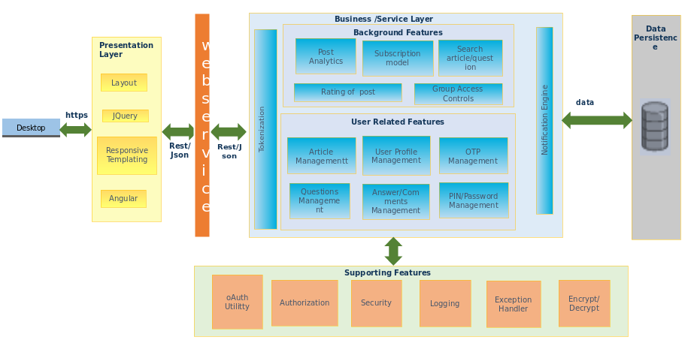

Data sources
Data sources for this tool comprises of various data warehouse tables like user profile data, articles data, Question data, question as well as articles analytical data linked with questions as well as articles. Group access control data in which the user can relate to more than one group for authorization purpose. Tokenization data to store the token generated for the purpose of authentication of the API.

Use Case Diagram
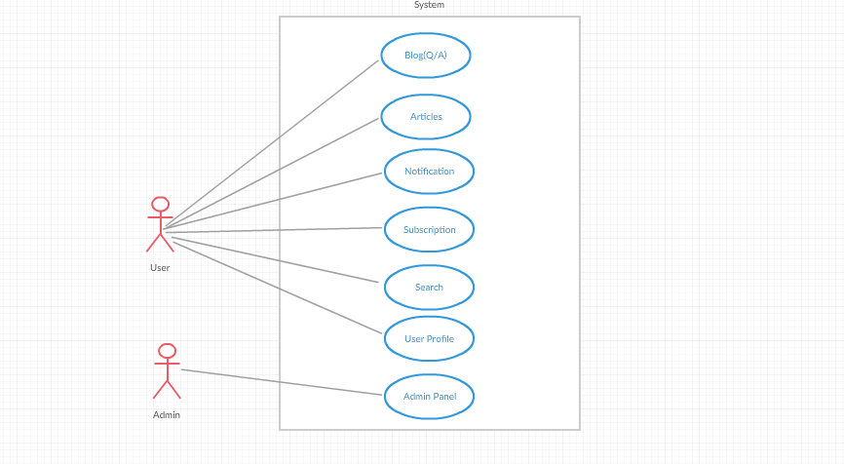

Knowledge Management platform
Knowledge management repository platform is the frontend application in which the user as well as the Admin can logged in and view the relevant activities as per their interest and also user can contribute to the question as well on article bank by asking the queries or sharing his/her knowledge. Moreover the user can efficiently search the question as well as article for the same and also subscribed to the interested articles or questions for tracking the activities related to that question or similar questions.

Detailed Design (Low Level)

Admin Panel Screen Diagram
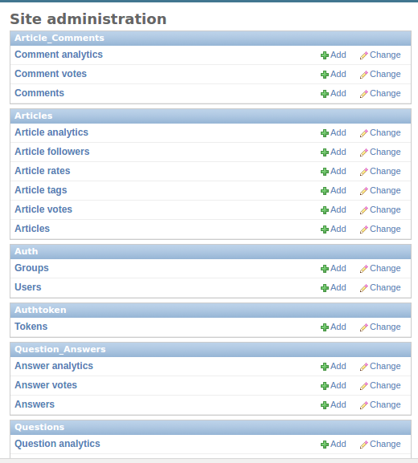

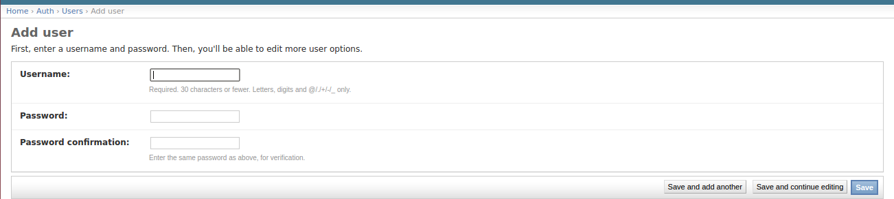
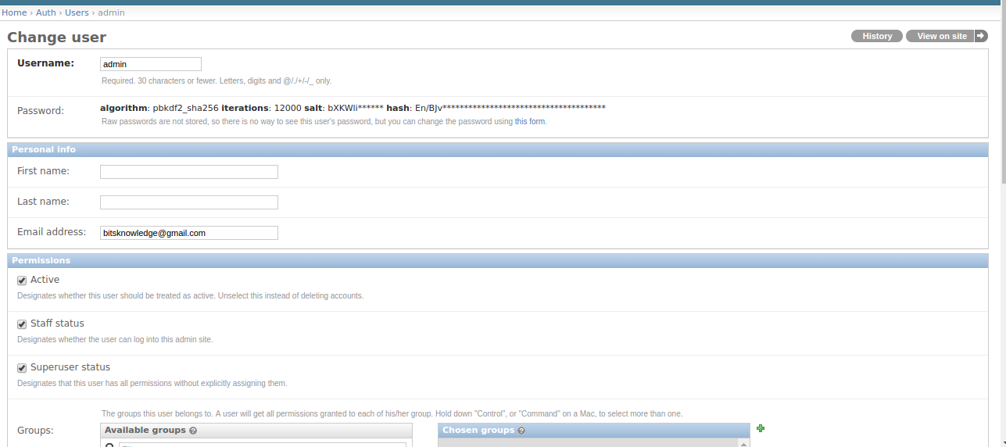
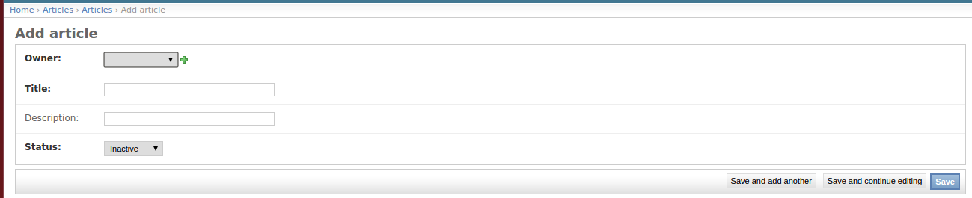
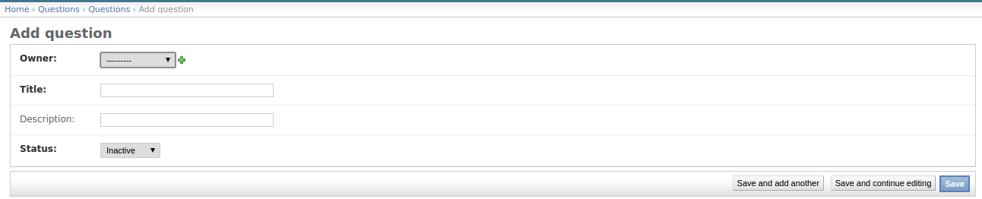

API Swagger Screen Shot

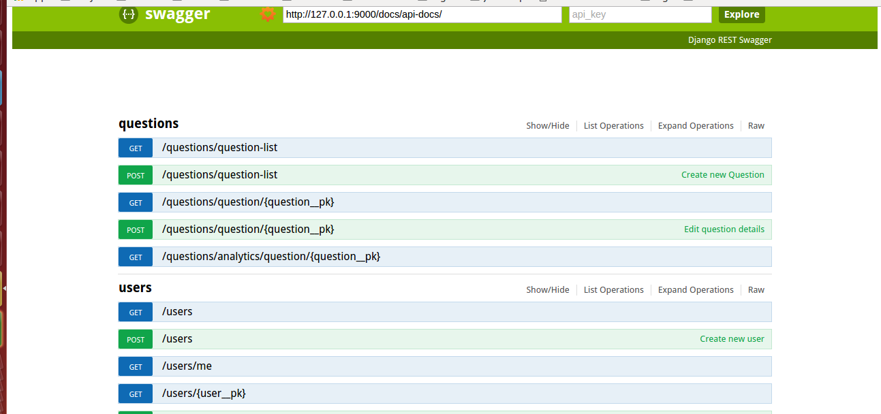

Backend data model tables

User table | auth_user
Column description | Column name | Data type
password | password | VARCHAR(128)
is_superuser | is_superuser | TINYINT(1)
last_login | last_login | DATE
username | username | VARCHAR(30)
first_name | first_name | VARCHAR(30)
last_name | last_name | VARCHAR(30)
email | email | VARCHAR(75)
is_staff | is_staff | TINYINT(1)
is_active | is_active | TINYINT(1)
date_joined | date_joined | DATE

Article table | articles_article
Column description | Column name | Data type
Owner of the article | owner_id | INT
Title of article | title | VARCHAR(128)
Description of article | description | VARCHAR(500)
Status of the article | status | INT
created_on | created_on | DATE

Article Analytic Table | article_analytics
Column description | Column name | Data type
Id of article | article_id | INT(11)
No of views of article | views | INT(11)
No of likes of article | likes | INT(11)
Average rating of article | Average rating | INT(11)
Users rated this article | no_of_raters | INT(11)
No of followers of article | no_of_followers | INT(11)
Up vote | up_vote | INT(11)
Down vote | down_ote | INT(11)
Created on | created_on | Date

Article Comment table | article_comments_comment
Column description | Column name | Data type
Id of article | article_id | VARCHAR(128)
is_superuser | user_comment_id | TINYINT(1)
last_login | comment | DATE
date_joined | created_on | DATE

Article Tag Table | articles_articletag
Column description | Column name | Data type
Name of tag | name | VARCHAR(100)
created_on | created_on | DATE

Article Asset Table | articles_asset
Column description | Column name | Data type
Id of article | article_id | INT(11)
file | file | VARCHAR 100

Question table | questions_question
Column description | Column name | Data type
Owner of the article | owner_id | INT
Title of question | title | VARCHAR(128)
Description of question | description | VARCHAR(500)
Status of the question | status | INT
created_on | created_on | DATE

Question Analytic table | questions_questionanalytic
Column description | Column name | Data type
Id of question | question_id | INT(11)
No of views of question | views | INT(11)
No of likes of question | likes | INT(11)
Average rating of question | Average rating | INT(11)
Users rated this question | no_of_raters | INT(11)
No of followers of question | no_of_followers | INT(11)
Up vote | up_vote | INT(11)
Down vote | down_ote | INT(11)
Created on | created_on | Date

Question Answer table | question_answers_answer
Column description | Column name | Data type
Id of question | question_id | VARCHAR(128)
User id | user_comment_id | TINYINT(1)
Answer | answer | DATE
Created on | created_on | DATE

QuestionTag table | article_comments_comment
Column description | Column name | Data type
name | Name of tag | VARCHAR(128)
Created on | created_on | DATE

Auth Token table | auth_token
Column description | Column name | Data type
Token key of user | key | VARCHAR(40)
Id of user | user_id | INT(11)
created_on | created_on | DATE

Auth group | auth_group
Column description | Column name | Data type
Name of group | name | VARCHAR(80)
created_on | created_on | DATE

Auth User group | auth_user_group
Column description | Column name | Data type
Id of user | user_id | INT(11)
Id of group | group_id | INT(11)

Auth Permissions group | auth_user_group
Column description | Column name | Data type
Name of permission | name | VARCHAR(11)
Content type | content_type | INT(11)
Type of permission | code_name | VARCHAR

Coding & Unit Testing

Coding Strategy

Best Practices
The concept of re usability and scalability are taken care in the codes.

Coding Convention

Construction

Code Review
Manual code review will be done.

Unit Testing
Manual unit testing will be done.

QA

QA Strategy

QA Scope

Functional QA

QA Assessment

Future Extensibility

Scope for Future Extension
As an enhancement, we can do the analysis on the platform to figure it out the number of associates are interested in which stack or which stack is most famous within our organization and it can also be collaborate with the HCM portal for tracking the user knowledge and his/her rating. It can also be extended by leveraging the data analysis algorithm to predict the technology or viewpoints of the associates by analyzing the data models.

Guidelines
The following are tips and guidelines for Django developers

As a Django developer performance tips,

- Turn on the Django template caching loading stated below:-
TEMPLATE_LOADERS = ( ('django.template.loaders.cached.Loader', ( 'django.template.loaders.filesystem.Loader', 'django.template.loaders.app_directories.Loader'))

Use select_related () and prefetch_related () to fetch the data having relationship as stated below.
queryset = Article.objects.select_related ().active()

- Use RAW _SQL for complex queries it will increase the readability of the code as well as the performance.

- Retrieve individual objects using a unique, indexed column.

article = Article.objects.get(id=10)

- Retrieve everything at once if you know you will need all the data.

article = Article.objects.all();

- Don’t retrieve things which we you don’t need use values to retrieve data.

Article.objects.filter (user).values ("title")

- Use Django default middleware which will makes your HTTP request performance better

- Use defer() and only() appropriately.

- Use queryset .count () instead of len (object) if we want only length.

- Use foreign key value directly instead of object if we want only id.

- Modularize the Product into relevant apps for making it maintainable.

- Use stable version of third party Django applications.

References

