NAME: Saurav khatri

ROLL NUM: 27(CE/D)

Unit 4. CONTROL STRUCTURES

* IF ELSE QUESTIONS

1. WAP to check weather number is odd or even.

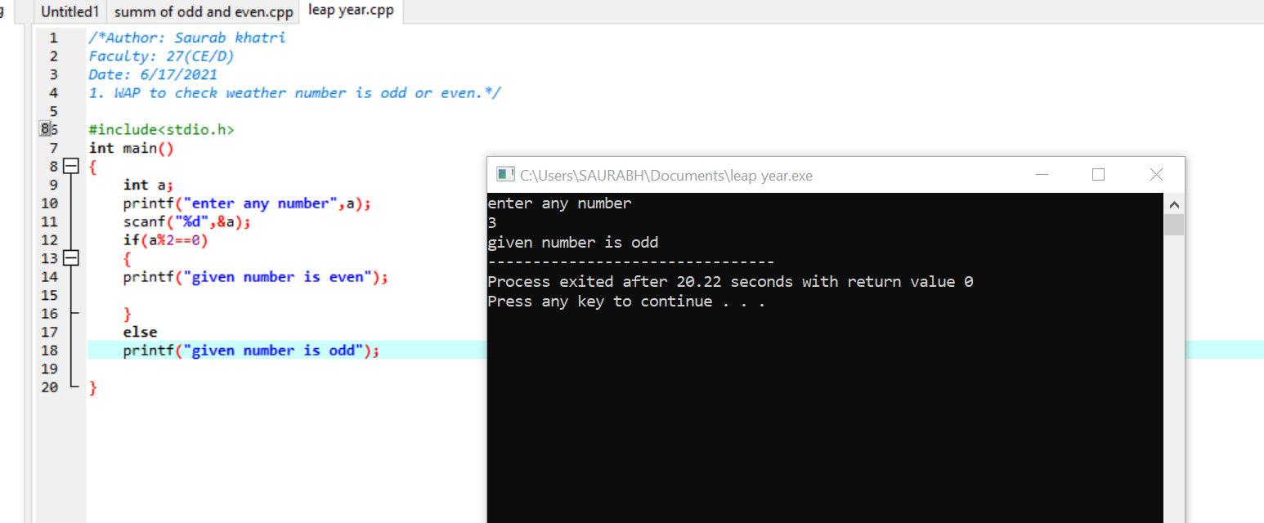

1. WAP to find maximum of two number.

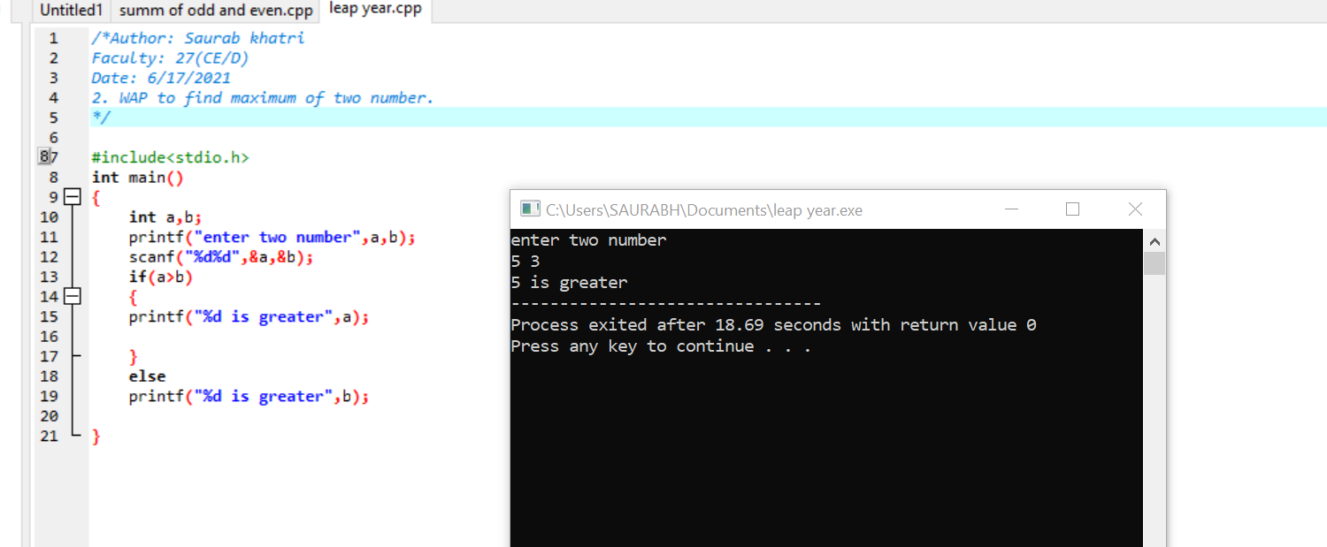

1. WAP to find if number is positive or negative.

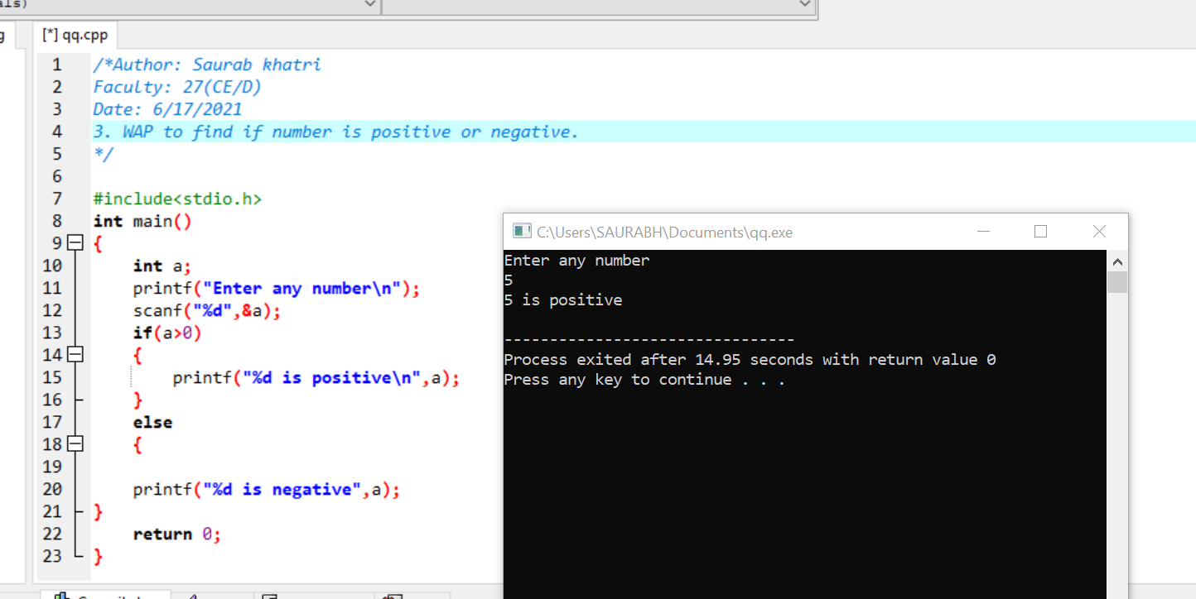

1. WAP to find maximum of three number.

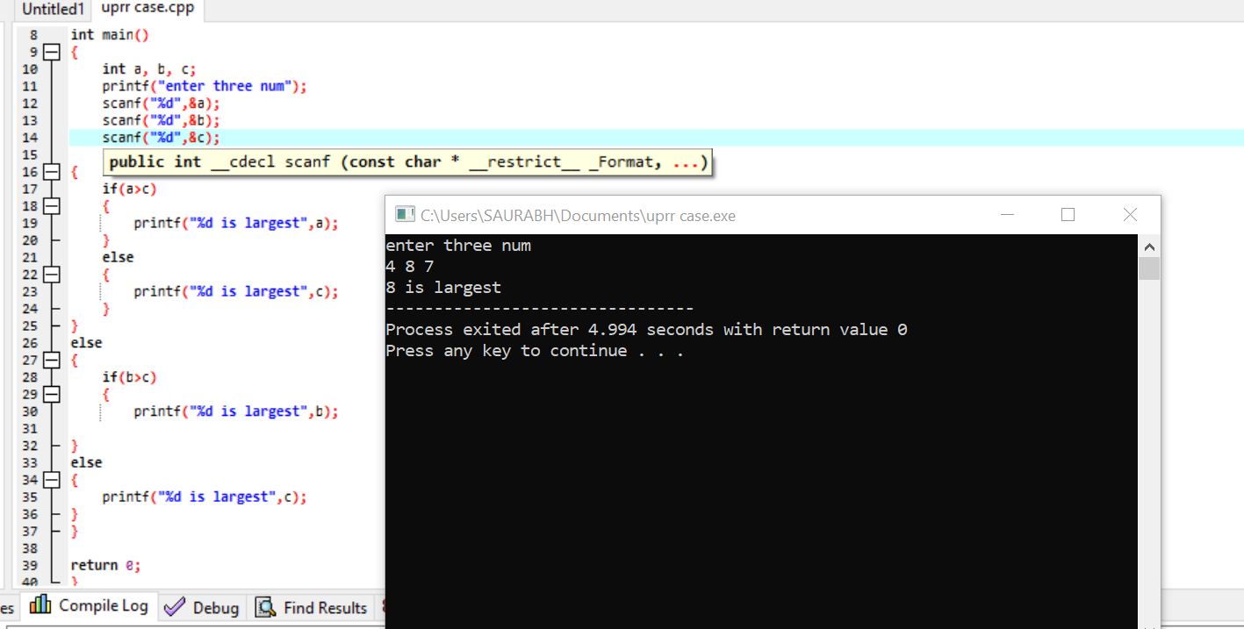

1. WAP to find maximum of four number.

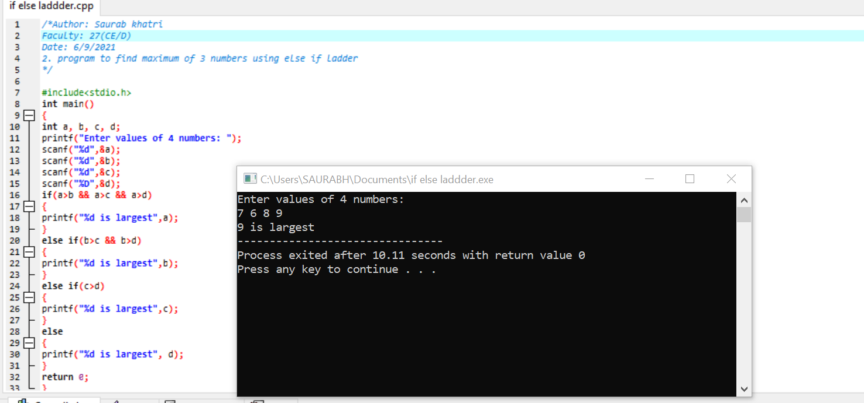

1. WAP to find whether the given character is Uppercase, Lowercase, digit or Symbol.

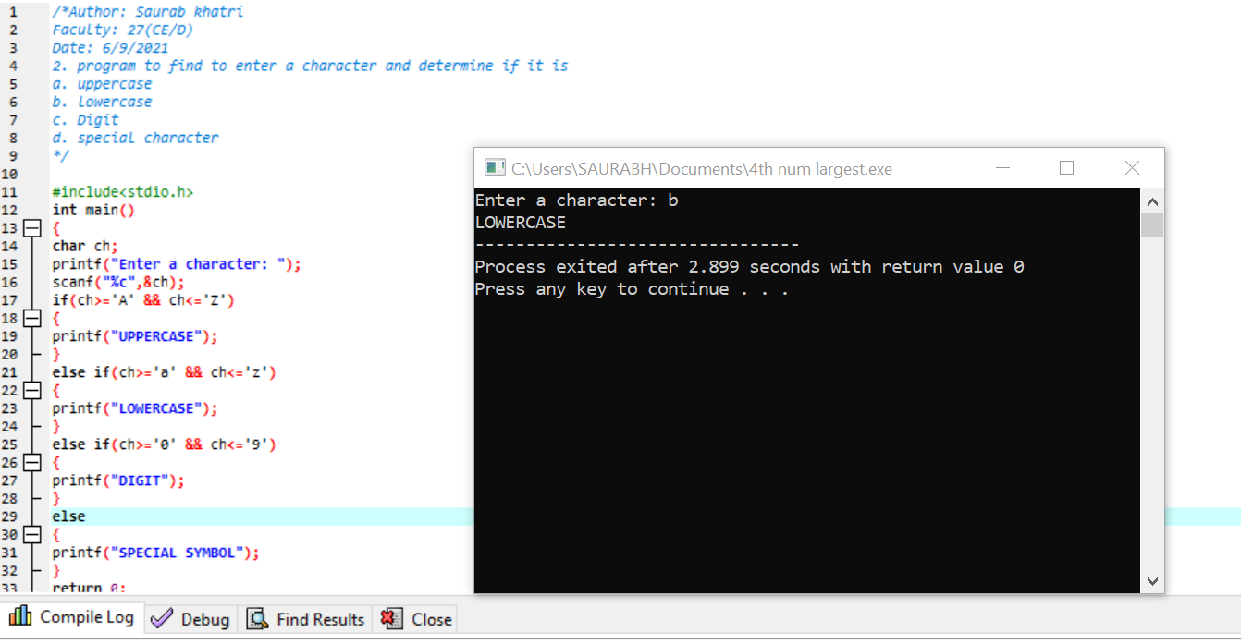

1. WAP to input 5 marks of student and calculate percentage. Based on percentage display Division of student. (Above 80%= Distinction, 60%- 79%=First Division, 50%- 59% = Second Division, 40%- 49%, Third Division, Below 40%= Fail).



1. WAP to find whether year is leap year or not. (A year that is exactly divisible by four is a leap year, except for a year that is exactly divisible by 100 but, the year is a leap year if it is exactly divisible by 400).

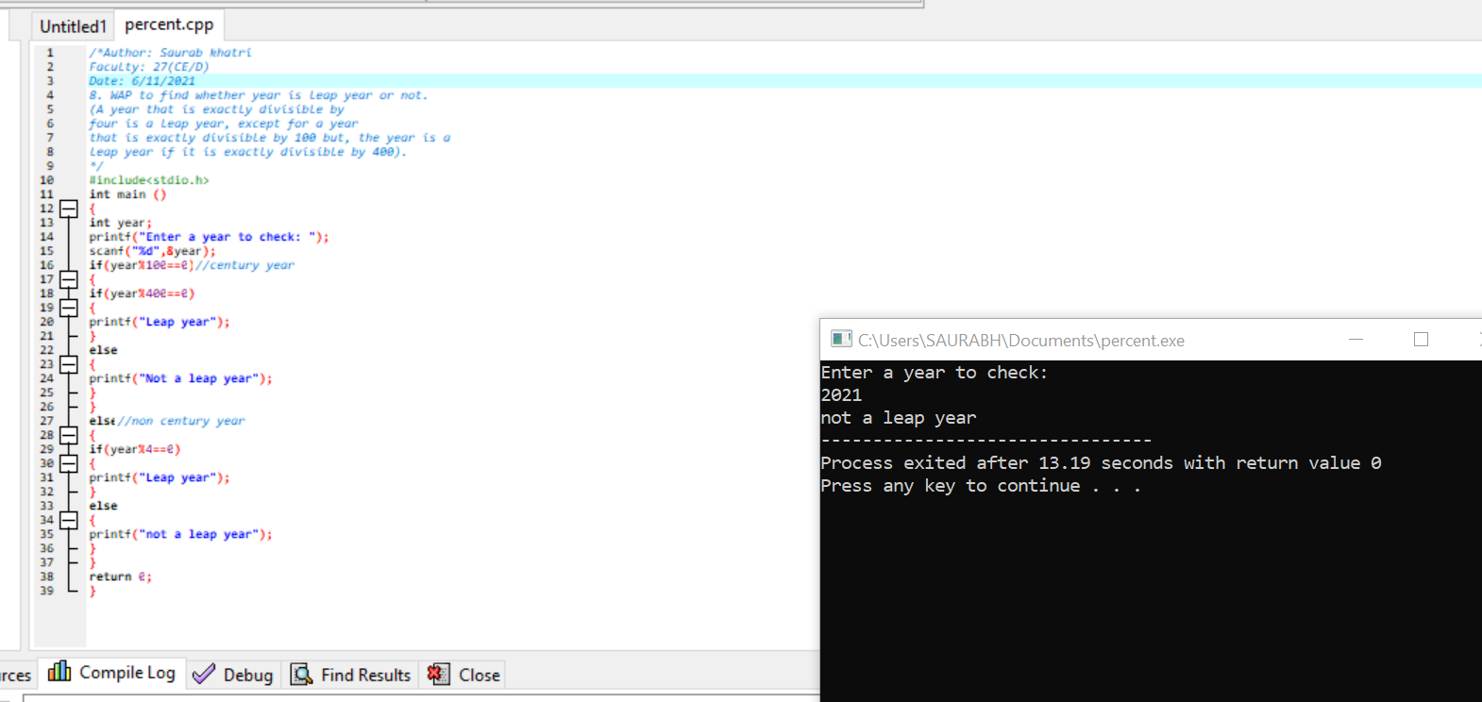

1. WAP to find roots of a quadratic equation when coefficients are entered by user.

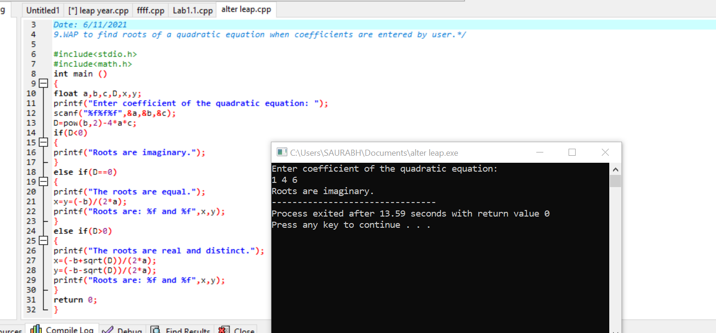

1. Calculate the amount of electricity bill consumed. Input the unit consumed And,

• for first 100 units= Rs.8/unit

• for next 200 units=Rs12/unit

• Beyond 300 units=Rs15/unit All users are charged with meter charge with Rs.50.

Now calculate total amount to be paid.

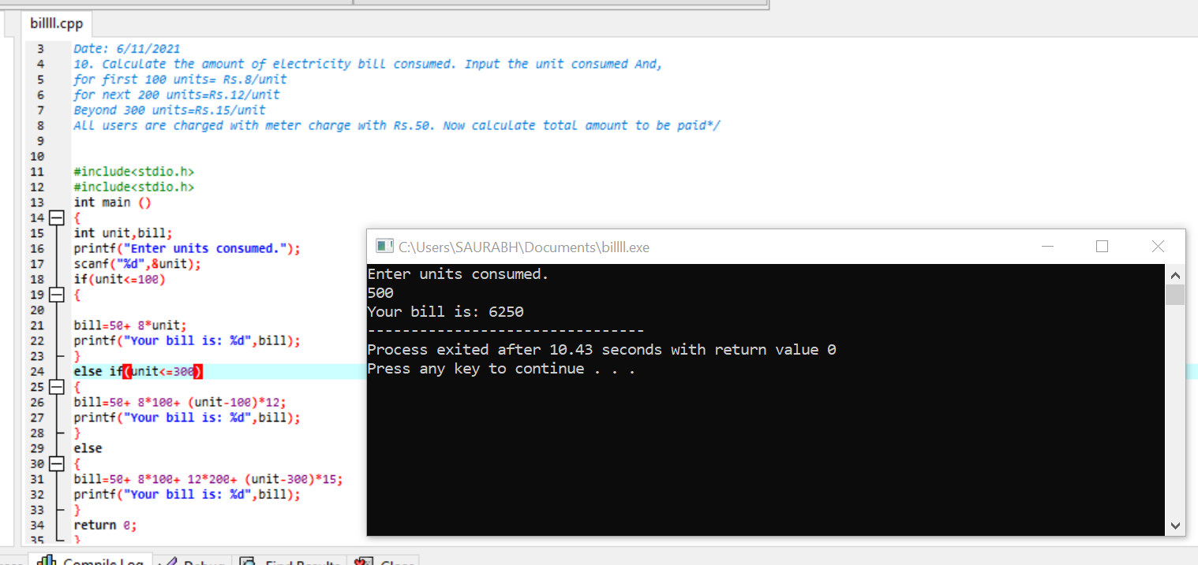

1. Calculate the amount of electricity bill consumed. Input the unit consumed And,

• for first 20 units= Rs.80

• for next 80 units=Rs7.5/unit

• for next 100 units=Rs8.5/unit

• Beyond 200 units= Rs9.5/unit All users are charged with tax rate of 15% in total amount. Now calculate total amount to be paid.

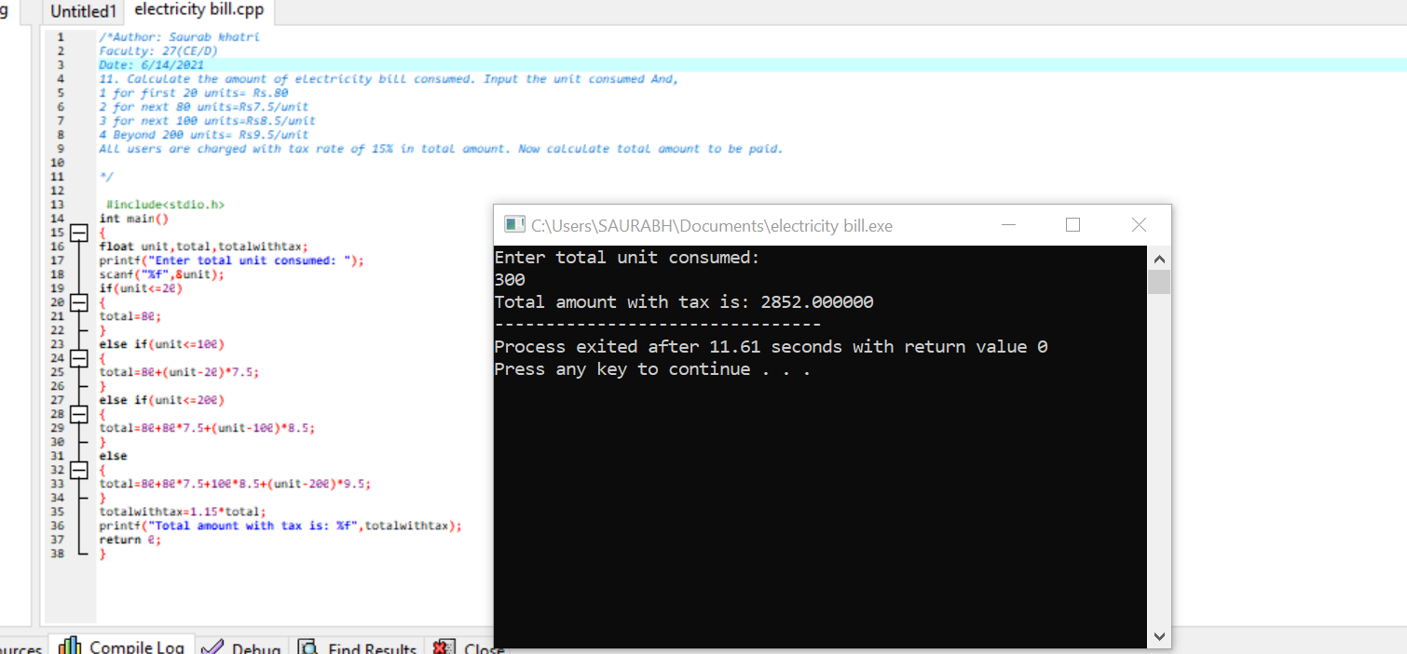

1. Company insures drivers in following cases

• If driver is unmarried

• If driver is unmarried male and above 30 yrs of age

• If driver is unmarried female and above 25 yrs of age.

