User Manual

This manual will help the end-users/operators/operational managers to learn and know about using the omniPresence Command Central ad use the features of the omniPresence RF ID system.

First of all, omniPresence features are integrated in all in 1 omniPresence Command Central Software. This software is a terminal mode (Character User Interface) as well as Graphical User Interface.
The most common functions have been made User Friendly by incorporating the Graphical User Interface in the software. We made sure that the common tasks are done at a easy pace and are not slowed by the clumsy CUI. We are also incorporated a 3rd party database tool from OpenOffice.org named OpenOffice Base.
Before reading this manual one must read the workflow of the omniPresence RF ID system given chapter 4.

We now start demonstrating the software interface and interoperability with other 3rd party softwares.

Minimum software requirements

- Linux Operating System with Kernel 2.6.25 release. The system should be configured of the latest LSB (Linux Standard Base) and intltool. (Specifically OpenSUSE v 11.0 or above)
- Bluez Bluetooth Stack and Libraries.
- MySQL backend server database. (Client (optional)) version 5.1
- GNOKII libraries v 0.6.26
- Posix Threading Libraries.

Minimum Hardware Requirements
- A intel X86 Machine (2.26GhZ and Above (Pentium or above)).
- 512 MB Primary Memory
- Class 2 Bluetooth Adapter with inbuilt HCI controller Stack.
- Nokia Symbian S60 v2 Mobile Phone.

Installation
The installation of omniPresence is done in 3 steps:
- Ensuring the dependencies exist in the system viz the hardware and the software requirements
- Installing the backend database server and creating the database schema as per specification.
- Installing the omniPresence software system and placing the appropriate dependencies in appropriate locations viz “/usr/share/omniPresence”

Ensuring the dependencies exist
This is done by checking that the software and hardware dependencies exist in the software.
- The Linux system can be upgraded/installed from the Linux distribution site. (e.g fedora.com, opensuse.com etc). If you do have a linux system but have a older version of kernel (to see kernel version type uname -r on terminal), you can download the latest version of kernel form the sote kernel.org. Every linux system has a online Update repositories, you can update the intltool and LSB by an online Update from the version of operating system you are using.
- Bluez Bluetooth stack can be downloaded and installed from bluez.org. You can have installation RPMs from internet or you can download the code. To install just compile the code, run ./configure and ./make to integrate bluez stack with the system.
- MySQL can be downloaded from website mysql.com. The mysql website gives the remade rpm to be installed. Just download the server version and install it with the command
“rpm -ivh <RPM SETUP FILE>” on terminal.
- Gnokii libraries can be downloaded from GNOKII.org and can be installed in similar manner.
- Posix Threading Libraries comes integrated with the kernel 2.6.25.

Creating the database Schema
The database schema can be created by issuing the DDL commands described in the chapter 3. You will also have to input/import the companies existing in employees database of the organisation to workersDB database of omniPresence.This makes the omniPresence ready for execution.
Installing the omniPresence software system
This implies creating directory
/usr/share/omniPresence/
/usr/share/omniPresence/BACKUP

Creating a OpenOffice Base Document and connect it to the omnipresence database.
Document Name : omniPresenceFE.odb
Location : /usr/share/omniPresence
The omniPresence Executable can exist anywhere in the Linux FileSystem but for system integration place it in the bin Directory in your home directory.

So Lets start the description of the omniPresence Command Central.
(O.P.C.C.)
After the system integration, the omniPresence can be started by simply typing “omniPresence” at terminal prompt.
If not integrated with the system, the omnipresence can be started by typing <PATH> omniPresence at the terminal.

Upon starting the omniPresence will initialize all its system components an
would ask for the authentication
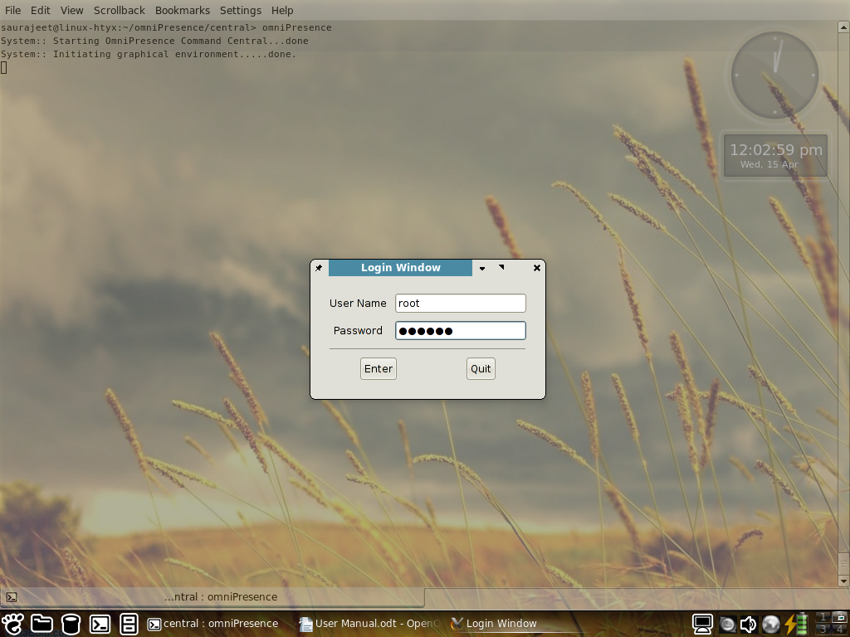
Once authenticated the opcc prompt would appear which looks like

Typing “Menu”or “Help” would give the menu List and

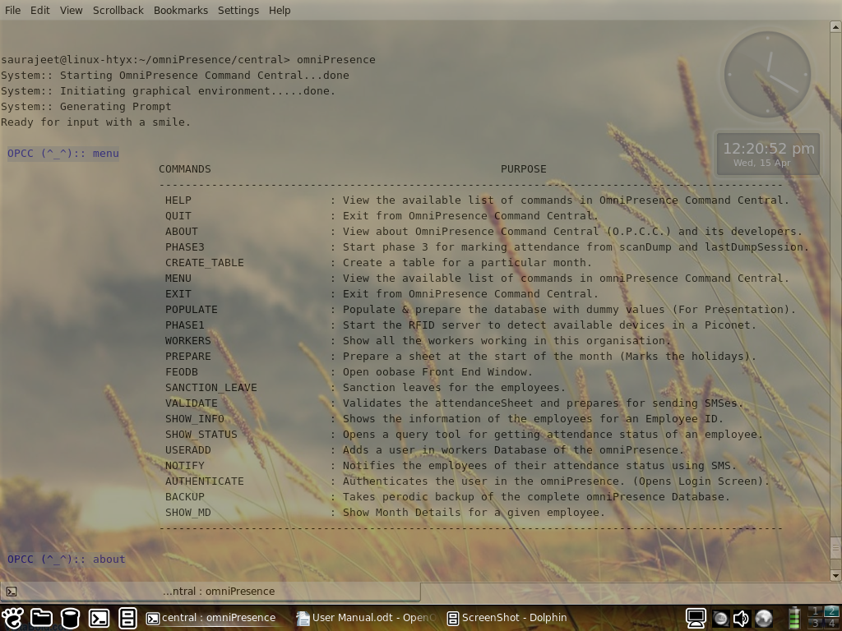

The commands list are as follows:
- HELP
- QUIT
- ABOUT
- PHASE3
- CREATE_TABLE
- MENU
- EXIT
- POPULATE
- PHASE1
- WORKERS
- PREPARE
- FEODB
- SANCTION_LEAVE
- VALIDATE
- SHOW_INFO
- SHOW_STATUS
- USERADD
- NOTIFY
- AUTHENTICATE
- BACKUP
- SHOW_MD

HELP
View the available list of commands in OmniPresence Command Central.

QUIT
Exit from OmniPresence Command Central.

ABOUT
View about OmniPresence Command Central (O.P.C.C.) and its developers.

PHASE3
Start phase 3 for marking attendance from scanDump and lastDumpSession.

CREATE_TABLE
Create a table for a particular month.

MENU
View the available list of commands in omniPresence Command Central.

EXIT
Exit from OmniPresence Command Central.

POPULATE
Populate & prepare the database with dummy values (For Presentation).

PHASE1
Start the RFID server to detect available devices in a Piconet.

WORKERS
Show all the workers working in this organisation.

PREPARE
Prepare a sheet at the start of the month (Marks the holidays).

FEODB
Open oobase Front End Window.

SANCTION_LEAVE
Sanction leaves for the employees.

VALIDATE
Validates the attendanceSheet and prepares for sending SMSes.

SHOW_INFO
Shows the information of the employees for an Employee ID.

SHOW_STATUS
Opens a query tool for getting attendance status of an employee.

USERADD
Adds a user in workers Database of the omniPresence.

NOTIFY
Notifies the employees of their attendance status using SMS.

AUTHENTICATE
Authenticates the user in the omniPresence. (Opens Login Screen).

BACKUP
Takes periodic backup of the complete omniPresence Database.

1
SHOW_MD
Show Month Details for a given employee.

One can start “PHASE1” by simply typing phase1 on the terminal.
It checks the system time and1 starts once it finds the system time in future of the last dump session's time.
The screen shot is:

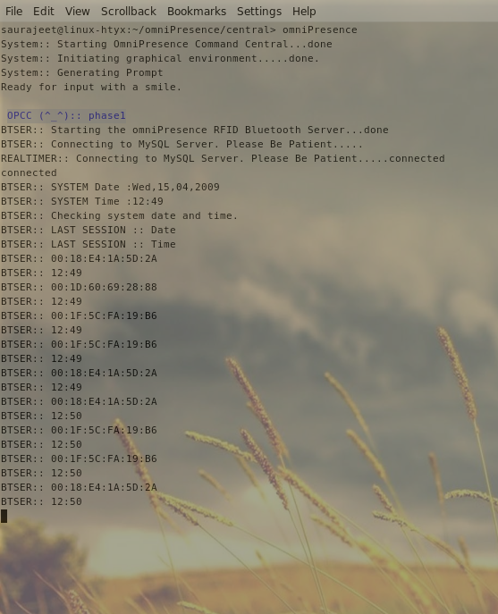
“PHASE3”

“CREATE_TABLE” can be initiated by typing create_table in the OPCC terminal. It asks the month and year for which attendance sheet is to be created.
The screen shot is:

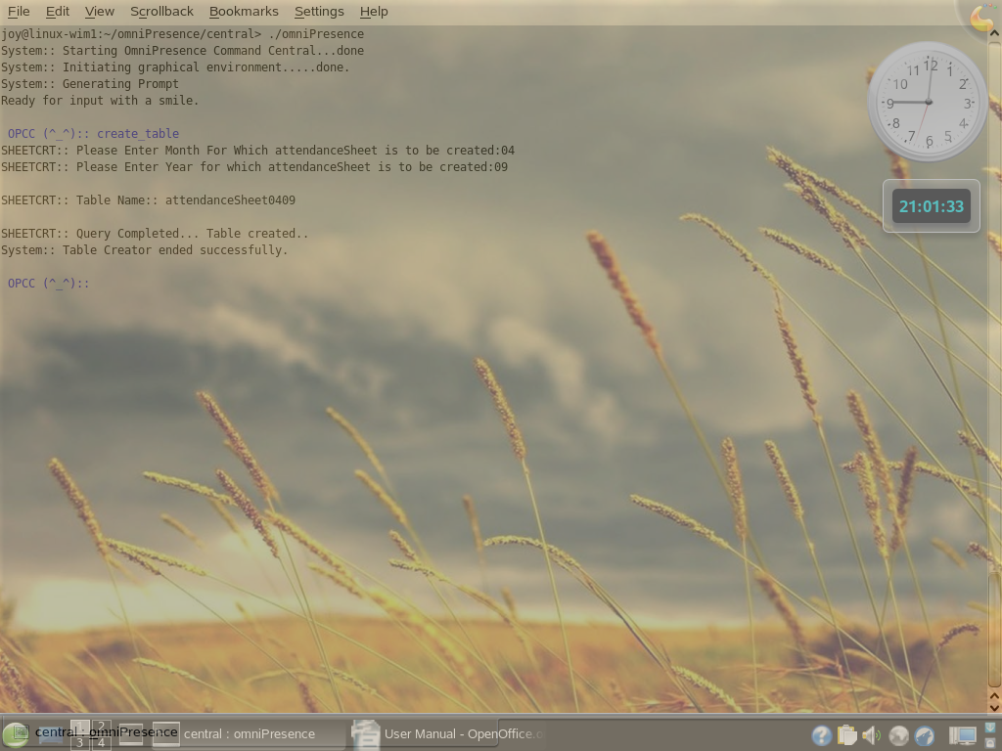
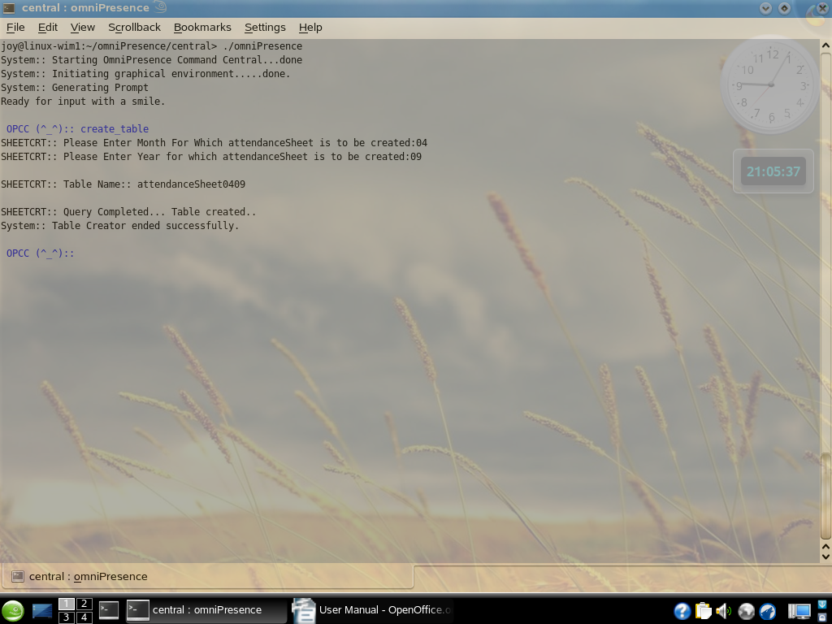
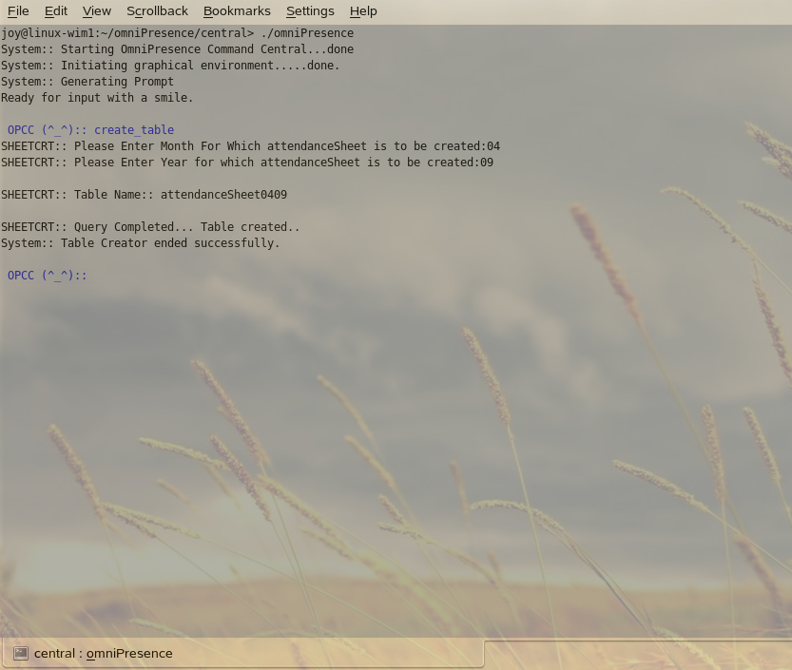

“PREPARE” can be initiated by typing prepare in the OPCC terminal. This is responsible for preparing the attendance sheet. In other words, it is responsible for copying workers and for mentioning the number of holidays.
The screen shot is:
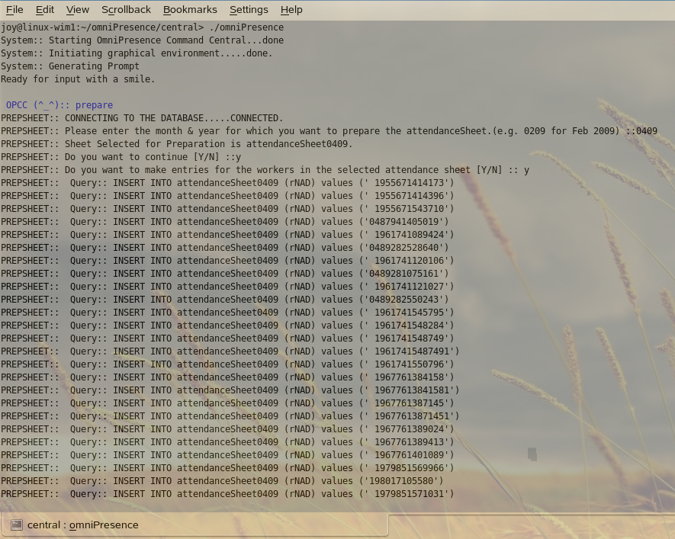
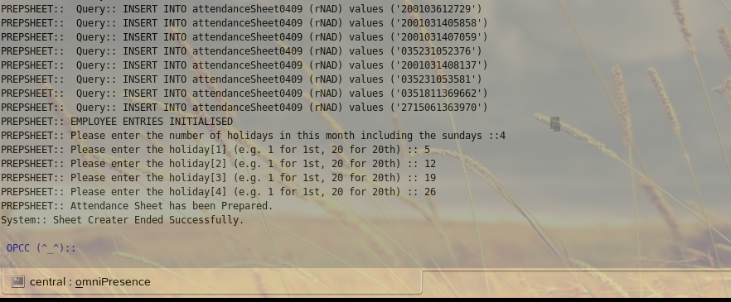

“SANCTION_LEAVE” is initiated by typing sanction_leave in the terminal. This is responsible for issuing a leave. It asks for employee id, month, number of leaves and the date of leaves.
The screen shot is:

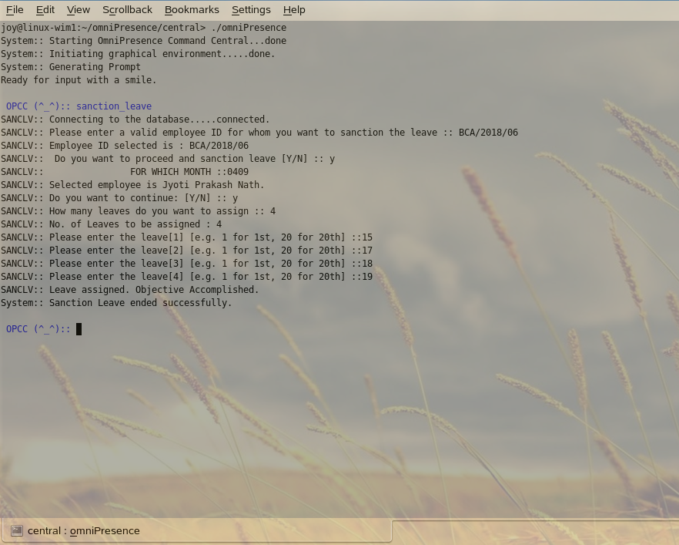

“SHOW_INFO” can be invoked by typing show_info in the OPCC terminal. This is responsible for showing the information of the worker like MAC, Name and phone number provided with empid.
The screen shot is:

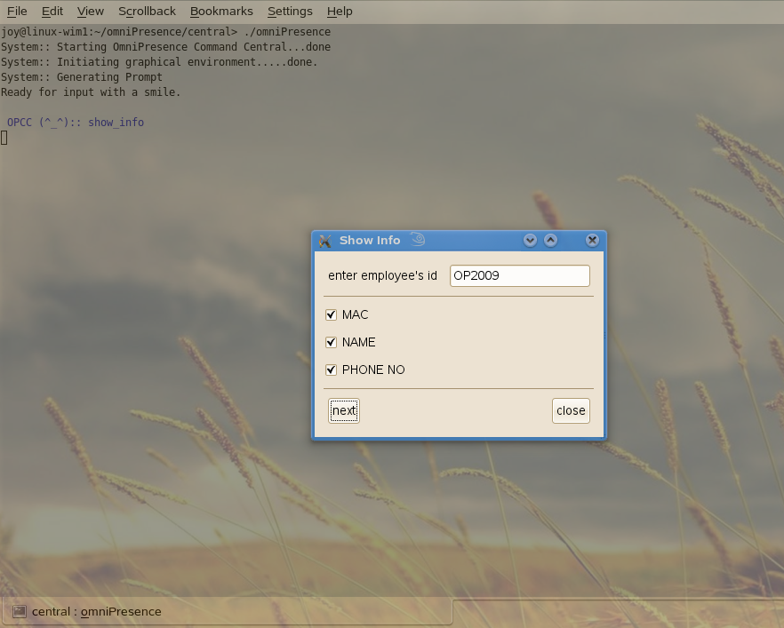

“SHOW_STATUS” can be initialized by typing show_status at the OPCC terminal. This is to show the status of a worker for a particular day of a particular month of a specified year.
The screen shot is:

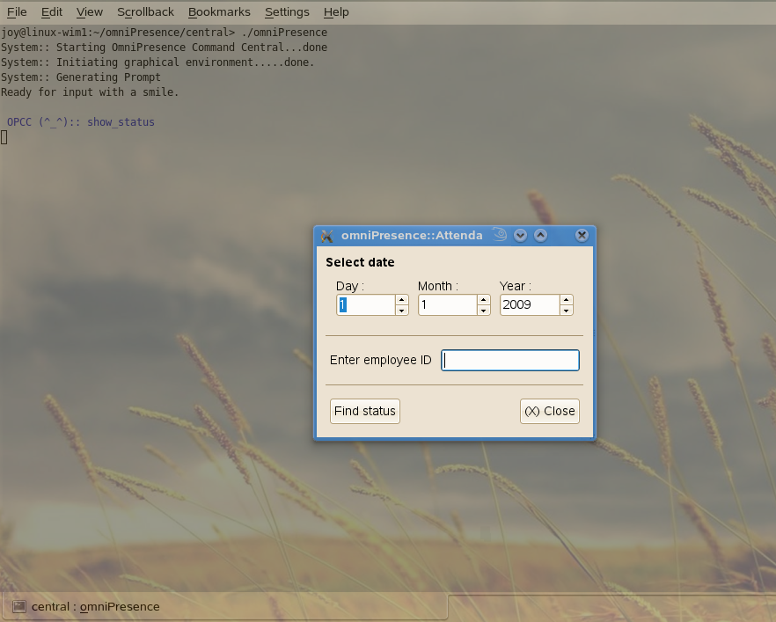

“USERADD” can be initialized by typing useradd in the OPCC terminal. This can be used to add single or multiple numbers of new workers to the database.
The screen shot is:

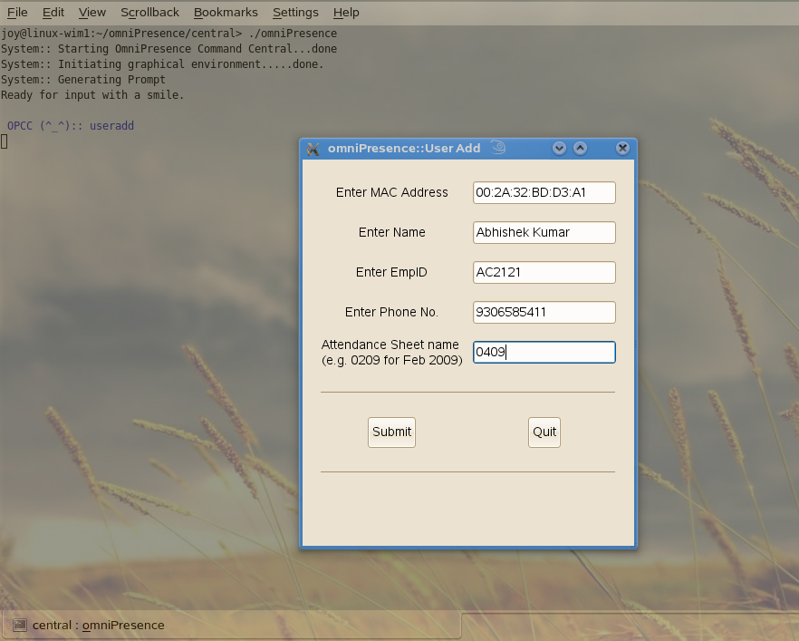

“BACKUP” can be initialized by typing backup in the OPCC terminal. This is used to create and load a backup file as required.
The screen shots are:

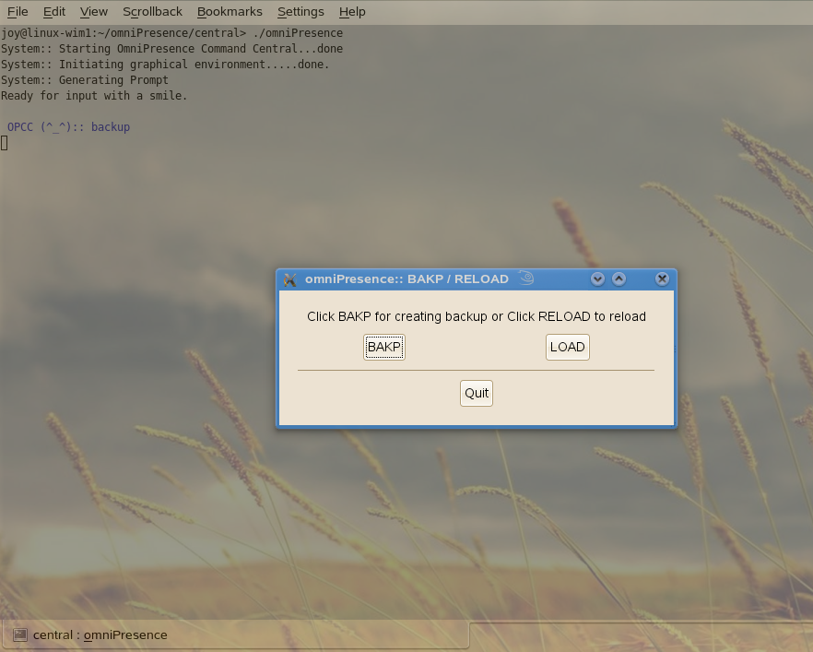

when backup is clicked, the following is displayed in the OPCC.
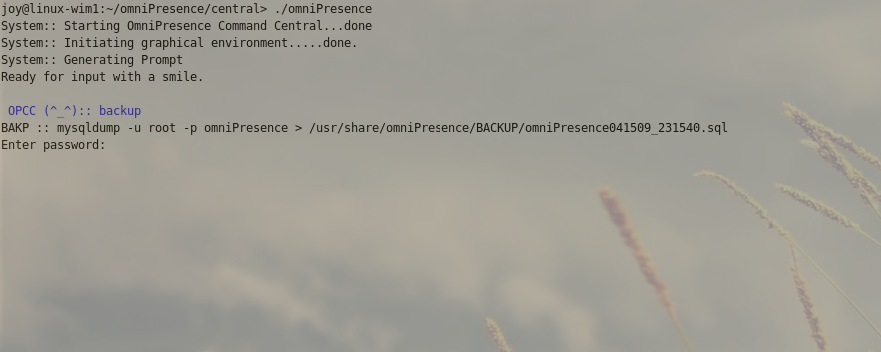

When the load is clicked, this window is displayed. You have to locate the location of the backup file and then click the OK button to load.

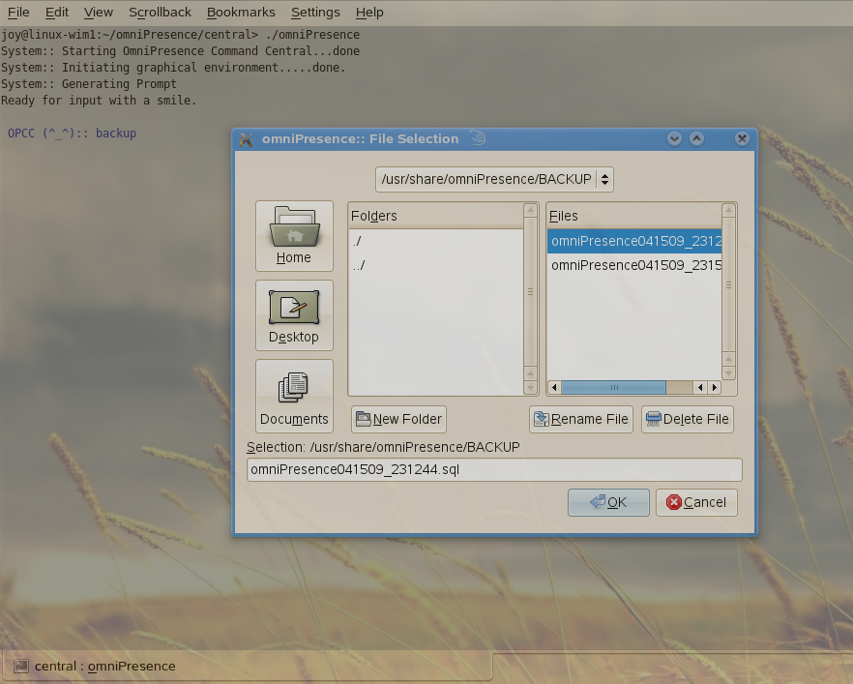

“SHOW_MD” is used to display the entire months attendance record of a worker, provided with empid.
The screen shots are:
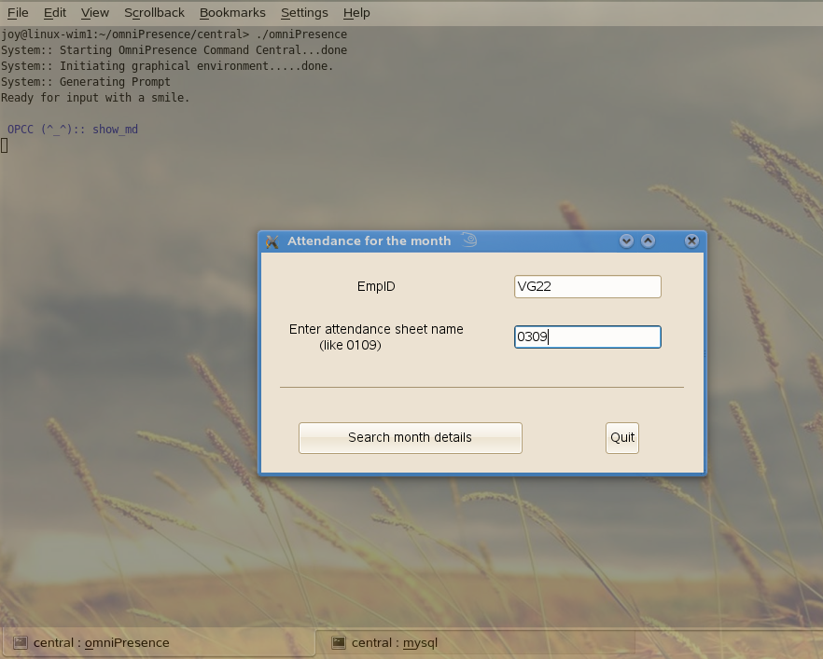

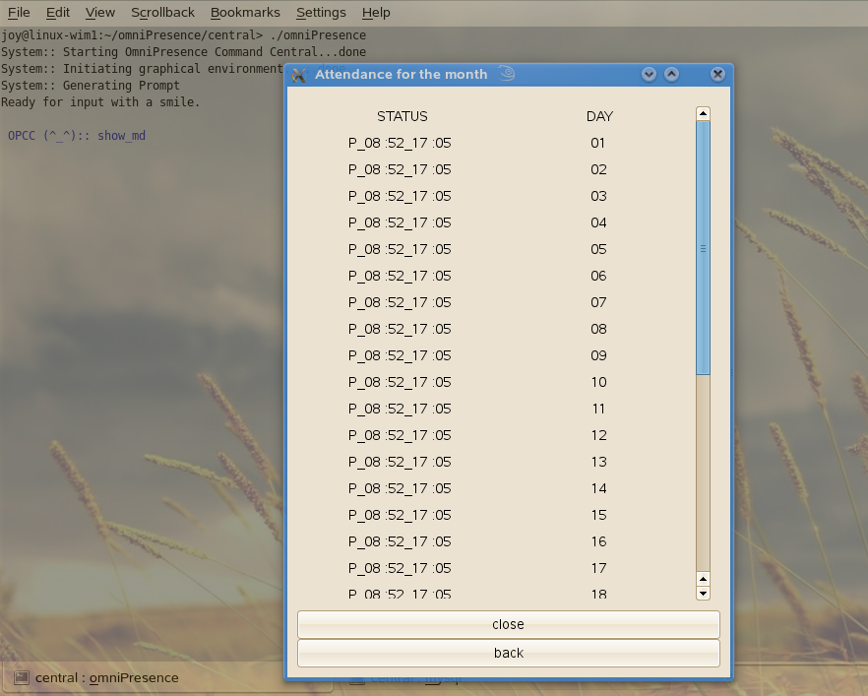

“FEODB” can be initialized by typing feodb in the OPCC terminal. This provides a front end to show all the databases and can also be used for report generation.
The screen shot is:



