A Survey and Comparison of Various Software based Distributed Shared Memory (DSM) Design Methodologies

Saura Mandal
B.E(I.T) Final Year Student
Jadavpur University, Salt Lake City, Block-LB, Plot No. 8, Sector - III, Kolkata – 700098, India.
Email id: saura.mandal1@gmail.com
Tarun Naskar
B.E(I.T) Final Year Student
Jadavpur University, Salt Lake City, Block-LB, Plot No. 8, Sector - III, Kolkata – 700098, India.
Email id: naskartaru@gmail.com

Abstract— It is important to optimize the distributed system features to obtain maximum possible performance from the distributed systems. A distributed shared memory (DSM) is a kind of mechanism that allows a system’s multiple processors to access shared data without using inter process communication (IPC). DSM can be designed using hardware and/or software methodologies based on various considerations of data being shared in multiprocessor environments. In hardware DSM systems, special network interfaces and cache coherence circuits are required which is more expensive. It is better to design DSM in software because sharing of data is a problem which can be easily handled in software and not in hardware. This paper discusses various design methodologies based on granularity of data being shared like object based, shared variable based and page based with their features and drawbacks.
Keywords: Interprocess Communication (IPC), Distributed Shared Memory (DSM),Hardware DSM,Software DSM, Object Based DSM, Shared Variable Based DSM, Page Based DSM, Distributed Global Address Space (DGAS)

INTRODUCTION

A distributed shared memory (DSM) is a kind of mechanism that allows multiple processors to access shared
data without using interprocess communications. To construct such a multiprocessor system, the underlying hardware
and/or software must move data items (memory contents) among processors in a way that provides the illusion of a
globally shared address space. So, distributed shared memory is also known as a distributed global address space (DGAS).
As DSM system involves moving of data from one node to another node, so bandwidth and performance are the important criteria for design. [1]
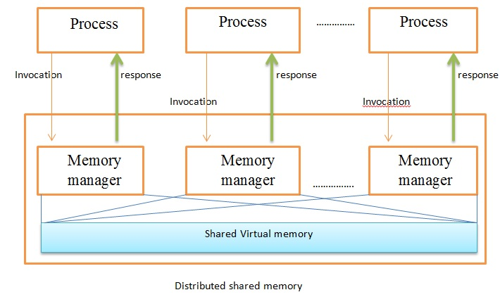
Figure 1: Distributed Shared Memory

The various DSM implementations are as given below:
- Object-based DSM – It requires special programming language features to determine when a remote machine’s memory is to be accessed.
- Shared Variable-based DSM – It requires custom compilers to add special instructions to program code in order to detect remote access.
- Page Based DSM – It uses the memory management unit (MMU) to trap remote access attempts. [2]
II. RELATED WORK

There are several classic models used to implement distributed shared memory system. Modern research and development of systems with multiple processors has shown significant progress. IVY [1], Mirage [2], are good examples of page-based DSM. In such models, each of the CPUs in the system has its own private memory and, hence cannot reference remote memory directly. When a CPU addresses a word in the address space that is backed by a page currently located on a different machine, a trap to the operating system occurs and the required page must be fetched by software. The operating system acquires the necessary page by sending a message to the machine where the page is currently residing and asking for it. Thus both placement and access are done in software in these two models. [5]
Particularly, in Mirage, the DSM provides a form of network transparency to make network boundaries invisible for shared memory and is upward compatible with an existing interface to shared memory. The protocol used in Mirage has the following features designed to reduce network traffic and sustain high performance:-

- 1. The model is based on page segmentation
- 2. The writer of a page retains access to that page for a fixed period of time independent of subsequent read and write requests.
- 3. There may be upgrades or downgrades in the modes of pages that are distributed throughout the network.
Munin[3] and Midway [4] are good examples of shared-variable DSM. In such models, only a selected portion of their address spaces, namely shared variable and other data structures, are shared. User-supplied information is required to determine which variables are shared and which are not. For example, Munin uses loosely coherent memory, based on the partial order specified by a shared memory parallel program, and uses type-specific memory coherence. Instead of a single memory coherence mechanism for all shared data objects, Munin employs several different mechanisms, each appropriate for a different class of shared data object. These type-specific mechanisms are part of a runtime system that accepts hints from the user or the compiler to determine the coherence mechanism to be used for each object. This, encouraged us to write a paper on- "Survey and Comparison of Various Software based Distributed Shared Memory".

III.NEED OF DSM

Sharing of data is an essential requirement of any distributed system. Eventually, single processor systems will give way to multiple processors. It is less expensive to run 10 inexpensive processors cooperatively than it is to buy a supercomputer 10 times fast. [4] For this kind of design to reduce various overheads, it is important to optimize the imbalance between processors and memory. It is important to investigate new architectural designs which are easy to expand. A solution to these problems is Distributed Shared Memory (DSM). [4]
There are various advantages of programming in distributed shared memory for multiprocessor environment as stated below:-
- Sharing data becomes a problem which has to be tackled in the software and not in hardware as in multiprocessor systems.
- Shared memory programs are usually shorter and easier to understand.
- Large or complex data structures may easily be communicated.
- Programming with shared memory is a well-understood problem.
- Shared memory gives transparent process-to-process communication.

iv.DSM DESIGN ISSUES

The objective of distributed shared memory is to present the global view of the entire address space to a program, executing on any machine. A DSM manager on a particular machine would capture all the remote data accesses made by any process running on that machine. [7] An implementation of DSM would involve various choices. Some of them are as below:
- Implementation level of DSM Mechanism.
- Semantics for concurrent access.
- Semantics (Replication/Partial/ Full/R/W)
- System consistency model & Granularity of data.
- Data is replicated or cached.
- Remote access by HW or SW.
- Caching/replication controlled by HW or SW. [8]

V. DSM DESIGN METHODOLOGIES

To design DSM useful to multiple processors in a distributed system, we choose to allow multiple readers access to the same region of shared memory. This improves performance and saves space by allowing multiple processes on possibly different nodes to work together in the same shared address space. [9] Based on the granularity of data DSM is divided in three categories viz. object based DSM, shared variable based DSM and page based DSM.

Object based DSM:

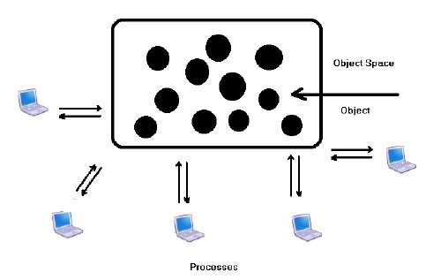
Figure 2: Object Based DSM

An object is a programmer defined encapsulated data structure. It consists of internal data, object state and procedures.
The procedures are called methods or operations that operate on the object state. To access or operate on the internal
state, the program must invoke one of the methods. The method can change the internal state; return the state, or
something else. It also supports information hiding. Each object state has auxiliary variables which uses various
methods. [10]

Shared Variable based DSM:
Shared variable based DSM is used to share only certain variables and data structures that are needed by more than one
process into the environment. This way, the problem changes from how to do paging over the network to how to maintain a potentially replicated, distributed database consisting of the shared variables. Using shared variables that are individually managed also provides considerable opportunity to eliminate false sharing. [10]

Page based DSM:
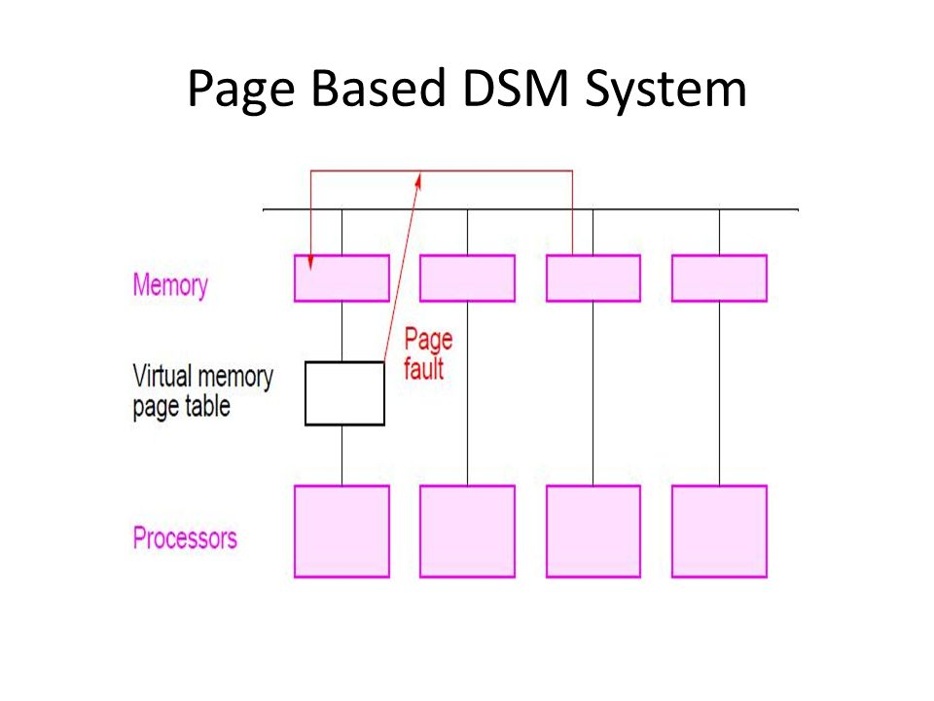
Figure 3: Page Based DSM
In this approach, a memory page is used as the unit of data sharing. Page based DSM closely emulates shared memory in multiprocessors that is managed by the operating system. The entire address space is divided into pages (chunks).
Whenever the virtual memory manager finds a request to an address space which is not local, it asks the DSM manager
to fetch that page from the remote machine. Such kind of page fault handling is simple and similar to what is done
for local page faults. [11]

VI. COMPARISON OF DSM DESIGN METHODOLOGIES

The table below shows the comparison of the three types of software based DSM design methodologies discussed in Section IV against various parameters: [12]

Item | Object Based | Shared Variable  based | Page Based
Transfer Medium | Network | Network | Network
Transfer Unit | Object | Variable | Page
Data Migration done  by | Software | Software | Software
Linear, Shared  Virtual Address  Space? | No | No | Yes
Possible Operations | General | R/W | R/W
Encapsulation and  Methods | Yes | No | No
Is Remote Access  Possible in hardware? | No | No | No
Is unattached  memory possible? | No | No | No
Who converts  Remote Memory  Access to message? | Runtime  System | Runtime System | OS

Table 1: Comparison of Software DSM Design Methodologies

VII. CONCLUSION

DSM combines the advantages of multiprocessors and multicomputer systems. It allows a system’s multiple processors to access shared data efficiently. In this paper, we have surveyed different Software Design Methodologies and have provided a comparison of them.

Acknowledgment

We are immensely grateful to Mr. Utpal Kumar Ray, Assistant Professor, Department of Information Technolgy, Jadavpur University for supporting and encouraging us to write this journal paper. Moreover, we thank Mr. Ryan Saptarshi Ray, Senior Research Fellow, Department of Information Technolgy, Jadavpur University for assistance.

References:
[1] Carlos Macian, Sarang Dharmapurikar and John Lockwood, “Beyond Performance: Secure and Fair Memory Management for Multiple System on a Chip”
[2] K. Li, "Shared Virtual Memory on Loosely Coupled Multiprocessors"
[3] B. Fleisch and G. Popek, "Mirage: A Coherent Distributed Shared Memory Design"
[4] J.K. Bennett, J.K. Carter and W. Zwaenepoel, "Munin: Distributed Shared Memory Based on Type-Specific Memory Coherence"
[5] B.N. Bershad and M.J. Zekauskas, "Midway: Shared Memory Parallel Programming with Entry Consistency for Distributed Memory Multiprocessors"
[6] Prof. Bal Gopal, Rizwan Beg and Pankaj Kumar,
“Memory Management Techniques for Paging on Distributed Shared Memory Framework,”International Journal of Computer Science and Information Technology, Volume 2, April 2010.

[7] Tomas Seidmann, “Distributed Shared Memory in Modern Operating Systems,” Ph.D. thesis, Slovak University of Technology, pp.812-19,Bratislava.
[8] Song Li, Yu Lin, and Michael Walker, “Region-based Software Distributed Shared Memory,” CS 656 Operating Systems, May 5, 2000
[9] Ajay Kshemkalyani and Mukesh Singhal, “CS 656 Operating Systems”, May 5, 2000
[10] Jelica Protic, Milo Tomasevic and Viljko Milutinovic, “Distributed Shared Memory: Concepts and Systems,” IEEE Parallel and Distributed Technology, Summer 1996.
[11] Varun Chandola, “Design Issues in Implementation of Distributed Shared Memory in User Space”
[12] Distributed Shared Memory, Available at: http://www.cs.gmu.edu/cne/modules/dsm/

