AI Data Insights Report
Generated on: 2026-03-17 16:59:29

Executive Summary
This dataset contains 8807 rows and 12 columns. AI analysis identified key patterns, potential predictors, and data quality issues. Recommendations are provided to improve analysis and prepare for machine learning.

Dataset Overview
Rows: 8807
Columns: 12
Column Names: show_id, type, title, director, cast, country, date_added, release_year, rating, duration, listed_in, description

Data Quality Score
Quality Score: 96%
Missing Data: 4.08%

Missing Values
show_id: 0
type: 0
title: 0
director: 2634
cast: 825
country: 831
date_added: 10
release_year: 0
rating: 4
duration: 3
listed_in: 0
description: 0

Visualizations
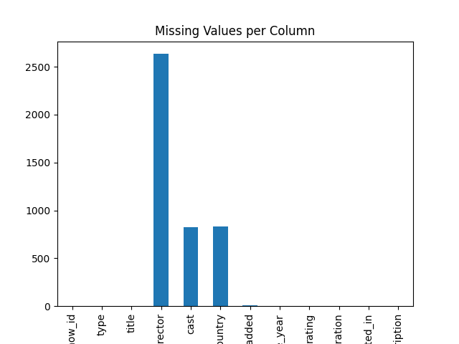
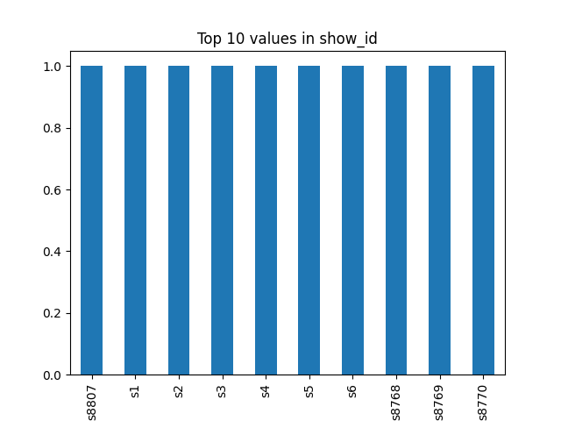

Key Insights
- # Comprehensive Data Analysis Report
- ## 1. Dataset Overview and Structure
- - **Dataset Size:**
- - **Rows:** 8,807
- - **Columns:** 12
- - **Columns and Data Types:**
- - `show_id`: Object (unique values: 8,807)
- - `type`: Object (unique values: 2)
- - Top values: "Movie" (6,131), "TV Show" (2,676)
- - `title`: Object (unique values: 8,807)
- - `director`: Object (unique values: 4,528)
- - `cast`: Object (unique values: 7,692)
- - `country`: Object (unique values: 748)
- - Top values: "United States" (2,818), "India" (972), "United Kingdom" (419)
- - `date_added`: Object (unique values: 1,767)
- - `release_year`: Integer (mean: 2014.18, std: 8.819, min: 1925, max: 2021)
- - `rating`: Object (unique values: 17)
- - Top values: "TV-MA" (3,207), "TV-14" (2,160), "TV-PG" (863)
- - `duration`: Object (unique values: 220)
- - Top values: "1 Season" (1,793), "2 Seasons" (425), "3 Seasons" (199)
- - `listed_in`: Object (unique values: 514)
- - `description`: Object (unique values: 8,775)
- - **Missing Values:**
- - `director`: 2,634
- - `cast`: 825
- - `country`: 831
- - `date_added`: 10
- - `rating`: 4
- - `duration`: 3
- - **Duplicate Rows:** 0
- ## 2. Data Quality Issues
- - **Missing Values:**
- - Significant missing values in `director` (29.45%), `cast` (9.37%), and `country` (9.43%).
- - Smaller but notable missing values in `date_added` (0.11%), `rating` (0.04%), and `duration` (0.03%).
- - **Data Types:**
- - `date_added` and `duration` are stored as objects, which may require conversion to datetime and numeric types, respectively, for better analysis.
- - **Unique Values:**
- - Columns like `show_id` and `title` have unique values for each row, indicating they are likely identifiers rather than categorical variables.
- ## 3. Key Statistical Findings
- - **Release Year:**
- - Mean release year is 2014.18 with a standard deviation of 8.819.
- - The dataset spans from 1925 to 2021.
- - The skewness of -3.447 indicates a left-skewed distribution, meaning more recent years are more common.
- - **Country Distribution:**
- - The United States has the highest number of entries (2,818), followed by India (972) and the United Kingdom (419).
- - **Rating Distribution:**
- - The most common rating is "TV-MA" (3,207), followed by "TV-14" (2,160) and "TV-PG" (863).
- - **Duration:**
- - The most common duration is "1 Season" (1,793), followed by "2 Seasons" (425) and "3 Seasons" (199).
- ## 4. Notable Patterns and Correlations
- - **Type Distribution:**
- - Movies (6,131) are more common than TV Shows (2,676).
- - **Top Directors and Cast:**
- - Rajiv Chilaka is the most frequent director with 19 entries.
- - David Attenborough is the most frequent cast member with 19 entries.
- - **Date Added:**
- - The most common dates added are January 1, 2020 (109), November 1, 2019 (89), and March 1, 2018 (75).
- - **Listed In:**
- - The most common categories are "Dramas, International Movies" (362), "Documentaries" (359), and "Stand-Up Comedy" (334).
- ## 5. Actionable Recommendations
- - **Data Cleaning:**
- - Address missing values in `director`, `cast`, and `country`. Consider imputation or removal based on the context.
- - Convert `date_added` to a datetime format for better temporal analysis.
- - Convert `duration` to a numeric format if possible, or create separate columns for seasons and episodes.
- - **Feature Engineering:**
- - Extract additional features from `date_added`, such as year, month, and day.
- - Create a new column for the number of seasons from `duration`.
- - **Exploratory Data Analysis (EDA):**
- - Analyze the distribution of `release_year` to understand trends over time.
- - Investigate the relationship between `country` and `type` to see if certain countries produce more movies or TV shows.
- - Explore the correlation between `rating` and `type` to understand if certain types are more likely to have specific ratings.
- - **Modeling:**
- - Develop predictive models for missing values in `director`, `cast`, and `country` using available features.
- - Build recommendation systems based on `listed_in` and `description` to suggest similar content.
- - **Visualization:**
- - Create visualizations to show the distribution of `release_year`, `country`, and `rating`.
- - Use heatmaps or correlation matrices to visualize relationships between numerical features.
- By addressing these recommendations, the dataset can be better prepared for advanced analytics and machine learning tasks, leading to more insightful and actionable findings.

Recommendations
- Handle missing values using appropriate techniques
- Encode categorical variables for machine learning
- Scale numerical features
- Perform feature engineering for better insights

User Notes & Observations
- saurav

Conclusion
This report combines AI-driven insights and human observations to support informed decision-making.

