Assigment 4 :

Execute Query :

USE bOOKsHOP

select r.REGION_NAME as "region", s.SUBREGION_NAME "subregion", t.code

as "warehouse", an.year_id as "year", m.month_id as "month", d.day_id as

"day", d.num_day as "num_day",

p.title as "book", p.price as "book price", f.sell_by_product as

"sell_by_product", f.ticket_number as "ticket_numnber"

from [OLAP_BOOKSHOP].[REGION] r,[OLAP_BOOKSHOP].[SUBREGION] s,

[OLAP_BOOKSHOP].[WAREHOUSE] t, [OLAP_BOOKSHOP].[YEAR] an,

[OLAP_BOOKSHOP].[MONTH] m, [OLAP_BOOKSHOP].[DAY] d,

[OLAP_BOOKSHOP].[BOOKS] p, [OLAP_BOOKSHOP].[FACTS_TICKET] f

where

f.warehouse_code = t.code and t.subregion_id = s.subregion_id and

 s.region_id = r.region_id and f.books_isbn = p.isbn and

f.day_id = d.day_id and d.month_id = m.month_id and m.year_id =

an.year_id

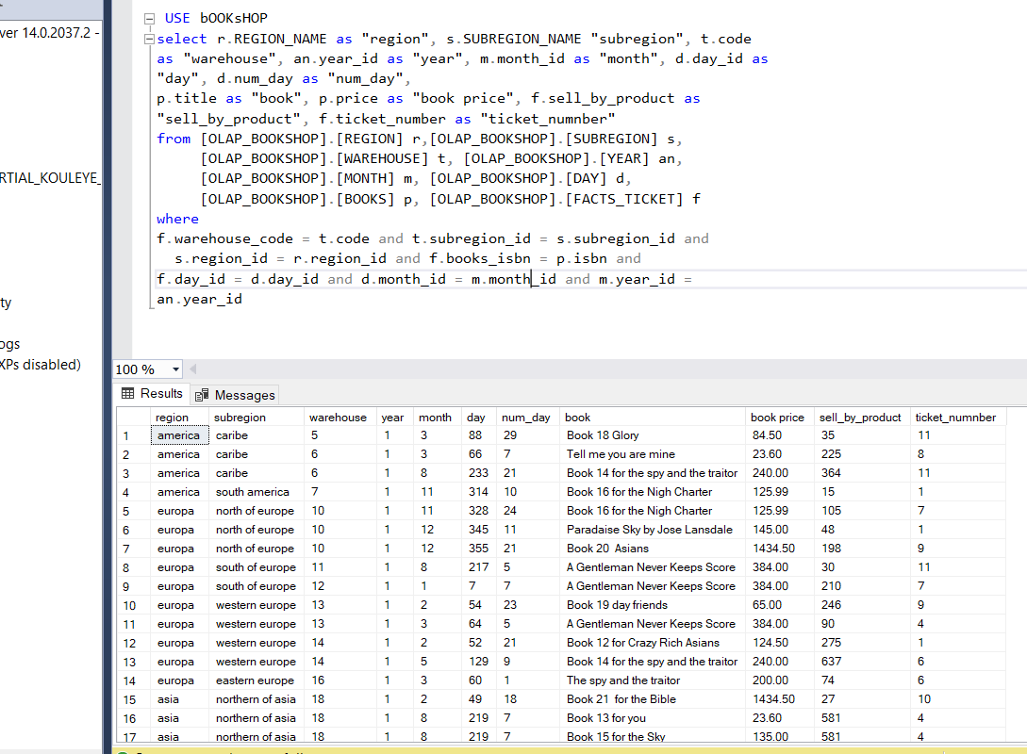

1. Document with Rapid Miner screenshots showing the generation of association rules where pairs of books have been bought together.

I will learn the Rapidminer user manual before answering this question. So i have install RapidMiner

