Four Queries:

1. MATCH (ga)-[r2:ESTA_GRUPO_INV]->(ac)-[r1:LINEA_INVESTIGA]->(li) WHERE li.name='Data Sciences' RETURN ac.name AS Researcher, ga.name AS AcademicGroup

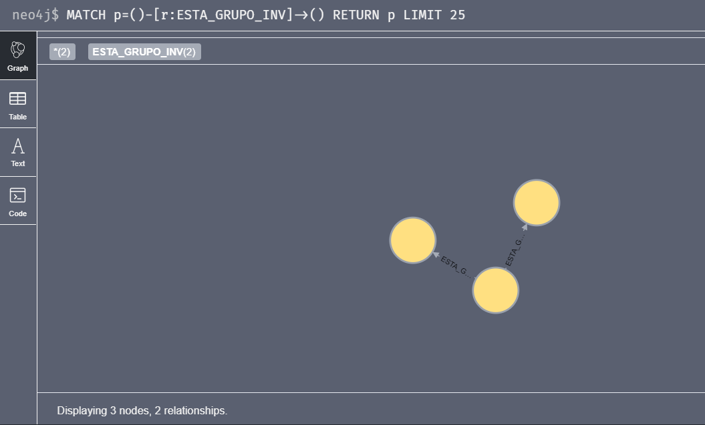

1. MATCH (arti)<-[r1:ESCRIBIO_ARTI]-(ac)-[r2:ADSCRIPCION]->(en) WHERE r1.tipo='conferencia' AND arti.anio=2018 RETURN en.nameAS entidad,arti.titulo AS nomArt, arti.anio AS year ORDER BY nomArt,year DESC

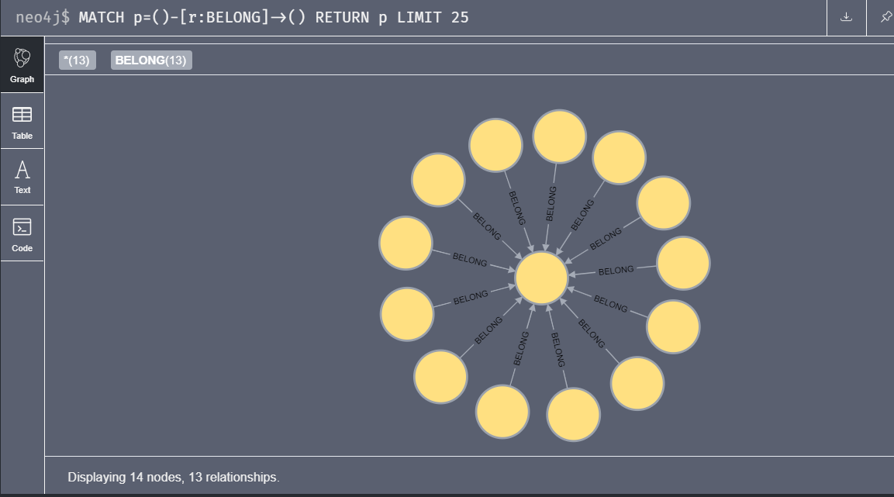

1. MATCH (aca)-[r:WRITE_ARTI]->(arti) WHERE r.tipo='conferencia' return arti.palabraClave1,arti.palabraClave2,arti.palabraClave3,arti.palabraClave4

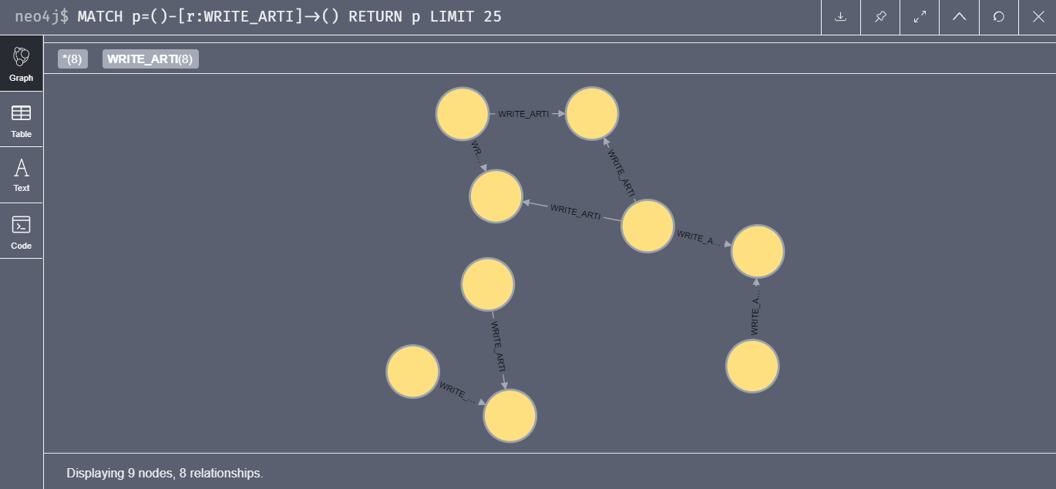

1. MATCH (arti)<-[r1:WRITE_ARTI]-(ac)-[r2:WORKSFOR]->(en) RETURN ac.name AS academico,arti.titulo AS articulo,r1.tipo AS tipo,arti.anio AS anio

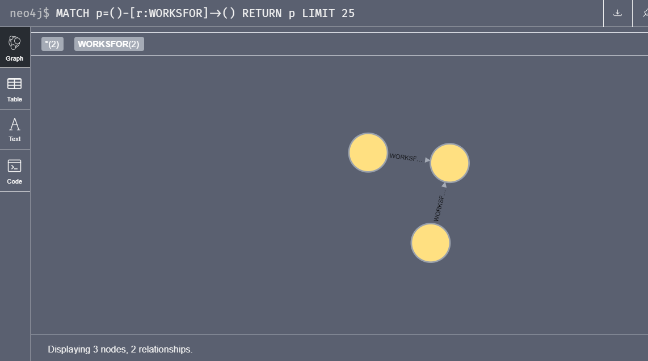

Other Graph Data:

