Team 7.5 GroupChatSweetner

- Deepak Sahu ( deepak@iiitkalyani.ac.in)

- Devendra Singh (devendrachauhan299@gmail.com)

- Jeevitha S (jeevithasuresh2000@gmail.com)

- Kishan Sahu (sahukishan06@gmail.com)

- Nadine Ben Harrath (nadinebenharrath@gmail.com)

- Rakshitha D (rakshupaapu1999@gmail.com)

- Saurav Chaudhary (sauravchaudhary_bt18@iiitkalyani.ac.in)

## 

## **Steps to Run the File**

1. Open jupyter notebook file in google colab.
2. Set Runtime to GPU.
3. Upload “Reddit.csv” in the files section.
4. Run All cells.
5. Go to the last cell and type your regular conversation-like sentence to know it’s topics. Example sentence:

“hmmm”

## **Future Scope**

1.This model predicts for english sentences for now.In future model can be extended with multilingual sentences.

2.More topics/labels can be added in future.

3.Conversation can belong to multiple topics.In future model can be transform to multilabel classification.

## **How far were we able to reach with our goals**

We have conceptualized the following pipeline to make a machine learning model as a chat moderator.

But in this long journey we were able to complete the parts (1, 2, 5, 7) which we had demonstrated using the jupyter notebook file.

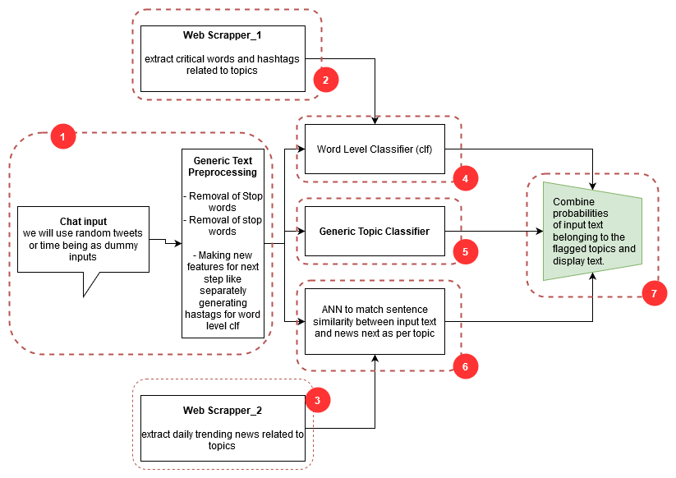



# 

# 

# Thank you note to PiAnalytixs team

We are thankful to the PiAnalytixs team for their constant support throughout this internship. We gained a lot of experience from this opportunity to work as a team and individually explore new domains and later collaborate our work.

Yours sincerely

Members of Team7.5