9.ReactHOL

App.js
import React from 'react';
import ListOfPlayers from './PlayersList';
import IndianPlayers from './IndianPlayer';
function App() {
const flag = false;
return (
<div className="App">
{flag ? <ListOfPlayers /> : <IndianPlayers />}
</div>
);
}
export default App;

App.css
.App {
text-align: center;
}
.App-logo {
height: 40vmin;
pointer-events: none;
}
@media (prefers-reduced-motion: no-preference) {
.App-logo {
animation: App-logo-spin infinite 20s linear;
}
}
.App-header {
background-color: #282c34;
min-height: 100vh;
display: flex;
flex-direction: column;
align-items: center;
justify-content: center;
font-size: calc(10px + 2vmin);
color: white;
}
.App-link {
color: #61dafb;
}
@keyframes App-logo-spin {
from {
transform: rotate(0deg);
}
to {
transform: rotate(360deg);
}
}

App.test.js
import { render, screen } from '@testing-library/react';
import App from './App';
test('renders learn react link', () => {
render(<App />);
const linkElement = screen.getByText(/learn react/i);
expect(linkElement).toBeInTheDocument();
});

index.css
body {
margin: 0;
font-family: -apple-system, BlinkMacSystemFont, 'Segoe UI', 'Roboto', 'Oxygen',
'Ubuntu', 'Cantarell', 'Fira Sans', 'Droid Sans', 'Helvetica Neue',
sans-serif;
-webkit-font-smoothing: antialiased;
-moz-osx-font-smoothing: grayscale;
}
code {
font-family: source-code-pro, Menlo, Monaco, Consolas, 'Courier New',
monospace;
}

index.js
import React from 'react';
import ReactDOM from 'react-dom/client';
import './index.css';
import App from './App';
import reportWebVitals from './reportWebVitals';
const root = ReactDOM.createRoot(document.getElementById('root'));
root.render(
<React.StrictMode>
<App />
</React.StrictMode>
);
// If you want to start measuring performance in your app, pass a function
// to log results (for example: reportWebVitals(console.log))
// or send to an analytics endpoint. Learn more: https://bit.ly/CRA-vitals
reportWebVitals();

IndianPlayer.js
import React from 'react';
class IndianPlayers extends React.Component {
render() {
const team = ['Sachin1', 'Dhoni2', 'Virat3', 'Rohit4', 'Yuvaraj5', 'Raina6'];
const odd = team.filter((_, i) => i % 2 === 0);
const even = team.filter((_, i) => i % 2 !== 0);
const t20 = ['Mr. First Player', 'Mr. Second Player', 'Mr. Third Player'];
const ranji = ['Mr. Fourth Player', 'Mr. Fifth Player', 'Mr. Sixth Player'];
const merged = [...t20, ...ranji];
return (
<div style={{ padding: '20px' }}>
<h2>Odd Players</h2>
<ul>
{odd.map((p, idx) => (
<li key={idx}>{['First', 'Third', 'Fifth'][idx]} : {p}</li>
))}
</ul>
<h2>Even Players</h2>
<ul>
{even.map((p, idx) => (
<li key={idx}>{['Second', 'Fourth', 'Sixth'][idx]} : {p}</li>
))}
</ul>
<h2>List of Indian Players Merged:</h2>
<ul>
{merged.map((p, idx) => (
<li key={idx}>{p}</li>
))}
</ul>
</div>
);
}
}
export default IndianPlayers;

PlayersList.js
import React from 'react';
class ListOfPlayers extends React.Component {
render() {
const players = [
{ name: "Mr. Jack", score: 50 },
{ name: "Mr. Michael", score: 70 },
{ name: "Mr. John", score: 40 },
{ name: "Mr. Ann", score: 61 },
{ name: "Mr. Elisabeth", score: 61 },
{ name: "Mr. Sachin", score: 95 },
{ name: "Mr. Dhoni", score: 100 },
{ name: "Mr. Virat", score: 84 },
{ name: "Mr. Jadeja", score: 64 },
{ name: "Mr. Raina", score: 75 },
{ name: "Mr. Rohit", score: 80 }
];
const below70 = players.filter(p => p.score < 70);
return (
<div style={{ padding: '20px' }}>
<h2>List of Players</h2>
<ul>
{players.map((p, idx) => (
<li key={idx}>{p.name} {p.score}</li>
))}
</ul>
<h2>List of Players having Scores Less than 70</h2>
<ul>
{below70.map((p, idx) => (
<li key={idx}>{p.name} {p.score}</li>
))}
</ul>
</div>
);
}
}
export default ListOfPlayers;

reportWebVitals.js
const reportWebVitals = onPerfEntry => {
if (onPerfEntry && onPerfEntry instanceof Function) {
import('web-vitals').then(({ getCLS, getFID, getFCP, getLCP, getTTFB }) => {
getCLS(onPerfEntry);
getFID(onPerfEntry);
getFCP(onPerfEntry);
getLCP(onPerfEntry);
getTTFB(onPerfEntry);
});
}
};
export default reportWebVitals;

setupTests.js
// jest-dom adds custom jest matchers for asserting on DOM nodes.
// allows you to do things like:
// expect(element).toHaveTextContent(/react/i)
// learn more: https://github.com/testing-library/jest-dom
import '@testing-library/jest-dom';

OUTPUT
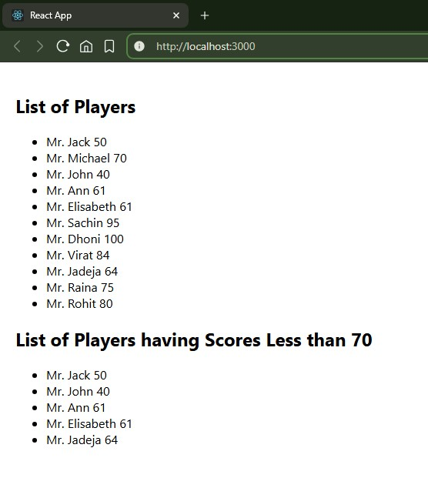

10.ReactHOL

App.js
import React from 'react';
import OfficeCard from './OfficeCard';
import offices from './Offices';

function App() {
const headingStyle = {
color: 'darkblue',
textAlign: 'center',
paddingTop: '20px'
};

return (
// Insert your component's return statement here
);
}
App.test-3.js
import { render, screen } from '@testing-library/react';
import App from './App';

test('renders learn react link', () => {
render();
const linkElement = screen.getByText(/learn react/i);
expect(linkElement).toBeInTheDocument();
});
index-1.css
body {
margin: 0;
font-family: -apple-system, BlinkMacSystemFont, 'Segoe UI', 'Roboto', 'Oxygen',
'Ubuntu', 'Cantarell', 'Fira Sans', 'Droid Sans', 'Helvetica Neue',
sans-serif;
-webkit-font-smoothing: antialiased;
-moz-osx-font-smoothing: grayscale;
}

code {
font-family: source-code-pro, Menlo, Monaco, Consolas, 'Courier New',
monospace;
}

index-1.js
import React from 'react';
import ReactDOM from 'react-dom/client';
import './index.css';
import App from './App';
import reportWebVitals from './reportWebVitals';

const root = ReactDOM.createRoot(document.getElementById('root'));
root.render(
// Your app JSX here
);

// If you want to start measuring performance in your app, pass a function
// to log results (for example: reportWebVitals(console.log))
// or send to an analytics endpoint. Learn more: https://bit.ly/CRA-vitals

reportWebVitals();

output
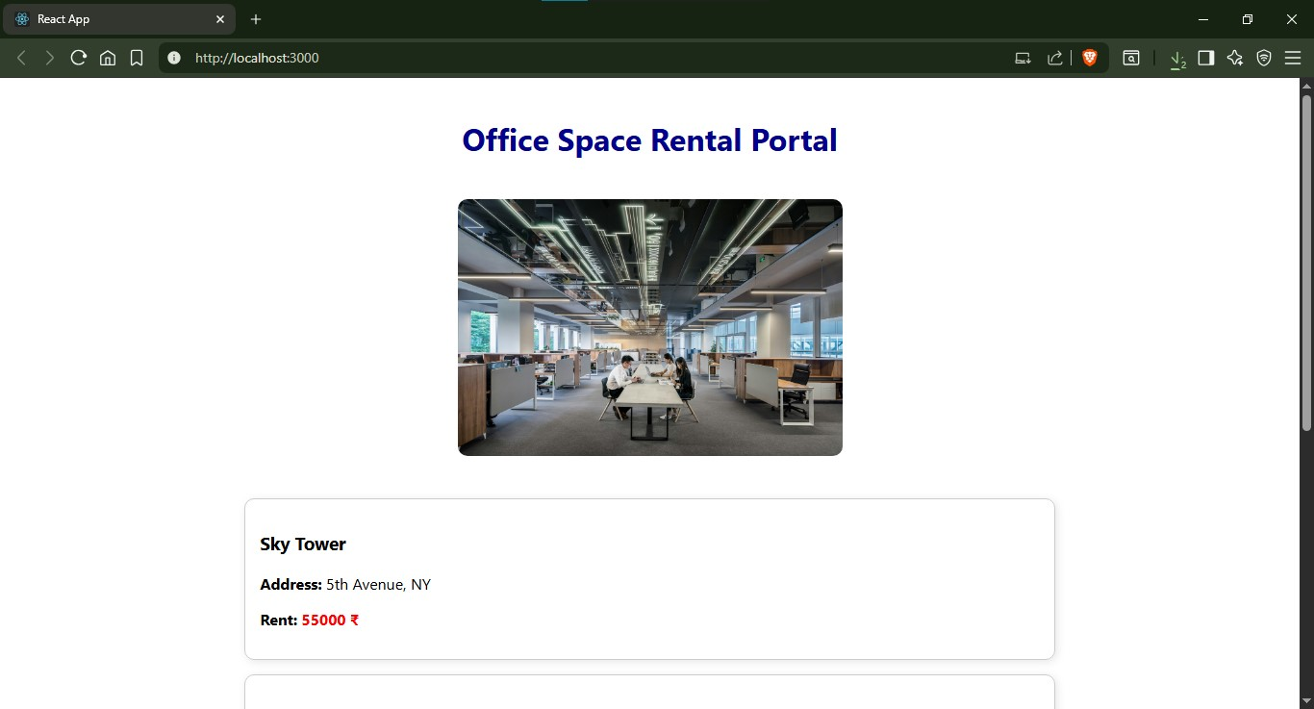

11.ReactHOL

App.js
import React from 'react';

import './App.css';

import EventExamples from './Event';

function App() {
return (
<div className="App">
<EventExamples />
</div>
);
}

export default App;
App.css
.App {
text-align: center;
}

.App-logo {
height: 40vmin;
pointer-events: none;
}

@media (prefers-reduced-motion: no-preference) {
.App-logo {
animation: App-logo-spin infinite 20s linear;
}
}

.App-header {
background-color: #282c34;
min-height: 100vh;
display: flex;
flex-direction: column;
align-items: center;
justify-content: center;
font-size: calc(10px + 2vmin);
color: white;
}

.App-link {
color: #61dafb;
}

@keyframes App-logo-spin {
from {
transform: rotate(0deg);
}
to {
transform: rotate(360deg);
}
}
App.test.js
import { render, screen } from '@testing-library/react';

import App from './App';

test('renders learn react link', () => {
render(<App />);
const linkElement = screen.getByText(/learn react/i);
expect(linkElement).toBeInTheDocument();
});

Event.js
import React, { useState } from 'react';

const EventExamples = () => {
const [counter, setCounter] = useState(0);
const [amount, setAmount] = useState('');
const [currency, setCurrency] = useState('Euro');

const increment = () => {
setCounter(counter + 1);
sayHello();
};

const decrement = () => {
setCounter(counter - 1);
};

const sayHello = () => {
alert(`Hello! This is a static message.`);
};

const sayWelcome = (message) => {
alert(message);
};

const handleClick = () => {
alert('I was clicked');
};

const handleSubmit = (e) => {
e.preventDefault();
const euroAmount = (amount * 0.011).toFixed(2);
alert(`Converting to Euro Amount: ${euroAmount}`);
};

return (
<div>
<h1>Counter: {counter}</h1>
<button onClick={increment}>Increase</button>
<button onClick={decrement}>Decrease</button>

<h2>Say Welcome</h2>
<button onClick={() => sayWelcome('Welcome to the app!')}>Say Welcome</button>

<h2>Event Click</h2>
<button onClick={handleClick}>Click Me</button>

<h2>Currency Converter</h2>
<form onSubmit={handleSubmit}>
<input
type="number"
value={amount}
onChange={(e) => setAmount(e.target.value)}
placeholder="Enter amount"
/>
<select value={currency} onChange={(e) => setCurrency(e.target.value)}>
<option>Euro</option>
<option>USD</option>
<option>INR</option>
</select>
<button type="submit">Convert</button>
</form>
</div>
);
};

export default EventExamples;

output
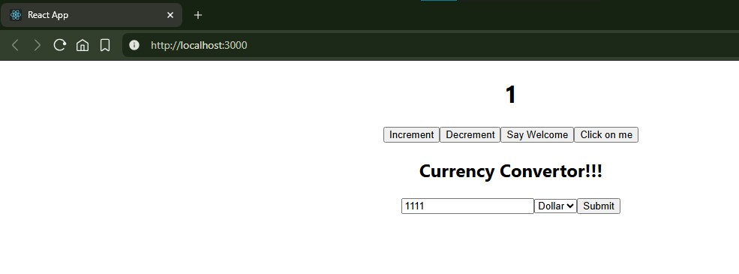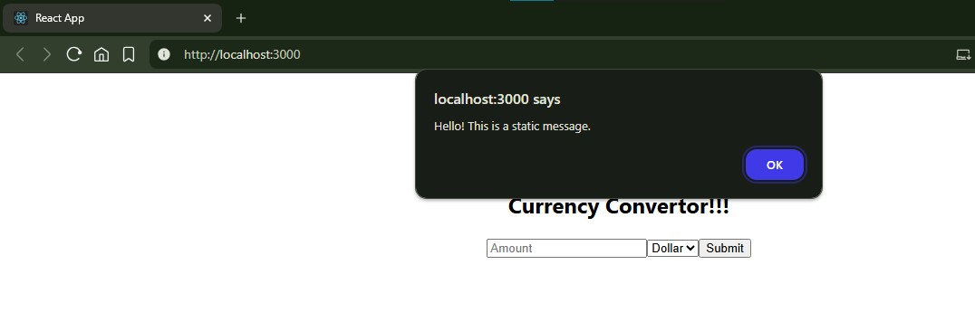

12.ReactHOL

App-1.js
import React, { useState } from 'react';
import { BrowserRouter as Router, Route, Routes } from 'react-router-dom';
import GuestPage from './GuestPage';
import UserPage from './UserPage';

const App = () => {
const [isLoggedIn, setIsLoggedIn] = useState(false);

const handleLogin = () => {
setIsLoggedIn(true);
};

const handleLogout = () => {
setIsLoggedIn(false);
};

return (
<Router>
<Routes>
{!isLoggedIn ? (
<Route path="/" element={<GuestPage onLogin={handleLogin} />} />
) : (
<Route path="/" element={<UserPage onLogout={handleLogout} />} />
)}
</Routes>
</Router>
);
};

export default App;

App-2.css
.App {
text-align: center;
}

.App-logo {
height: 40vmin;
pointer-events: none;
}

@media (prefers-reduced-motion: no-preference) {
.App-logo {
animation: App-logo-spin infinite 20s linear;
}
}

.App-header {
background-color: #282c34;
min-height: 100vh;
display: flex;
flex-direction: column;
align-items: center;
justify-content: center;
font-size: calc(10px + 2vmin);
color: white;
}

.App-link {
color: #61dafb;
}

@keyframes App-logo-spin {
from {
transform: rotate(0deg);
}
to {
transform: rotate(360deg);
}
}

App.test-3.js
import { render, screen } from '@testing-library/react';
import App from './App';

test('renders learn react link', () => {
render(<App />);
const linkElement = screen.getByText(/learn react/i);
expect(linkElement).toBeInTheDocument();
});
Index-1.css
body {
margin: 0;
font-family: -apple-system, BlinkMacSystemFont, 'Segoe UI', 'Roboto', 'Oxygen',
'Ubuntu', 'Cantarell', 'Fira Sans', 'Droid Sans', 'Helvetica Neue',
sans-serif;
-webkit-font-smoothing: antialiased;
-moz-osx-font-smoothing: grayscale;
}

code {
font-family: source-code-pro, Menlo, Monaco, Consolas, 'Courier New',
monospace;
}

OUTPUT
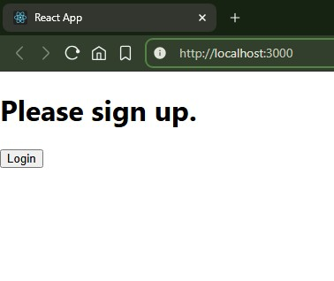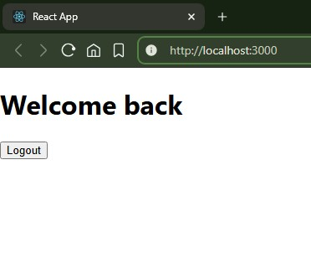

13.ReactHOL

App-1.js
import React from 'react';
import BookDetails from './BookDetails';
import BlogDetails from './BlogDetails';
import CourseDetails from './CourseDetail';

const App = () => {
const books = [
{ id: 1, name: 'Master React', price: '670' },
{ id: 2, name: 'Deep Dive into Angular 11', price: '800' },
{ id: 3, name: 'Mongo Essentials', price: '450' },
];
const blogs = [
{ id: 1, title: 'React Learning', author: 'Stephen Biz' },
{ id: 2, title: 'Welcome to learning React!', author: 'Schwedenier' },
];
const courses = [
{ id: 1, name: 'Angular', date: '4/5/2021' },
{ id: 2, name: 'React', date: '3/6/2021' },
];
return (
// The rendering code is cut off in your file
);
}
App-2.css
.App {
text-align: center;
}

.App-logo {
height: 40vmin;
pointer-events: none;
}

@media (prefers-reduced-motion: no-preference) {
.App-logo {
animation: App-logo-spin infinite 20s linear;
}
}

.App-header {
background-color: #282c34;
min-height: 100vh;
display: flex;
flex-direction: column;
align-items: center;
justify-content: center;
font-size: calc(10px + 2vmin);
color: white;
}

.App-link {
color: #61dafb;
}

@keyframes App-logo-spin {
from {
transform: rotate(0deg);
}
to {
transform: rotate(360deg);
}
}
App.test-3.js
import { render, screen } from '@testing-library/react';
import App from './App';

test('renders learn react link', () => {
render();
const linkElement = screen.getByText(/learn react/i);
expect(linkElement).toBeInTheDocument();
});
BlogDetails.js
import React from 'react';

const BlogDetails = ({ blogs }) => {
return (
// Code cut off. Should map blogs and display details.
// Example:
// blogs.length > 0 ? blogs.map(blog => (
// <div key={blog.id}>{blog.author}</div>
// )) : "No blogs available."
);
}
OUTPUT
