WEEK 6 REACT
1. ReactJS-HOL
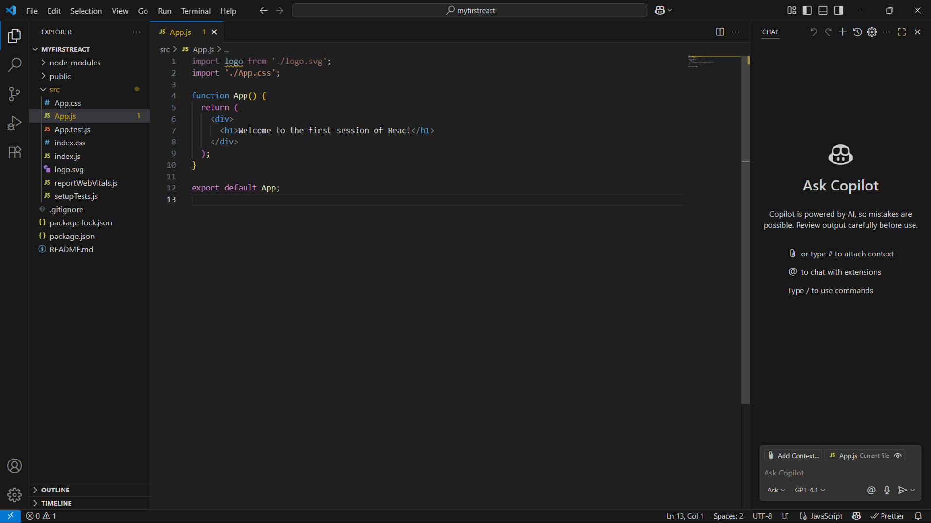
Code:

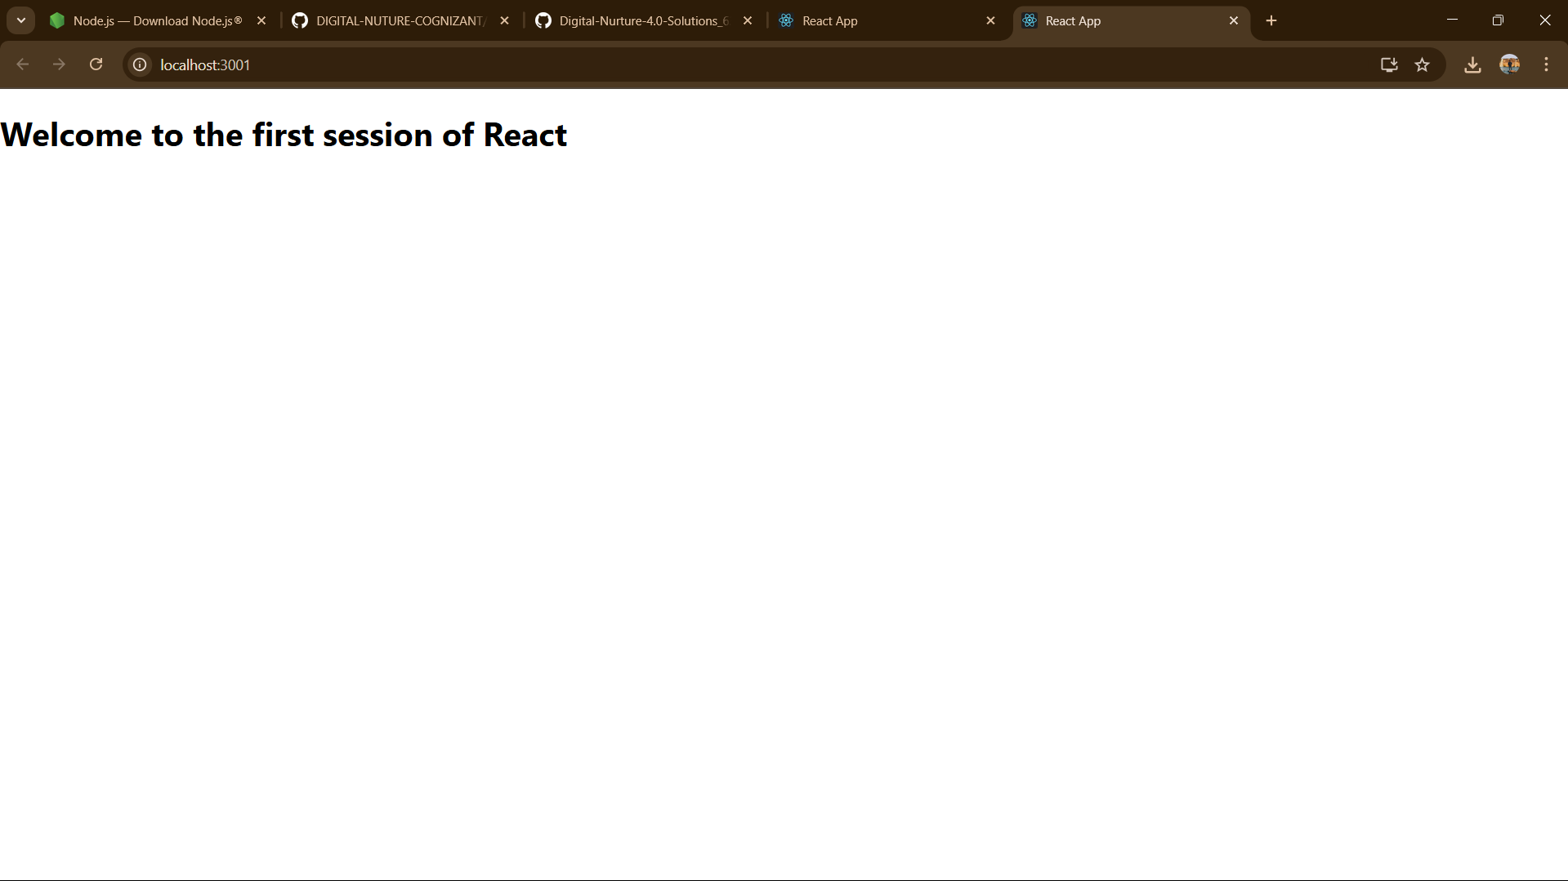
OUTPUT:

2. ReactJS-HOL

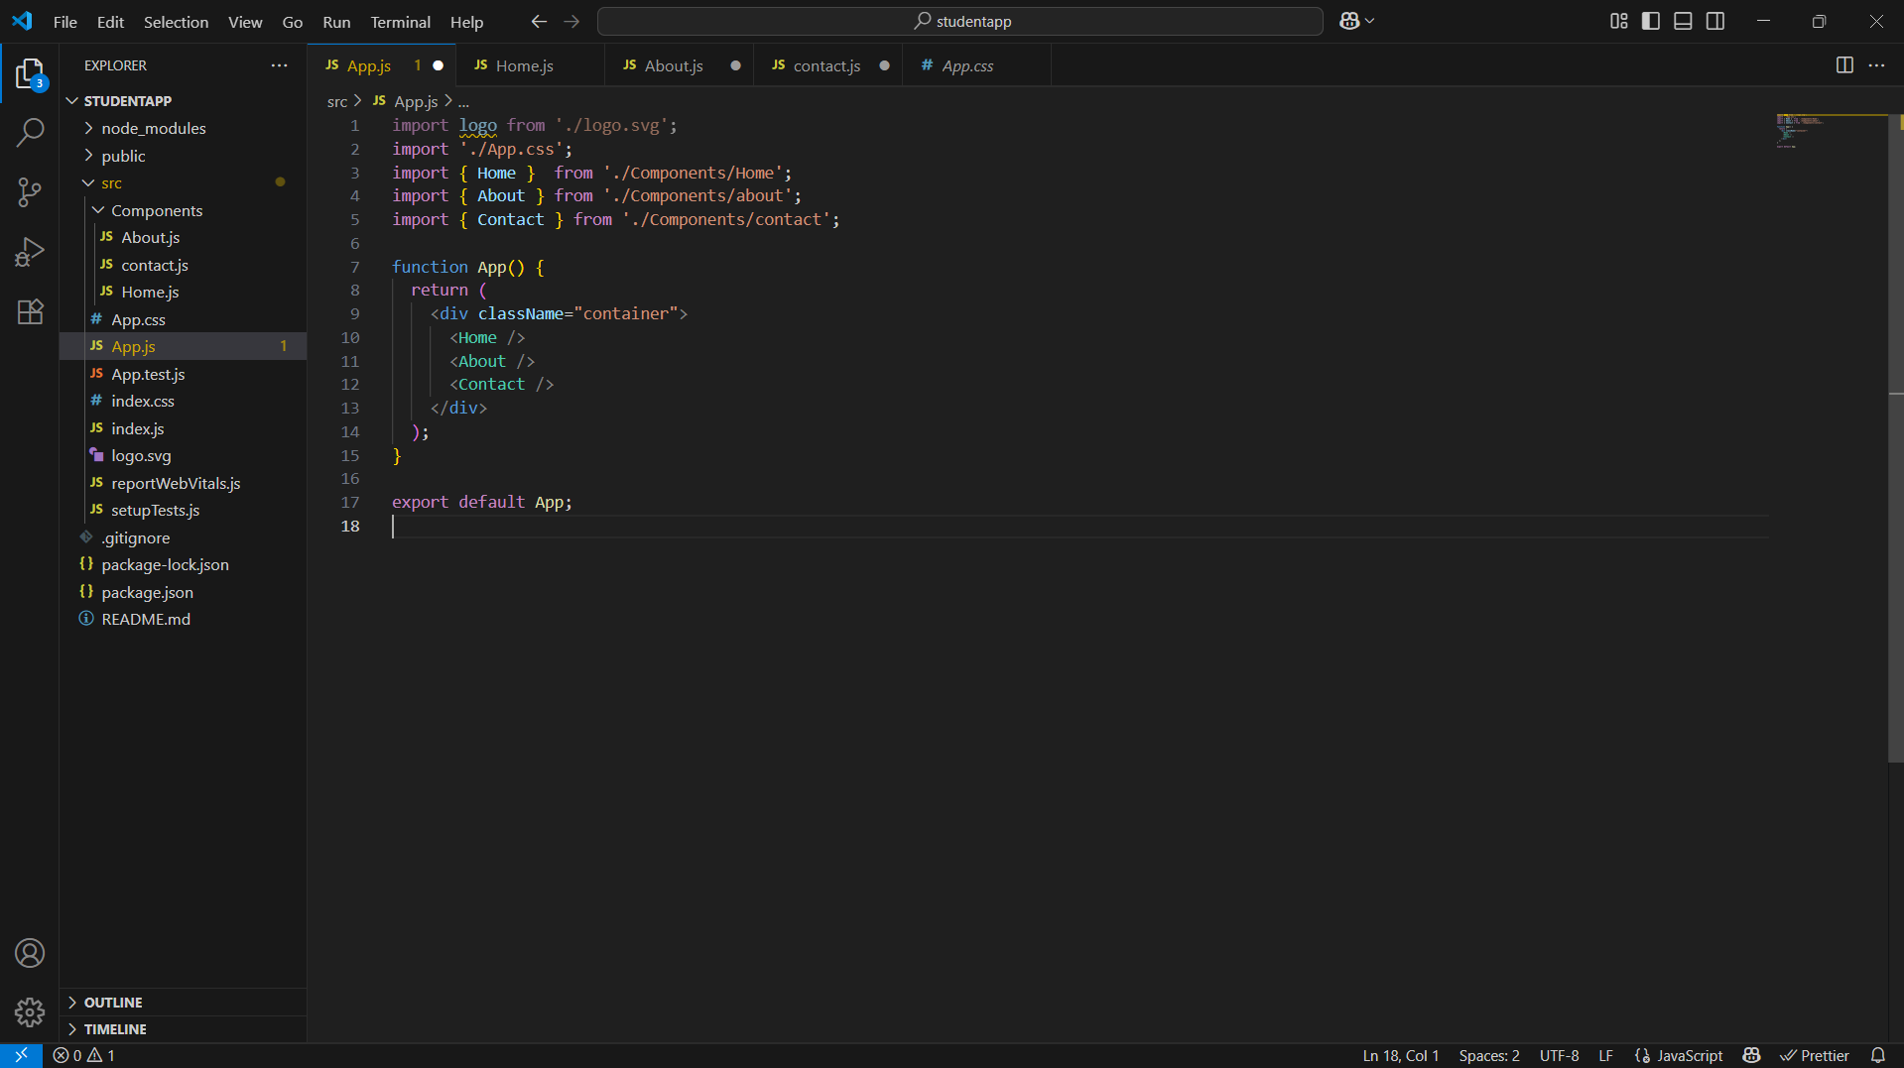
App.js code

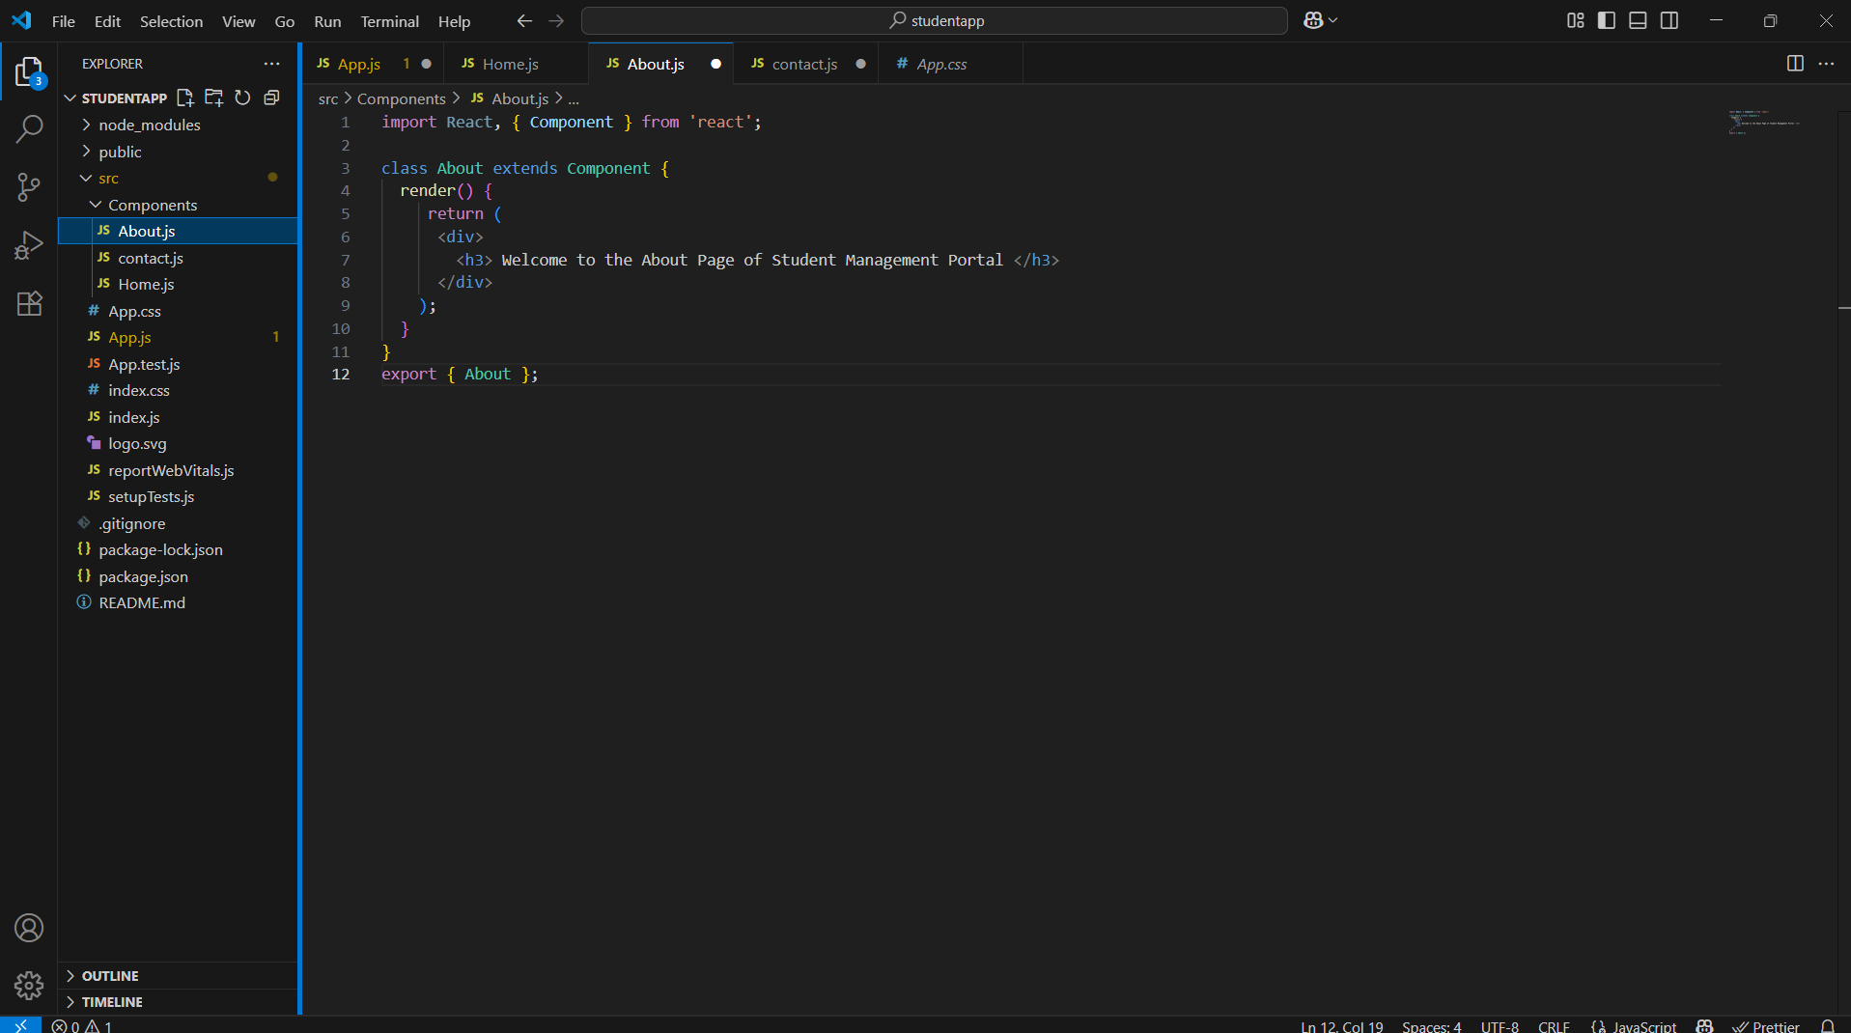
ABout.js

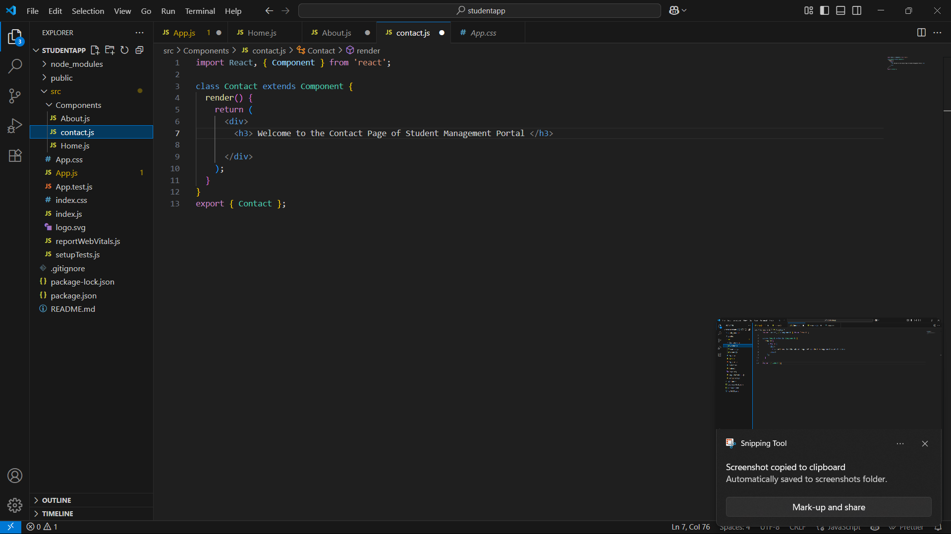
Contact.js

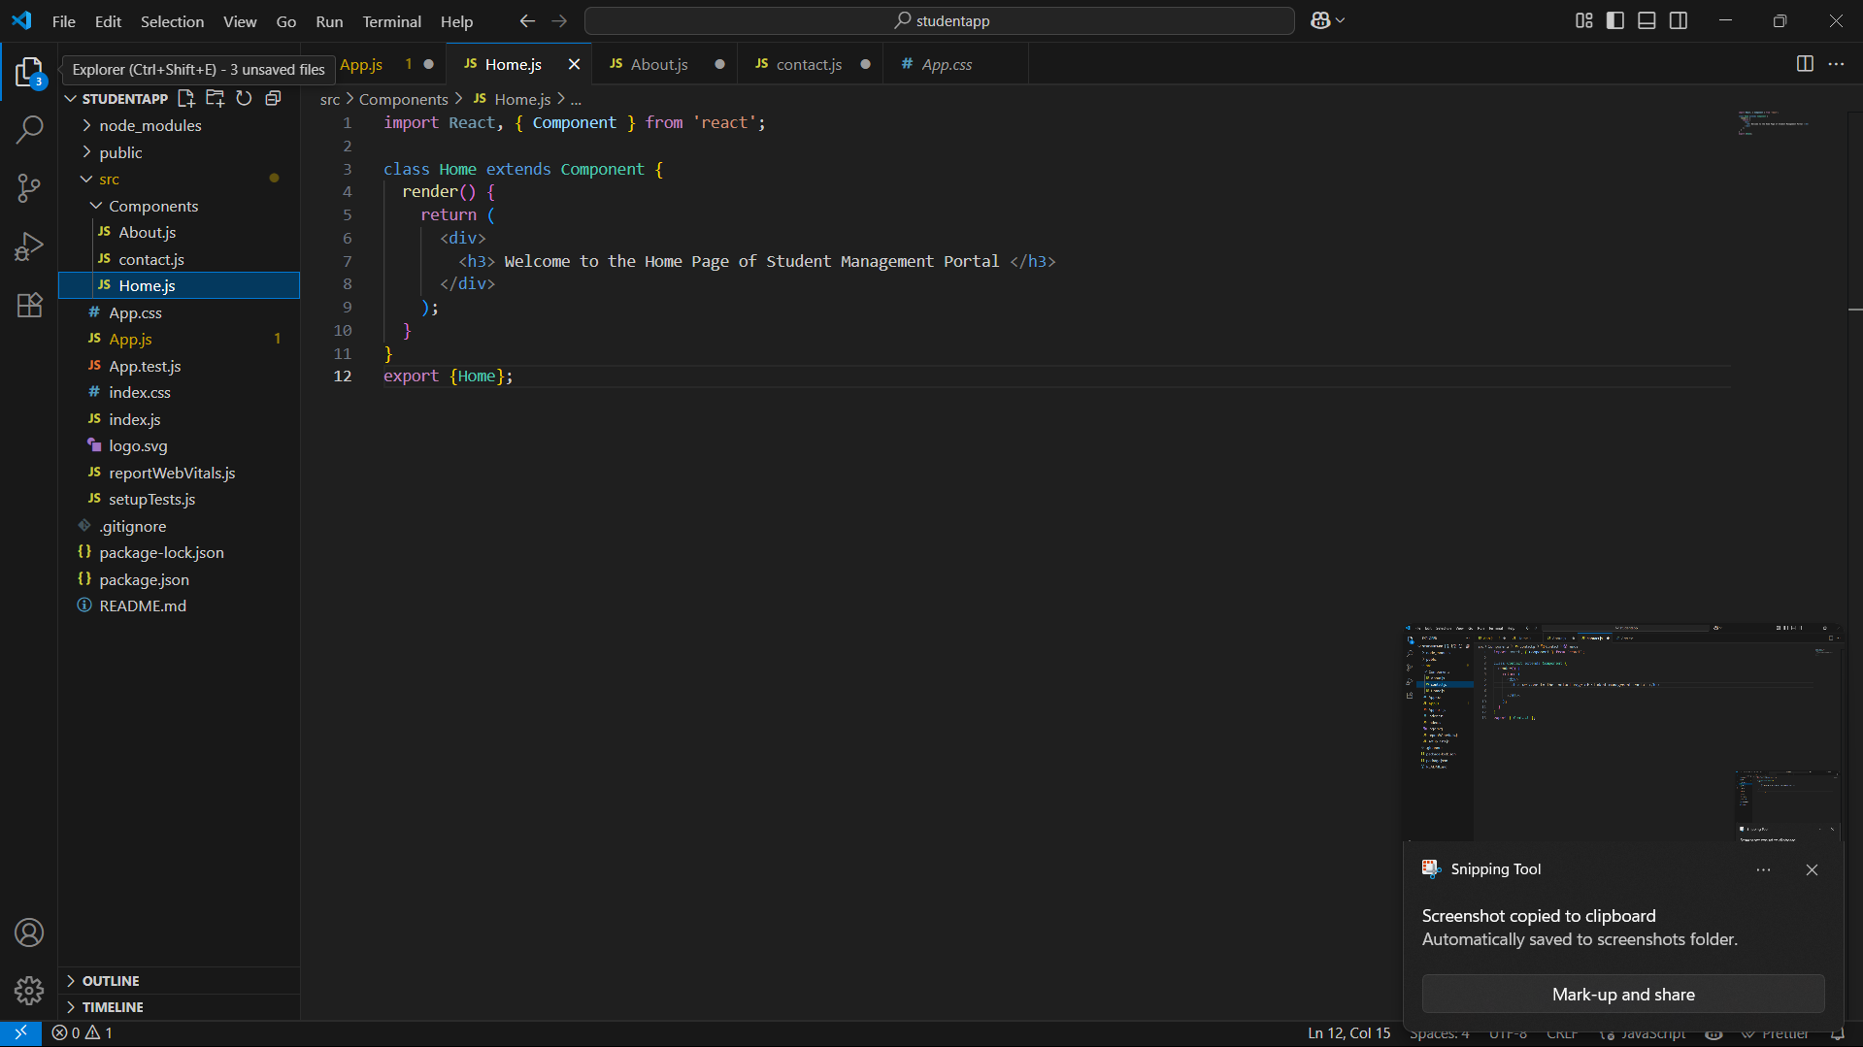
Home.js

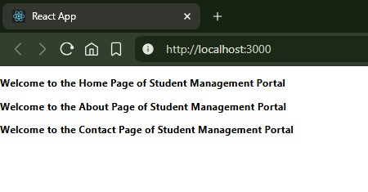
Output

3. ReactJS-HOL
calculatorScore.js
import '../Stylesheets/mystyle.css'

const percentToDecimal = (decimal)=>{
return(decimal.toFixed(2)+'%')
}

const calcScore = (total,goal)=>{
return percentToDecimal(total/goal)
}

const CalculateScore = ({Name, School, Total, goal}) => {
return(
<div className="formatstyle">
<h1><font color="Brown">Student Details:</font></h1>
<div className="Name">
<b><span>Name: </span></b>
<span>{Name}</span>
</div>
<div className="School">
<b><span>School: </span></b>
<span>{School}</span>
</div>
<div className="Total">
<b><span>Total: </span></b>
<span>{Total}</span>
<span>Marks</span>
</div>
<div className="Score">
<b>Score:</b>
<span>
{calcScore(Total, goal)}
</span>
</div>
</div>
);
}

export {CalculateScore};

Mystyle.css
.Name
{
font-weight:300;
color:blue;
}
.School
{
color:crimson;
}
.Total
{
color:darkmagenta;
}
.formatstyle
{
text-align:center;
font-size:large;
}
.Score
{
color:forestgreen;
}

APP.js
import {CalculateScore} from '../src/Components/CalculateScore';
import './App.css';

function App() {
return (
<div>
<CalculateScore Name={"Steeve"}
School={"DNV Public School"}
Total={284}
goal={3}
/>
</div>
);
}

export default App;
output

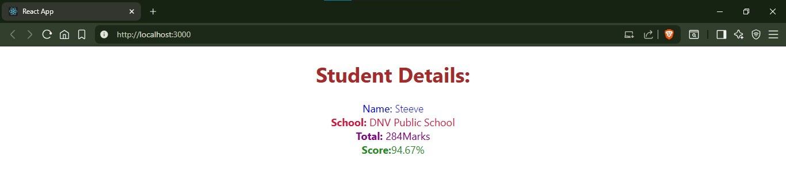
4. ReactJS-HOL
App.cs
.App {
text-align: center;
}

.App-logo {
height: 40vmin;
pointer-events: none;
}

@media (prefers-reduced-motion: no-preference) {
.App-logo {
animation: App-logo-spin infinite 20s linear;
}
}

.App-header {
background-color: #282c34;
min-height: 100vh;
display: flex;
flex-direction: column;
align-items: center;
justify-content: center;
font-size: calc(10px + 2vmin);
color: white;
}

.App-link {
color: #61dafb;
}

@keyframes App-logo-spin {
from {
transform: rotate(0deg);
}
to {
transform: rotate(360deg);
}
}
App.js
import Posts from './Posts';
import React from 'react';
import './App.css';

function App() {
return (
<div className="App"><Posts/></div>);
}

export default App;

POST.js
import React from 'react';

class Post extends React.Component {
render() {
const { id, title, body } = this.props;

return (
<div className="post">
<h3>Post #{id}</h3>
<h2>{title}</h2>
<p>{body}</p>
</div>
);
}
}

export default Post;

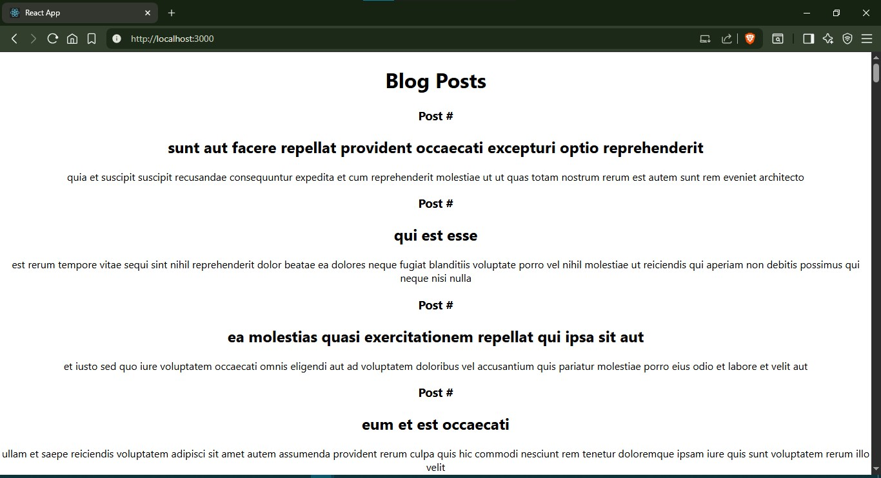
output

5. ReactJS-HOL

COHORT.JS
class Cohort {
constructor(cohortCode,
startDate,
technology,
trainerName,
coachName,
currentStatus) {
this.cohortCode = cohortCode;
this.coachName = coachName;
this.trainerName = trainerName;
this.technology = technology;
this.startDate = startDate;
this.currentStatus = currentStatus;
}
}
const CohortsData =[
new Cohort('INTADMDF10','22-Feb-2022', '.NET FSD', 'Jojo Jose','Aathma', 'Scheduled'),
new Cohort('ADM21JF014','10-Sep-2021', 'Java FSD', 'Elisa Smith','Apoorv', 'Ongoing'),
new Cohort('CDBJF21025','24-Dec-2021', 'Java FSD', 'John Doe','Aathma', 'Ongoing'),
new Cohort('INTADMJF12','22-Feb-2022', 'Java FSD', 'To Be Assigned','Ibrahim', 'Scheduled'),
new Cohort('CDE22JF011','24-Dec-2021', 'Java FSD', 'Emma Swan','Apoorv', 'Ongoing'),
new Cohort('INTADMDF09','22-Feb-2022', 'Dataware Housing', 'Babjee Rao','Aathma', 'Scheduled'),
new Cohort('ADM22DF001','10-Sep-2021', '.NET FSD', 'Marie Curie','Ibrahim', 'Ongoing'),
];
export {Cohort, CohortsData};

CohortDetails.js
import React from 'react';
import styles from './CohortDetails.module.css';

function CohortDetails({ cohort }) {
const statusStyle = {
color: cohort.currentStatus.toLowerCase() === 'ongoing' ? 'green' : 'blue'
};

return (
<div className={styles.box}>
<h3 style={statusStyle}>
{cohort.cohortCode} - {cohort.technology}
</h3>
<dl>
<dt>Started On</dt>
<dd>{cohort.startDate}</dd>
<dt>Current Status</dt>
<dd>{cohort.currentStatus}</dd>
<dt>Coach</dt>
<dd>{cohort.coachName}</dd>
<dt>Trainer</dt>
<dd>{cohort.trainerName}</dd>
</dl>
</div>
);
}

export default CohortDetails;
APP.JS

import React from 'react';
import './App.css';
import styles from './CohortDetails.module.css';
import { CohortsData } from './Cohort'
import CohortDetails from './CohortDetails';

function App() {

return (
<div className={styles.container}>
<h2>Cohorts Details</h2>
<div className={styles['cards-wrapper']}>
{CohortsData.map((cohort, index) => (
<CohortDetails key={index} cohort={cohort} />
))}
</div>
</div>
);
}

export default App;

OUTPUT
