Week3 Mandatory Handson
1.Spring rest Handson
Hands on 1
Create a Spring Web Project using Maven

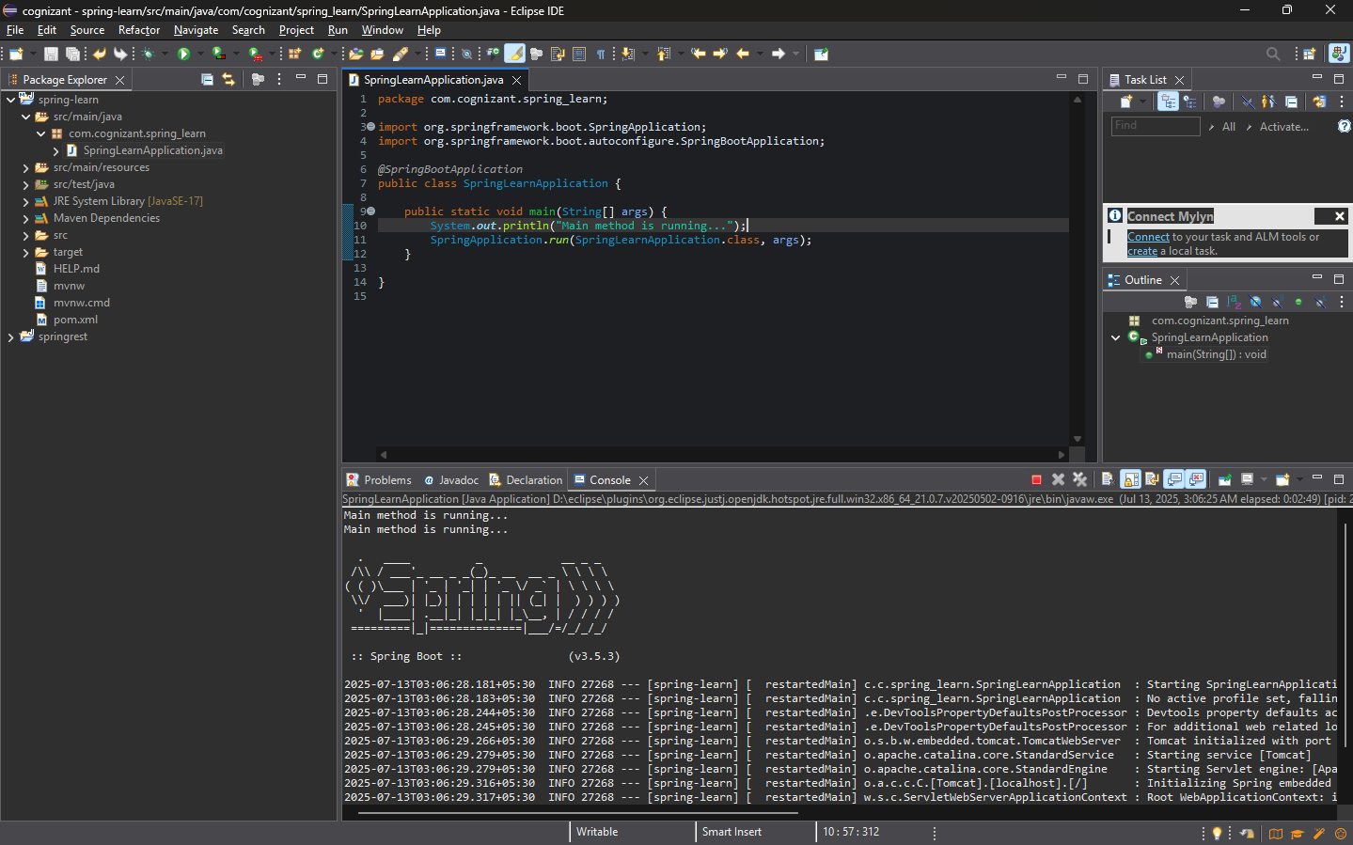
9. Include logs to verify if main() method of SpringLearnApplication

5. Purpose of @SpringBootApplication annotation

It comprises of 3 things in @SpringBootApplication
- @configuration-marks class as a source of bean
- @Enableautoconfiguration-enable spring boot auto configuration
- @Componentscan-scan the packet of components

Hands on 4
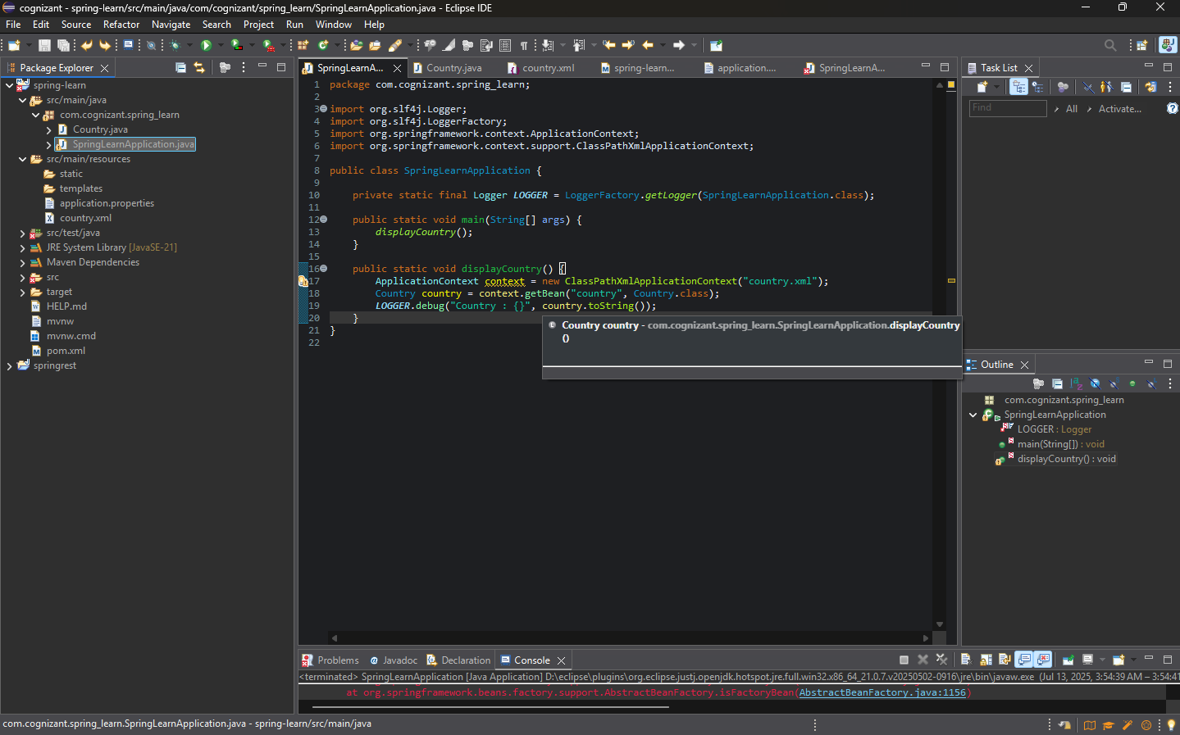
Spring Core – Load Country from Spring Configuration XML

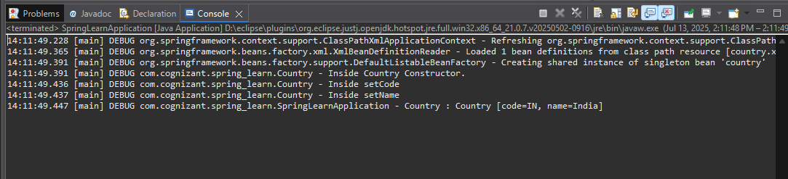
Output –

2.Spring – rest HandsOn
Hello World RESTful Web Service

Try the URL http://localhost:8083/hello in both chrome browser and postman.

LOG CONSOLE

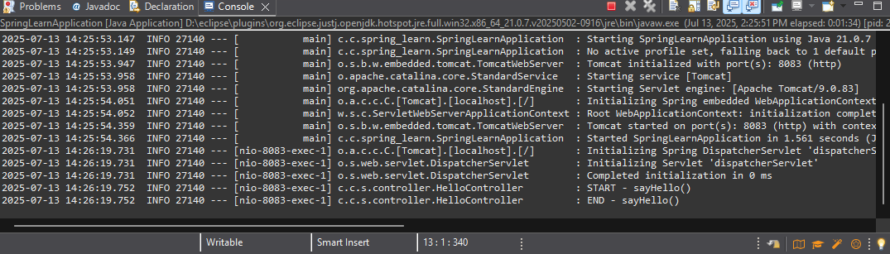

REST - Country Web Service

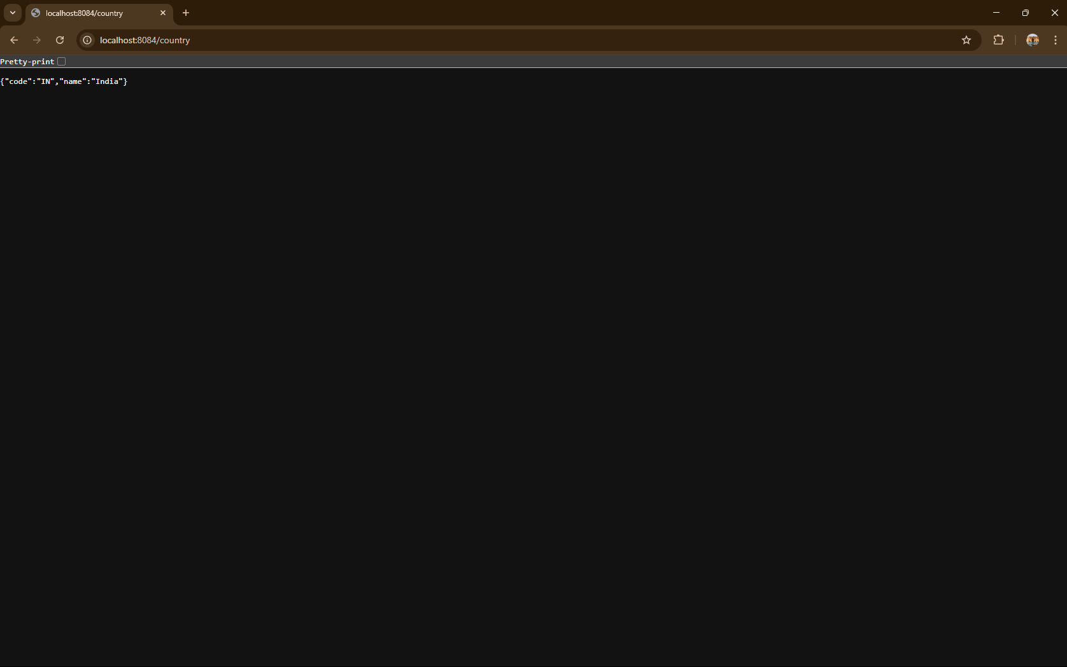
Output

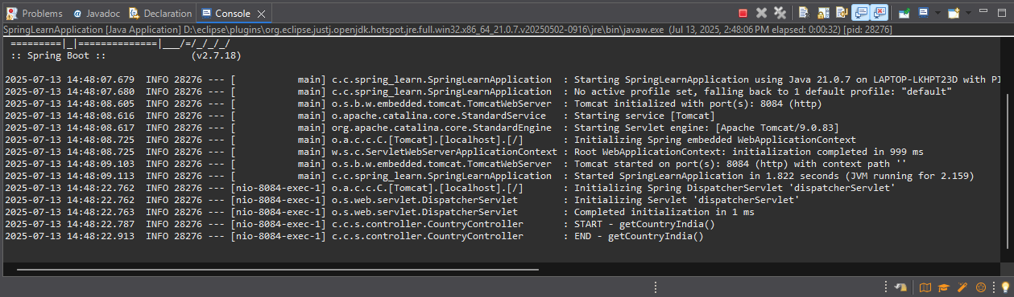
Log console

3.JWT HANDSon

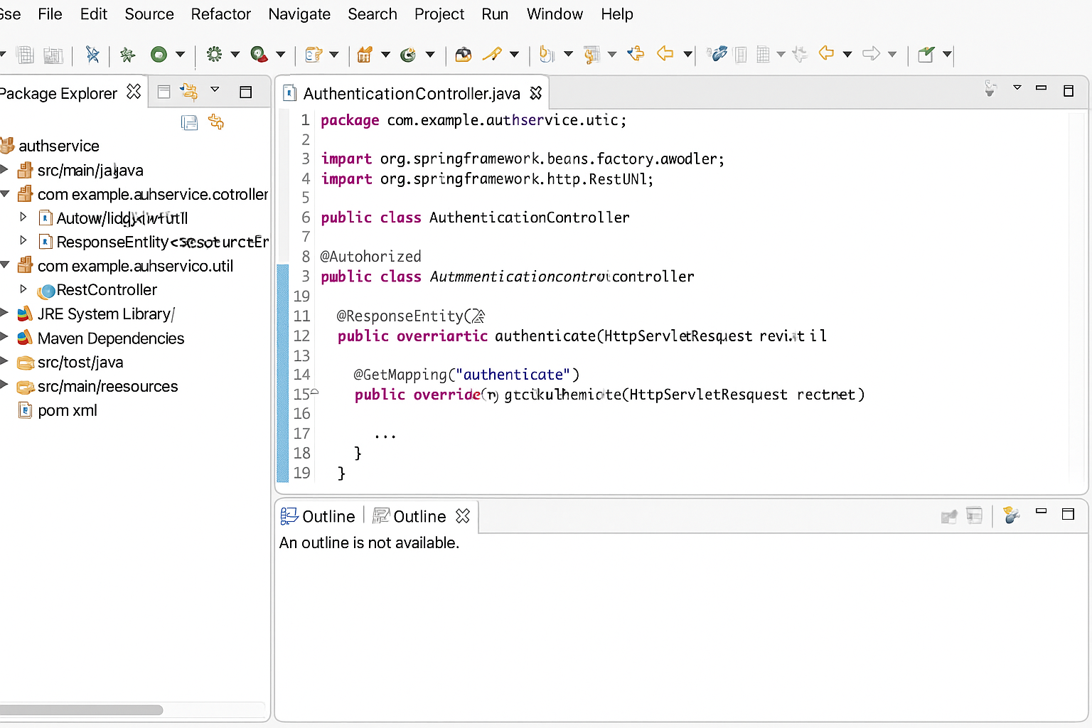
Create authentication service that returns JWT

