Exercise 1: Configuring a Basic Spring Application

ApplicationContext.xml
<?xml version="1.0" encoding="UTF-8"?>
<beans xmlns="http://www.springframework.org/schema/beans"
xmlns:xsi="http://www.w3.org/2001/XMLSchema-instance"
xsi:schemaLocation="
http://www.springframework.org/schema/beans
https://www.springframework.org/schema/beans/spring-beans.xsd">

<bean id="bookRepository" class="com.library.repository.BookRepository"/>
<bean id="bookService" class="com.library.service.BookService">
<property name="bookRepository" ref="bookRepository"/>
</bean>

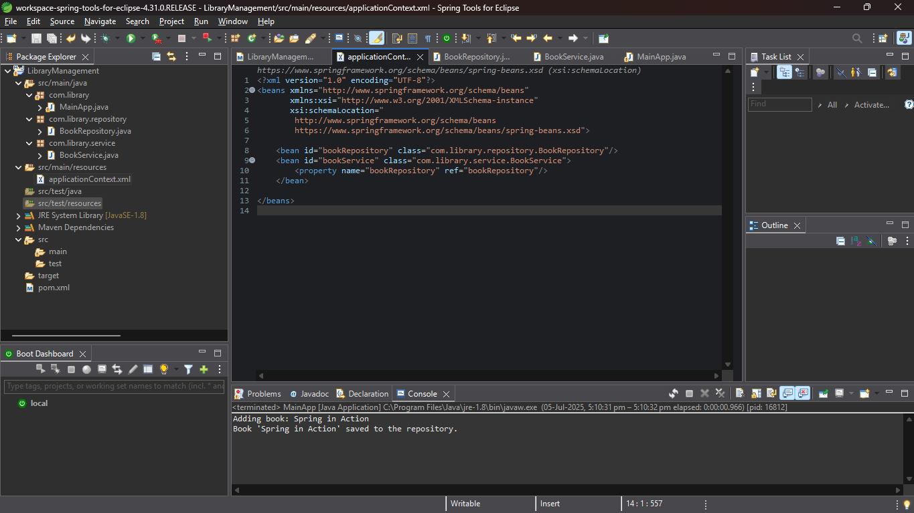
</beans>

2.
package com.library.repository;

public class BookRepository {
public void saveBook(String bookName) {
System.out.println("Book '" + bookName + "' saved to the repository.");
}
}

3.
package com.library.service;

import com.library.repository.BookRepository;

public class BookService {
private BookRepository bookRepository;

// Setter for dependency injection
public void setBookRepository(BookRepository bookRepository) {
this.bookRepository = bookRepository;
}

public void addBook(String bookName) {
System.out.println("Adding book: " + bookName);
bookRepository.saveBook(bookName);
}
}

4.Main
package com.library;

import org.springframework.context.ApplicationContext;
import org.springframework.context.support.ClassPathXmlApplicationContext;
import com.library.service.BookService;

public class MainApp {
public static void main(String[] args) {
ApplicationContext context = new ClassPathXmlApplicationContext("applicationContext.xml");

BookService bookService = (BookService) context.getBean("bookService");

bookService.addBook("Spring in Action");
}
}
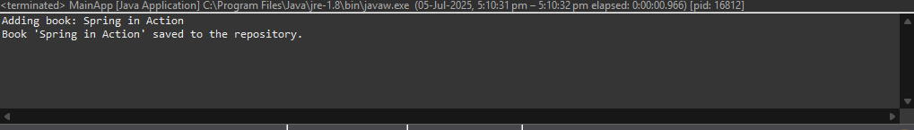

Exercise 2: Implementing Dependency Injection
- This exercise is the continuation of 1st one so in 1st exercise all are done.
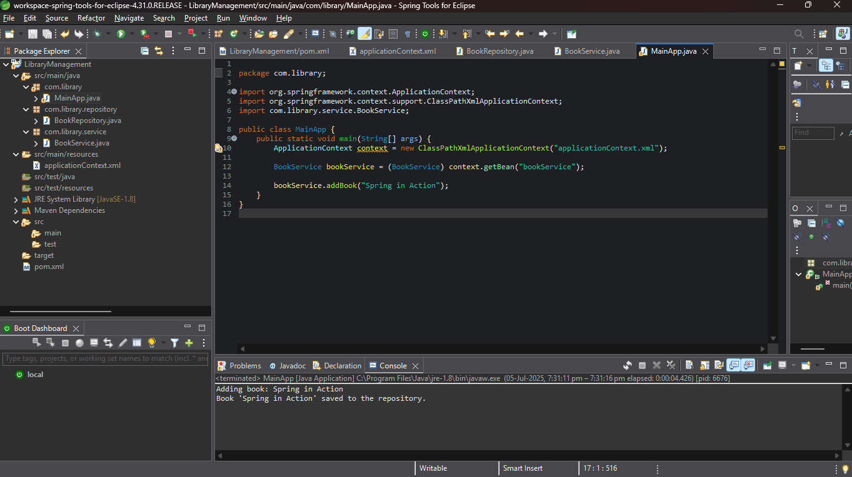
Exercise 3: Implementing Logging with Spring AOP

1.AOP DEPENDENCY

<groupId>com.library</groupId>
<artifactId>LibraryManagement-AOP</artifactId>
<version>1.0-SNAPSHOT</version>

<dependencies>
<dependency>
<groupId>org.springframework</groupId>
<artifactId>spring-context</artifactId>
<version>5.3.30</version>
</dependency>

<dependency>
<groupId>org.springframework</groupId>
<artifactId>spring-aspects</artifactId>
<version>5.3.30</version>
</dependency>

2.
package com.library.aspect;

import org.aspectj.lang.ProceedingJoinPoint;
import org.aspectj.lang.annotation.Around;
import org.aspectj.lang.annotation.Aspect;

@Aspect
public class LoggingAspect {

@Around("execution(* com.library.service.*.*(..))")
public Object logExecutionTime(ProceedingJoinPoint joinPoint) throws Throwable {
long start = System.currentTimeMillis();

Object result = joinPoint.proceed(); // Proceed with method execution

long duration = System.currentTimeMillis() - start;
System.out.println("Executed method: " + joinPoint.getSignature() +
" in " + duration + "ms");

return result;
}
}

3.
<?xml version="1.0" encoding="UTF-8"?>
<beans xmlns="http://www.springframework.org/schema/beans"
xmlns:aop="http://www.springframework.org/schema/aop"
xmlns:xsi="http://www.w3.org/2001/XMLSchema-instance"
xsi:schemaLocation="
http://www.springframework.org/schema/beans
https://www.springframework.org/schema/beans/spring-beans.xsd
http://www.springframework.org/schema/aop
https://www.springframework.org/schema/aop/spring-aop.xsd">

<aop:aspectj-autoproxy/>

<bean id="bookRepository" class="com.library.repository.BookRepository"/>
<bean id="bookService" class="com.library.service.BookService">
<property name="bookRepository" ref="bookRepository"/>
</bean>
<bean id="loggingAspect" class="com.library.aspect.LoggingAspect"/>
</beans>

4.
package com.library;

import org.springframework.context.ApplicationContext;
import org.springframework.context.support.ClassPathXmlApplicationContext;
import com.library.service.BookService;

public class MainApp {
public static void main(String[] args) {
ApplicationContext context = new ClassPathXmlApplicationContext("applicationContext.xml");
BookService bookService = (BookService) context.getBean("bookService");
bookService.addBook("Clean Code");
}
}

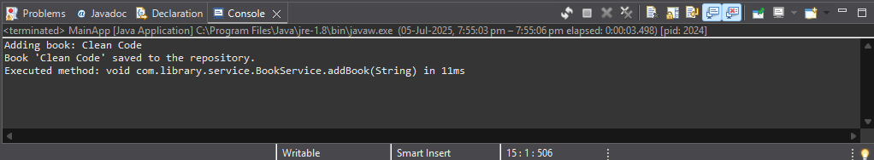
Exercise 4: Creating and Configuring a Maven Project
Updated pom xml file
<project xmlns="http://maven.apache.org/POM/4.0.0"
xmlns:xsi="http://www.w3.org/2001/XMLSchema-instance"
xsi:schemaLocation="http://maven.apache.org/POM/4.0.0
http://maven.apache.org/xsd/maven-4.0.0.xsd">

<modelVersion>4.0.0</modelVersion>

<groupId>com.library</groupId>
<artifactId>LibraryManagement</artifactId>
<version>1.0-SNAPSHOT</version>

<properties>
<maven.compiler.source>1.8</maven.compiler.source>
<maven.compiler.target>1.8</maven.compiler.target>
</properties>

<dependencies>
<!-- Spring Context (Core) -->
<dependency>
<groupId>org.springframework</groupId>
<artifactId>spring-context</artifactId>
<version>5.3.30</version>
</dependency>

<!-- Spring AOP -->
<dependency>
<groupId>org.springframework</groupId>
<artifactId>spring-aspects</artifactId>
<version>5.3.30</version>
</dependency>

<!-- AspectJ runtime (needed for AOP) -->
<dependency>
<groupId>org.aspectj</groupId>
<artifactId>aspectjweaver</artifactId>
<version>1.9.21</version>
</dependency>

<!-- Spring Web MVC (for future web integration) -->
<dependency>
<groupId>org.springframework</groupId>
<artifactId>spring-webmvc</artifactId>
<version>5.3.30</version>
</dependency>

<!-- Servlet API (optional but required for Spring WebMVC if you plan to use it) -->
<dependency>
<groupId>javax.servlet</groupId>
<artifactId>javax.servlet-api</artifactId>
<version>4.0.1</version>
<scope>provided</scope>
</dependency>
</dependencies>

<build>
<plugins>
<!-- ✅ Compiler plugin for Java 1.8 -->
<plugin>
<artifactId>maven-compiler-plugin</artifactId>
<version>3.11.0</version>
<configuration>
<source>1.8</source>
<target>1.8</target>
</configuration>
</plugin>
</plugins>
</build>

</project>

Exercise 5: Configuring the Spring IoC Container
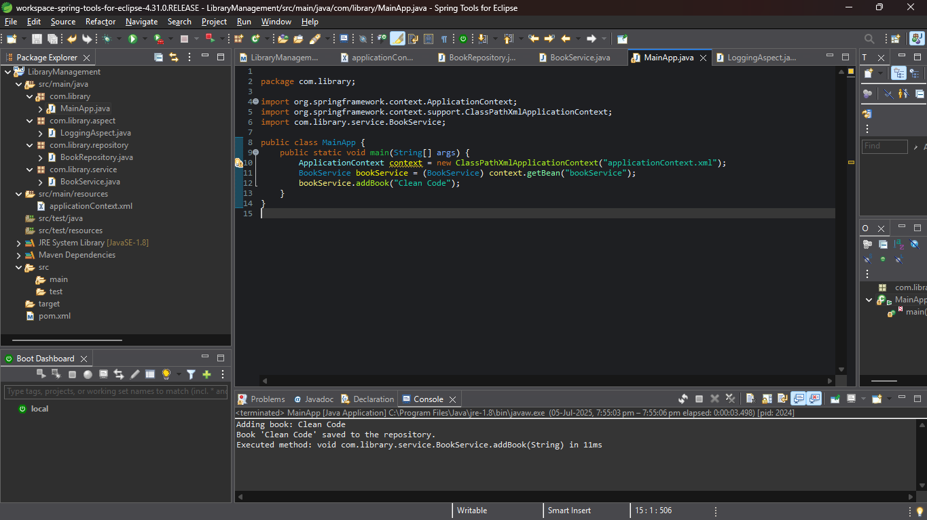
All implementation are done with proper outputs and ss.

Exercise 7: Implementing Constructor and Setter Injection

1.
<?xml version="1.0" encoding="UTF-8"?>
<beans xmlns="http://www.springframework.org/schema/beans"
xmlns:xsi="http://www.w3.org/2001/XMLSchema-instance"
xsi:schemaLocation="http://www.springframework.org/schema/beans
https://www.springframework.org/schema/beans/spring-beans.xsd">

<!-- Book Repository Bean -->
<bean id="bookRepository" class="com.library.repository.BookRepository" />

<!-- Book Service Bean with constructor and setter injection -->
<bean id="bookService" class="com.library.service.BookService">
<!-- Constructor Injection -->
<constructor-arg value="Library Book Service"/>

<!-- Setter Injection -->
<property name="bookRepository" ref="bookRepository"/>
</bean>
</beans>

4.main
package com.library;

import org.springframework.context.ApplicationContext;
import org.springframework.context.support.ClassPathXmlApplicationContext;
import com.library.service.BookService;

public class MainApp {
public static void main(String[] args) {
ApplicationContext context = new ClassPathXmlApplicationContext("applicationContext.xml");

BookService bookService = (BookService) context.getBean("bookService");
bookService.addBook("Java: The Complete Reference");
}
}
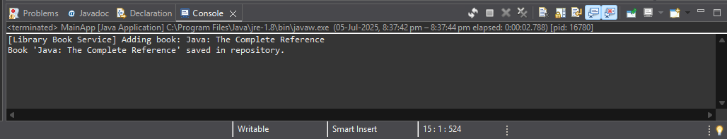

Spring Data JPA with Spring Boot, Hibernate

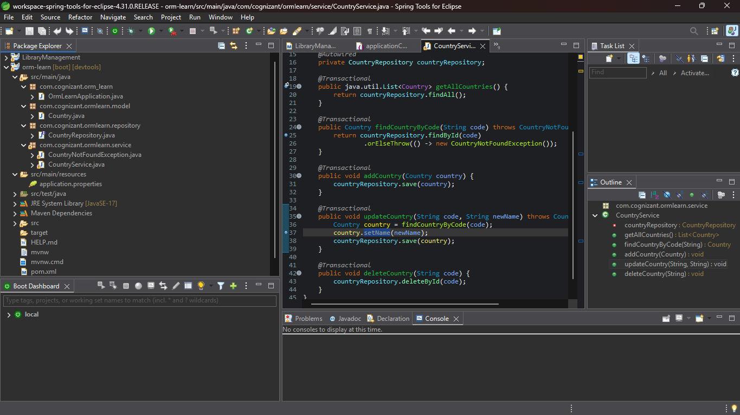
1. As per given instruction

2. Difference between JPA, Hibernate and Spring Data JPA

1. Java Persistence API (JPA)
Aspect | Description
What it is | A specification (interface) for ORM in Java.
Who defines it | Defined by Java EE (now Jakarta EE), currently JSR 338.
Purpose | Provides a standard API to persist data to relational databases.
Implementation | JPA itself has no implementation — needs a provider like Hibernate.
Key Interfaces | EntityManager, PersistenceContext, Query
Annotation Examples | @Entity, @Id, @GeneratedValue, @ManyToOne, @OneToMany
2. Hibernate
Aspect | Description
What it is | A concrete ORM framework that implements JPA.
Relation to JPA | Hibernate is the most popular JPA provider.
Extra Features | Provides features beyond JPA like caching, filters, interceptors.
Configuration | Can use XML (hibernate.cfg.xml) or annotations.
API Usage | Hibernate can be used directly (via Session, Transaction) or via JPA.
Pros | Powerful, flexible, mature ecosystem.
3. Spring Data JPA
Aspect | Description
What it is | A Spring module that provides abstraction over JPA.
Purpose | Simplifies DAO layer with automatic repository implementations.
Base Interface | JpaRepository<T, ID> — prebuilt CRUD methods.
Query Methods | Method naming convention for queries (e.g., findByName() auto-implemented)
No Boilerplate | Removes need to write EntityManager or JPQL manually.
Implementation | Uses a JPA provider (like Hibernate) under the hood.

