SQL

SQL COMMANDS

1. Data definition language(DDL)

Create, Alter, Drop, Truncate, Rename

1. Data manipulation language(DML)

Select, Insert, Update, Delete

1. Data control language

Grant, Revoke

1. Transaction control language

Commit, Rollback, Savepoint

1. Constraints

Primary key, Foreign key, Check, Unique, Default, Not Null

# SQL CREATE DATABASE Statement

CREATE DATABASE database_name;

###### SQL DROP DATABASE Statement

DROP DATABASE database_name;

###### SQL USE Statement

USE database_name;

# Create table in SQL

create table <table-name>(column1 datatype, column2 datatype, column3 datatype);

ex->

create table emp(id int , name varchar(20), salary int(10));

## To see the table structure

desc table_name;

### Insert data into table

there are two ways

INSERT INTO table_name (column1, column2, column3, ...)  
VALUES (value1, value2, value3, ...);

INSERT INTO table_name  
VALUES (value1, value2, value3, ...);

# Alter Command

* Add column/columns
* Remove column/columns
* Modify datatype
* Modify datatype length
* Add constraints
* Remove constraints
* Rename column/table

##### SQL UPDATE Statement

UPDATE table_name

#### SET column1 = value1, column2 = value2....columnN=valueN

[ WHERE CONDITION ];

##### Difference between Alter and Update in SQL

alter🡪 It is a DDL command

update🡪 It is a DML command

if we want to double the column value then

update table_name set column_name=column_name*2;

update table_name set column_name=column_name*2 where column2=column2 value ;

### Difference between Delete, Drop & Truncate in SQL

delete🡪It is a DML command

delete from table_name;

delete from table_name where column=value;

drop🡪It is a DDL command

drop table table_name

truncate🡪It is a DDL command

truncate table table_name;

what is difference between delete and truncate

the difference is that using delete command we can delete the rows conditionally but truncate deletes all the rows

### Constraints in SQL

i)Unique

ii) Not Null

iii) primary key

iv) check

check (age>10);

v) Foreign key

vi) default

salary int default 10000;

Subqueries🡪Refer to sql files mentioned in the resources

### Correlated subquery(Synchronized query)

->It is a subquery that uses values from outer query

->Top to down approach

Difference between nested subquery, correlated subquery and Joins

#### Nested subquery🡪Bottom up

correlated subquery🡪top down approach

#### Joins🡪cross product+condition

### Find Nth Highest salary using SQL

#### If we are taking example of employee table

select id,salary from emp e1 where N-1=(select count(distinct salary) from em p e2 where e2.salary=e1.salary);

Resources

Tables

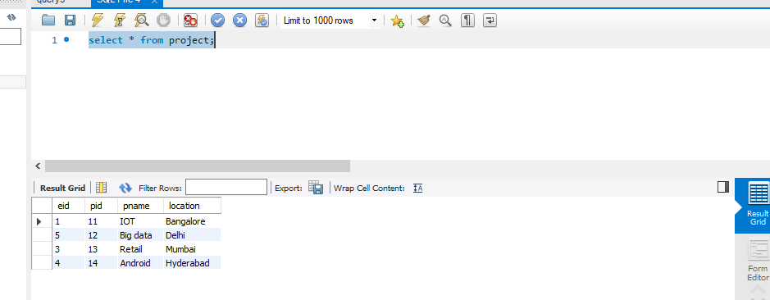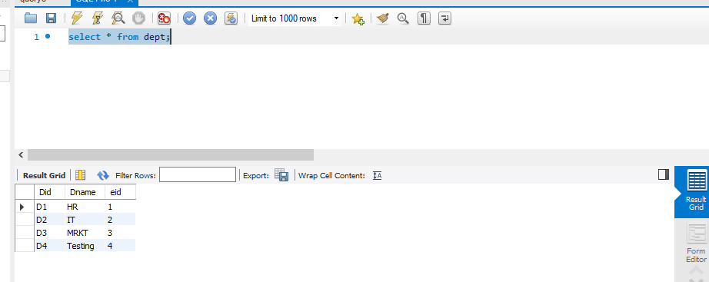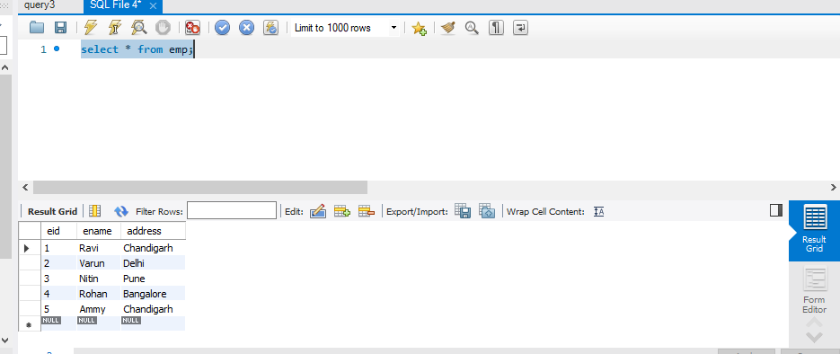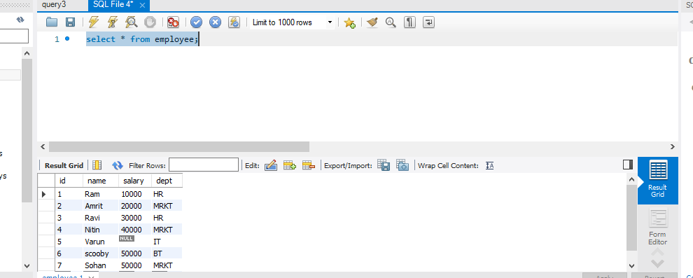

# Used Queries

