E-COMMERCE SALES
& PROFITABILITY REPORT
A data-driven analysis of sales trends, product performance, and customer segment profitability

Prepared for Stakeholder Review
July 5, 2026

Executive Summary
This report analyzes e-commerce performance across time, product categories, subcategories, and customer segments to surface the key drivers of sales and profit. The analysis reveals a timing gap between peak sales and peak profit, a clear category leader, and one customer segment that outperforms all others on every measure that matters.
Key Highlights
- Sales peak in November, but profit peaks in December — indicating a lag between holiday purchasing and profit realization.
- Technology is the leading category in both sales and profit, driven primarily by the Phones subcategory.
- Furniture generates solid sales but the lowest profit of any category, pointing to margin pressure that warrants review.
- Office Supplies and the Envelopes subcategory are the weakest performers by sales and may benefit from bundling or repositioning.
- The Consumer segment leads on every metric — highest total sales, highest total profit, and the most efficient sales-to-profit ratio — making it the top priority for retention and growth investment.

Detailed Analysis

Q1. What are the monthly sales trends, and which months recorded the highest and lowest sales?
Guidelines
Aggregated total sales for each month and plotted a line chart to identify the months with the highest and lowest sales.
Visualization
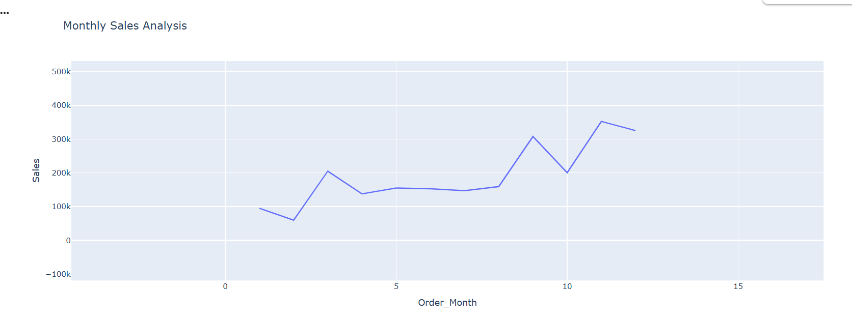
Observation
November recorded the highest monthly sales, while February recorded the lowest.
Business Insight
Sales peak sharply in November, likely driven by holiday-season shopping such as Black Friday and Cyber Monday, while February marks the seasonal low point — an opportunity for targeted promotions during slower months.

Q2. How do sales vary across product categories, and which categories generate the highest and lowest sales?
Guidelines
Calculated total sales for each product category and plotted a pie chart to visualize each category's contribution to overall sales.
Visualization
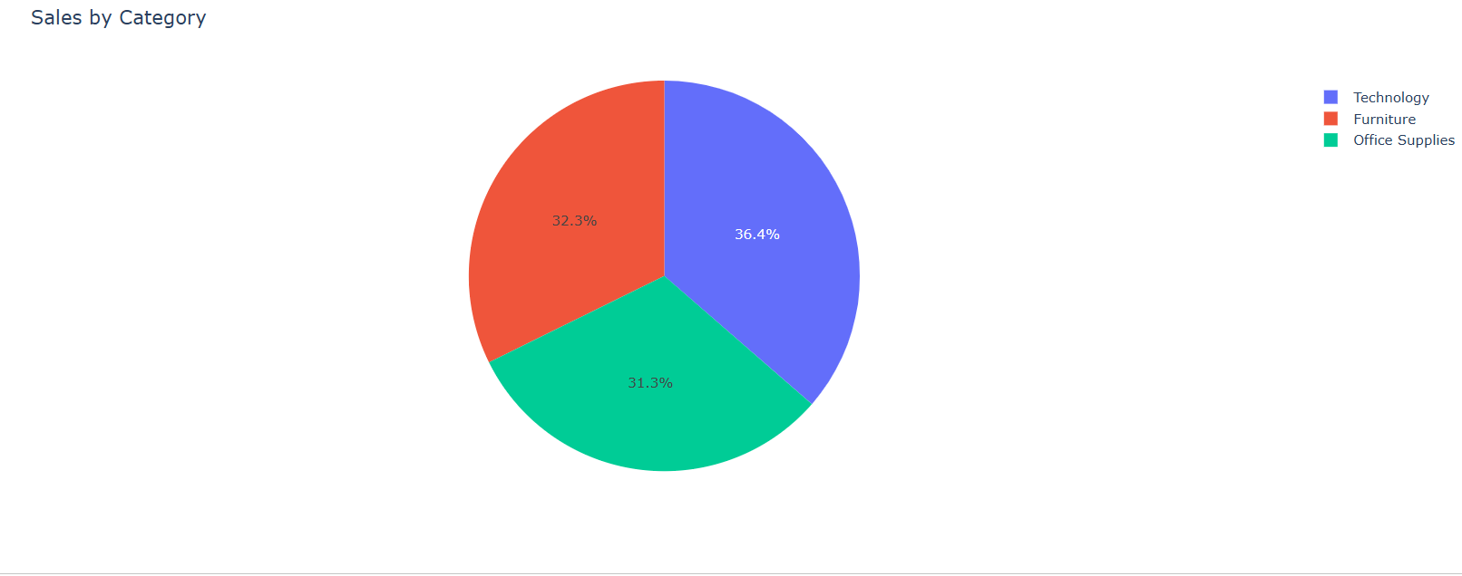
Observation
The Technology category generated the highest sales, while Office Supplies generated the lowest.
Business Insight
Technology products are the primary sales driver and merit continued investment, while Office Supplies may benefit from bundling or promotional strategies to boost demand.

Q3. How do sales vary across product subcategories?
Guidelines
Calculated total sales for each subcategory and plotted a bar chart to compare performance across all subcategories.
Visualization
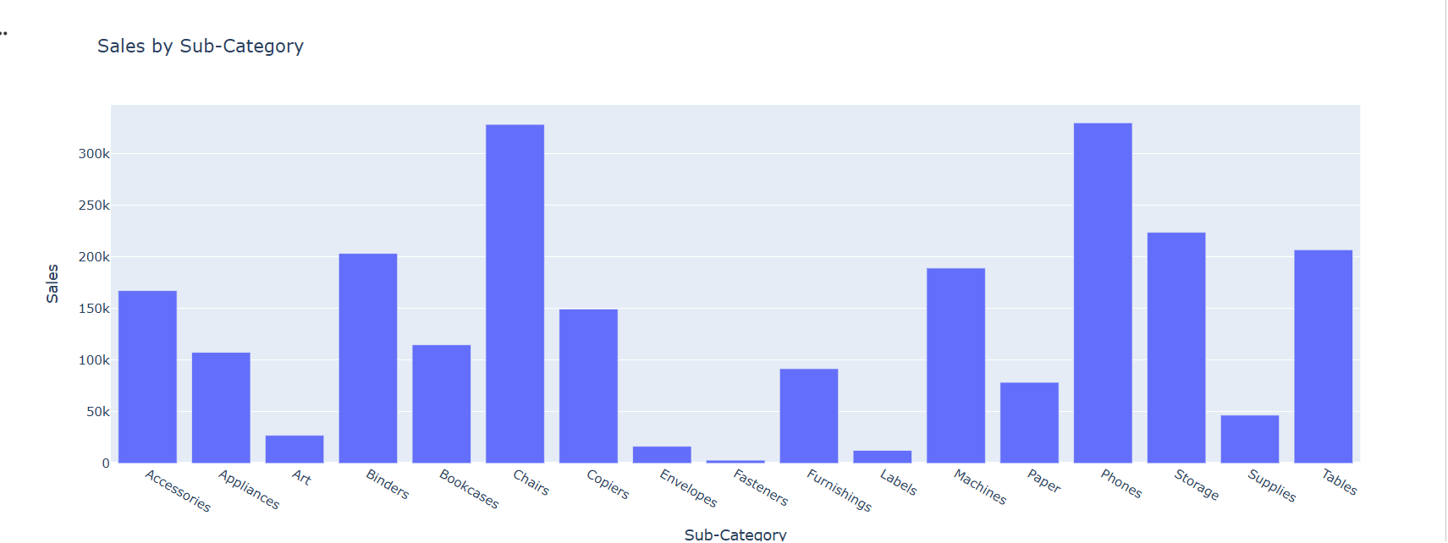
Observation
The Phones subcategory recorded the highest total sales, while Envelopes recorded the lowest.
Business Insight
Phones are the strongest-performing subcategory and a key revenue contributor within Technology, while consistently low performers such as Envelopes warrant a review of pricing, placement, or continued stocking.

Q4. What is the monthly profit trend, and which months generated the highest and lowest profit?
Guidelines
Calculated total profit for each month and plotted a line chart to identify the months with the highest and lowest profit.
Visualization
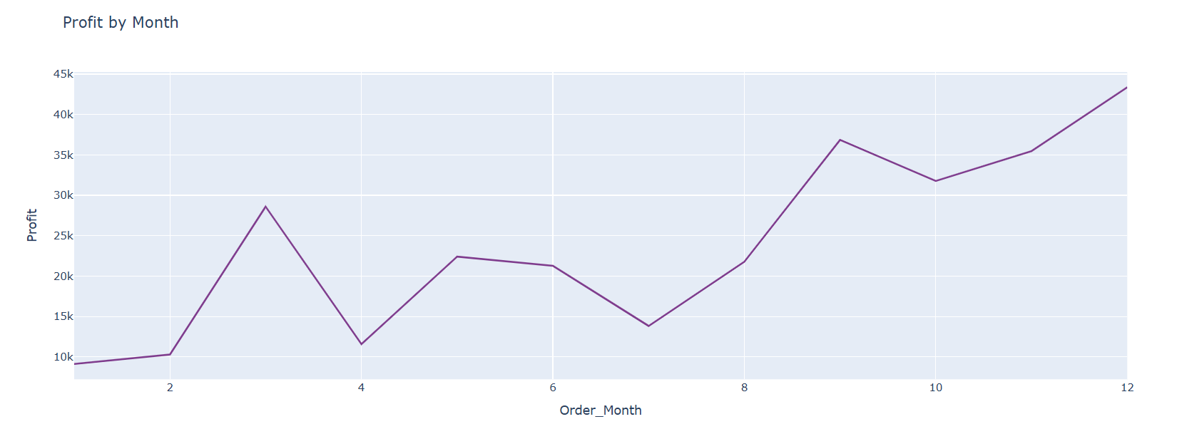
Observation
December generated the highest profit, while January generated the lowest.
Business Insight
Profit peaks in December align with year-end and holiday purchasing, while the January decline suggests a post-holiday slowdown that could be offset with early-year promotional campaigns.

Q5. How does profit vary by category, and which categories are the most and least profitable?
Guidelines
Calculated total profit for each product category and plotted a pie chart to visualize each category's share of overall profit.
Visualization
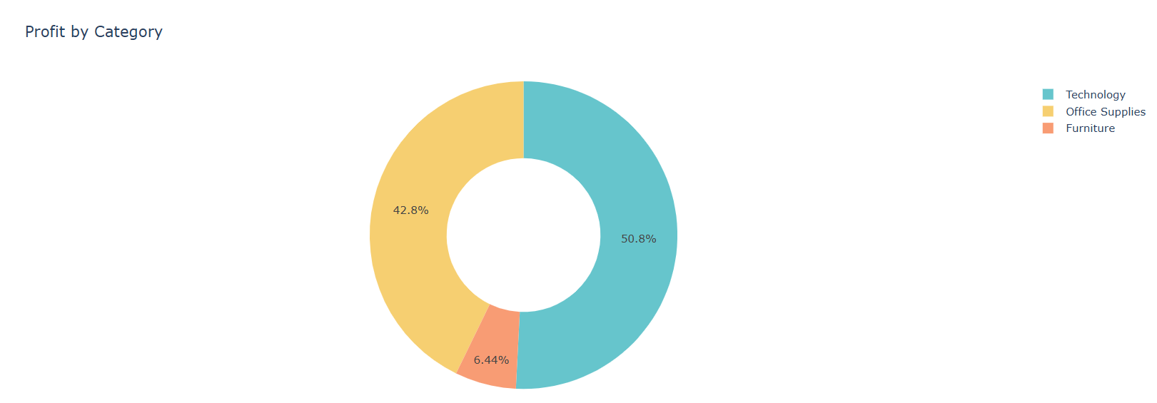
Observation
The Technology category generated the highest profit, while Furniture generated the lowest.
Business Insight
Furniture's comparatively low profit despite meaningful sales volume points to thin margins, indicating a need to review pricing or cost structure for this category.

Q6. How do sales and profit compare across customer segments?
Guidelines
Calculated total sales and total profit for each customer segment and plotted a stacked column chart comparing both metrics across segments.
Visualization
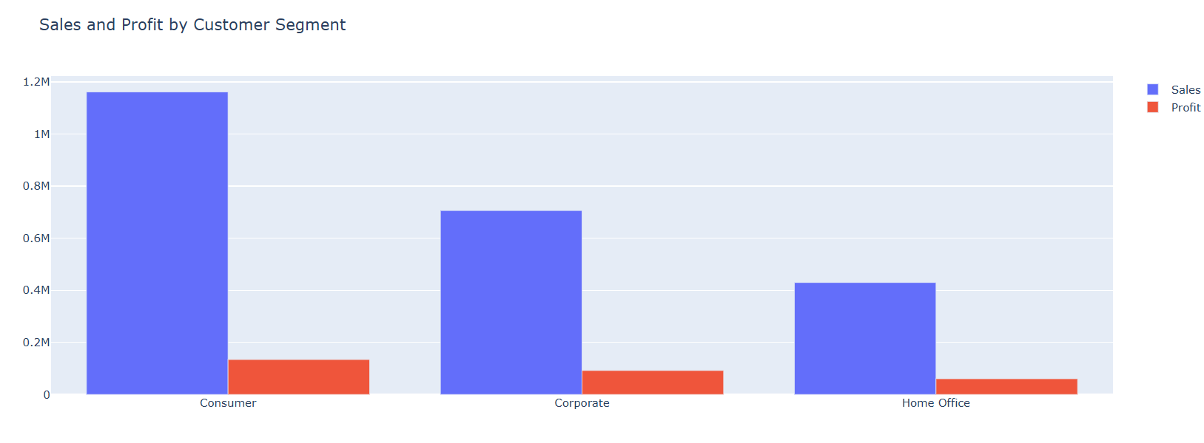
Observation
The Consumer segment generated the highest total sales and total profit among all customer segments.
Business Insight
The Consumer segment is the most valuable customer group by both revenue and profit, making it the top priority for retention and loyalty initiatives.

Q7. How does the sales-to-profit ratio compare across customer segments?
Guidelines
Calculated the sales-to-profit ratio for each customer segment and plotted a bar chart to compare efficiency across segments.
Visualization
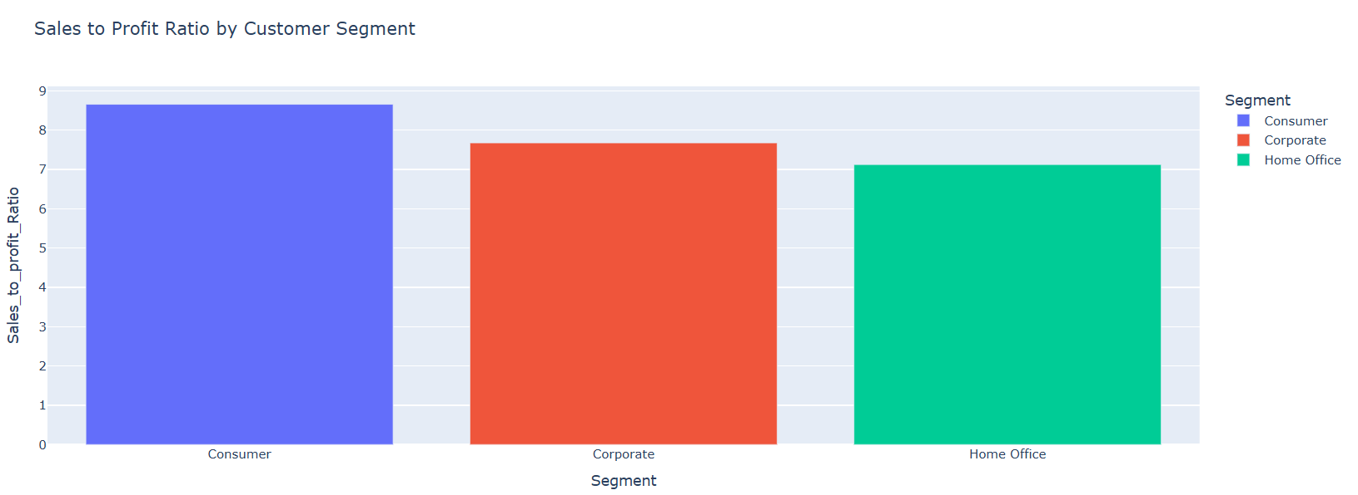
Observation
The Consumer segment has the highest sales-to-profit ratio among all customer segments.
Business Insight
Beyond generating the most revenue, the Consumer segment also converts sales into profit most efficiently — reinforcing it as the most strategically important segment for marketing and retention investment.

Key Takeaways & Recommendations
Recommendations
- Launch early-year (January–February) promotional campaigns to offset the post-holiday sales and profit slowdown.
- Continue prioritizing investment in the Technology category, particularly Phones, as the strongest sales and profit driver.
- Review pricing and cost structure for Furniture to address its disproportionately low profit margin relative to its sales volume.
- Evaluate bundling, repositioning, or phase-out for consistently low performers such as Office Supplies and Envelopes.
- Prioritize retention and loyalty programs for the Consumer segment, given its leadership in sales, profit, and profit efficiency.

