HOTEL BOOKING
DATA ANALYTICS REPORT
An analysis of booking cancellations, guest behaviour, pricing, and market segments

Prepared using Python, pandas, NumPy, matplotlib and Seaborn
July 2, 2026
By- Saurav Kumar

Contents
Objective Questions
Q1. What is the average lead time for bookings that are cancelled versus those that are not cancelled?
Q2. Which month has the highest number of bookings?
Q3. What is the distribution of ADR (Average Daily Rate) across different customer types?
Q4. How many bookings had special requests, and what is the average number of special requests per booking?
Q5. What is the cancellation rate for each market segment?
Q6. Which distribution channel has the highest average ADR?
Q7. What is the correlation between lead time and the length of stay?
Q8. What is the average lead time for repeat guests compared to new guests?
Q9. How many bookings include children and/or babies?
Q10. What is the most common combination of reserved room type and assigned room type?
Subjective Questions
Q1. How does lead time affect the likelihood of booking cancellations?
Q2. What impact do special requests have on booking cancellations?
Q3. What trends can be observed in the booking behaviour of international guests compared to domestic guests?
Q4. What is the impact of the day of the week on booking cancellations?
Q5. What are the most common countries for international guests, and how do their booking patterns compare to domestic guests?

Objective Questions

Q1. What is the average lead time for bookings that are cancelled versus those that are not cancelled?
Guidelines
Analysed the dataset and calculated the average lead time for cancelled and non-cancelled bookings, then plotted a bar chart using the Seaborn library.
Visualization
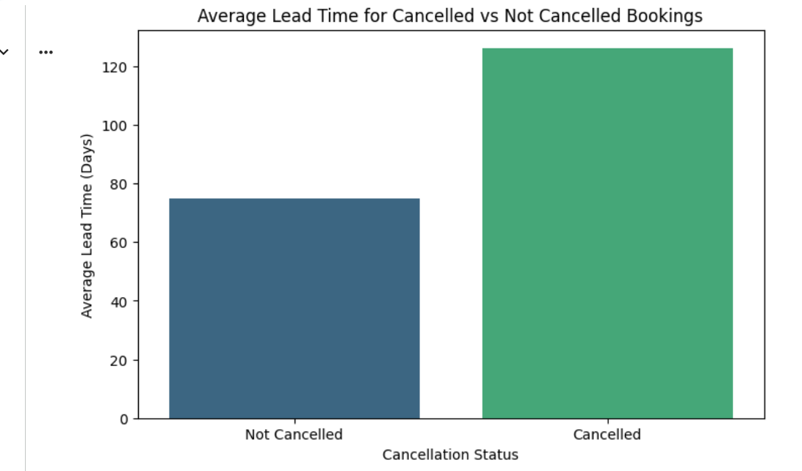
Observation
A higher average lead time is associated with a higher cancellation risk.
Insight
Customers who book several months before arrival have more time to modify or cancel their travel plans, which may contribute to the higher cancellation rate.

Q2. Which month has the highest number of bookings?
Guidelines
Calculated the total number of bookings per month, sorted the results in descending order, identified the month with the highest booking count, and plotted a count plot using the Seaborn library.
Visualization
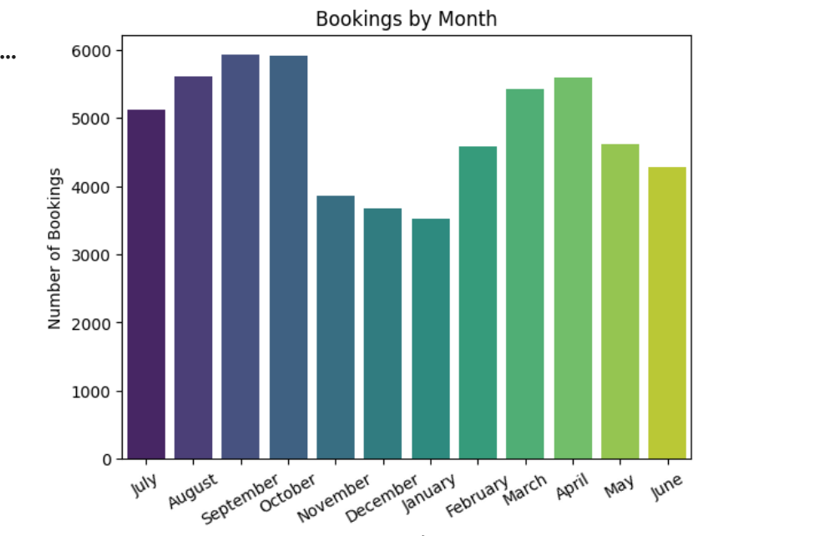
Observation
September has the highest booking count.
Insight
The increased booking volume in September suggests seasonal demand, making it one of the most important revenue-generating months for the hotel.

Q3. What is the distribution of ADR (Average Daily Rate) across different customer types?
Guidelines
Calculated the Average Daily Rate (ADR) for each customer type and plotted the results as a bar chart.
Visualization
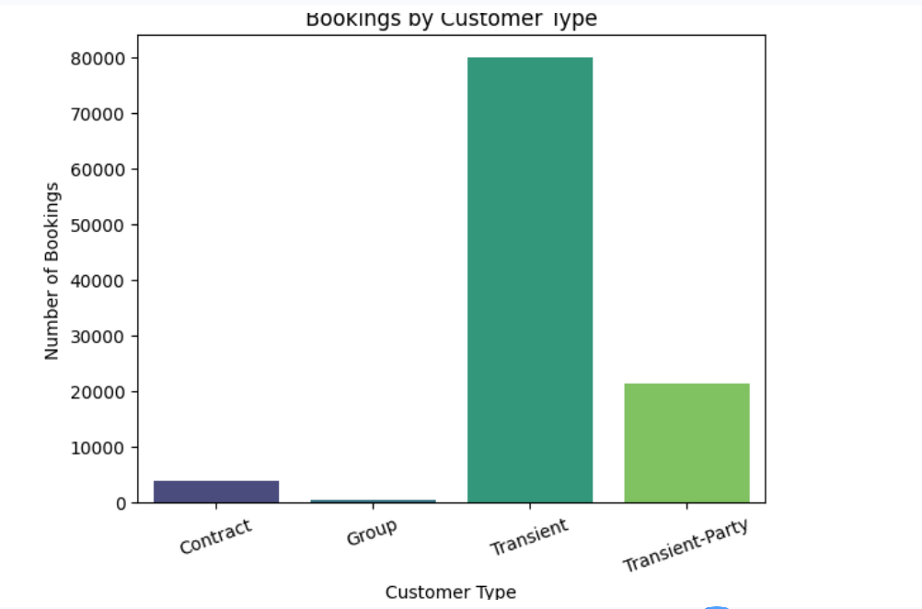
Observation
Transient guests generate the highest Average Daily Rate (ADR).
Insight
Transient guests generate the highest ADR, indicating that they are the most valuable customer segment in terms of room revenue.

Q4. How many bookings had special requests, and what is the average number of special requests per booking?
Guidelines
To determine the total count of special requests, the data frame was first filtered to identify bookings with at least one special request, and the total number of special requests was then counted. The average number of special requests per booking was calculated using pandas' mean function.
Visualization
Insight
A significant proportion of customers personalize their stay through special requests, indicating that customer expectations extend beyond basic room reservations and facilities, and should be considered during operational planning.

Q5. What is the cancellation rate for each market segment?
Guidelines
Used pandas' group by() function to calculate the total percentage cancellation rate for each customer segment.
Visualization
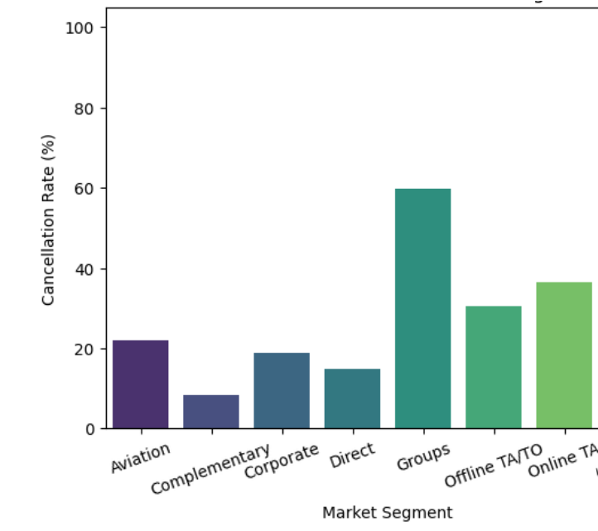
Observation
The 'Groups' market segment has the highest cancellation rate among all channels.
Insight
Group bookings represent the highest cancellation risk, making them the least reliable customer segment for occupancy planning.

Q6. Which distribution channel has the highest average ADR?
Guidelines
Calculated the average ADR for each distribution channel using pandas functions and plotted a bar graph representing each distribution channel alongside its average ADR.
Visualization
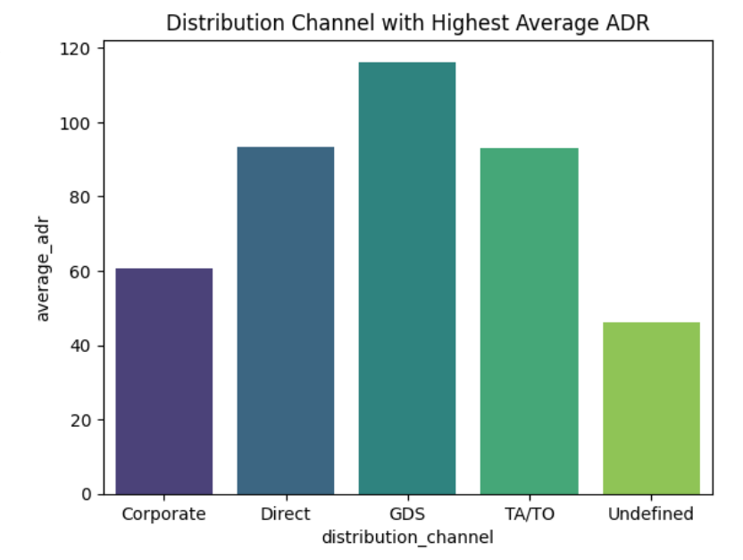
Observation
The GDS distribution channel has the highest average ADR among all distribution channels.
Insight
Bookings received through the GDS channel generate the highest revenue per occupied room, making it the most valuable distribution channel from a pricing perspective.

Q7. What is the correlation between lead time and the length of stay?
Guidelines
Calculated the length of stay using the number of weekend nights and week nights, determined its correlation with lead time, and plotted a scatter plot.
Visualization
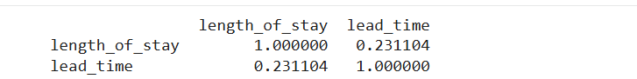
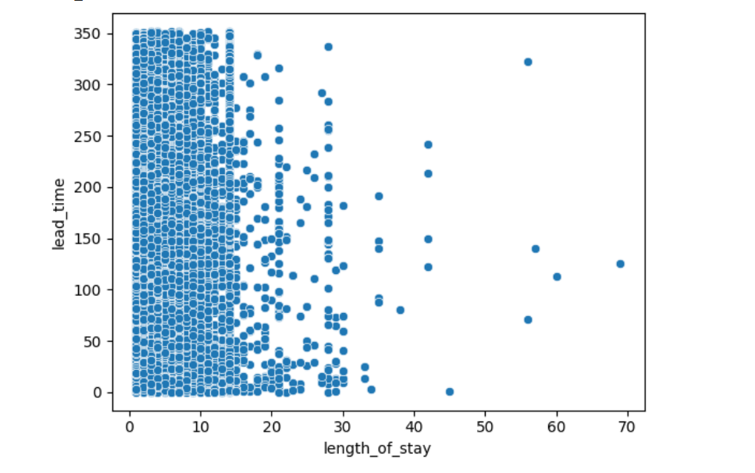
Observation
The correlation coefficient between lead time and length of stay is 0.23, indicating a weak positive relationship.
Insight
Customers who book further in advance tend to stay slightly longer; however, the relationship is weak, indicating that lead time alone is not a strong predictor of length of stay.

Q8. What is the average lead time for repeat guests compared to new guests?
Guidelines
Calculated the average lead time for repeat and new guests and plotted a bar chart comparing the two groups.
Visualization
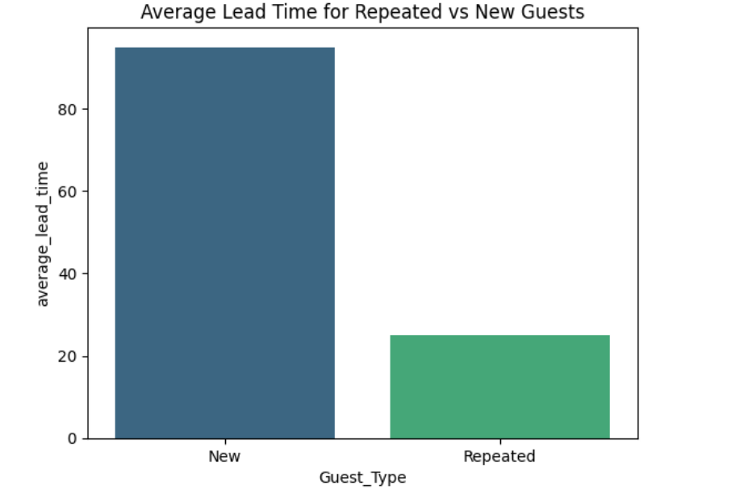
Observation
New guests have a higher average lead time.
Insight
New guests appear to plan their trips further in advance, possibly because they spend more time comparing hotels, planning itineraries, or securing accommodation early.

Q9. How many bookings include children and/or babies?
Guidelines
Filtered the data frame to identify bookings with at least one child or baby, then calculated the total count of such bookings.
Visualization

Q10. What is the most common combination of reserved room type and assigned room type?
Guidelines
Used pandas' group by() function to determine the total count for each combination of reserved room type and assigned room type, then identified the combination with the highest count.
Visualization
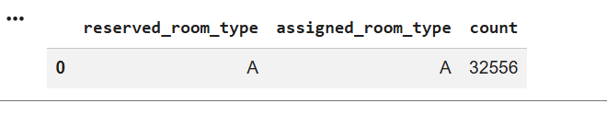
Observation
The combination of reserved room type 'A' and assigned room type 'A' has the highest count.

Subjective Questions

Q1. How does lead time affect the likelihood of booking cancellations?
Guidelines
Calculated the average lead time for cancelled and non-cancelled bookings and plotted a box plot to visualize the distribution across each category.
Visualization
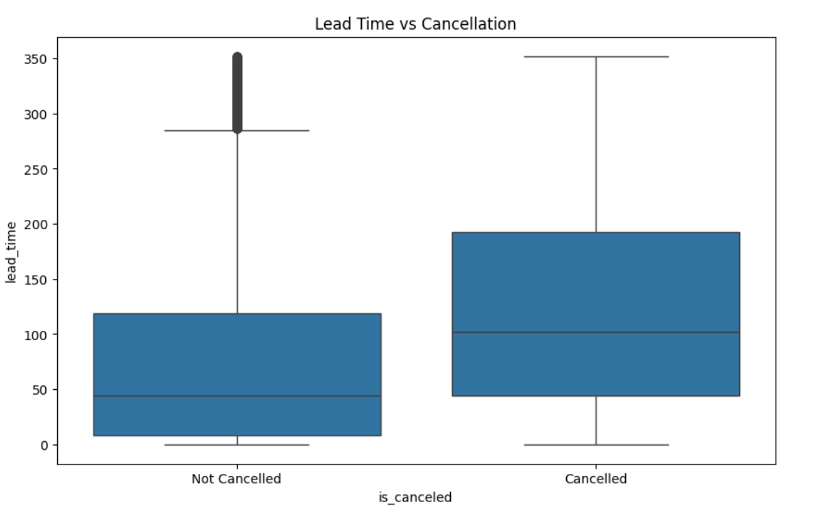
Observation
Cancelled bookings generally have a significantly higher lead time.
Insight
Customers with longer lead times have a significantly higher cancellation rate.
Recommendations
- Send automated reminder emails or SMS messages 30–60 days before arrival.
- Offer flexible rescheduling instead of outright cancellations.
- Provide exclusive discounts or loyalty points for confirming bookings closer to the arrival date.
Business Impact
- Lower cancellation rate.
- Reduced revenue loss from last-minute room vacancies.

Q2. What impact do special requests have on booking cancellations?
Guidelines
Calculated the cancellation rate for each type of special request and plotted a line chart showing special requests versus cancellation rate.
Visualization
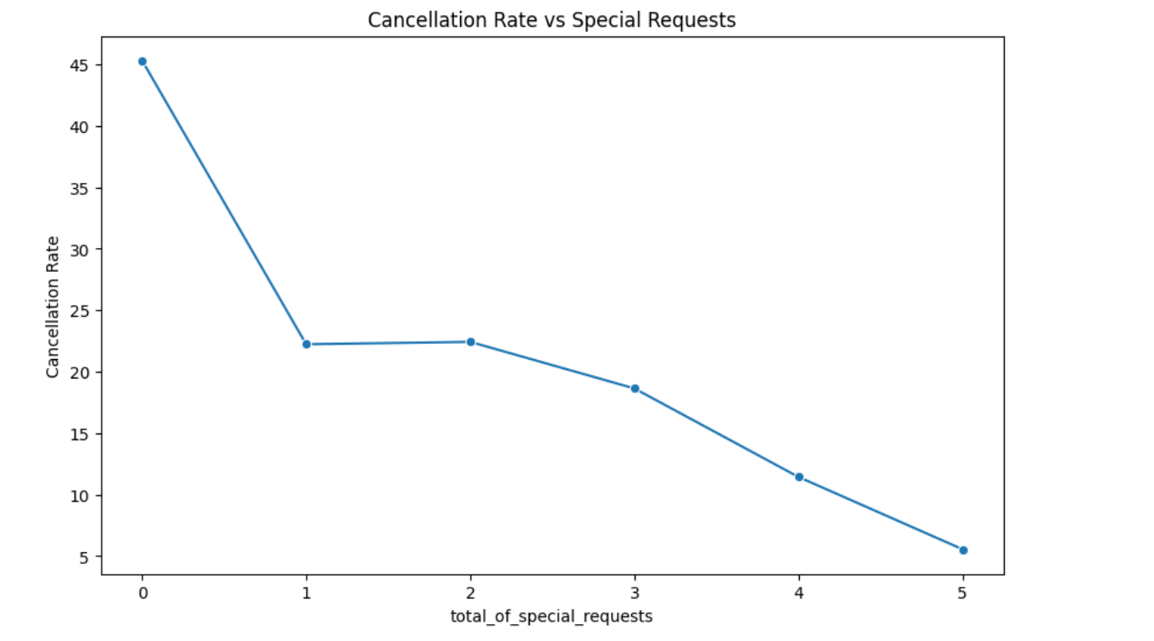
Observation
As the number of special requests from customers increases, the cancellation rate decreases.
Insight
Guests making multiple special requests are less likely to cancel, suggesting stronger purchase intent and higher commitment.
Recommendations
- Ensure that all special requests are acknowledged and fulfilled whenever possible.
- Give priority to customers who submit special requests.
Business Benefit
- Higher guest satisfaction.
- Lower cancellation risk.
- Better customer experience.

Q3. What trends can be observed in the booking behaviour of international guests compared to domestic guests?
Guidelines
Filtered domestic and international guests, then calculated the total bookings, average lead time, cancellation rate, and average ADR for each group.
Visualization
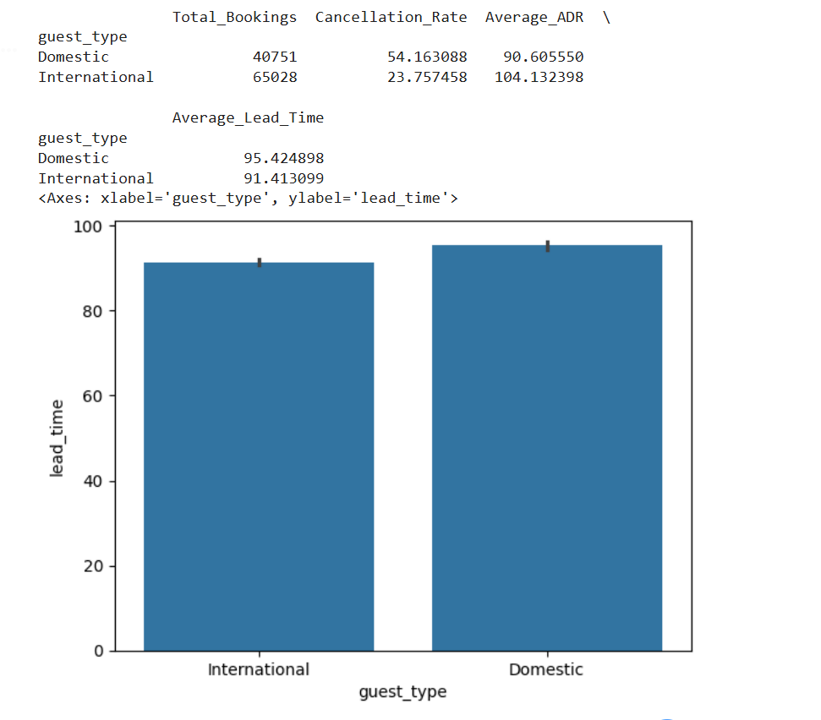
Observation
Domestic guests have higher lead times compared to international guests.
Insight
International guests generally book earlier, stay longer, and often generate a higher ADR than domestic guests.
Recommendations
- Focus digital marketing campaigns on the countries that contribute the most international bookings.
- Introduce early-booking incentives specifically for international guests.
Business Impact
- Higher international bookings.
- Increased revenue.
- Better return on marketing investment (ROI).

Q4. What is the impact of the day of the week on booking cancellations?
Guidelines
Calculated the cancellation rate for each day of the week and plotted a bar graph.
Visualization
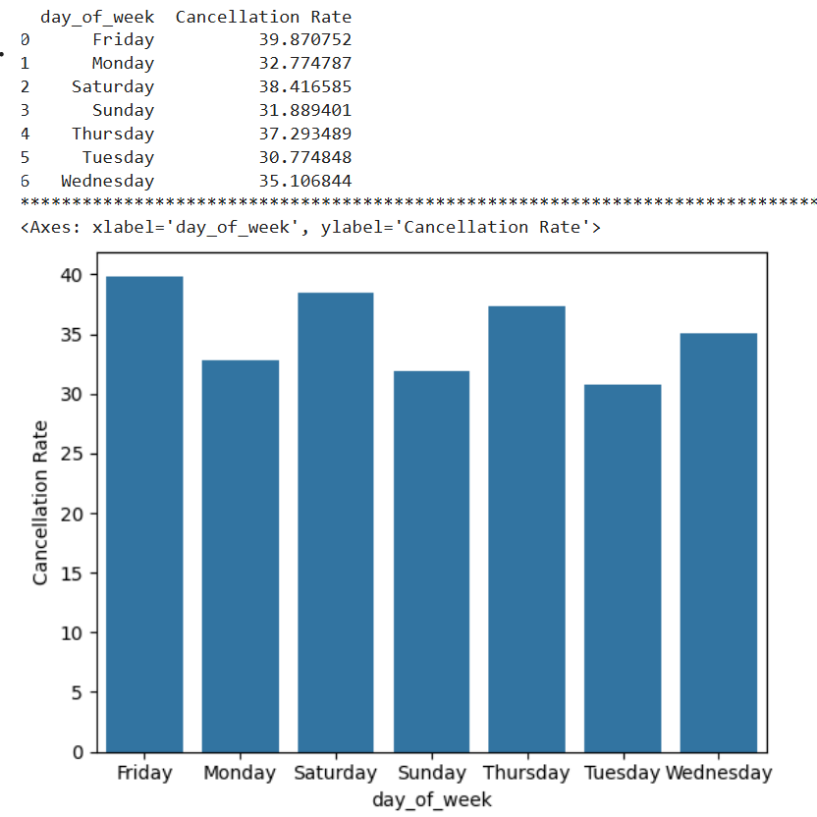
Observation
Weekend bookings exhibit a higher cancellation rate compared to weekday bookings.
Insight
Weekend reservations are more prone to cancellations, making weekend occupancy more difficult to predict and increasing the risk of unsold rooms during peak demand periods.
Recommendations
- Introduce weekend booking-confirmation campaigns.
- Launch weekend promotional campaigns.
- Use dynamic overbooking strategies for weekends.
Business Impact
- Increased occupancy.
- Reduced unsold inventory.
- Additional revenue opportunities.

Q5. What are the most common countries for international guests, and how do their booking patterns compare to domestic guests?
Guidelines
Filtered all international guest bookings, calculated the total number of bookings for each country, and selected the top 10 countries with the highest number of international bookings.
Visualization
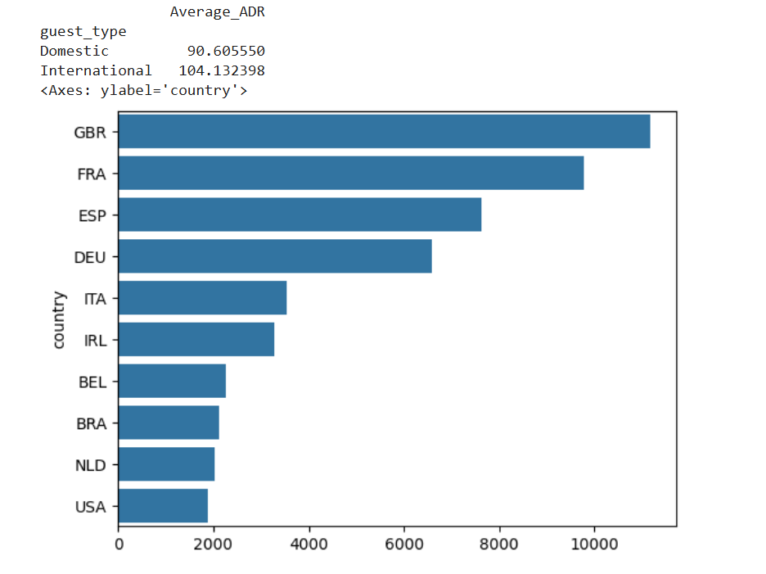
Insight
A small number of international countries contribute a large share of foreign bookings, enabling targeted marketing campaigns and personalized guest services.
Recommendations
- Launch targeted marketing campaigns for international customers within their respective countries.
- Offer discounts and rewards to encourage repeat international bookings.
Business Impact
- More international customer engagement.
- More revenue generation.

