**Fast Food Finder**

**Prepared by**

Saurav Shah(16IT127)

**Under the supervision of**

Prof. Ravi patel Sir

A Report Submitted to

Charotar University of Science and Technology

for Partial Fulfillment of the Requirements for the

Degree of Bachelor of Technology

in Information Technology

IT345 Software Group Project-II (B.Tech IT 5th sem)

**Submitted at**



**DEPARTMENT OF INFORMATION TECHNOLOGY**

**Chandubhai S. Patel Institute of Technology**

**At: Changa, Dist: Anand – 388421**

**October 2018**



**CERTIFICATE**

This is to certify that the report entitled “**Fast Food Finder**” is a bonafied work carried out by **Mr. Saurav shah (16it127)**under the guidance and supervision of **Prof. Ravi Patel** for the subject **Software Group Project-II(IT345)** of **5th** Semester of Bachelor of Technology in **Information Technology** at Faculty of Technology & Engineering – CHARUSAT, Gujarat.

To the best of my knowledge and belief, this work embodies the work of candidate **himself**, has duly been completed, and fulfills the requirement of the ordinance relating to the B.Tech. Degree of the University and is up to the standard in respect of content, presentation and language for being referred to the examiner.

|  |
| --- |
| Under supervision of,  Prof. Ravi Patel  Assistant Professor  Dept. of Information Technology  CSPIT, Changa, Gujarat. |
| Prof. Parth Shah  Head & Associate Professor  Department of Information Technology  CSPIT, Changa, Gujarat. |

**Chandubhai S Patel Institute of Technology**

At: Changa, Ta. Petlad, Dist. Anand, PIN: 388 421. Gujarat

**ACKNOWLEDGEMENT**

We have found this rare opportunity to evince a word of thanks to all those who played a key role in the successful completion of our project.

We sincerely thank our Head of Department Dr.Parth Shah sir for giving the chance as well as support for all the time being and his able guidance and continuous encouragement made us work in all the challenges during project development.

We express deep gratitude to assistant Prof. Ravi Patel internal project guide from faculty of Engineering ,Charusat for their valuable suggestions help and moral support .we also thank to all those who not find a separate name but have helped directly and indirectly.

SAURAV SHAH(16IT127)

**ABSTRACT**

* In this app we tried to make people’s problem of finding fast food very easy. By using Fast Food Finder app we can find fast food very easily. Also, we can find menu of our desired restaurant. For those people who do not know where is their favourite restaurant we have also included a feature that can help you finding the location of the restaurant by using google map.

**Index**

* **Chapter 1 Introduction ………………………………6**
* **Project summary………………………………………6**
* **Chapter 2 Implementation………………………...7**
* **Chapter 3 Actual Android App…............................11**
* **Chapter 4 Advantages and features…………………15**
* **Chapter 5 Limitations………………………………..16**
* **Chapter 6 Conclusion……...……………………..17**
* **References**

|  |  |  |  |  |  |
| --- | --- | --- | --- | --- | --- |
|  |  |  |  |  |  |

**Chapter 1:Summary of Project**

* In this app we tried to make people’s problem of finding fast food very easy. By using Fast Food Finder app we can find fast food very easily. Also, we can find menu of our desired restaurant. For those people who do not know where is their favourite restaurant we have also included a feature that can help you finding the location of the restaurant by using google map.

**Chapter 2:** **Implementation**

* To implement this project I have to initially learn the android studio and how to development any android mobile application that makes us to do more familiar with the java and XML. We have learned some of the new concepts of the java for this project.
* It is basically based on the simple xml and java programming languages.
* We have use the android studio tool to make this app .

**Snapshort:**

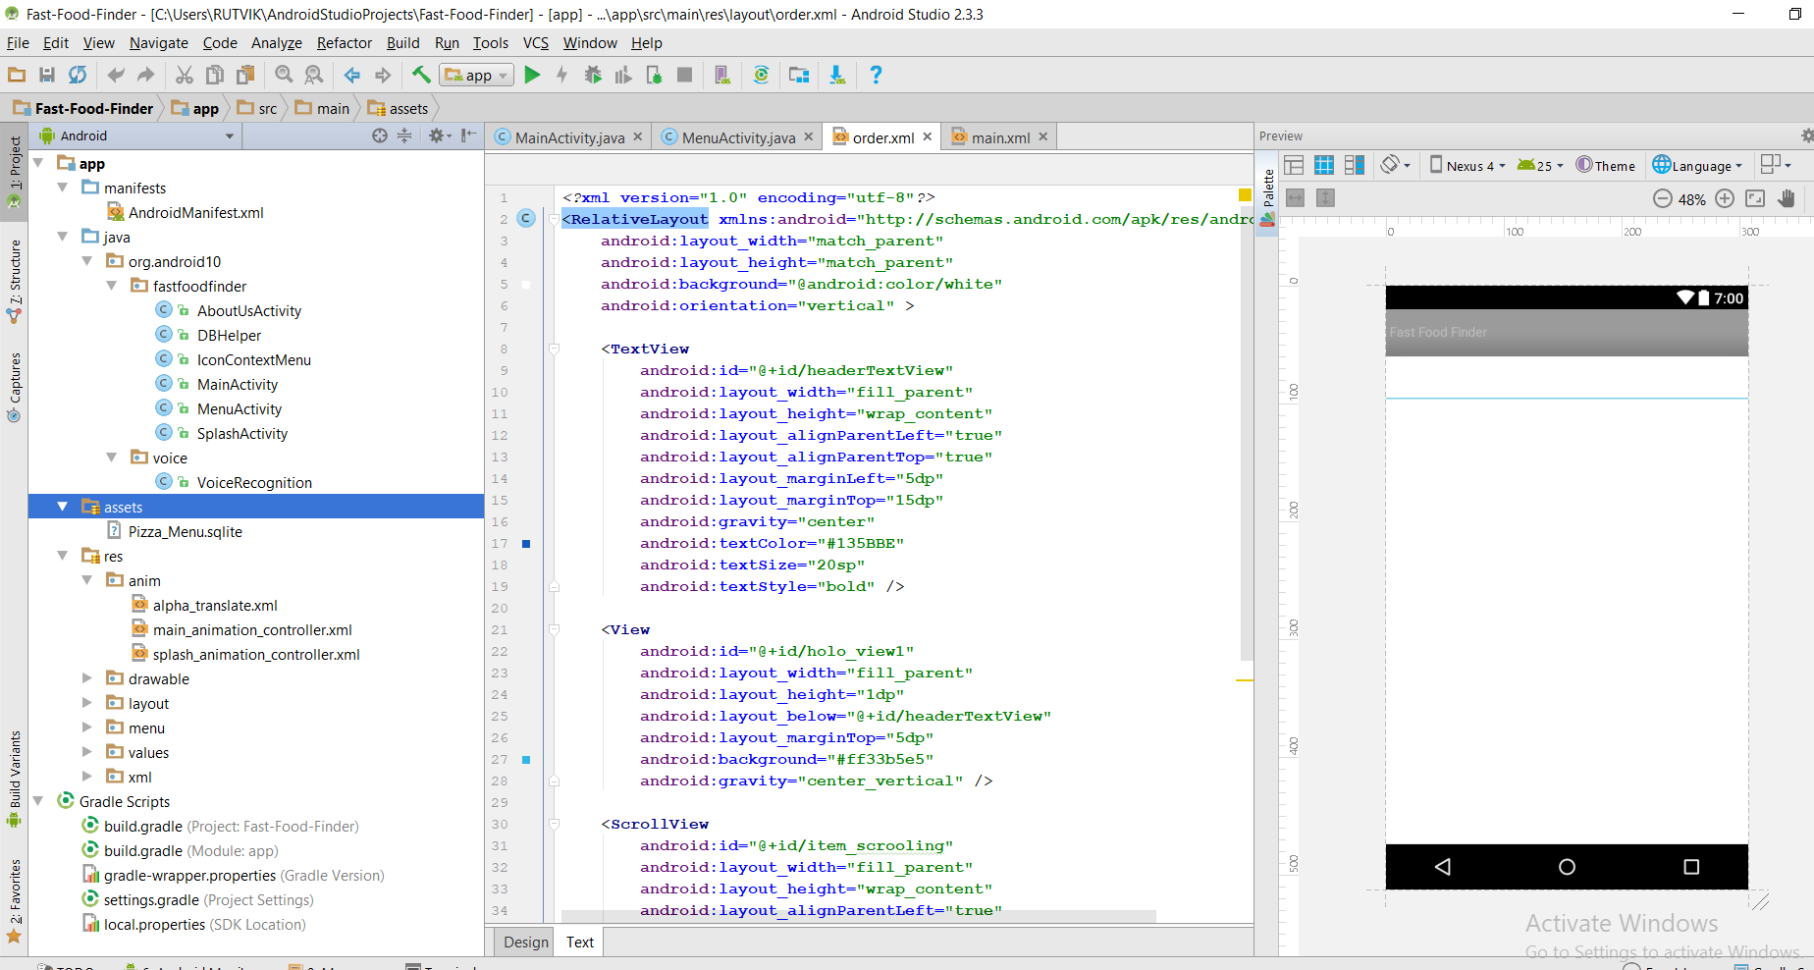

**This screenshot shows the implementation of java files in application .**

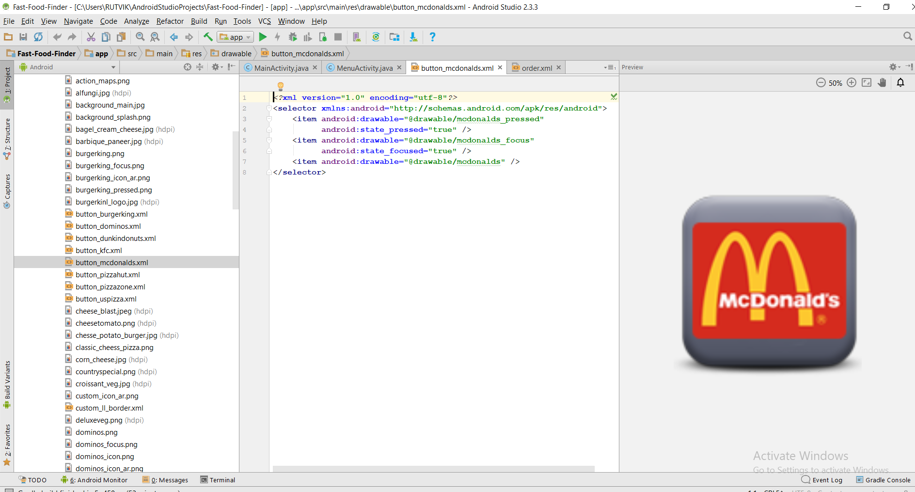

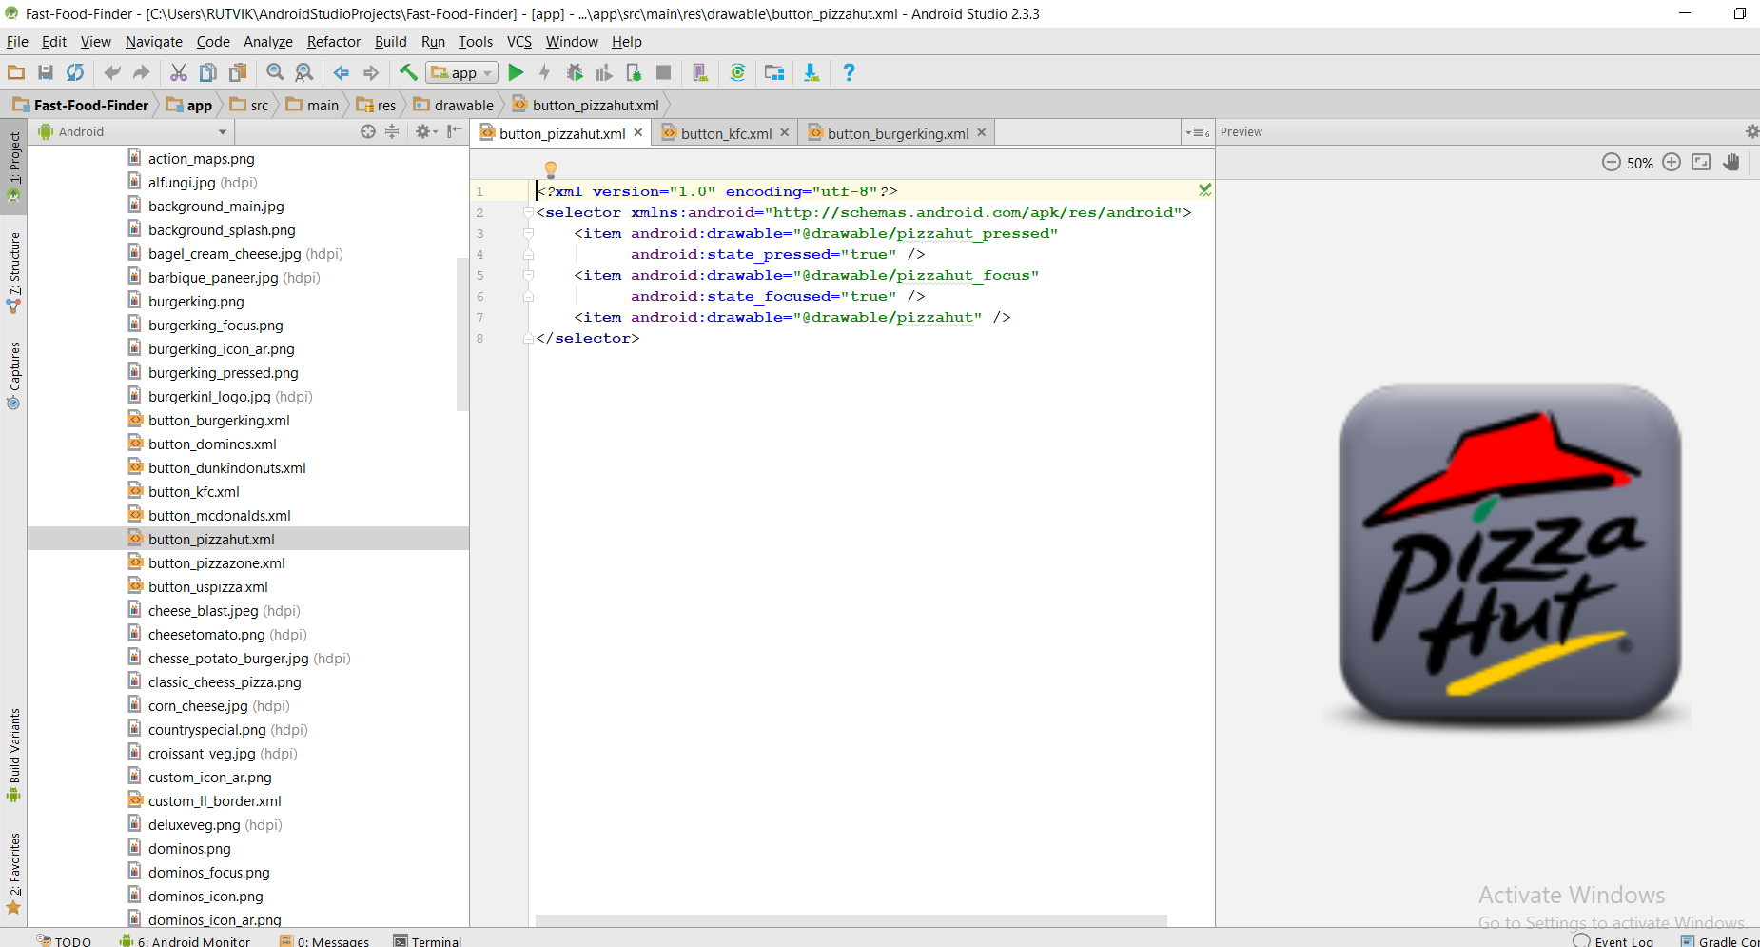

**These two screenshots show the icons which are displayed in the application.**

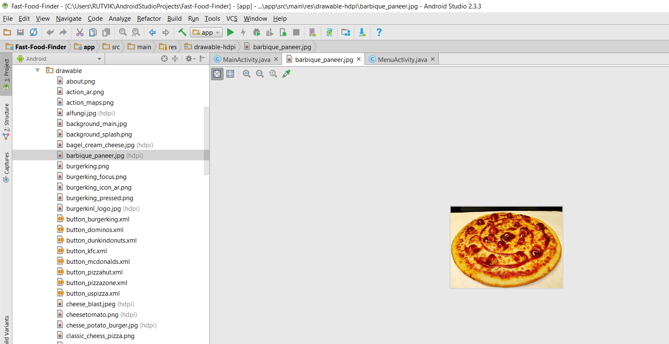

This screenshot shows us the icon in the restaurant menu of the application.

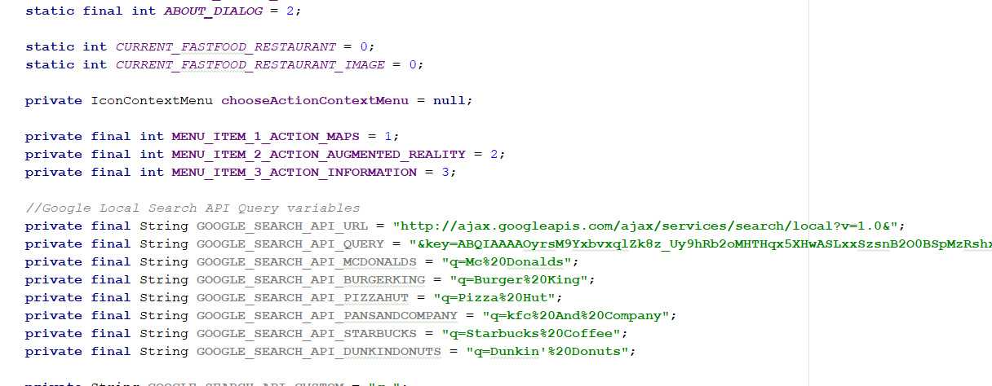

Above screenshot shows us that how we implemented the feature: Restaurant locator using google maps.

**Chapter 3:Actual Android App**

Home Page:

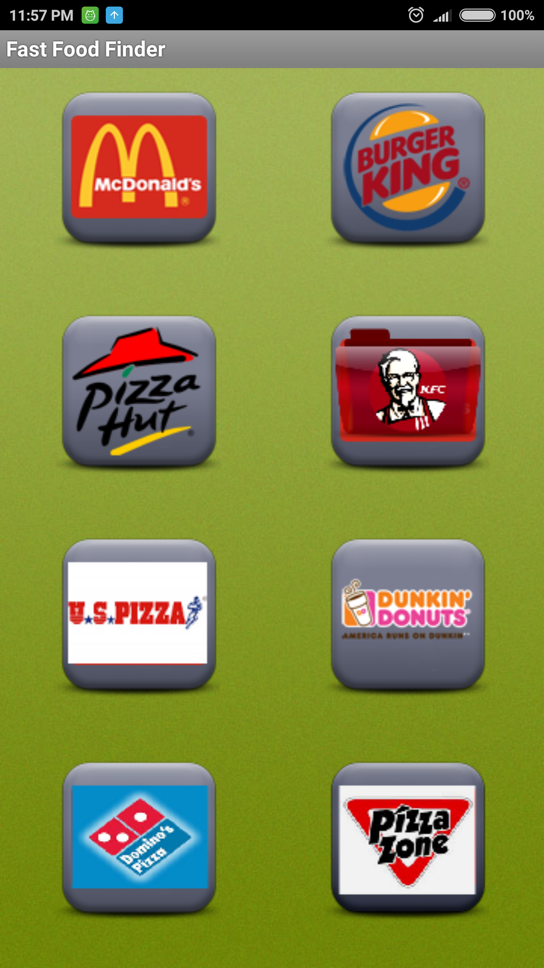

This is how your application will look like when you open it.

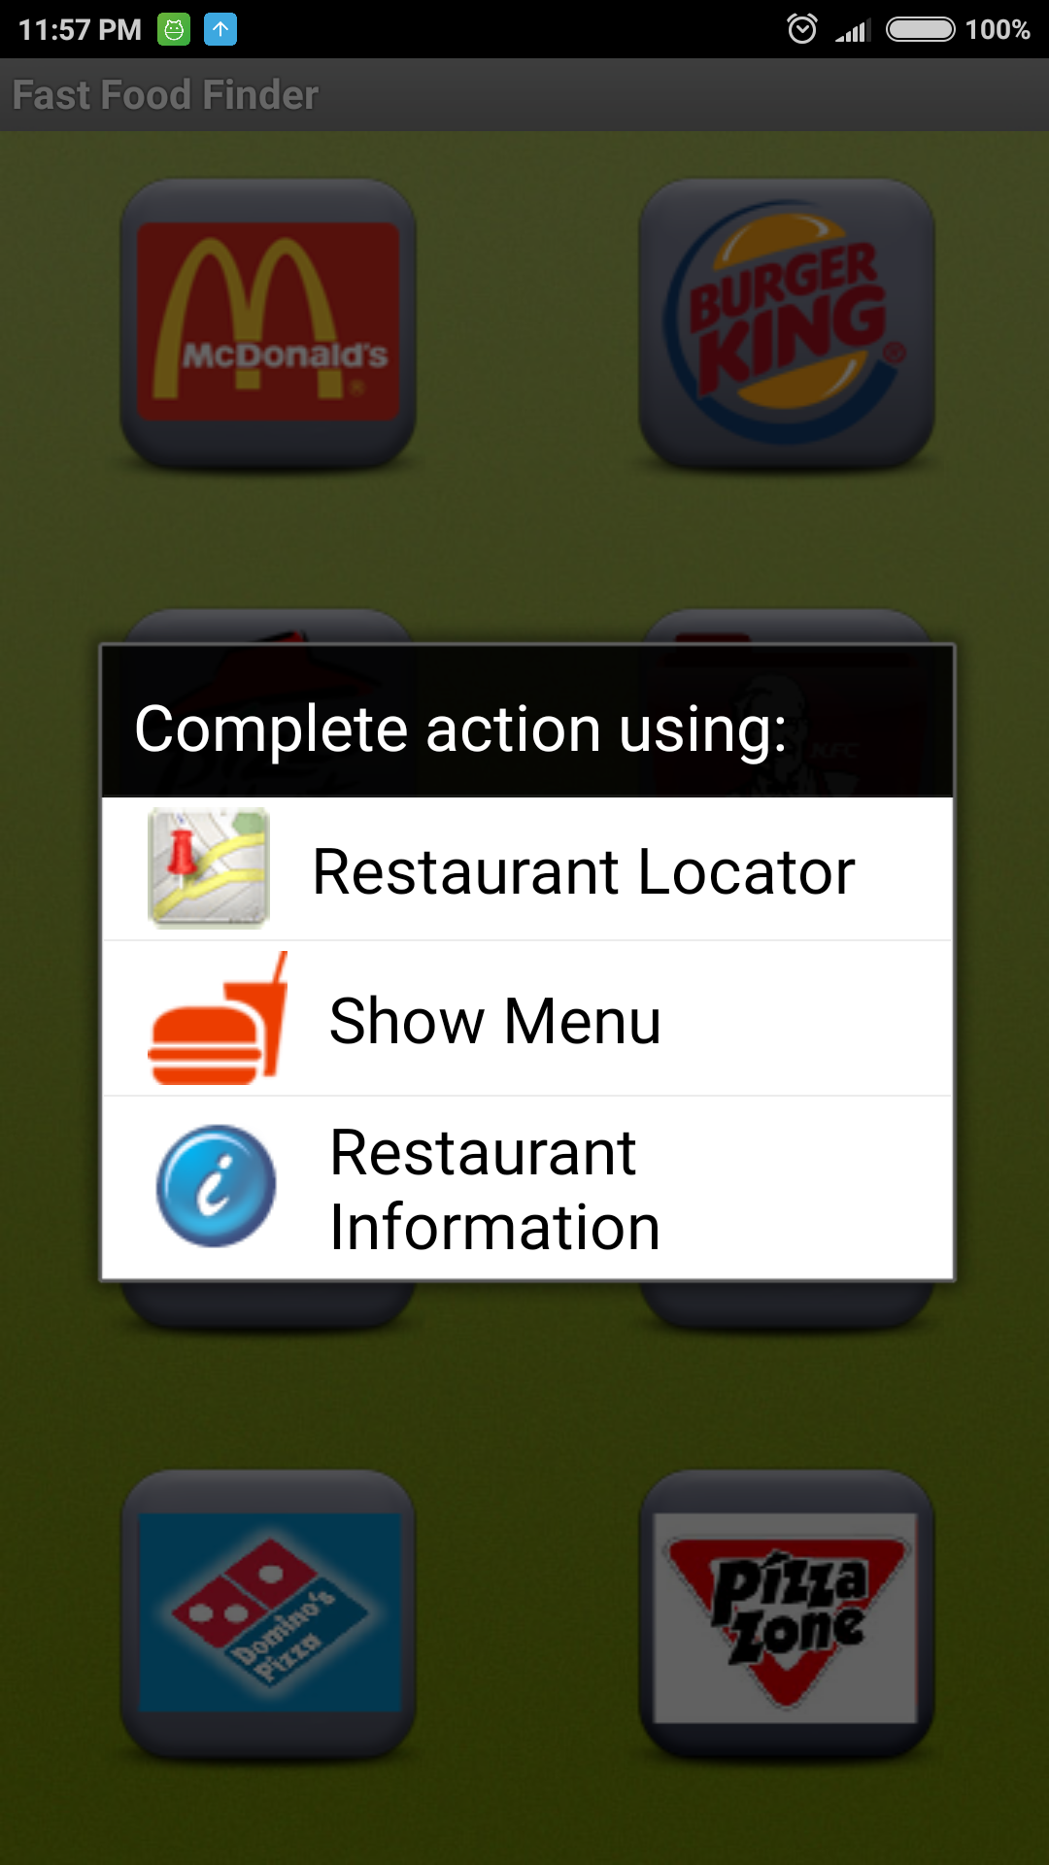

This kind of a menu will pop up when we click on any particular restaurant.

First option- Restaurant Locator:

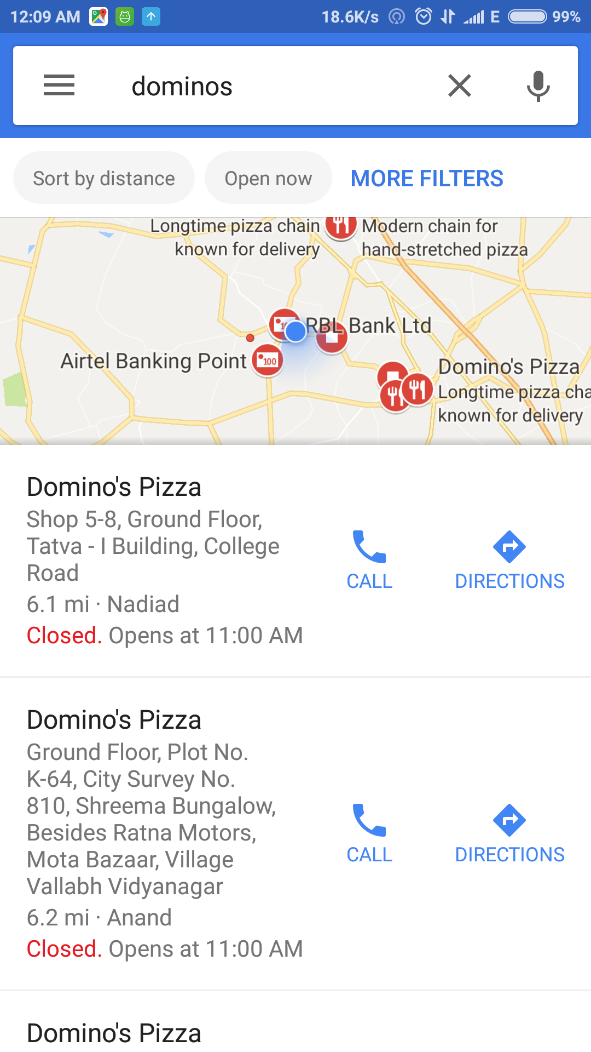

This is what the restaurant locator option is, it will redirect you to the google maps.

Second Option-Show Menu:

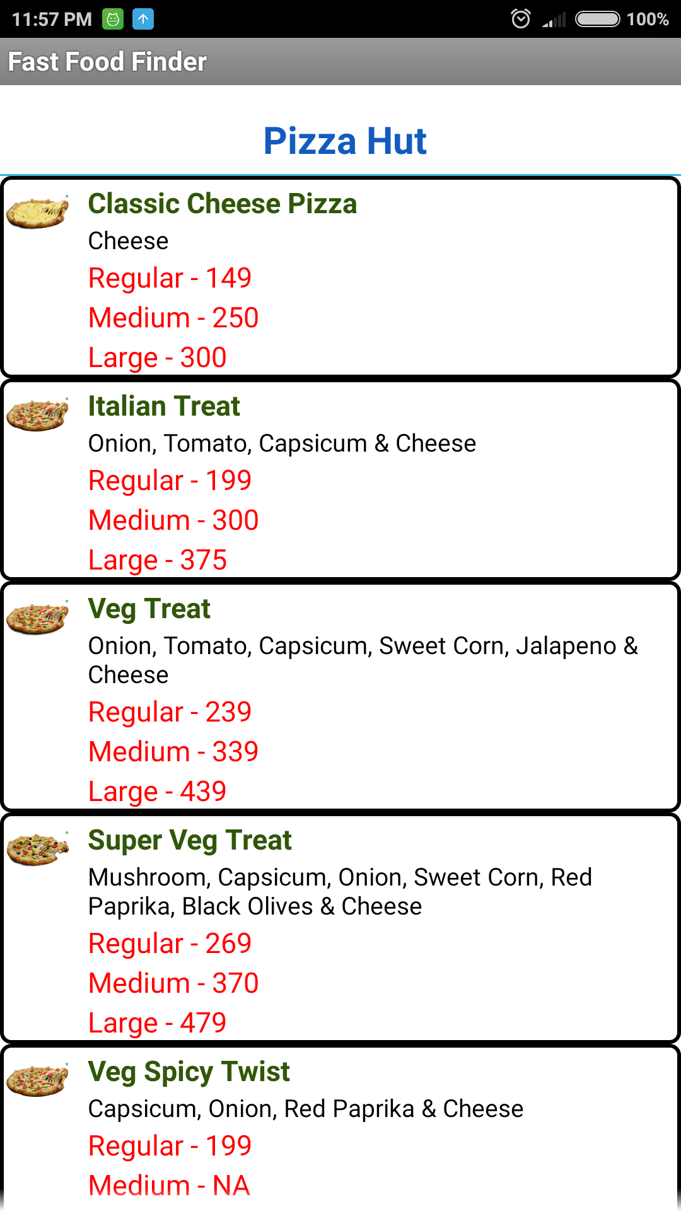

This is the menu of the restaurant chosen by user.:

**Chapter 4 :Advantages and features**

**1. ADVANTAGES:**

* An easy way to find food.
* You can see restaurant menu.
* You can find restaurant location easily.

**2. FEAURES:**

* Easy to Use User Interface

**Chapter 5: Limitations**

* It provides flexibility to those people who love to eat fast food.
* It is not possible for the people to went to particular restaurant and then order but they can find their menu in Fast Food Finder. With Fast Food Finder people don’t need to worry about locations of the restaurant. It is not live updated app.

**Conclusion:**

* By Fast Food Finder, It provides flexibility to those people who love to eat fast food.
* With Fast Food Finder people don’t need to worry about locations of the restaurant**.**

**References:-**

[**https://developer.android.com/index.html**](https://developer.android.com/index.html)

[**https://stackoverflow.com/**](https://stackoverflow.com/)

**https://www.youtube.com/watch?v=Ad41Bh704ms&list=PL5BwW6U5HV8neX1HAodPcor10Q5hTQIen**