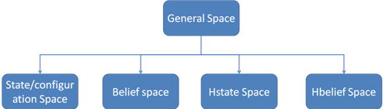
FIRM Toolbox Architecture:
