**Docker& Kubernets Assignment**

* For the REST API, I created an endpoint using the Spring Boot framework, added the necessary dependencies, and configured the controller class to handle the API endpoints.
* Regarding Docker, I created a Docker file for the REST API, and after setting up a Docker Hub account, I built and pushed the Docker image to Docker Hub. The image has been made public and can be accessed through this link: [Insert Docker Hub image path here].
* For Kubernetes, I set up a local Kubernetes cluster using Minikube and created YAML files for the deployment and service of the REST API. The deployment YAML includes two replicas of the Docker image.

**Deliverables**

**1**.**Git Hub public repository:**

<https://github.com/sauravarya01/courses>

**2**.**Docker File:**

From openjdk:11  
 **WORKDIR /myapp  
 COPY target/courses-0.0.1-SNAPSHOT.jar /myapp**  
 **CMD [ "java","-jar","courses-0.0.1-SNAPSHOT.jar" ]**  
 **EXPOSE 9001**

**3.Docker Image**

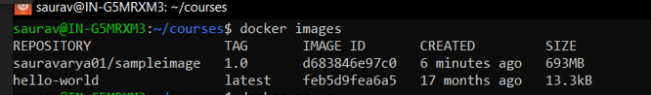

**4.Image path from Docker Hub Repo:**

[**https://hub.docker.com/r/sauravarya01/sampleimage**](https://hub.docker.com/r/sauravarya01/sampleimage)

**5 Yaml File**

Deployment.yaml

apiVersion : apps/v1

kind: Deployment

metadata:

name: docker-assignment-deployment

labels:

app: docker-assignment

spec:

selector:

matchLabels:

app: docker-assignment

replicas: 2

template:

metadata:

labels:

app: docker-assignment

spec:

containers:

- name: docker-assignment

image: sauravarya01/sampleimage:1.0

ports:

- containerPort: 9001

Service.yaml

apiVersion : v1

kind: Service

metadata:

  name: docker-assignment-service

spec:

  type: NodePort

  selector:

    app: docker-assignment

  ports:

  - port: 9001

    targetPort: 9001

    nodePort: 30002

**Screeshots:**

6. One for Deployment Created Successfully and Second for Total Number of Deployments.

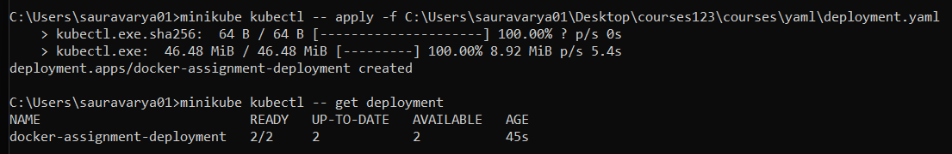

7. One for Screenshot of Service Created Successfully and Second for Total Number of Running services.

8. Screenshot for Number of Running Pods.

9. Screenshot of Running Application. (Show Endpoint is accessible successfully through browser)

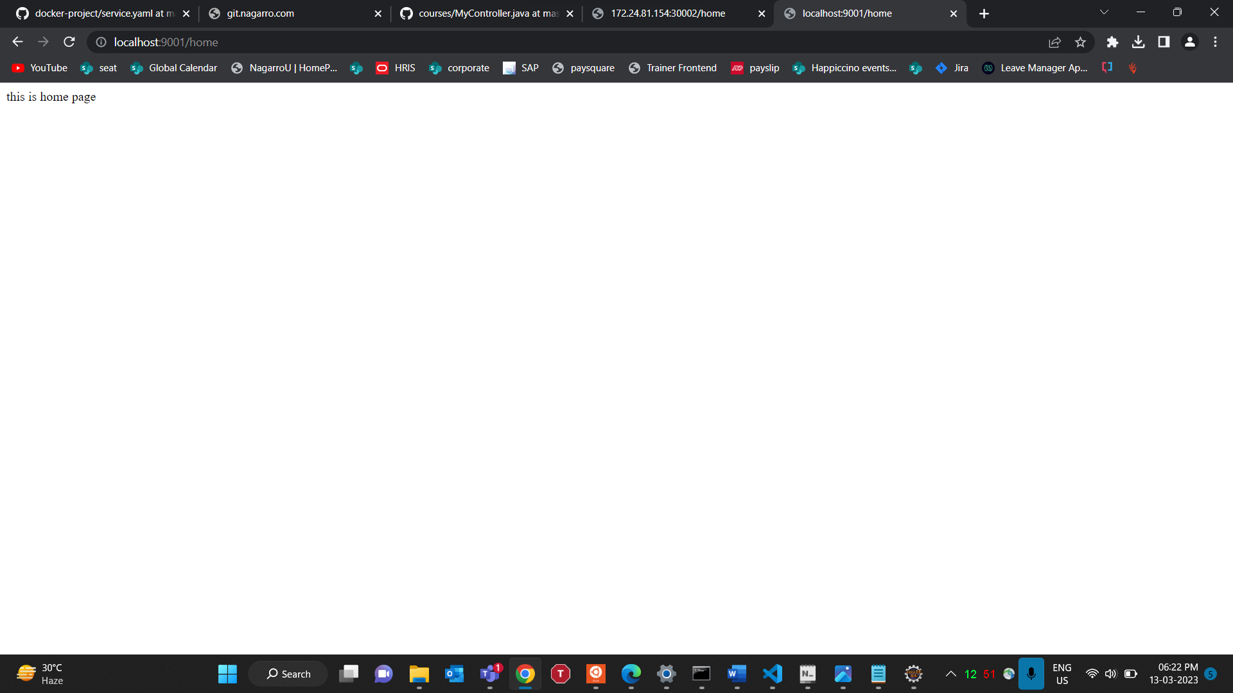

10. Screenshot - Access pod through the service endpoint only

