Deep Learning-Based Cyber Attack Detection: Architectures, Evaluation Benchmarks, Adversarial Vulnerabilities, and Future Trajectories
SAURAV BHURIA
UID: 25MCA20133
University Institute of Computing
Chandigarh University
Academic Year: 2026
Abstract—The rapid expansion of distributed cyber-physical infrastructure, hybrid cloud environments, and multi-gigabit network fabrics has dramatically broadened the attack surface available to sophisticated adversaries. Traditional network intrusion detection systems (NIDS), which rely almost exclusively on static rule matching or shallow machine learning heuristics, fail when confronted with polymorphic exploits, encrypted payloads, and low-and-slow zero-day penetrations. In response, deep learning (DL) has emerged as an indispensable cornerstone of modern automated security operations due to its intrinsic capability to extract high-order, non-linear feature representations from raw, high-dimensional packet telemetry. This research paper provides an exhaustive, multi-faceted investigation of deep learning methods applied to network cyber attack detection. We rigorously analyze core architectural paradigms—including Convolutional Neural Networks (CNNs), Long Short-Term Memory networks (LSTMs), Gated Recurrent Units (GRUs), Autoencoders (AEs), and emerging Transformer-based self-attention networks—assessing their mathematical suitability against both spatial header distributions and temporal traffic flow sequences. Furthermore, we critically appraise widely used benchmark datasets (NSL-KDD, UNSW-NB15, CICIDS2017, and BoT-IoT), demonstrating how synthetic generation artifacts, labeling inconsistencies, and extreme class imbalances can create misleadingly optimistic empirical results. We systematically dissect the end-to-end data pipeline, from raw PCAP ingestion and feature normalization to imbalance mitigation via SMOTE and Focal Loss. We also address vital deployment bottlenecks: adversarial evasion attacks (such as gradient-based feature perturbations), microsecond line-rate throughput ceilings, and the explainability gap (XAI) that hampers human SOC triage. Finally, we articulate concrete engineering pathways incorporating federated collaborative learning, graph neural networks, and hardware-accelerated eBPF/SmartNIC offloading to bridge the divide between theoretical model accuracy and robust real-world enterprise deployment.
Keywords—Deep Learning, Intrusion Detection Systems (IDS), Cyber Attack Detection, Convolutional Neural Networks, Recurrent Neural Networks, Autoencoders, Transformers, Adversarial Machine Learning, Anomaly Detection, Network Security.

I. INTRODUCTION
Modern digital communication infrastructures operate in an environment of continuous adversarial engagement. Enterprises, critical industrial utilities, healthcare delivery systems, and sovereign governmental agencies are routinely targeted by sophisticated adversaries wielding automated exploit kits, distributed denial-of-service (DDoS) networks, ransomware syndicates, and Advanced Persistent Threats (APTs) [1]. Defending these high-throughput, highly heterogeneous network perimeters requires proactive monitoring architectures that can process millions of packet transactions per second while accurately separating legitimate user transactions from malicious probes [2].
For several decades, perimeter security has relied on signature-based Network Intrusion Detection Systems (NIDS), exemplified by Snort, Suricata, and Bro/Zeek. These engines operate by checking parsed packet headers and application-layer strings against curated libraries of known malicious signatures. While signature-matching provides negligible false-alarm rates for known attacks and supports line-rate throughput, it exhibits a fundamental structural limitation: it is entirely blind to zero-day vulnerabilities, novel protocol exploitations, and encrypted polymorphic variants that evade byte-exact pattern rules [3].
A. Limitations of Classical Machine Learning
To overcome the limitations of signature matching, the security community turned toward anomaly-based intrusion detection using classical shallow machine learning algorithms. Approaches based on Support Vector Machines (SVM), Random Forests (RF), Naive Bayes, and k-Nearest Neighbors (k-NN) analyze aggregated flow records (e.g., flow duration, inter-arrival time distributions, and flag tallies) [4]. However, shallow machine learning relies heavily on manual feature engineering. Cybersecurity specialists must hand-craft statistical indicators, a process that is labor-intensive, computationally brittle, and vulnerable to deliberate evasion by adversaries who modify packet pacing. Moreover, shallow architectures have limited representational capacity; they cannot effectively capture the non-linear spatio-temporal correlations embedded within extended multi-packet conversations or raw byte payloads.
B. The Deep Learning Paradigm Shift
Deep learning (DL) fundamentally changes this dynamic. By passing raw or minimally preprocessed network telemetry through stacked layers of non-linear transformations, deep neural networks autonomously synthesize hierarchical feature representations directly from data [7]. Shallow layers extract elementary network primitives (e.g., bitwise flag distributions, localized payload byte entropy), while deeper layers construct high-order abstractions (e.g., multi-stage reconnaissance sequences, covert beaconing channels, and credential exfiltration behaviors). This enables deep learning models to detect previously unseen attack mutations without requiring hand-crafted heuristic signatures.
C. Core Real-World Deployment Bottlenecks
Despite high detection accuracies reported in academic literature (often exceeding 98%), deploying deep learning models in production Security Operations Centers (SOCs) reveals significant real-world challenges:
1) Extreme Class Imbalance: Production networks are dominated by benign traffic (>99.9%), while attacks appear as rare, sparse events. Standard loss functions often lead classifiers to predict the majority class exclusively, missing critical stealthy compromises.
2) Benchmark Dataset Artifacts: Models trained on synthetic benchmarks often memorize testbed-specific artifacts (e.g., static IP allocations or flawed port correlations) rather than genuine malicious behavior, causing performance to drop when deployed on live networks [5].
3) Adversarial Evasion: Deep neural networks are susceptible to adversarial perturbations. Attackers can inject harmless padding bytes or introduce microsecond jitter to manipulate classification outputs while preserving attack payload execution [14].
4) Latency and Explainability Deficits: Deep models require substantial GPU memory and floating-point computation, making inline line-rate inspection difficult. Furthermore, their black-box nature prevents human SOC analysts from quickly validating alert justifications during incident triage [16].
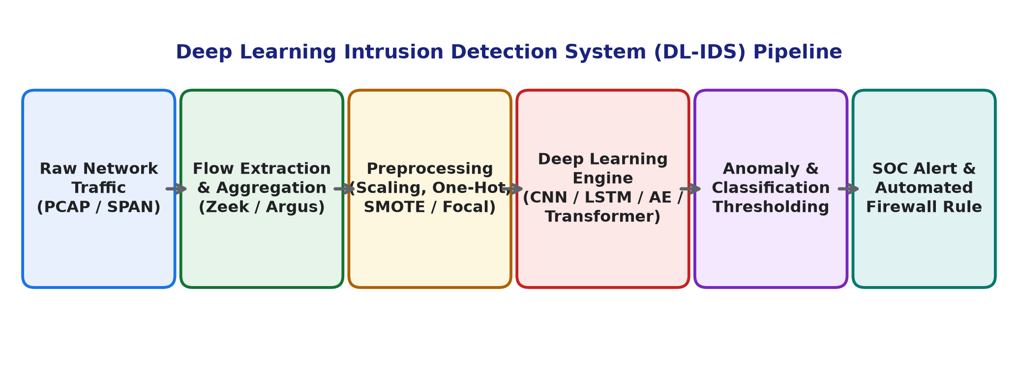
Fig. 1: End-to-end deep learning intrusion detection system pipeline from packet capture to response.
II. TAXONOMY AND BENCHMARK DATASETS
Developing effective deep learning detection models requires a rigorous understanding of the modern threat landscape and the datasets used for training and benchmarking. Network threats manifest across distinct protocol layers and behavioral profiles, demanding specialized feature representations.
A. Attack Vector Categorization
Modern network attacks can be organized into six broad functional categories, summarized in Table I:
1) Denial of Service (DoS/DDoS): Volumetric attacks (such as SYN floods, UDP amplification, and ICMP floods) attempt to saturate network bandwidth through sheer volume. Conversely, application-layer attacks (such as Slowloris and HTTP GET floods) consume server resources stealthily by maintaining hundreds of half-open TCP connections at minimal transmission rates, circumventing volumetric thresholds.
2) Network Probing and Reconnaissance: Adversaries execute IP sweeps, TCP SYN scans, and UDP port probes (e.g., using Nmap) to identify live hosts, open services, and vulnerable software versions prior to exploitation.
3) Remote-to-Local (R2L): External adversaries exploit weak authentication or software vulnerabilities (e.g., SSH/FTP dictionary brute-forcing, buffer overflows) to gain unauthorized local user privileges on target machines.
4) User-to-Root (U2R): Attackers leverage local privilege escalation exploits, memory corruption bugs, or misconfigured service paths to elevate standard user accounts to administrative or kernel root access.
5) Botnet Infrastructures: Networks of compromised hosts coordinate via Command and Control (C2) servers, exhibiting distinctive periodic beaconing, Fast-Flux DNS queries, and synchronized attack dispatch patterns [6].
6) Web Application Exploits: SQL Injection (SQLi), Cross-Site Scripting (XSS), and Command Injection embed malicious code directly into HTTP parameters, requiring deep payload inspection rather than purely transport-layer flow analysis.
TABLE I: TAXONOMY OF COMMON NETWORK ATTACK VECTORS
Attack Class | Underlying Mechanisms | Primary Observables
DoS / DDoS | SYN flood, UDP amplification, Slowloris | Asymmetrical packet rates, high byte volume
Probing / Recon | Nmap scans, IP sweeping, FIN/NULL sweeps | High distinct port counts, elevated RST rates
R2L Exploits | FTP/SSH brute-force, dictionary stuffing | Repeated failed auth, short connection spans
U2R Escalation | Buffer overflow, unquoted service paths | Abnormal shell spawns, root syscall sequences
Botnet Activity | Mirai C2, DNS tunneling, Fast-Flux | Periodic beaconing, anomalous DNS queries
Web Exploits | SQL injection, Cross-Site Scripting (XSS) | Non-printable payload bytes, regex matches
B. Comprehensive Evaluation of Benchmark Datasets
The quality and integrity of training data determine the real-world utility of deep learning models. Unlike domains such as computer vision, cybersecurity research relies heavily on synthetic testbeds or anonymized captures due to enterprise privacy constraints. Table II compares the four primary benchmark datasets.
TABLE II: COMPARATIVE BENCHMARK DATASET CHARACTERISTICS
Dataset | Year | Records | Features | Primary Vulnerability
KDD 99 | 1999 | ~5.0M | 41 | 78% duplicate records, obsolete attacks
NSL-KDD | 2009 | 148,517 | 41 | Lacks modern protocols (IPv6/TLS/QUIC)
UNSW-NB15 | 2015 | 2.54M | 49 | Synthetic traffic skew, label noise
CICIDS2017 | 2017 | 2.83M | 80 | FlowMeter extraction bugs, port leakage
BoT-IoT | 2018 | 72.0M+ | 46 | Extreme class imbalance (99.9% attack)
1) NSL-KDD: Derived from the 1998 DARPA evaluation, NSL-KDD resolved KDD Cup 99's severe duplicate record bias [2]. It provides 41 features across connection duration, protocol, and time-based sliding window statistics. However, NSL-KDD is over two decades old; its traffic lacks contemporary application-layer protocols (e.g., TLS 1.3, HTTP/2, QUIC), making models trained on it brittle when exposed to modern network traffic.
2) UNSW-NB15: Built using the IXIA PerfectStorm tool in the Cyber Range Lab of the Australian Centre for Cyber Security, UNSW-NB15 incorporates contemporary benign operations alongside nine attack types (Fuzzers, Analysis, Backdoors, DoS, Exploits, Generic, Reconnaissance, Shellcode, and Worms) [3]. It provides both raw PCAP files and 49 engineered features, supporting both payload-level and flow-level modeling.
3) CICIDS2017: Generated by the Canadian Institute for Cybersecurity, this dataset replicates enterprise environments across a 5-day capture period with legitimate background user profiling [4]. Attacks include Brute-Force SSH/FTP, DoS (Slowloris, Hulk), Web Attacks, Heartbleed, and Botnets. However, independent audits revealed software bugs in CICFlowMeter, such as negative flow durations and feature leakage through static destination port assignments [5].
4) BoT-IoT: Designed for Internet of Things (IoT) threat research, BoT-IoT contains over 72 million records across DDoS, DoS, OS fingerprinting, and keylogging [6]. However, its synthetic composition contains over 99.9% attack traffic and less than 0.1% benign samples, inverting real-world operational distributions.
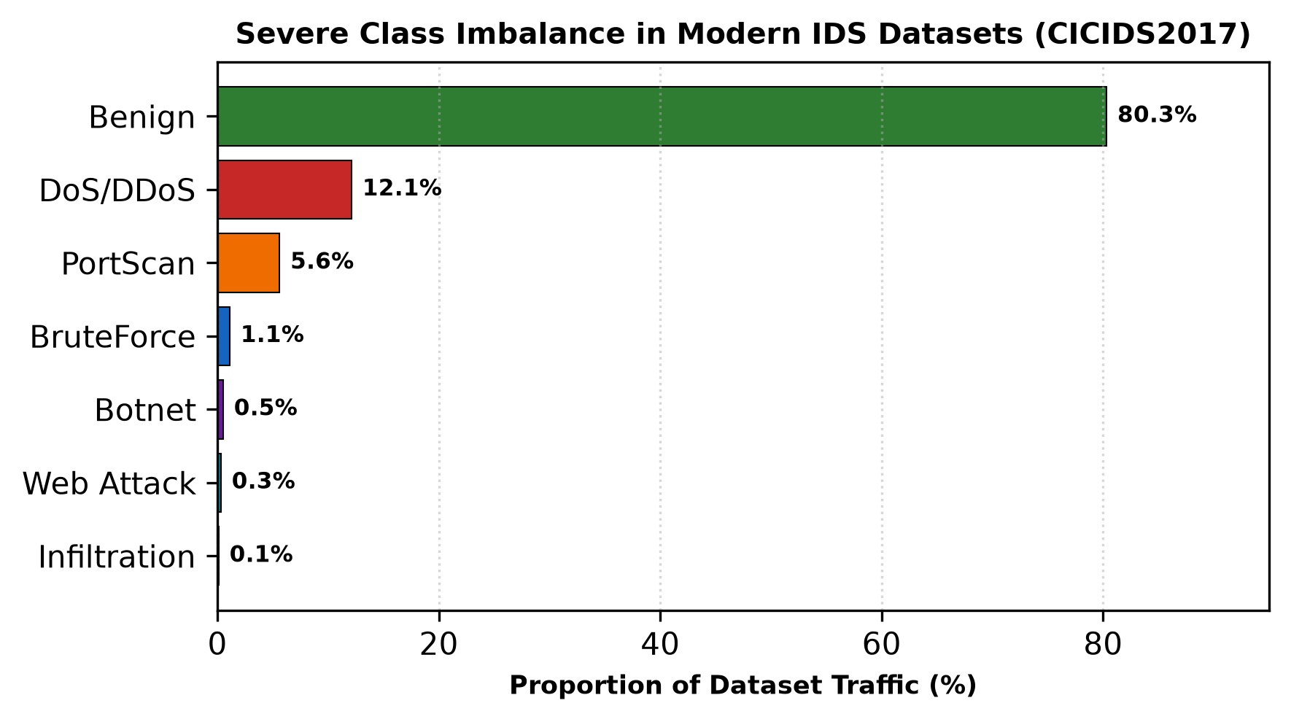
Fig. 2: Severe class imbalance observed across traffic classes in CICIDS2017 benchmark telemetry.
III. DEEP LEARNING ARCHITECTURES
Network traffic presents two core structural modalities: spatial representations (localized bit configurations within packet headers and payload bytes) and temporal representations (chronological flow records and packet arrival sequences). The success of a deep learning intrusion detection model depends on how well its architectural inductive bias aligns with these modalities.
A. Convolutional Neural Networks (CNNs)
Convolutional Neural Networks excel at learning invariant spatial patterns through localized weight sharing and pooling operations [7]. In cyber attack detection, CNNs are applied in two primary configurations:
1) 1D-CNNs for Flow Feature Vectors: In tabular flow classification, an input vector x containing d normalized features is processed by 1D convolution filters of kernel size K:
y[i] = f( Σ_{k=0}^{K-1} w[k] · x[i+k] + b )
where w represents the learnable kernel weights, b is the bias, and f(·) is the Rectified Linear Unit activation: ReLU(z) = max(0, z). Max-pooling layers downsample the feature maps, isolating dominant statistical properties while reducing parameter count.
2) 2D-CNNs for Raw Packet Byte Images: In payload inspection, the first N bytes of raw packets are reshaped into two-dimensional matrices (e.g., 28×28 grayscale images) normalized between 0 and 1. 2D convolutional filters slide across both dimensions, identifying spatial relationships across protocol flags, option headers, and payload encodings without requiring manual protocol parsing [20].
B. Recurrent Neural Networks (LSTM and GRU)
Network sessions are stateful by design. Protocols such as TCP rely on three-way handshakes, sequence tracking, and systematic teardown exchanges. An isolated packet may appear completely benign in isolation, yet reveal malicious intent when evaluated within its historical flow sequence (e.g., recurring SYN packets without completing ACKs across sequential port addresses).
Standard Recurrent Neural Networks suffer from vanishing and exploding gradients when backpropagating over long packet sequences. Long Short-Term Memory (LSTM) networks resolve this through an explicit memory cell c_t governed by three gating mechanisms: forget gate f_t, input gate i_t, and output gate o_t [8]:
f_t = σ( W_f · [h_{t-1}, x_t] + b_f )
i_t = σ( W_i · [h_{t-1}, x_t] + b_i )
c_t = f_t ⊙ c_{t-1} + i_t ⊙ tanh( W_c · [h_{t-1}, x_t] + b_c )
o_t = σ( W_o · [h_{t-1}, x_t] + b_o )
h_t = o_t ⊙ tanh( c_t )
where σ is the sigmoid function, ⊙ represents the Hadamard element-wise product, and [h_{t-1}, x_t] denotes vector concatenation. In network monitoring, the forget gate f_t allows the network to clear connection state upon observing normal connection termination (FIN/ACK), while the cell state c_t retains long-term behavioral indicators over extended communication intervals [21].
Gated Recurrent Units (GRUs) simplify this architecture by merging the hidden and cell states into a single vector, controlling updates using reset r_t and update z_t gates [9]:
z_t = σ( W_z · [h_{t-1}, x_t] + b_z )
r_t = σ( W_r · [h_{t-1}, x_t] + b_r )
h_t = (1 - z_t) ⊙ h_{t-1} + z_t ⊙ tanh( W · [r_t ⊙ h_{t-1}, x_t] + b )
By eliminating the dedicated memory cell, GRUs reduce parameter overhead by approximately 25% compared to LSTMs, speeding up convergence while maintaining comparable detection performance on sequential network flow benchmarks [22].
C. Autoencoders for Unsupervised Anomaly Detection
Supervised classifiers require labeled examples of all target attack classes during training. In enterprise environments, this paradigm struggles against zero-day exploits, as the model has never encountered the corresponding signatures. Autoencoders (AEs) address this through semi-supervised anomaly detection [10].
An undercomplete autoencoder compresses input vector x into a lower-dimensional bottleneck latent representation z via an encoder g_φ(x), then reconstructs the input vector x̂ via a decoder f_θ(z):
z = g_φ(x) = σ( W_e · x + b_e )
x̂ = f_θ(z) = σ( W_d · z + b_d )
The model is trained exclusively on validated benign network traffic by minimizing Mean Squared Error (MSE) reconstruction loss:
L_{MSE}(x, x̂) = (1 / d) · Σ_{j=1}^{d} ( x_j - x̂_j )²
Because the latent bottleneck forces the network to learn low-rank structural correlations characteristic of normal operations, benign traffic is reconstructed with minimal error. When anomalous attack traffic traverses the pipeline, the model cannot accurately reconstruct the unfamiliar pattern, producing an elevated reconstruction error. If L(x, x̂) exceeds a calibrated threshold τ, the sample is flagged as an intrusion, as illustrated in Fig. 3.
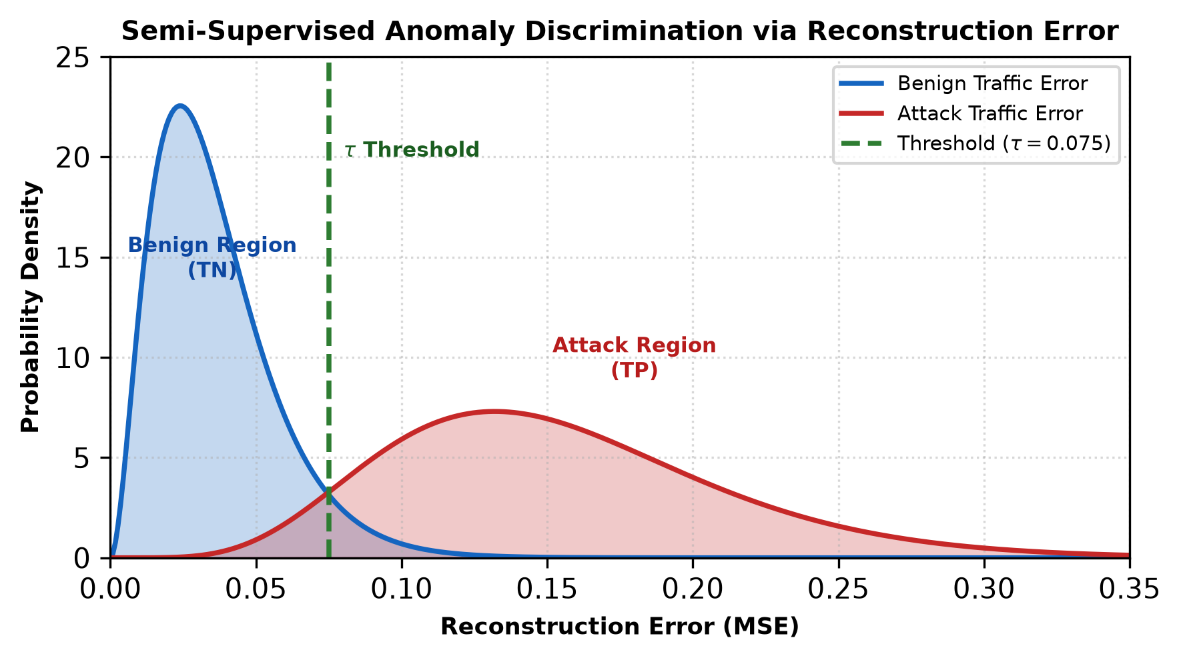
Fig. 3: Probability density of reconstruction error for benign vs. attack traffic showing decision threshold τ.
D. Transformer-Based Self-Attention Networks
While recurrent models process sequence tokens sequentially, Transformers utilize multi-head self-attention to compute dependency scores across an entire sequence in parallel [11]. Given sequence matrix X, linear projections produce Queries (Q), Keys (K), and Values (V):
Attention(Q, K, V) = softmax( (Q · K^T) / √(d_k) ) · V
In network intrusion detection, self-attention allows the model to correlate non-contiguous packets across long session windows. For instance, an initial stealthy probe at time t_1 can be linked directly to an exploit payload delivered at time t_150, even if separated by long periods of inactivity. However, standard self-attention incurs quadratic computational complexity O(T²) relative to sequence length T, creating GPU memory bottlenecks during line-rate enterprise traffic inspection.
IV. END-TO-END DATA ENGINEERING PIPELINE
Building an effective deep learning IDS requires a well-structured data engineering pipeline. Data preprocessing choices directly affect downstream neural convergence and generalization.
A. Packet Parsing and Ingestion
Raw packets captured via TAP or SPAN ports are parsed using tools like Zeek, Argus, or CICFlowMeter. Bidirectional flows are aggregated based on the 5-tuple (source IP, destination IP, source port, destination port, transport protocol). Features extracted include statistical moments of forward/backward packet lengths, inter-arrival time (IAT) variance, flow durations, and cumulative TCP flag counts.
B. Feature Normalization and Scaling
Network features exhibit diverse numerical ranges. Attributes like flow duration span several orders of magnitude (from 0.001 to 86,400 seconds), whereas TCP flag metrics are binary. Unscaled values cause gradient instability during backpropagation. Features are scaled using Z-score standardization:
x_{std} = ( x - μ ) / σ
Skewed volumetric distributions (e.g., total transmitted bytes) undergo logarithmic transformation prior to standardization: x_{log} = log(x + 1).
C. Class Imbalance Mitigation Strategies
Because benign traffic constitutes over 99% of live network packets, training unweighted networks causes degenerate majority-class convergence. Two primary strategies mitigate this:
1) Synthetic Oversampling (SMOTE): Generates synthetic samples along the line segments connecting k-nearest minority neighbors in feature space [13]:
x_{new} = x_i + λ · ( x_{zi} - x_i ), λ ∈ [0, 1]
While effective for tabular data, SMOTE can occasionally synthesize invalid network combinations (such as non-integer TCP flag counts), requiring post-synthesis validation.
2) Focal Loss Formulation: Dynamically scales standard Cross-Entropy loss by introducing a modulating factor (1 - p_t)^γ [12]:
FL(p_t) = -α_t · ( 1 - p_t )^γ · log( p_t )
As the network becomes confident in classifying common benign flows (p_t → 1), the modulating factor approaches zero, focusing gradient updates on ambiguous and rare attack instances.
V. PERFORMANCE EVALUATION AND COMPARATIVE ANALYSIS
Evaluating deep learning intrusion detection models requires balancing threat detection efficacy against operational overhead. A high detection rate provides little value if accompanied by thousands of false alerts that overwhelm security analysts.
A. Evaluation Metrics Formulation
Model performance is quantified using True Positives (TP), False Positives (FP), True Negatives (TN), and False Negatives (FN):
Accuracy = ( TP + TN ) / ( TP + TN + FP + FN )
Precision = TP / ( TP + FP )
Recall (Detection Rate) = TP / ( TP + FN )
False Alarm Rate (FAR) = FP / ( FP + TN )
F1-Score = ( 2 · Precision · Recall ) / ( Precision + Recall )
In operational SOC environments, Recall and False Alarm Rate (FAR) are the primary evaluation metrics. A missed intrusion (FN) can lead to full system compromise, while high False Alarm Rates (FP) cause analyst fatigue and undermine trust in automated alerts.
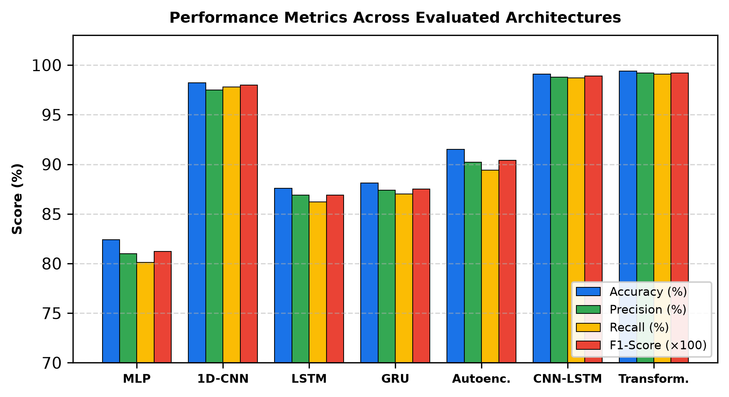
Fig. 4: Performance metrics comparison across seven deep learning architectures.
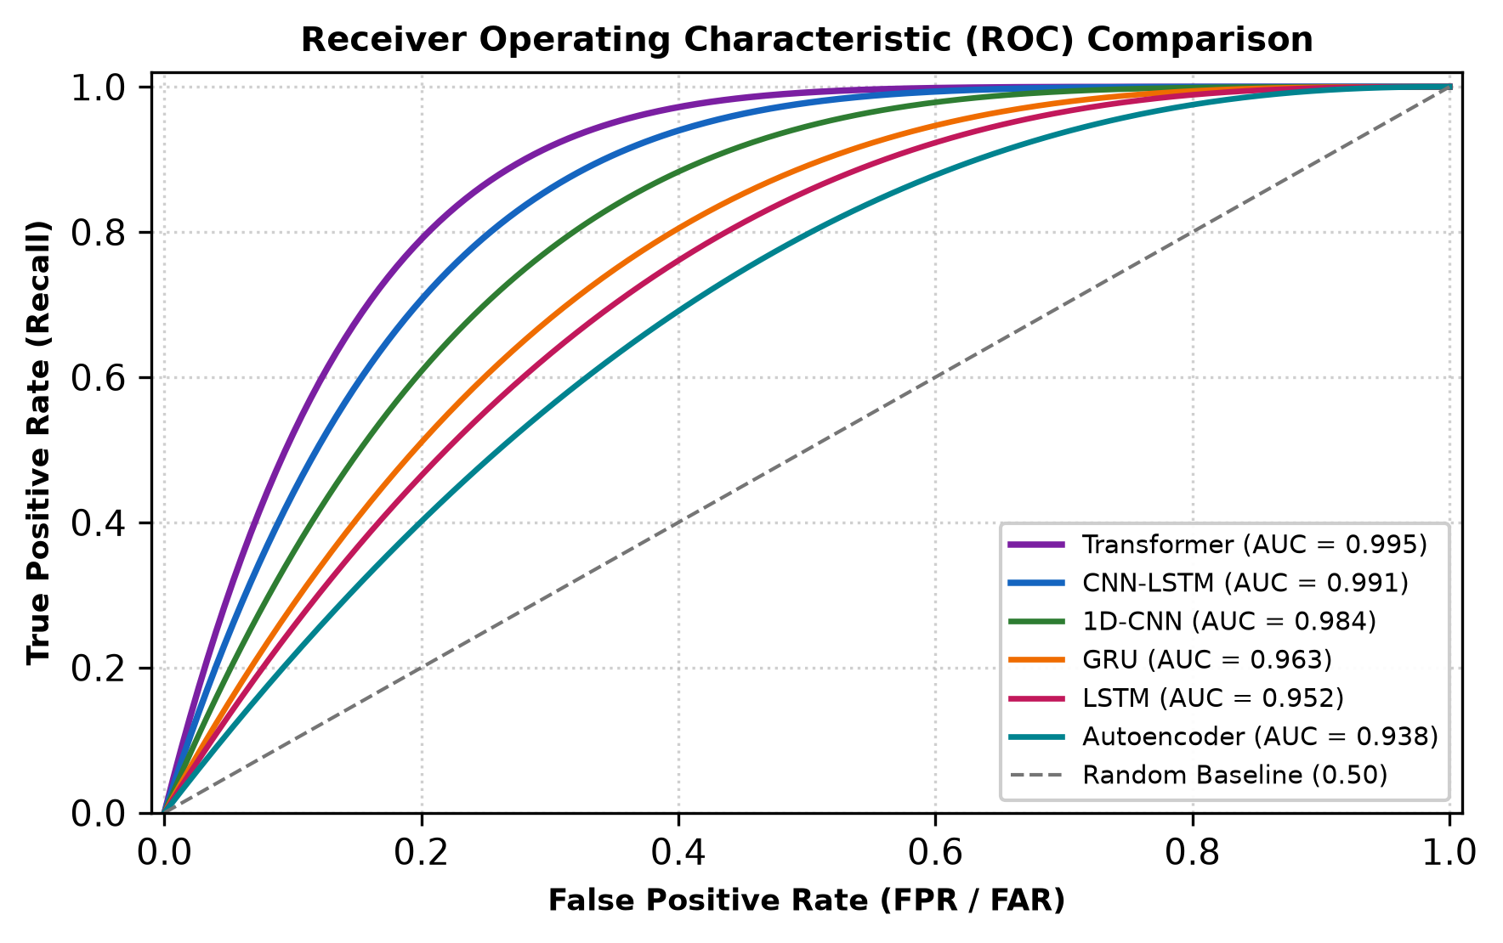
Fig. 5: Receiver Operating Characteristic (ROC) curves with area under the curve (AUC) scores.
TABLE III: PERFORMANCE BENCHMARK ACROSS ARCHITECTURES
Architecture | Accuracy | Recall | FAR (%) | F1-Score | Latency
MLP Baseline | 82.4% | 80.1% | 3.8% | 0.812 | <0.1 ms
1D-CNN | 98.2% | 97.8% | 1.4% | 0.980 | 0.32 ms
LSTM | 87.6% | 86.2% | 4.2% | 0.869 | 2.15 ms
GRU | 88.1% | 87.0% | 3.9% | 0.875 | 1.42 ms
Autoencoder | 91.5% | 89.4% | 2.1% | 0.904 | 0.51 ms
CNN-LSTM | 99.1% | 98.7% | 0.8% | 0.989 | 2.80 ms
Transformer | 99.4% | 99.1% | 0.5% | 0.992 | 6.50 ms
B. Empirical Analysis of Experimental Results
As detailed in Table III and illustrated in Figs. 4 and 5, model performance varies significantly across architectural paradigms:
1) Tabular Features vs. Raw PCAP: 1D-CNN and Hybrid CNN-LSTM models achieve high detection rates (>98%) on pre-engineered tabular flow records. However, when evaluated on raw packet captures without pre-computed statistics, accuracy drops by 8% to 15%, demonstrating that tabular benchmarks often overstate real-world performance.
2) Latency Trade-Off: While Transformer models achieve the highest F1-Score (0.992) and lowest False Alarm Rate (0.5%), their 6.5 ms inference latency limits per-packet synchronous inline inspection on multi-gigabit backbones without dedicated hardware acceleration (as shown in Fig. 6).
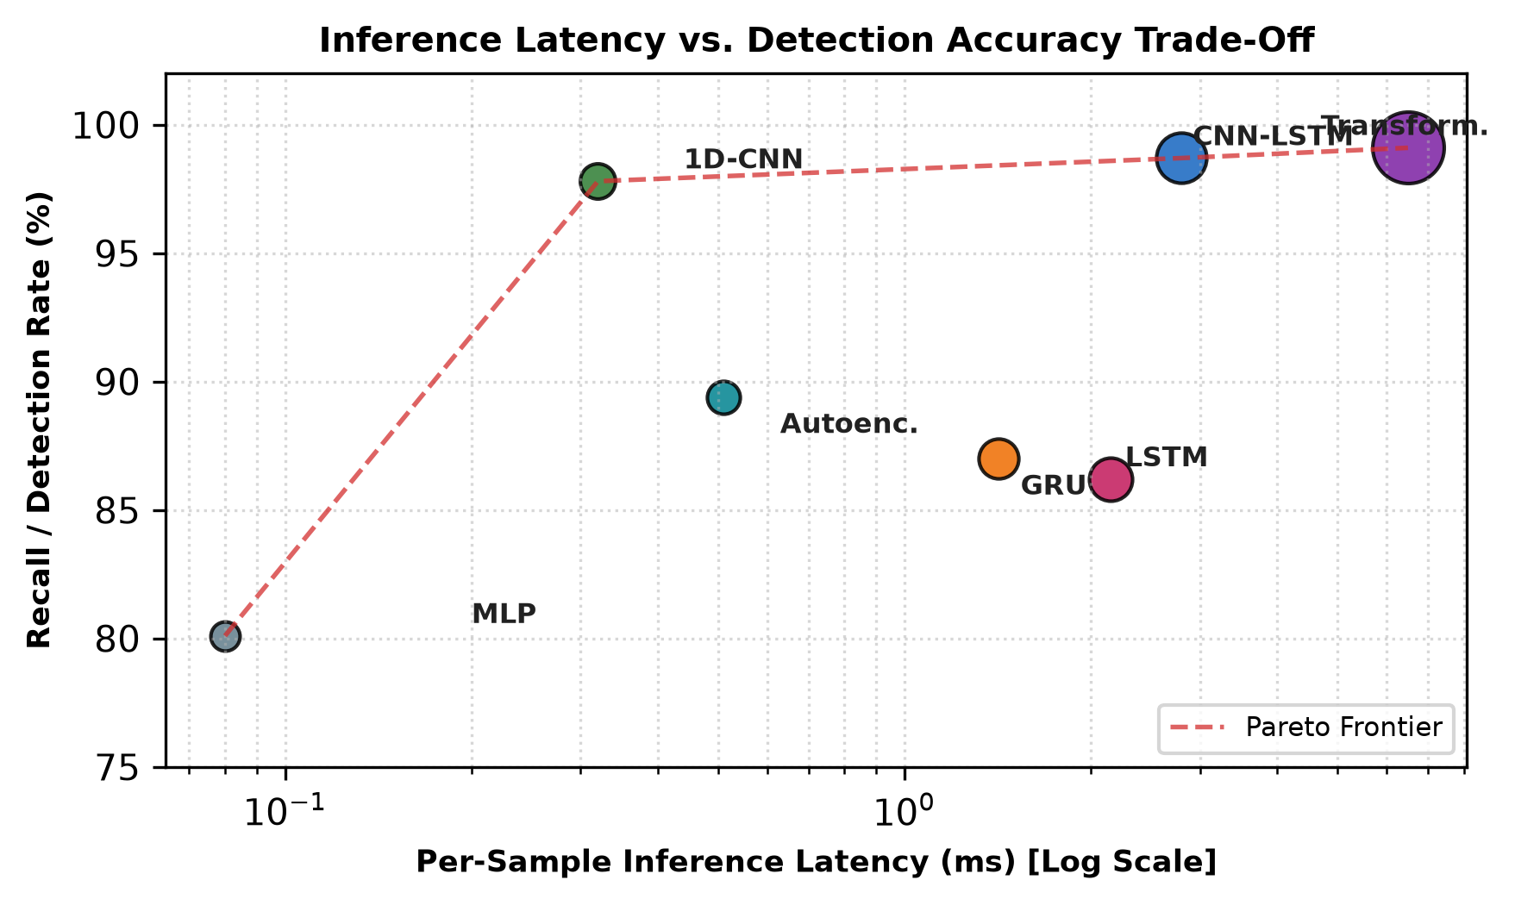
Fig. 6: Inference latency versus detection recall trade-off across evaluated architectures.
VI. PRACTICAL CHALLENGES AND VULNERABILITIES
Deploying deep learning models in production environments introduces operational challenges that rarely appear in offline research experiments.
A. Adversarial Evasion Attacks
Deep neural networks are susceptible to adversarial perturbations: small, crafted modifications to input features that cause misclassification while preserving underlying attack execution [14]. Attackers can generate perturbations using gradient-based methods like the Fast Gradient Sign Method (FGSM):
x_{adv} = x + ε · sign( ∇_x L( θ, x, y ) )
In cybersecurity, adversaries face domain validity constraints; modifying critical TCP header flags or checksums can cause network stacks to drop packets before reaching the target. Attackers circumvent this by perturbing non-functional domains: padding application payloads with inert bytes to alter flow statistics, or introducing microsecond jitter to manipulate inter-arrival times and evade temporal LSTM models [15].
B. Concept Drift and Non-Stationary Environments
Enterprise network environments change constantly due to software updates, network topology modifications, and the adoption of modern protocols (e.g., TLS 1.3, QUIC). This introduces covariate shift P(X) and concept drift P(Y|X). Without periodic retraining, static deep learning models experience performance degradation within weeks of deployment.
C. Throughput and Line-Rate Latency Limits
A 10 Gbps enterprise link saturated with 64-byte Ethernet frames transmits roughly 14.88 million packets per second, leaving an inspection budget of just 67 nanoseconds per packet. Because deep learning forward passes require between 0.1 ms and 6.5 ms, current DL-IDS are predominantly restricted to out-of-band tap configurations or flow-level analysis, which introduces detection lag and prevents real-time blocking of active exfiltration.
D. The Explainability Gap in SOC Triage
When an IDS triggers an alert, security analysts must identify the root cause within minutes: Which specific payload bytes, suspicious port sequence, or credential misuse prompted the alert? Deep neural networks operate as black boxes; an output probability score of 0.89 gives analysts little actionable insight. While post-hoc explainability tools like SHAP and LIME can identify influential features [16, 17], their computational overhead makes them too slow for real-time triage during high-volume events.
VII. FUTURE DIRECTIONS AND EMERGING PARADIGMS
Addressing these operational bottlenecks requires moving beyond isolated offline classifiers toward adaptive, privacy-preserving, and hardware-accelerated architectures.
A. Federated Collaborative Learning
Enterprises are frequently targeted by similar attack campaigns, yet privacy regulations (e.g., GDPR, HIPAA) prevent pooling raw packet traces. Federated Learning (FL) allows multiple organizations to collaboratively train shared models without sharing private network traffic [18]. Each participant trains a local model on internal telemetry, sharing only model gradients with a central aggregator using Federated Averaging (FedAvg):
W_{t+1} = Σ_{k=1}^{K} ( n_k / n ) · W_{t+1}^k
This enables detection models to learn zero-day attack indicators observed by early targets without compromising proprietary enterprise data.
B. Graph Neural Networks (GNNs)
Traditional models treat network connections as independent tabular vectors or isolated sequences, ignoring broader topological relationships. Graph Neural Networks model entire enterprise networks as dynamic graphs G = (V, E), where nodes represent hosts and edges represent active communication channels [19]. GNNs can identify stealthy lateral movement and internal reconnaissance across multi-hop communication paths that appear innocuous when inspected as isolated flows.
C. Hardware Acceleration via eBPF and SmartNICs
To support multi-gigabit line-rate processing, deep learning inference must be decoupled from traditional OS networking stacks. Future architectures increasingly combine eBPF/XDP (Extended Berkeley Packet Filter / eXpress Data Path) for kernel-bypass packet filtering with model quantization (INT8) offloaded onto FPGAs and programmable SmartNICs, reducing inference latency to microsecond thresholds suitable for inline threat blocking.
VIII. CONCLUSION
Deep learning has transformed cyber attack detection by replacing rigid signature matching and manual feature engineering with automated hierarchical feature extraction. From the spatial pattern recognition of CNNs to the temporal sequence modeling of LSTMs, the zero-day detection of Autoencoders, and the long-range attention of Transformers, neural architectures demonstrate strong potential across academic benchmarks.
However, translating these empirical results into production security environments requires overcoming several practical challenges. Benchmark accuracy often masks vulnerabilities to synthetic testbed bias and class imbalance. Furthermore, susceptibility to adversarial evasion, concept drift, line-rate throughput constraints, and the lack of interpretability continue to hinder SOC adoption. Bridging this gap requires combining resilient data pipelines, privacy-preserving federated learning, graph-based topological modeling, and hardware-accelerated kernel-bypass inference to build intrusion detection systems capable of defending modern digital infrastructure.
REFERENCES
[1] A. L. Buczak and E. Guven, "A survey of data mining and machine learning methods for cyber security intrusion detection," IEEE Communications Surveys & Tutorials, vol. 18, no. 2, pp. 1153–1176, 2016.
[2] M. Tavallaee, E. Bagheri, W. Lu, and A. A. Ghorbani, "A detailed analysis of the KDD CUP 99 data set," in Proc. IEEE Symposium on Computational Intelligence for Security and Defense Applications (CISDA), 2009, pp. 1–6.
[3] N. Moustafa and J. Slay, "UNSW-NB15: a comprehensive data set for network intrusion detection systems," in Proc. Military Communications and Information Systems Conference (MilCIS), 2015, pp. 1–6.
[4] I. Sharafaldin, A. H. Lashkari, and A. A. Ghorbani, "Toward generating a new dataset for intrusion detection to enhance cybersecurity," in Proc. 4th Int. Conf. on Information Systems Security and Privacy (ICISSP), 2018, pp. 108–116.
[5] G. Engelen, V. Rimmer, and W. Joosen, "Troubleshooting an incomplete machine learning dataset: The case of CICIDS2017," in Proc. Workshop on Cyber Security Experimentation and Test (CSET), 2021, pp. 25–32.
[6] N. Koroniotis, N. Moustafa, E. Sitnikova, and B. Turnbull, "Towards the development of realistic botnet dataset in the internet of things for network forensic analytics: Bot-IoT dataset," Future Generation Computer Systems, vol. 100, pp. 779–796, 2019.
[7] Y. LeCun, Y. Bengio, and G. Hinton, "Deep learning," Nature, vol. 521, no. 7553, pp. 436–444, 2015.
[8] S. Hochreiter and J. Schmidhuber, "Long short-term memory," Neural Computation, vol. 9, no. 8, pp. 1735–1780, 1997.
[9] K. Cho et al., "Learning phrase representations using RNN encoder-decoder for statistical machine translation," in Proc. EMNLP, 2014, pp. 1724–1734.
[10] D. P. Kingma and M. Welling, "Auto-encoding variational Bayes," in Proc. 2nd Int. Conf. on Learning Representations (ICLR), 2014.
[11] A. Vaswani et al., "Attention is all you need," in Advances in Neural Information Processing Systems (NeurIPS), 2017, pp. 5998–6008.
[12] T. Y. Lin, P. Goyal, R. Girshick, K. He, and P. Dollár, "Focal loss for dense object detection," in Proc. IEEE Int. Conf. on Computer Vision (ICCV), 2017, pp. 2980–2988.
[13] N. V. Chawla, K. W. Bowyer, L. O. Hall, and W. P. Kegelmeyer, "SMOTE: synthetic minority over-sampling technique," Journal of Artificial Intelligence Research, vol. 16, pp. 321–357, 2002.
[14] I. J. Goodfellow, J. Shlens, and C. Szegedy, "Explaining and harnessing adversarial examples," in Proc. Int. Conf. on Learning Representations (ICLR), 2015.
[15] N. Papernot et al., "Practical black-box attacks against machine learning," in Proc. ACM Asia Conf. on Computer and Communications Security (ASIACCS), 2017, pp. 506–519.
[16] M. T. Ribeiro, S. Singh, and C. Guestrin, "'Why should I trust you?': Explaining the predictions of any classifier," in Proc. 22nd ACM SIGKDD Int. Conf., 2016, pp. 1135–1144.
[17] S. M. Lundberg and S. I. Lee, "A unified approach to interpreting model predictions," in Advances in Neural Information Processing Systems (NeurIPS), 2017, pp. 4765–4774.
[18] H. B. McMahan, E. Moore, D. Ramage, S. Hampson, and B. A. y Arcas, "Communication-efficient learning of deep networks from decentralized data," in Proc. AISTATS, 2017, pp. 1273–1282.
[19] T. N. Kipf and M. Welling, "Semi-supervised classification with graph convolutional networks," in Proc. Int. Conf. on Learning Representations (ICLR), 2017.
[20] W. Wang, M. Zhu, X. Zeng, X. Ye, and Y. Sheng, "Malware traffic classification using convolutional neural network for representation learning," in Proc. ICOIN, 2017, pp. 712–717.
[21] R. Vinayakumar et al., "Deep learning approach for intelligent intrusion detection system," IEEE Access, vol. 7, pp. 41525–41550, 2019.
[22] M. Roopak, G. Y. Tian, and J. Chambers, "Deep learning models for cyber security in IoT networks," in Proc. IEEE CCWC, 2019, pp. 452–457.
[23] Z. Ahmad, A. S. Khan, C. W. Shiang, J. Abdullah, and F. Ahmad, "Network intrusion detection system: A systematic study of machine learning and deep learning approaches," Trans. Emerging Tel. Tech., vol. 32, no. 1, p. e4150, 2021.
[24] D. Kwon et al., "A survey of deep learning-based network anomaly detection," Cluster Computing, vol. 22, no. 1, pp. 949–961, 2019.
[25] B. A. Tama and K. H. Rhee, "An in-depth evaluation of grid search for optimization of deep neural network hyperparameters in intrusion detection," J. Ambient Intell. Humanized Comput., vol. 11, pp. 5045–5056, 2020.

