Road Lane Line Detection

# Members (Group no. 21):-

# Pirtpal Singh (18103022)

# Saurav Anthwal (18103052)

# Saurav Chugh (18103044)

# Sahil Sabharwal (18103059)

**Under the supervision of**

**1. Mrs Rupali Verma**

**2. Mrs Alka Jindal**

# Motivation :-

# The road accidents are the main causes for the sudden death in this world. Even though we have many good and advanced techniques in this world, we are left over with something to make it better than before. The road lane detection and object detection is one of the important ways that we can improve the safety in roads. Vehicle crashes remain the leading cause of accident death and injuries in Malaysia and Asian countries claiming tens of thousands of lives and injuring millions of people each year. Most of these transportation deaths and injuries occur on the nation’s highways. Countries like U.S, India, other Asian countries have many deaths and injuries due to heavy traffic. In intelligent transportation systems with improved technologies, the vehicles are made more sophisticated with better infrastructure. But the way to move on the roads by means of lane and object detection aspect is neglected by many automobile companies and the ways to improve these aspects does not change from many years. Lane detection and object detection plays vital role for accidents. For human vision and human intelligence the task of lane detection and object detection changes due to variations in the road conditions. Sometimes it is very easy to detect with the human eyes but in some conditions due to externals effects the human intelligent have detection problems. Due too many external conditions that appears for the lane detection and obstacle detection which may lead for the accidents. They are conditions such as appearances such as change of Light conditions at Night vision, shadows caused by building and trees, existence of surrounding objects, Mismatching of lanes, and lane changes in curved roads. So in our research we provide the way to improve the lane detection and object detection in vehicles as it is important than rest of the other categories that may avoid the many road accidents. Lane should have to be detected clearly even with the external factors in consideration. The object detection will provide driving person confidences even in the different lighting and different environments situations by improved techniques to detect the objects.

# Objective:-

1.) To identify dangerous situations involves deep analysis of the environment, including elements such as road, vehicles, pedestrians, traffic signs, etc. and the relationships among them.

2.) To integrate the use of advanced technologies with driving assistances system.

3.) To create a system that provides a means of warning to the driver has the potential to save a considerable number of lives

**Requirement:-**

We will be making this project using python3 language and using concepts of machine learning and deep learning. We will be using different libraries:- moviepy, opencv, matplotlib, numpy. OpenCv library of python will be used to make this projects. Python compilers like spyder, jupyterNotebooks will be used to compile.

**Details:-**

Lane Line detection is a critical component for self driving cars and also for computer vision in general. This concept is used to describe the path for self-driving cars and to avoid the risk of getting in another lane.To detect the lane we have to detect the white markings on both sides on the lane.

Using computer vision techniques in Python, we will identify road lane lines in which autonomous cars must run. This will be a critical part of autonomous cars, as the self-driving cars should not cross it’s lane and should not go in opposite lane to avoid accidents.

To detect white markings in the lane, first, we need to mask the rest part of the frame. We do this using frame masking. The frame is nothing but a NumPy array of image pixel values.

After making we need to detect lane lines. The technique used to detect mathematical shapes like this is called Hough Transform. Hough transformation can detect shapes like rectangles, circles, triangles, and lines.

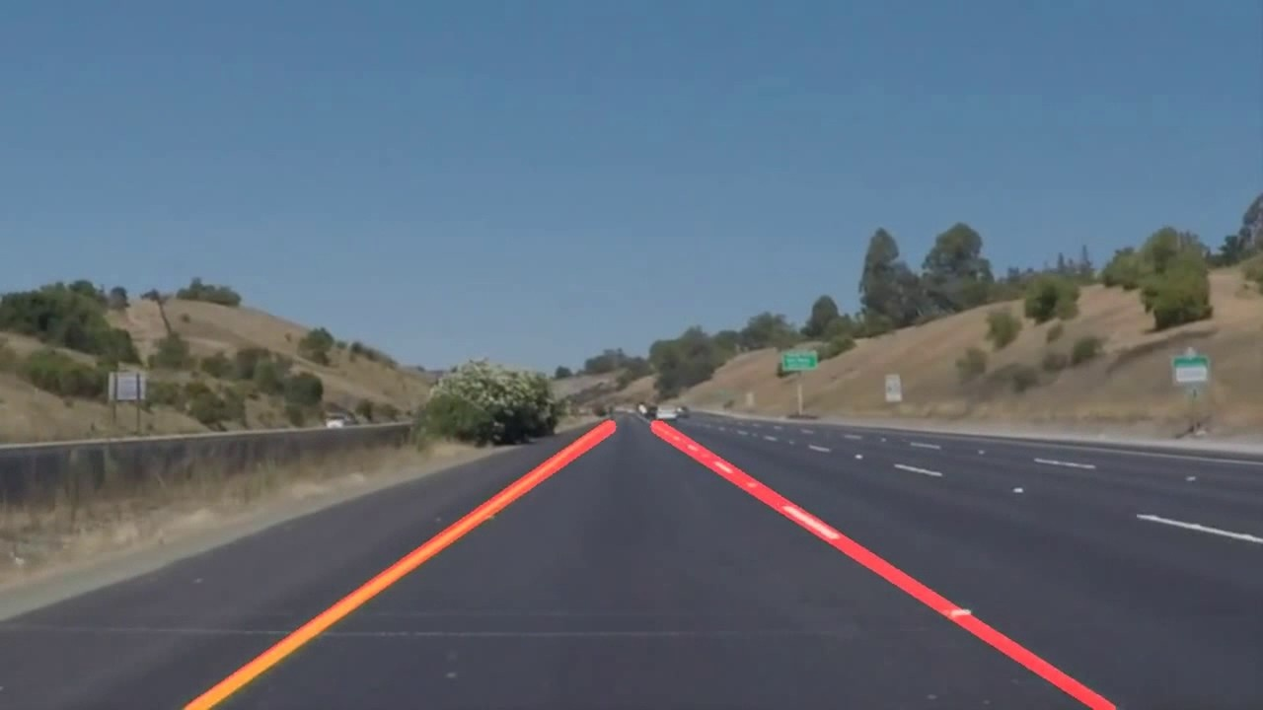

**Algorithms used :-**

1.)Canny Transform, a popular edge-detection algorithm. Here, it takes two threshold values to determine how little and how much change is acceptable to be considered a valid edge. This is an important parameter that we tweak to achieve the best possible result.

We use this algorithm to detect edges on both side of road, which acts as a framework for our area of work.

We mask out most of the image and only keep the bottom part of the road in view to avoid unnecessary processing of edges (like trees,other vechicles,etc).

2.) Hough Transform :- to convert the pixel dots that were detected as edges into meaningful lines. It takes a bunch of parameters, including how straight should a line be to be considered a line and what should be the minimum length of the lines. It will also connect consecutive lines for us.This is a key parameter for us to be able to join a dashed lane into a single detected lane line.

**WORKFLOW DIAGRAM:-**

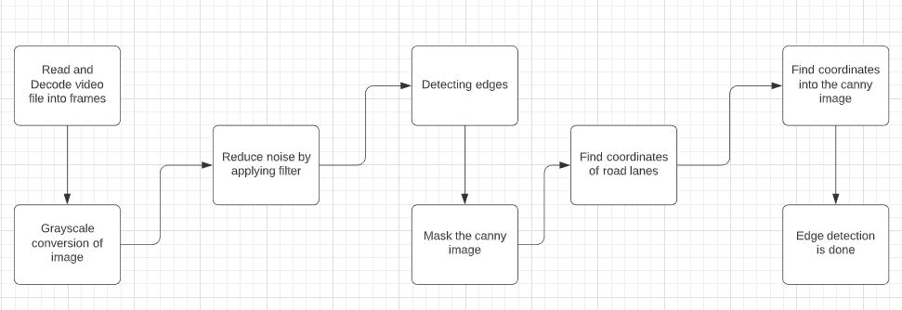

**Key features of application:-**

1.) Application will detect lines using python and OpenCV (Open-Source Computer Vision).

2.) OpenCV is a library of programming functions mainly aimed at real-time computer vision. OpenCV was built to provide a common infrastructure for computer vision applications and to accelerate the use of machine perception.

3.) MoviePy , a Python library is used for processing video in this project . MoviePy can read and write all the most common audio and video formats, including GIF, and runs on Windows/Mac/Linux, with Python 2.7+ and 3 (or only Python 3.4+ from v.1.0).