1. Using for loop, write and run a Python program for this algorithm.
Here is an algorithm to print out n! from 0! to 10!
Ans.

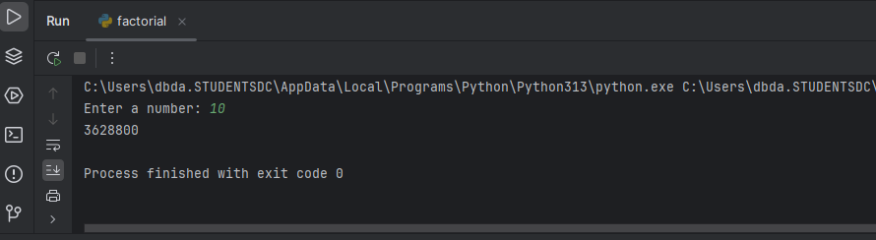

- Find prime numbers between a given range - start(take start no) , end (take end number)
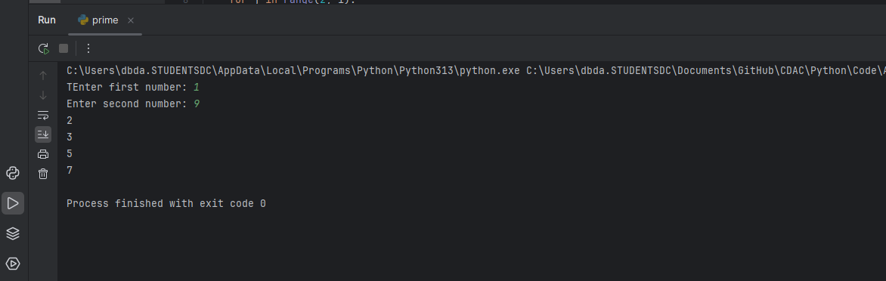

3. Write a python program to swap a 3 digit number
input 321
output 123
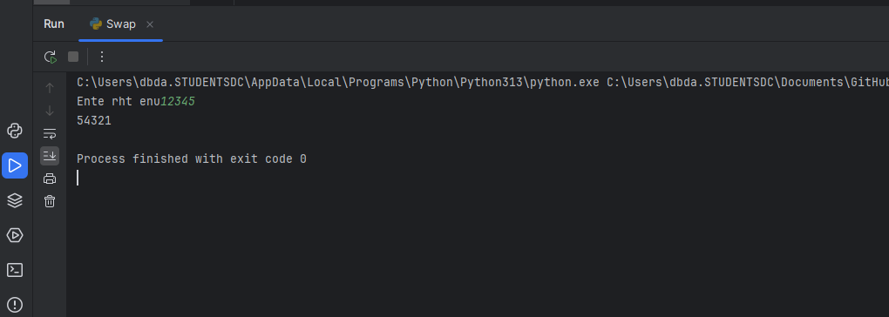

4. Count Digits, Even/Odd, Sum
e.g. 23456
output digits : 5
sum : 20
Even digits : 3
odd digits :2
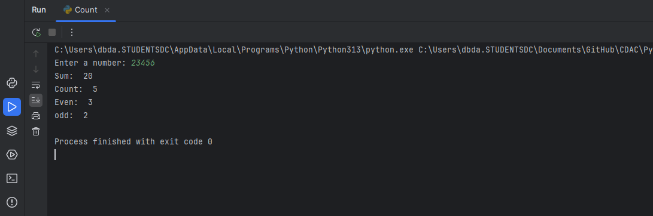

5. Write a program to check if given triangle is valid if 3 sides of the triangle are provided.
Also print the type of triangle

- Find LCM and GCD for given numbers [taek 2 numbers] using loops only

GFG Armstrong number:
