- The main point is that when a Seller registers for a Selling Plan via Dokan, the system doesn't work when we check the box 'recurring payment' - see attached

We need to make sure that every seller signed up to either the 'start up' plan or 'pro' plan are charged on a monthly basis with the option to downgrade/upgrade or cancel at any time

Can you please look into this for us?

E.g. when signing up for ‘Pro’ Plan or ‘Start up’ Plan – sellers still can’t seem to list products?

2. From a commission point of view, we need you to undertake tests and to be certain on the following:
Brags takes a 10% Commission on EVERY Product Sale - the commission goes directly to us (the site owner)
Braggers (affiliates) also take an additional 5% on EVERY Successful Affiliate Product Sale - the commission goes directly to Affiliate (we, the site owner need to approve this commission)
So, typically 10% commission is charged on every sale but sometimes 15% is charged if it is an affiliate sale .... Brags (the site owner) will always get 10% commission on every sale no matter what
Please can you double check the above and make sure the site is set up in this way... we need to be certain here

3. On the Registration page below, please say
‘REGISTER (as a Customer or a Seller)’ on the right hand side
If you looking to purchase products on Brags, please select ‘I am a Customer’ to access your order status and history. If you are a Seller, please select ‘I am Seller’ to apply to sell.

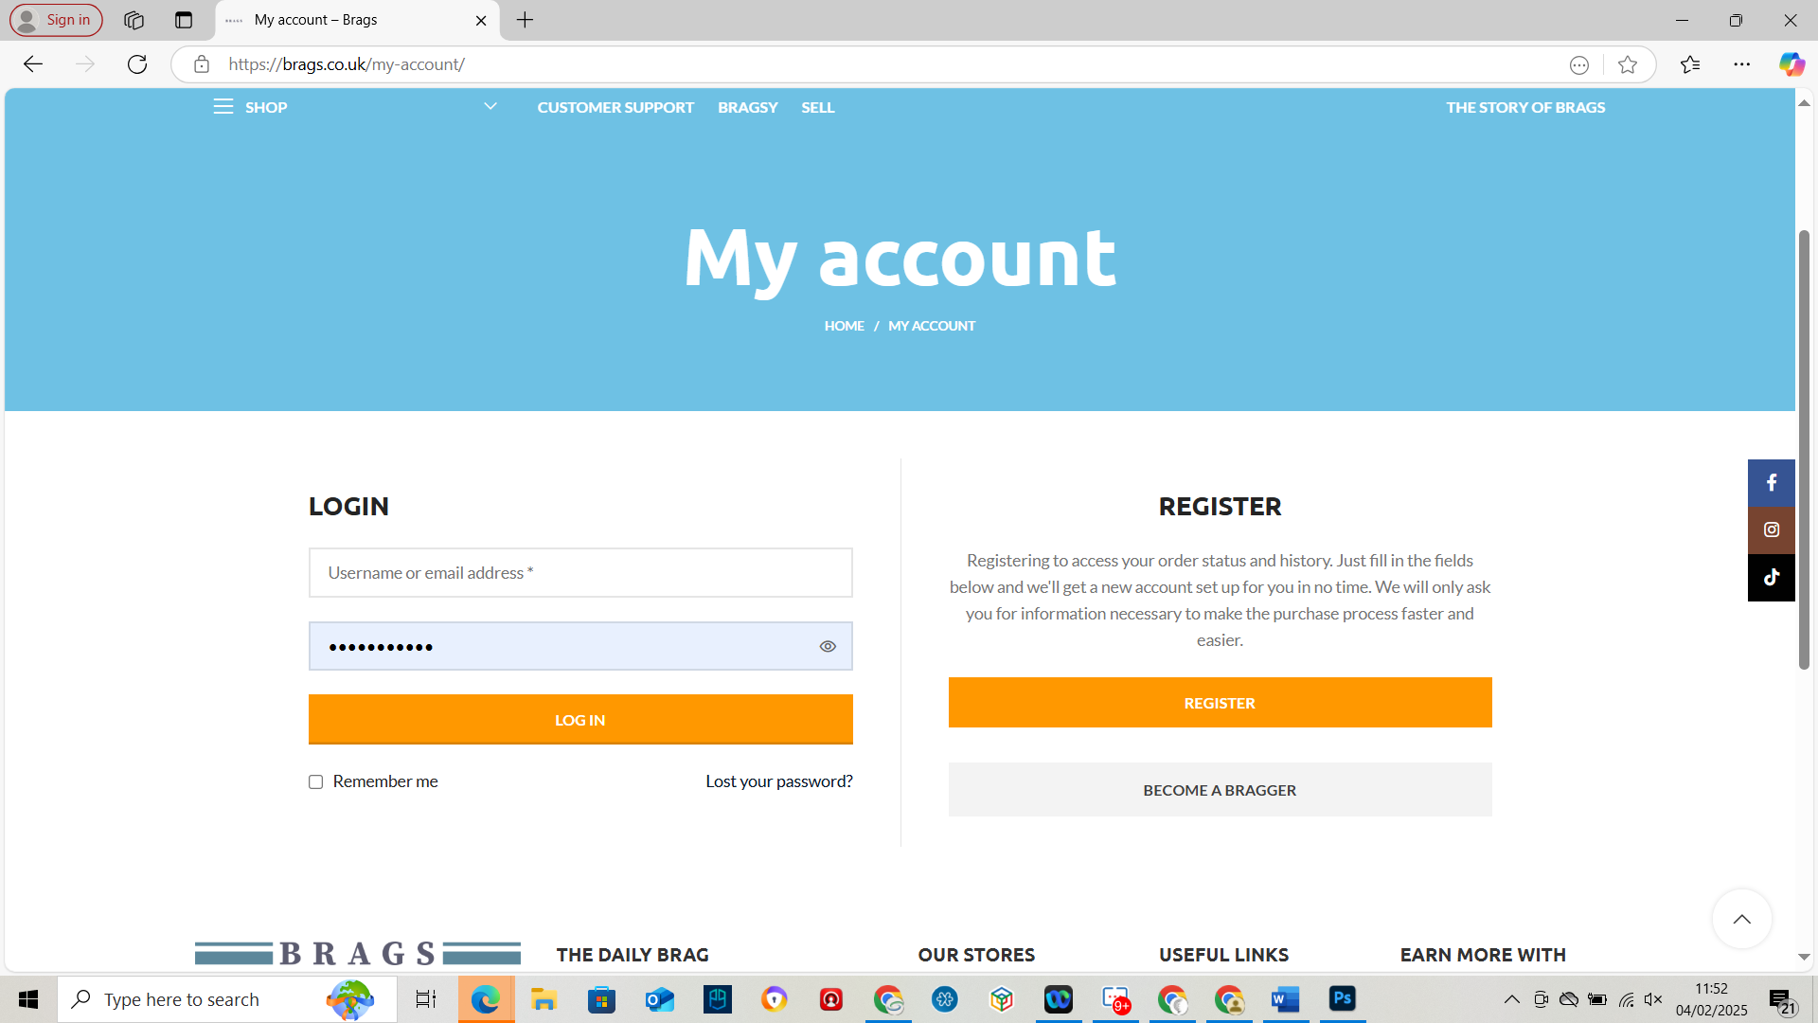

4. Can you please include ‘Business Type’ as a dropdown that includes the following options
Private Company
Public Company
Partnership
Self-Employed
Other

5. Can we also add the following fields into the Seller Registration page under both Seller Account Types ‘Business’ and ‘Individual’

If you will be selling ‘Branded’ products, please confirm the following:
(check box) I will be selling Branded products on Brags and I/my company has the rights to sell these products in the UK
Brands you intend to sell on Brags
(Multi-line Box to input multiple Brand Names)
Proof of Brand Ownership/Authorisation from the Brand Owner
Choose File (option to upload multiple files, up to 10 – JPEGS/Word Docs/PDFs)
If you will be selling ‘Unbranded’ Products, please confirm the following:
(check box) I will be selling unbranded products on Brags and I/my company has the rights to sell these products in the UK

Where to input fields when ‘Business’ account type is selected
Remove ‘Business Information’ when seller selects ‘Individual’ as account type but please include new ‘Brand’s Fields above
6. Please include our Seller Policy under the Seller Registration Only
Please confirm that you have read and agree to our Terms & Conditions and Brags Seller Policy
7. Please update Privacy Policy under registration to this link
www.brags.co.uk/privacy-policy/

8. Under ‘Select Category’ on main customer search
Can you please make sure these are set by Default to our Parent Categories

These are our Parent Categories displayed under SHOP (please replicate to the same place next to product search bar.

