Warm-Up 1: List Active Products
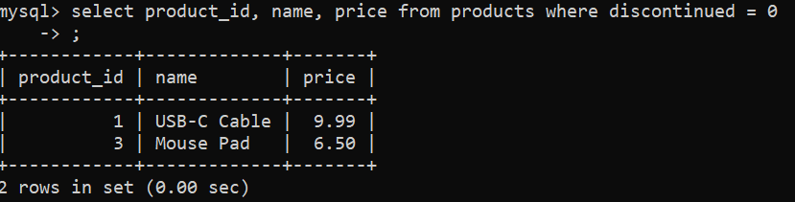

Warm-Up 2: Students Missing Email
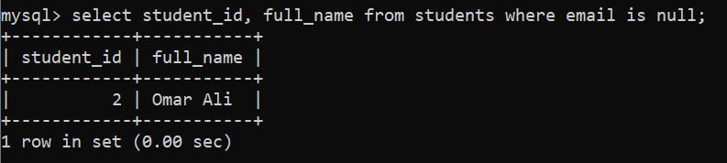
Warm-Up 3: Upcoming Appointments
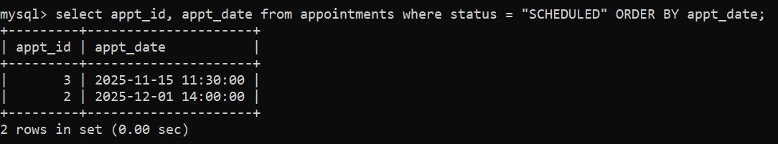
Warm-Up 4: Price Filter
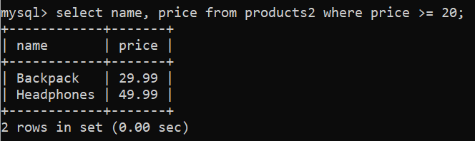
Warm-Up 5: Sort by Last Name
