Guided 1: First Look at an E-commerce DB
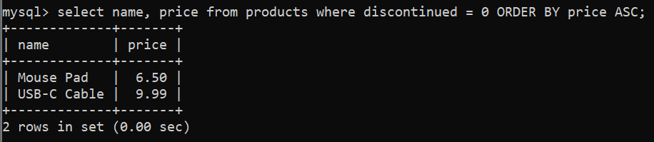
Guided 2: Student Enrollment Check
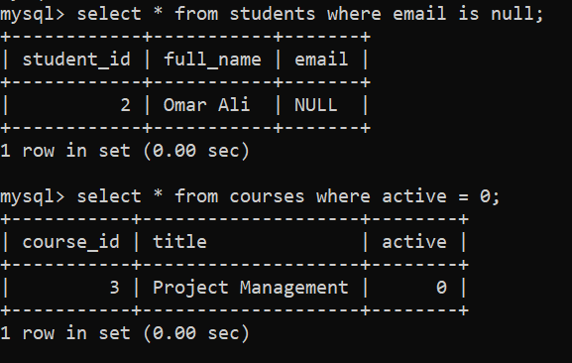
Guided 3: Appointment Status Report
