Independent 1: Email Rollup
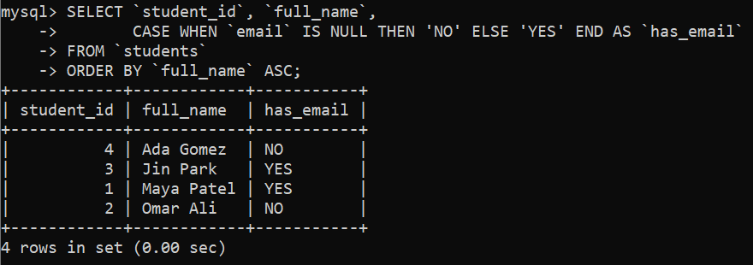
Independent 2: Active Products Only
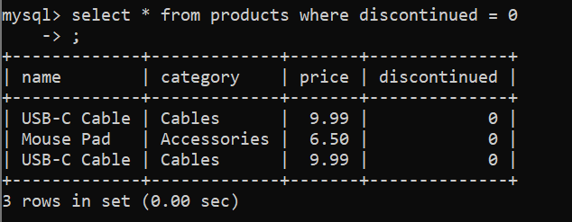
Independent 3: Upcoming Schedules
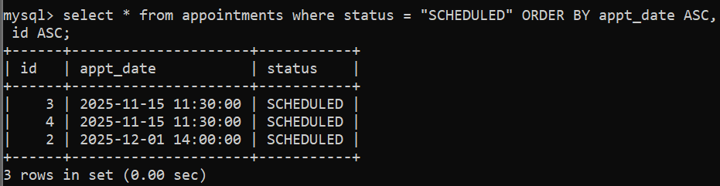
Independent 4: Price Bands
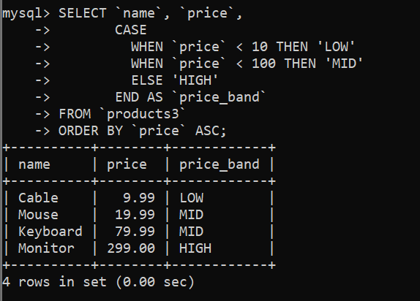
Independent 5: First and Last Names
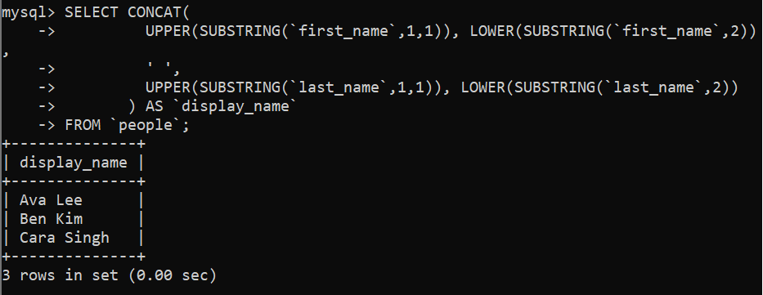
Independent 6: Unique Categories
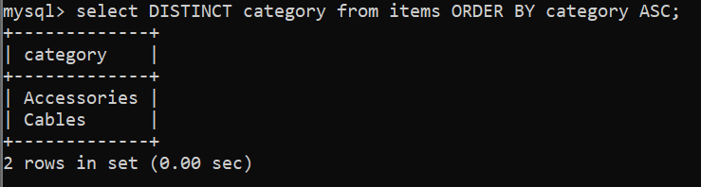
Independent 7: Orders Integrity Check
