Take-Home 1: Customer Overview Starter
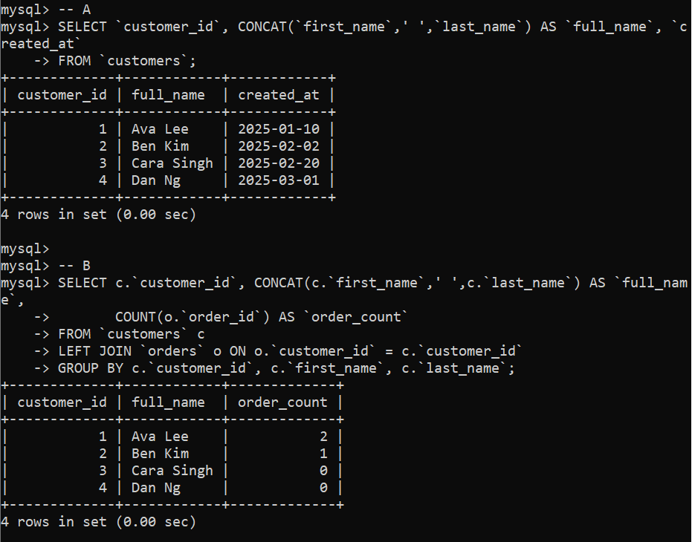
Take-Home 2: Product Availability and Sales
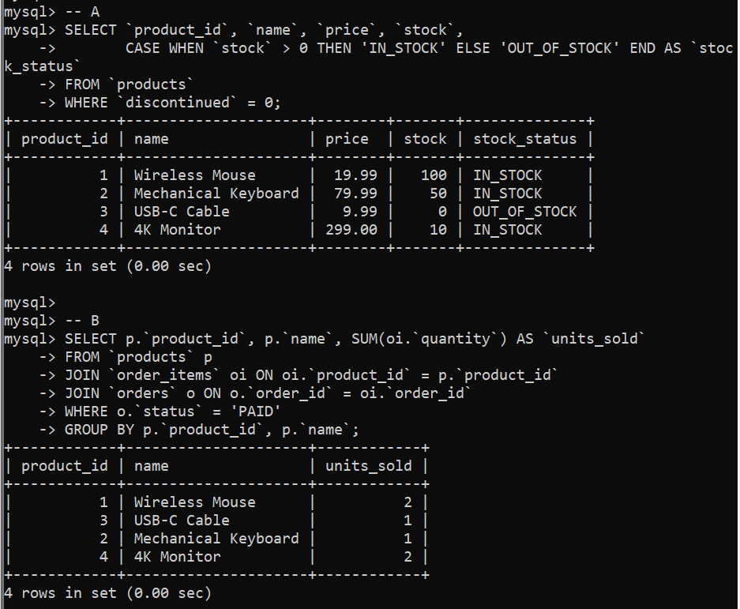
Take-Home 3: Education Snapshot
