Activity 1: Clean Product Listing for a Promo Email
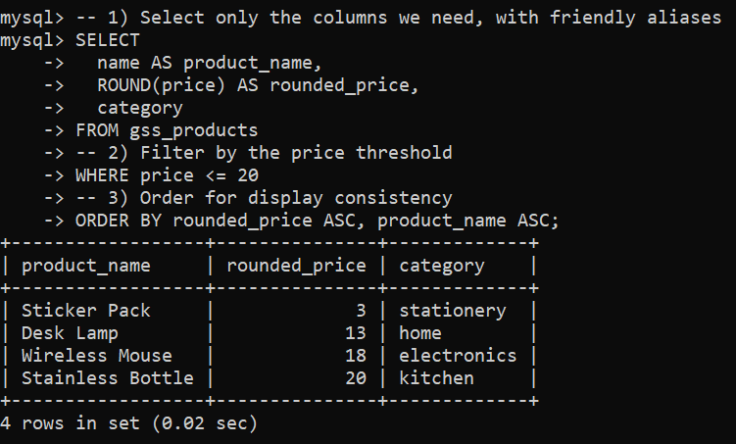
Activity 2: Student Directory With Missing Emails
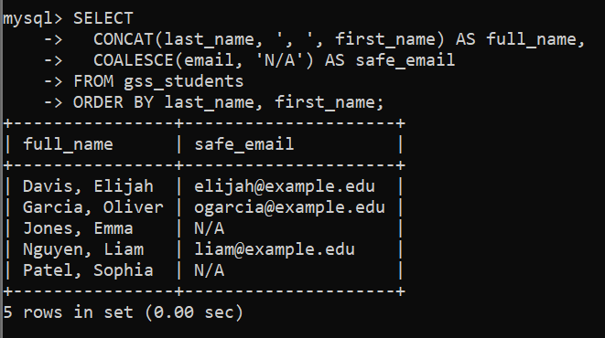
Activity 3: Clinic Appointments --- Today’s Schedule
