EASY :
- Simple Filtering in E-commerce
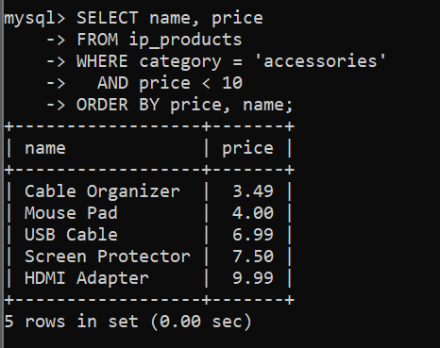
- DISTINCT Cities
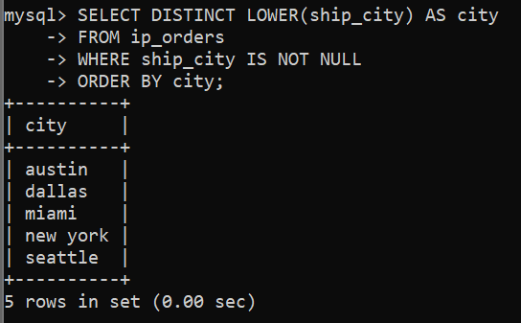
- LIKE Patterns
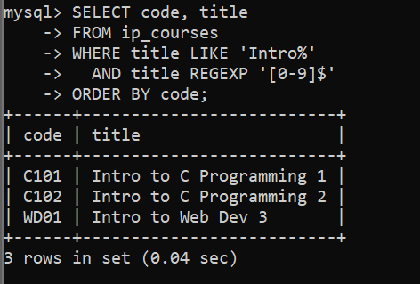
MEDIUM :
- Case-Insensitive Search With Safe Output
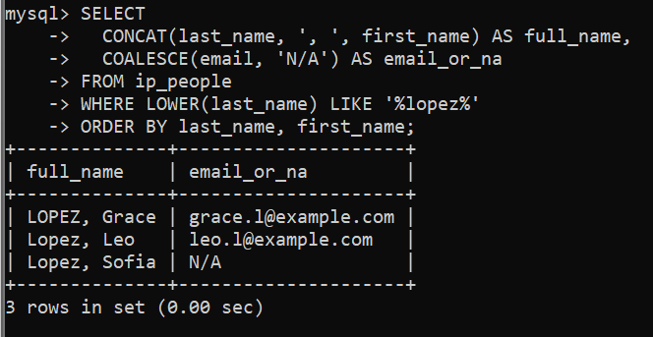
- BETWEEN and Edge Cases
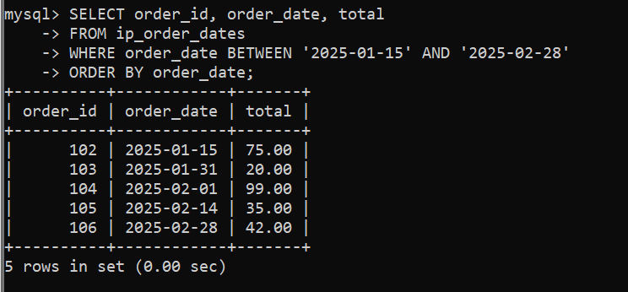
- Multi-Condition Logic With OR/AND
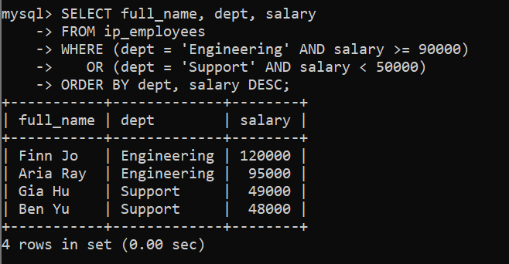
Challenge : Comprehensive Filter, Null Handling, and Aliases
