- Scalar Subquery in SELECT
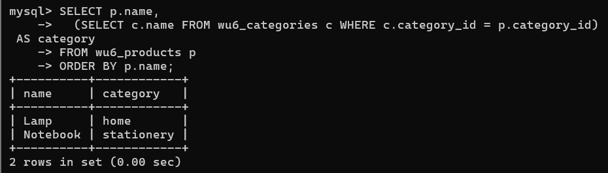
- EXISTS (semi-join)
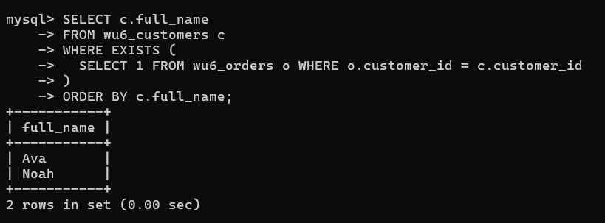
- NOT IN vs NOT EXISTS with NULLs
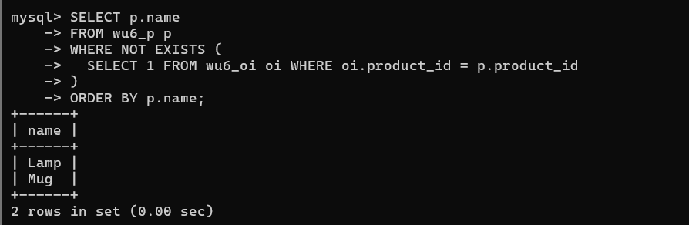
- Derived Table (FROM subquery)
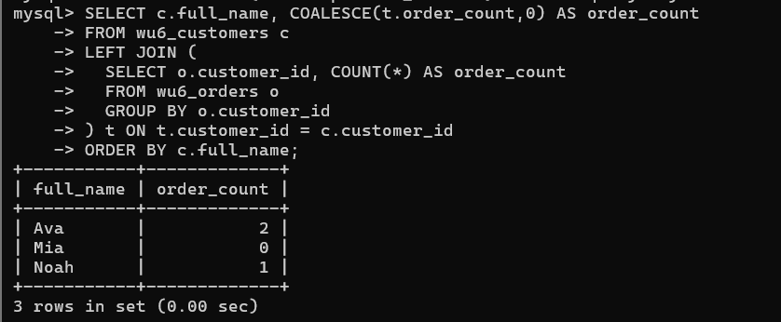
- Simple CTE for Staging
