Activity 1 : Latest Order Per Customer (Correlated Subquery)
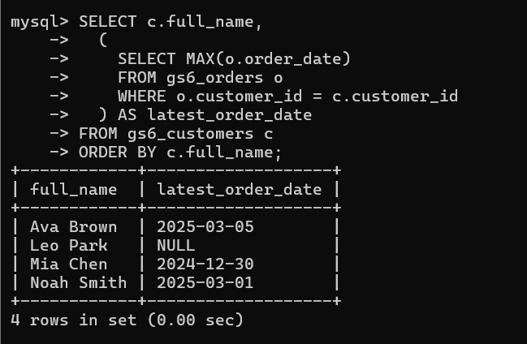
How would you filter to only customers with a latest order
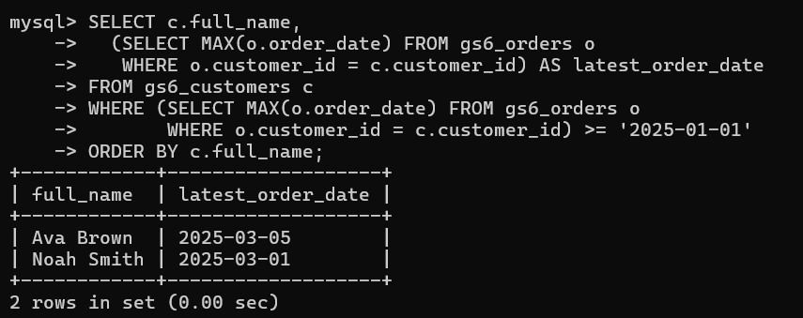
Activity 2 : Top Product per Category (Derived Table + Window)
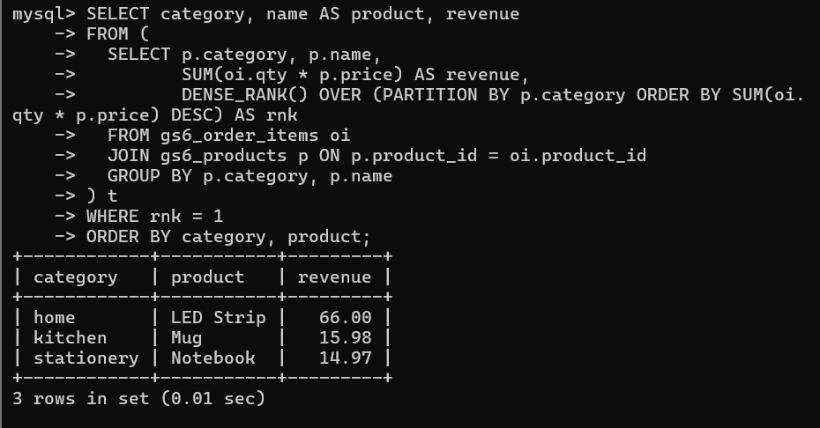
Alternative : Using CTE (More Readable)
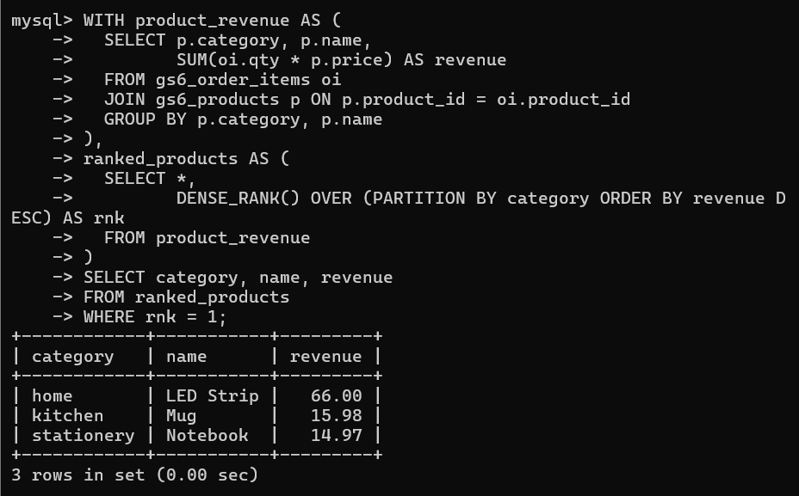
Activity 3 : KPI Pipeline with CTE (Non-recursive)
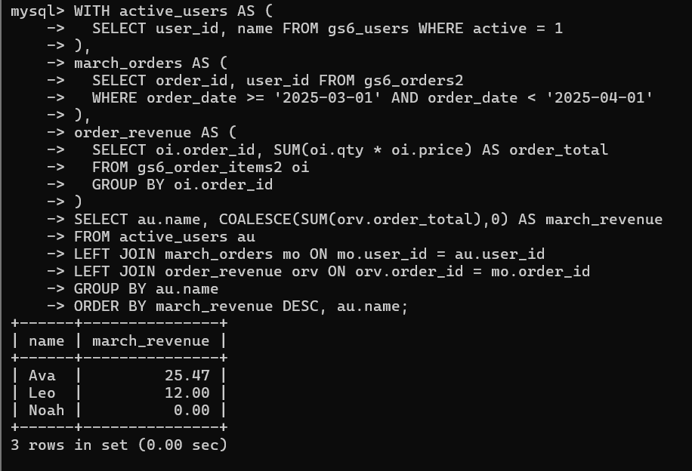

How would you extend this to compute average order value per active user for March?
