Easy :
- Customers with Orders (EXISTS)
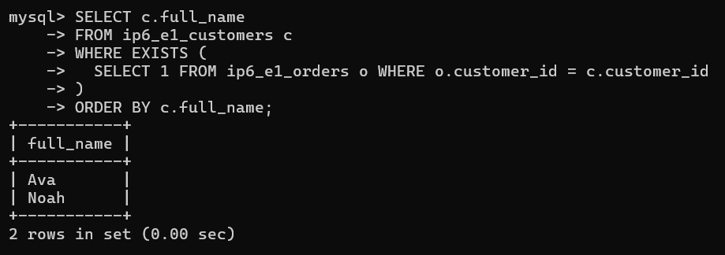
- Above/Below Average Price (Scalar Subquery)
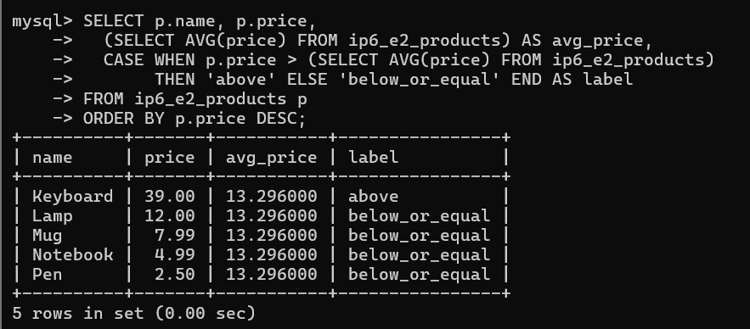
Alternative (More Efficient for Larger Tables) :
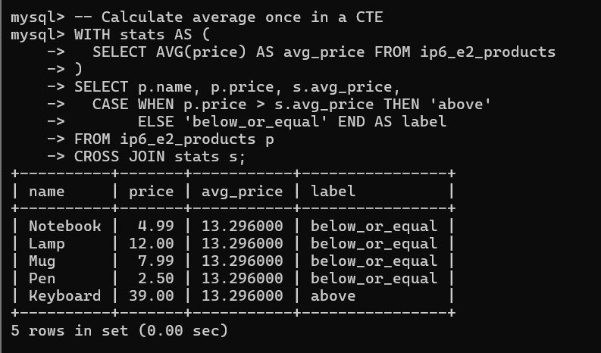
- Orders per Customer (Derived Table)
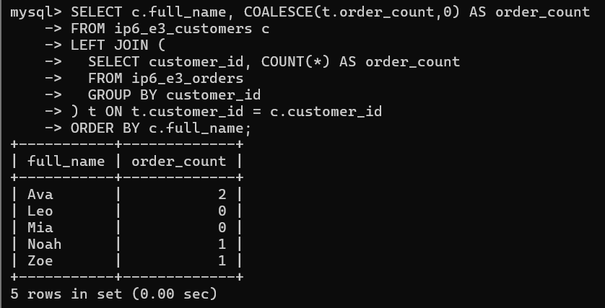
Medium :
- Above-Avg Spenders (Subquery in WHERE)
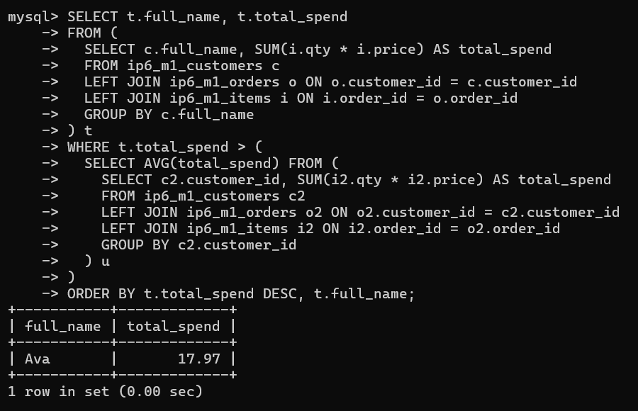
- Top 2 Products per Category (CTE + Window)
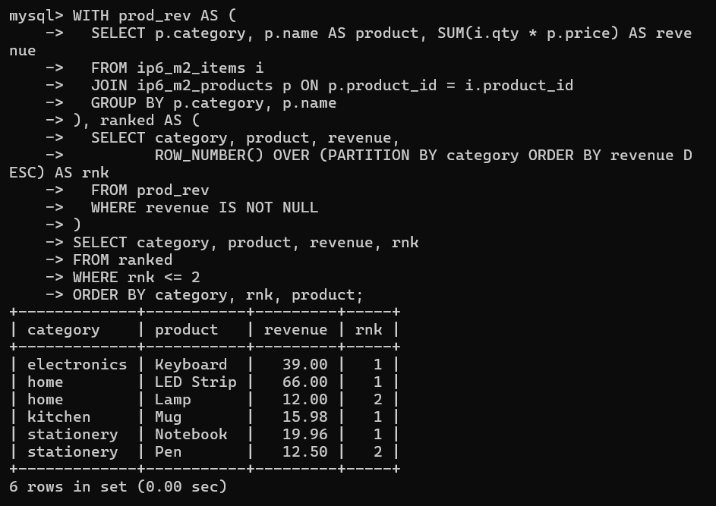
- NOT IN Trap (NULL-safe Anti-join)
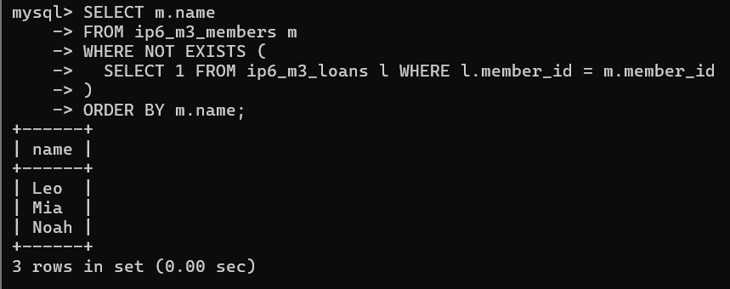
Challenge :
- Organization Chart Depth and Paths (Recursive CTE)
