Part A) Employees with a project (EXISTS)
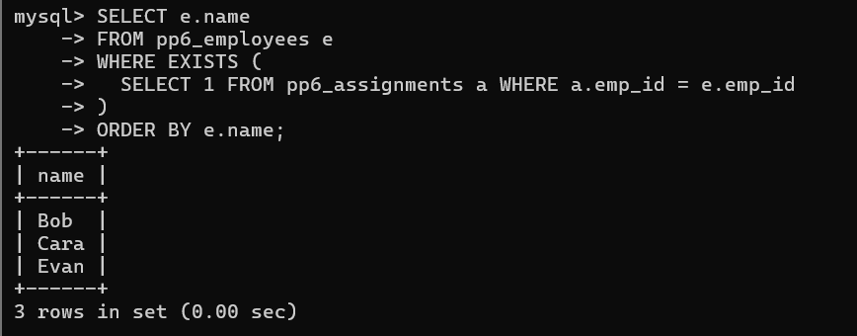
Part B) Manager name via scalar subquery
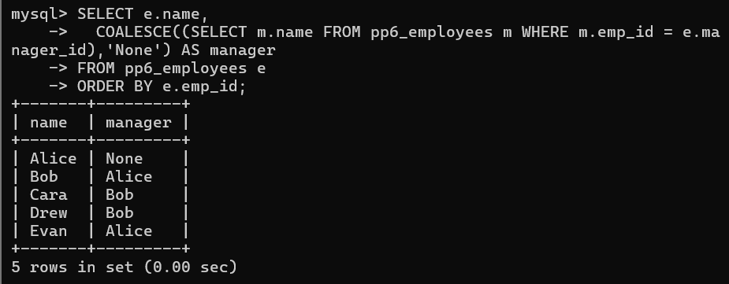
Part C) Org levels via recursive CTE
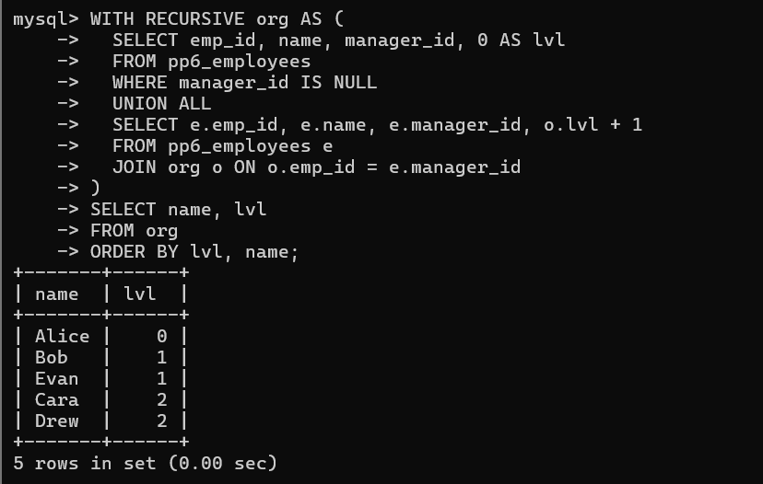
Alternative Without Recursion (For Small Hierarchies) :
