Challenge : Ticket Booking System
Part 1 : Discover the Problem ( Without Locking )
Partner A – Run This First :
-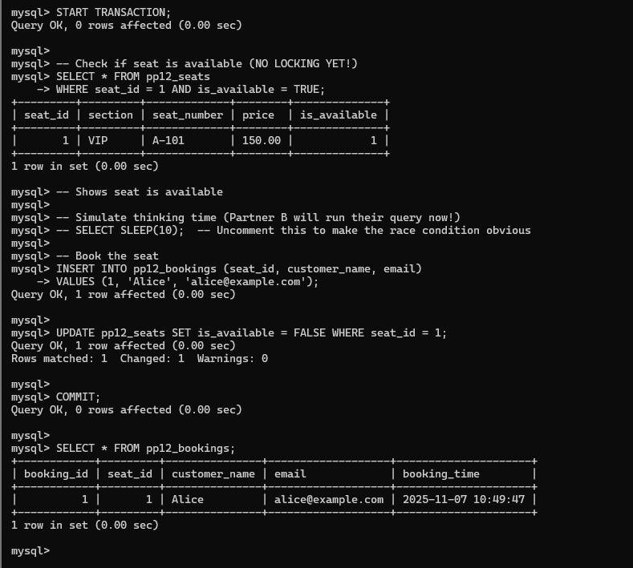
Partner B – Run This Immediately After Partner A Starts:
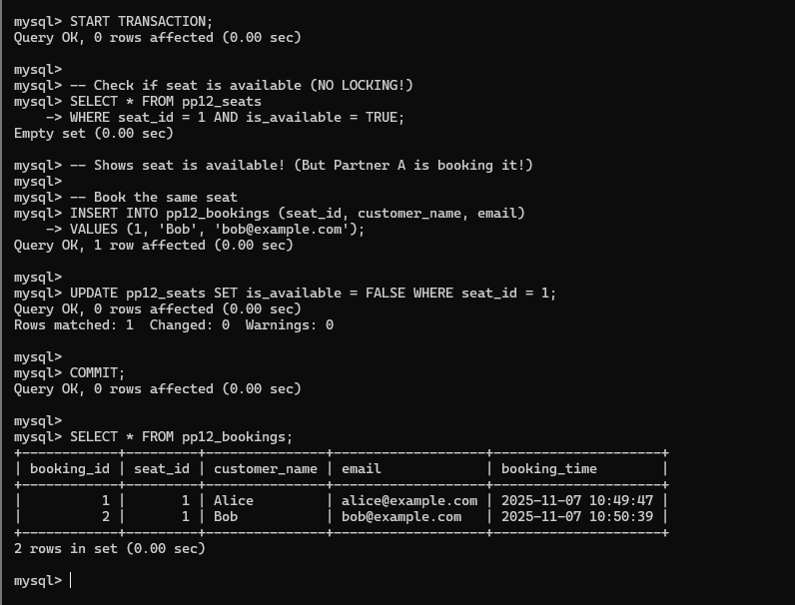
Part 2 : Fix It With Proper Locking
Partner A – Fixed Version :
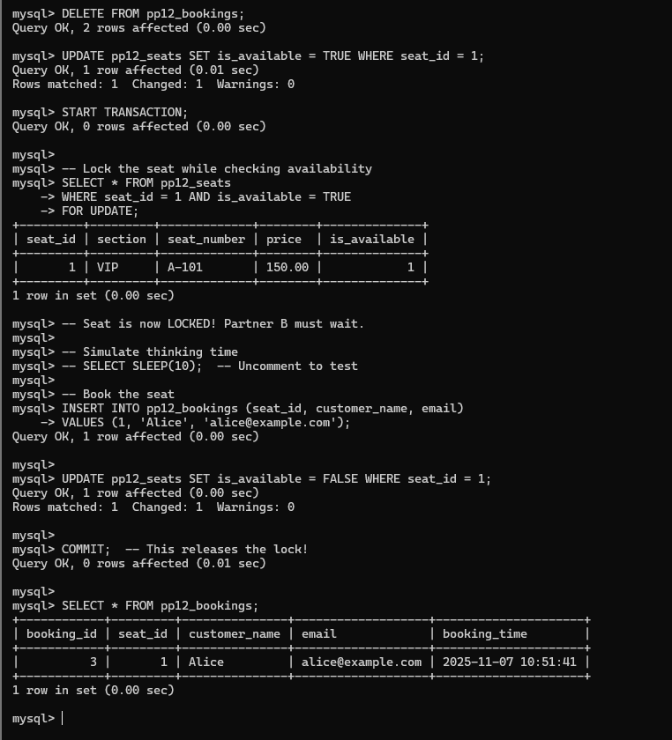
Partner B – Fixed Version ( Run Right After Partner A Starts) :
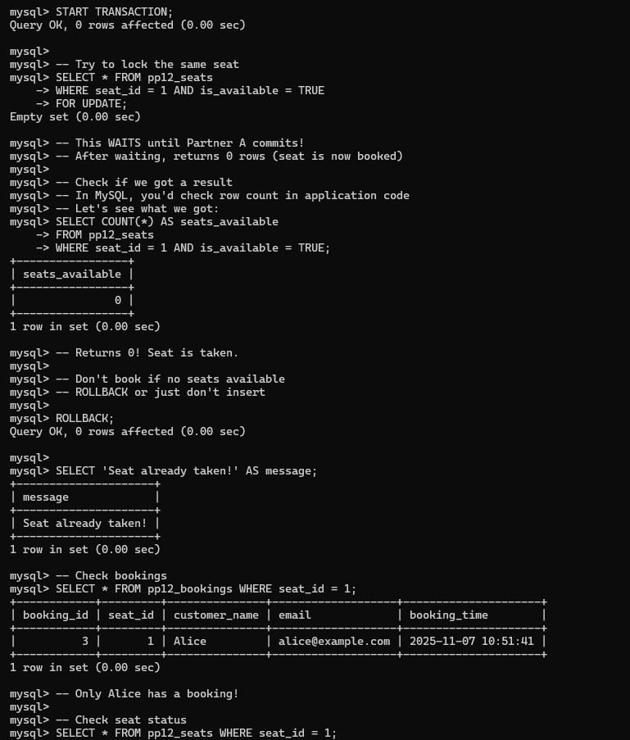
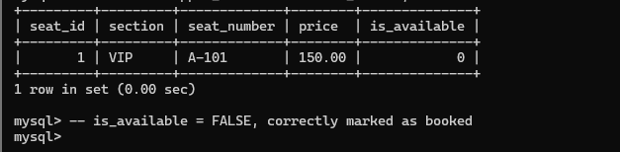
Partner 3 : Discussion Questions
