Activity 1 : E-Commerce Product Catalog Schema
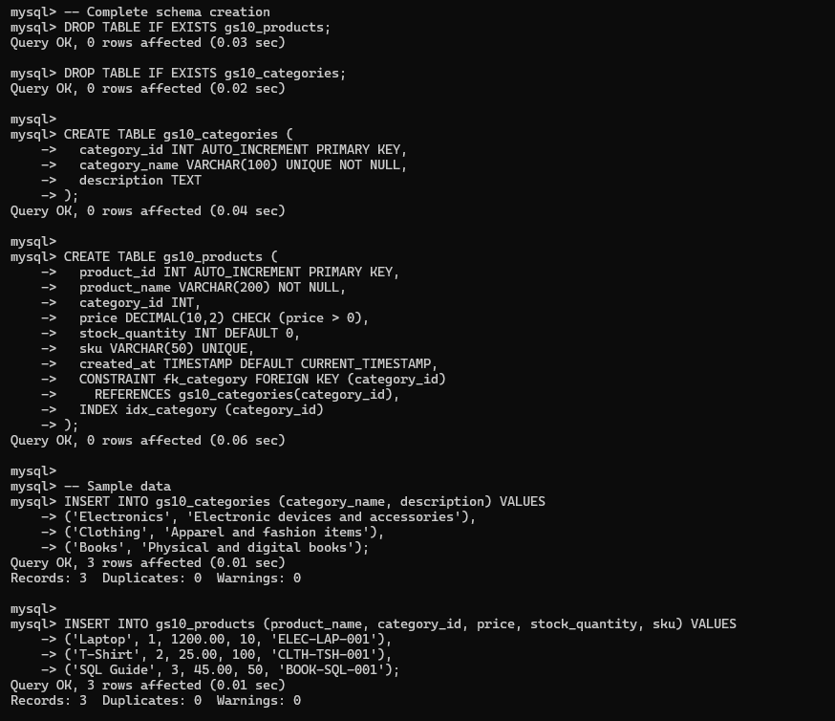
Activity 2 : User Account System with Audit
