- Orders with Customer Names (INNER JOIN)
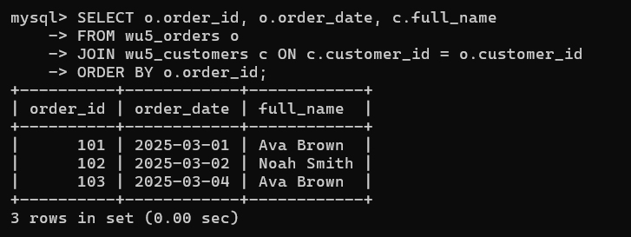
- Customers without Orders (LEFT JOIN anti-join)
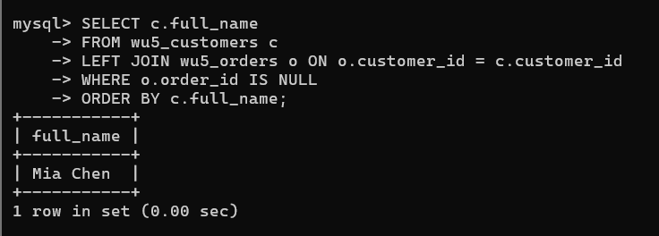
- Items per Order (JOIN + aggregate)
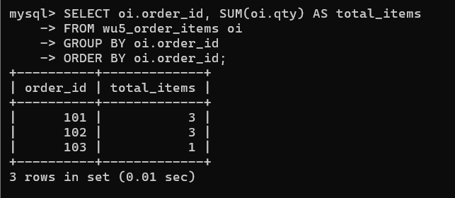
- Employees and Managers (SELF JOIN)
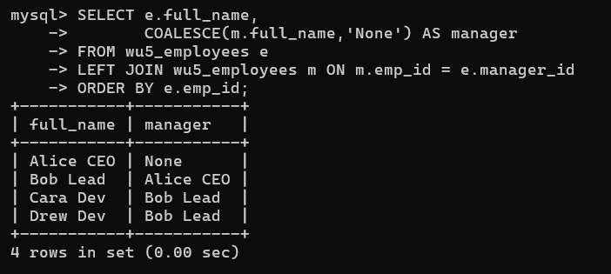
- Products Never Sold (LEFT anti-join)
