Activity 1 : Customer Spend Rollup
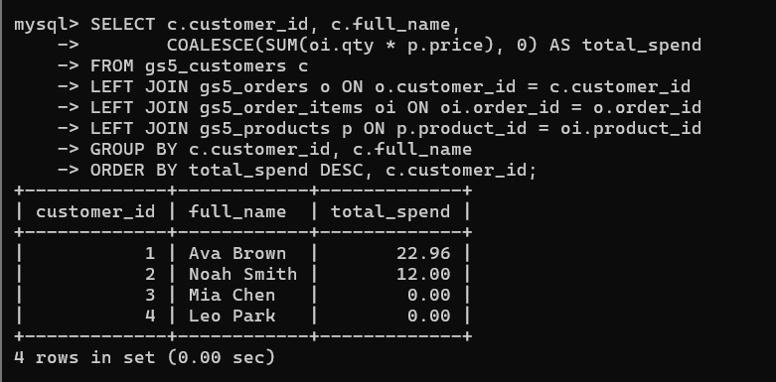
Activity 2 : Course Roaster Summary (Education)
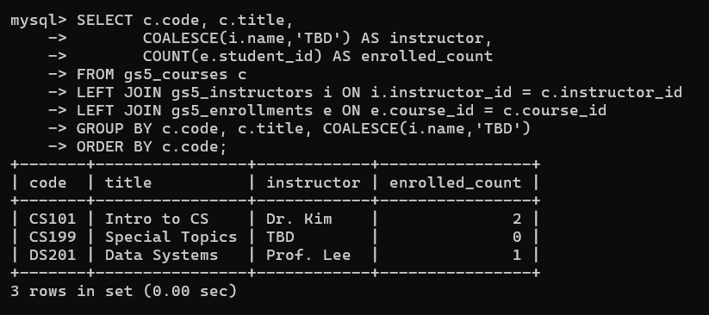
Activity 3 : Patient Visit Insights (Healthcare)
