Easy :
- Orders with Customer Name
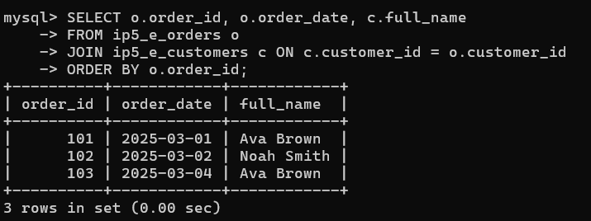
- Courses with Instructor
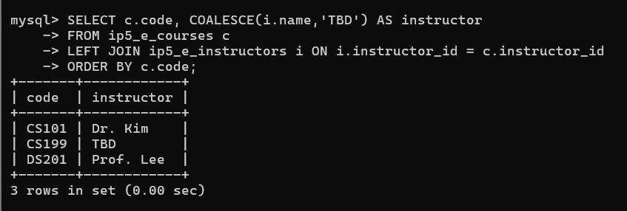
- Products Never Sold
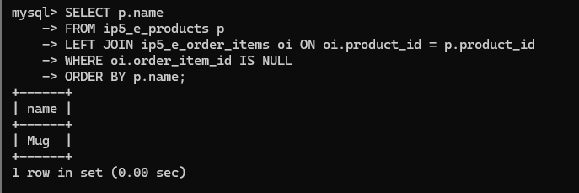
Medium :
- Revenue by Category
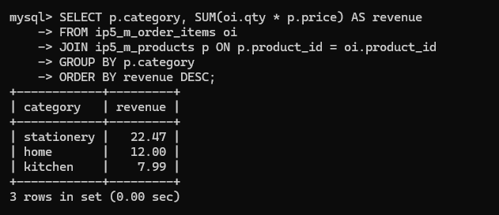
- Employees and Departments (including empty departments)
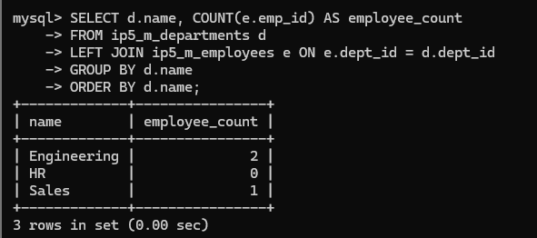
- Students Missing Prereqs (semi-join)
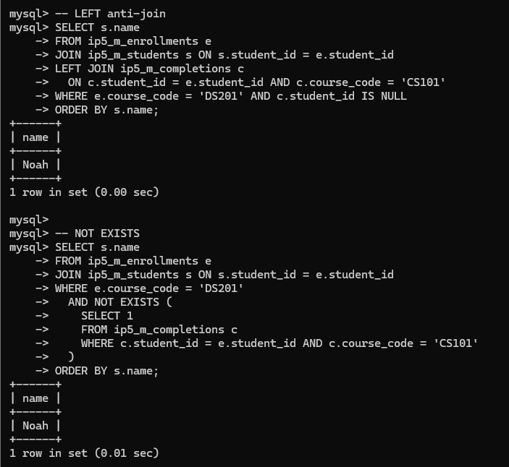
Challenge :
- Marketplace Analytics (many-to-many)
