- Row Numbers for Products
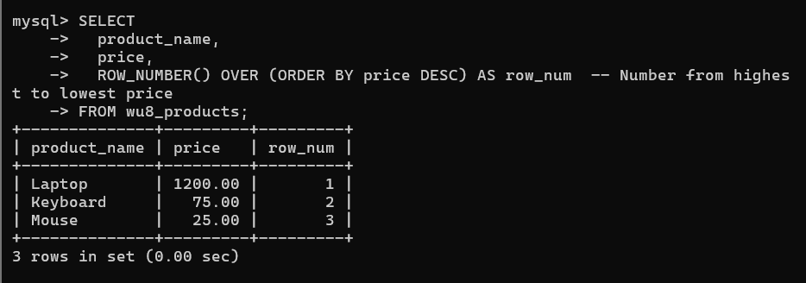
- Rank Students by Score
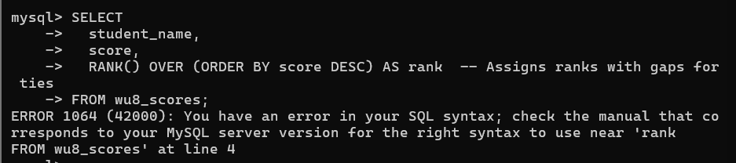
- Department Salary Ranking
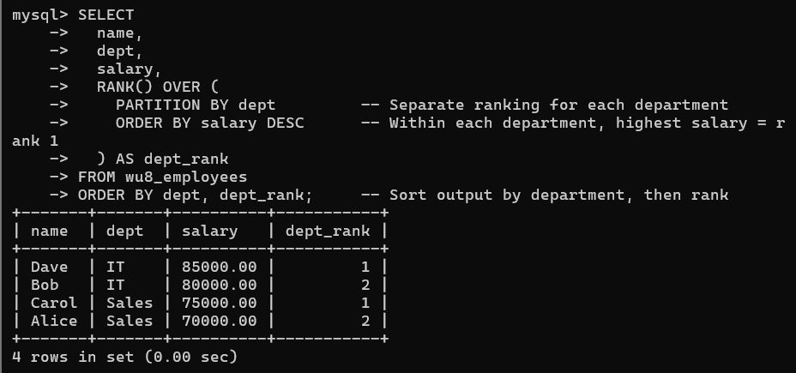
- Running Total of Sales
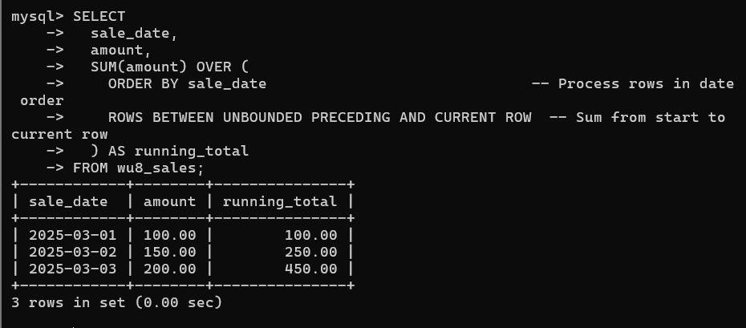
- Previous Month Comparison (LAG)
