Exercise 1 : Sales Ranking
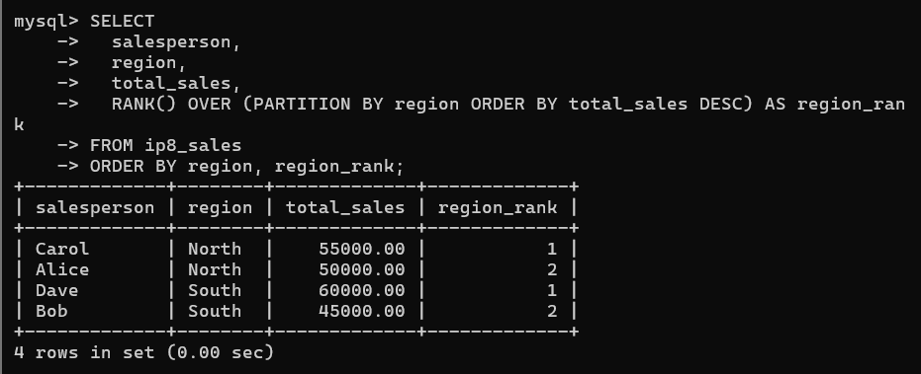
Exercise 2 : Running Total
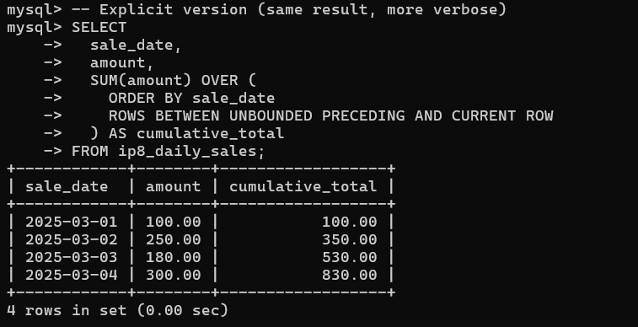
Exercise 3 : Month-over-Month Growth
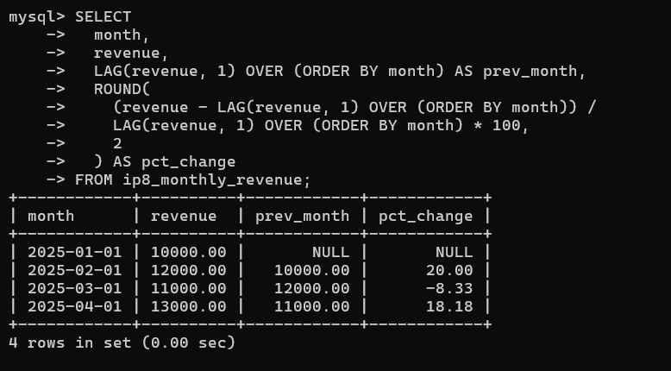
Exercise 4 : Top 3 Per Department
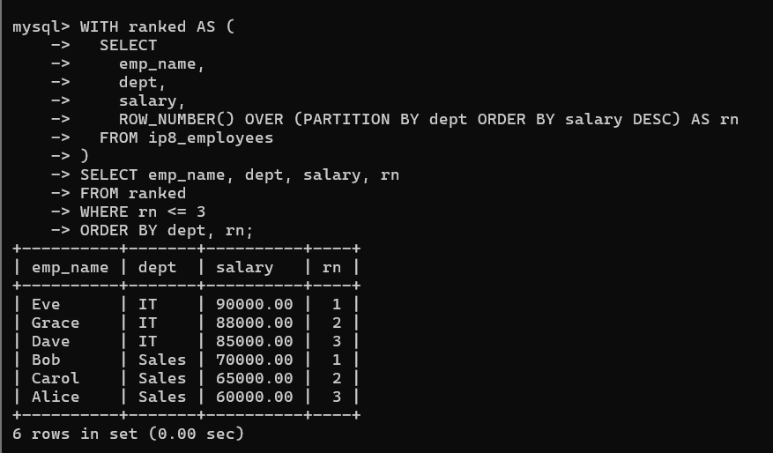
Exercise 5 : Moving Average
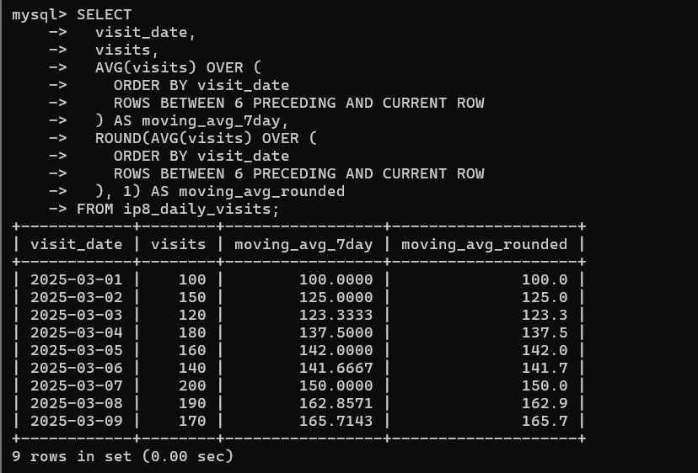
Exercise 6 : Quartile Analysis
