Part A : Regional Ranking (Driver: Partner 1, Navigator: Partner 2)
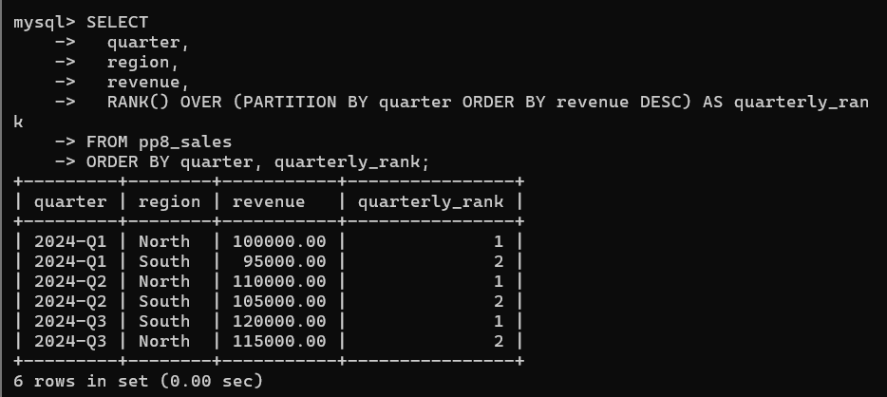
Part B : Quarter-over-Quarter Growth (Driver : Partner 2, Navigator: Partner 1)
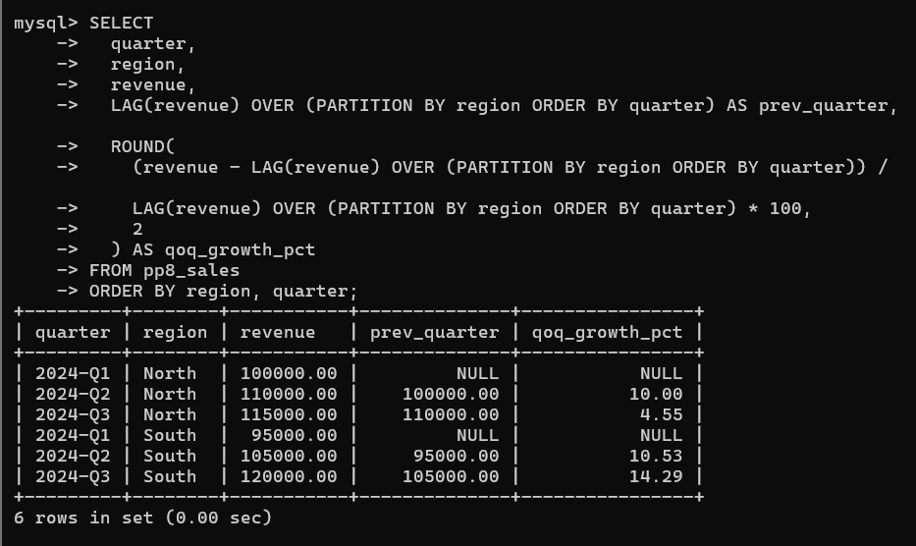
Part C : Cumulative Analysis (Both Partners Collaborate)
